NEW YORK UNIVERSITY

HISTORY

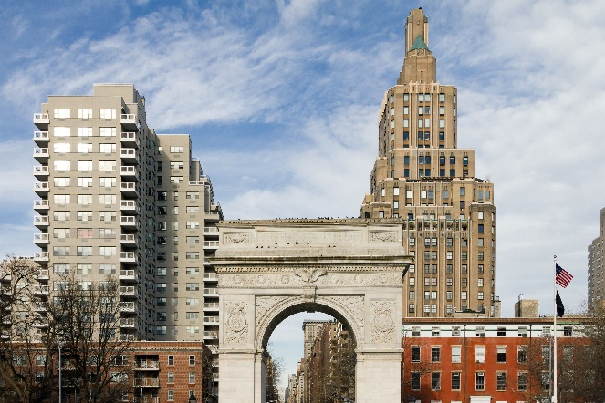

-New York University (NYU) founded in 1831 by Albert Gallatin as an institution to "admit based upon merit rather than birthright or social class"

SPORT

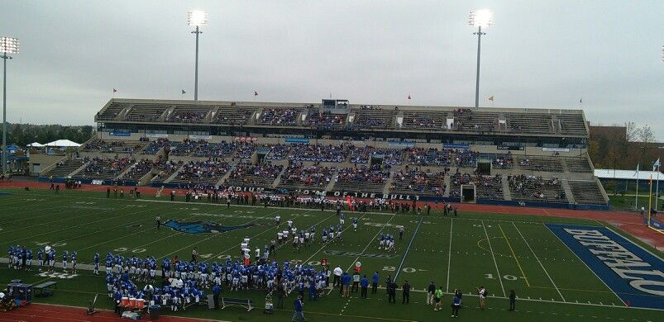

-NYU Violets is the nickname of the sports teams and other competitive teams at New York University The university sponsors 23 varsity sports, as well as club teams and intramural sports.

LIBRARY



-The system flagship is the Elmer Holmes Bobst Library, which houses millions of volumes, 272,000 serial titles, and over 43,000 linear feet of archives and provides access to thousands of electronic resources both on-site and online. Bobst Library receives 11,000 visits per day and circulates 246,000 items annually.

CANTEEN



-NYU Eats is fully committed to providing students with a wide variety of delicious, healthy and nutritious meal options—safely and responsibly.

Number of students

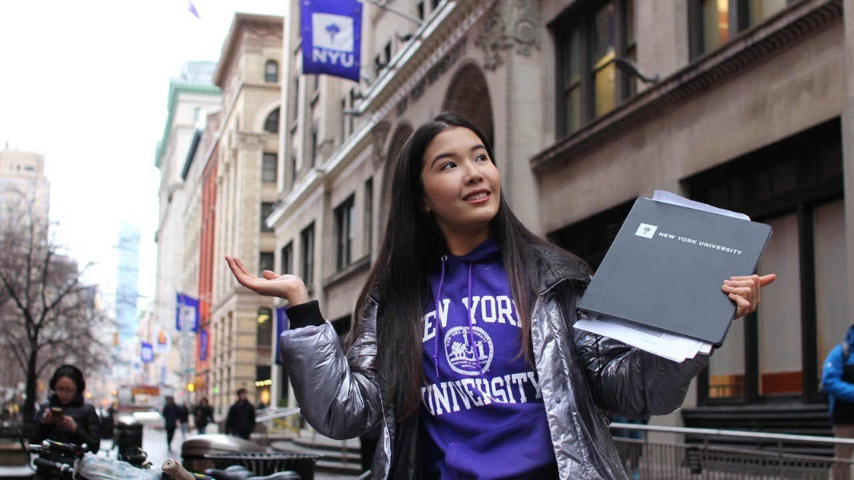

-After evaluating more than 85,000 admissions applications for its campuses in New York, The New York campus’ admitted class maintains last year’s record levels of diversity: 9 percent are African American and 18 percent are Latinx.

Availability of boarding



-Within each residence hall assignment, each student is provided the following:  
\*An extra long twin bed and mattress (39"x80")  
\*A desk and chair  
\*Drawer space (either underbed or dresser)  
\*Hanging space (either a closet or wardrobe cabinet)

LOCATION

