YESHIVA UNIVERSITY

HISTORY

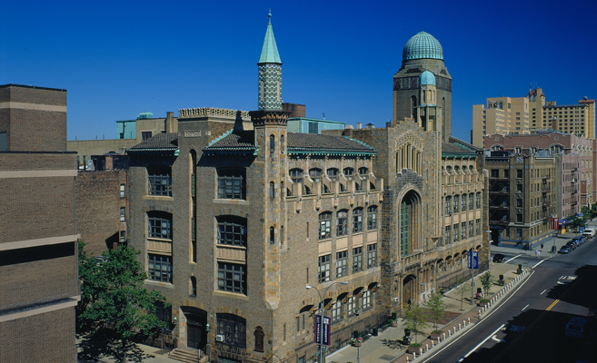

-Yeshiva University, a private university in New York City, with six campuses in New York and one in Israel, was founded in 1886. It is a research university ranked as 45th in the US among national universities by U.S. News & World Report in 2012.

SPORT

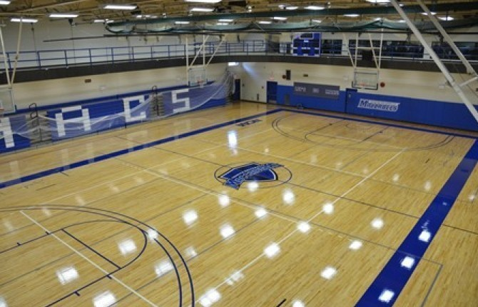

-Yeshiva University includes a variety of NCAA Division III-level sports teams. The teams, nicknamed "The Maccabees", include: men's baseball, basketball, golf, volleyball, wrestling, women's basketball, cross country, fencing, soccer, tennis, and volleyball

LIBRARY

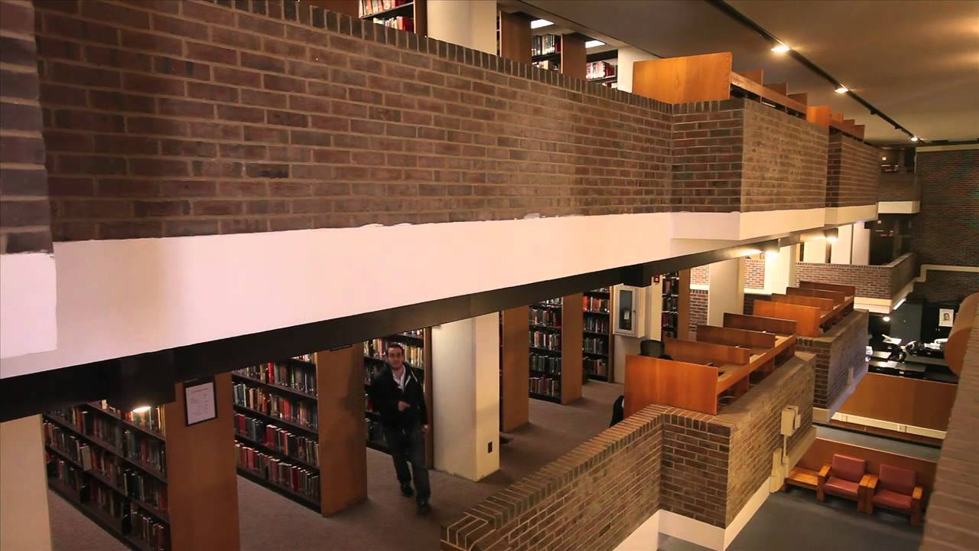

-The Mendel Gottesman Library of Hebraica/Judaica is one of the world's great Judaic library collections and the Jewish Studies research center at Yeshiva University's Wilf Campus. Occupying three levels in the Mendel Gottesman Library Building (levels 4 through 5A) the Library offers services and collections for advanced scholarship as well as for the student just beginning to explore the field

CANTEEN

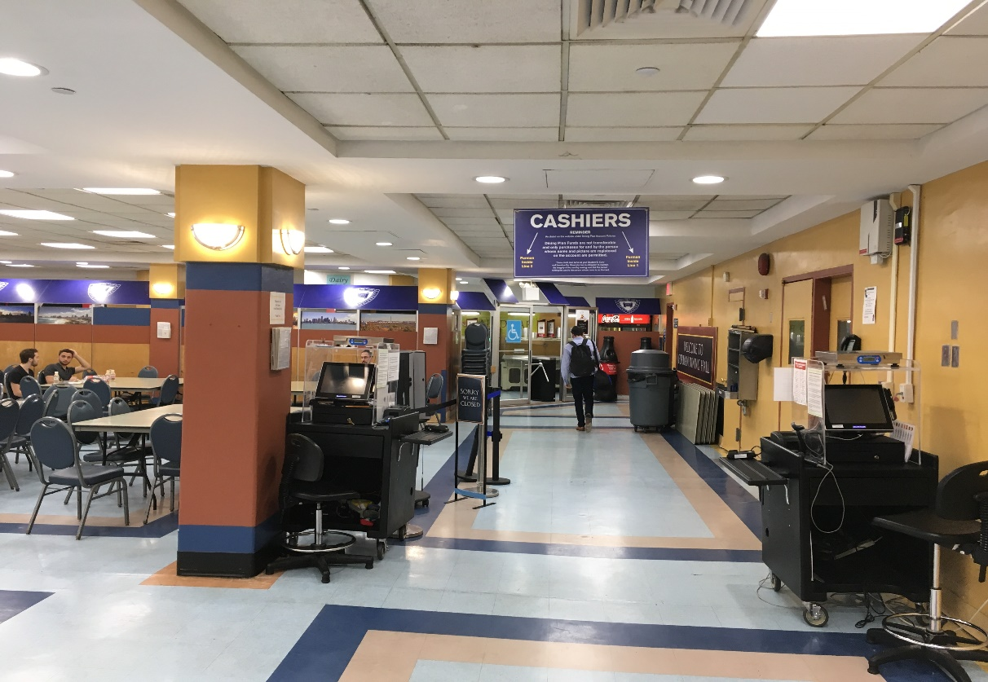

-Located on the lower level of the Leah and Joseph Rubin Residence Hall, 2501 Amsterdam Avenue, and one of the busiest locations on campus, this dining hall offers a full lunch and dinner menu daily for students and staff. Within the Furman Dining Hall are the Inside Serving Line and the Food Court. The Inside Serving Line offerings include hot entrees and sushi, prepackaged sandwiches & salads and a variety of grab-n-go items. The Food Court area is stocked with a large variety of groceries and beverages.

Number of students

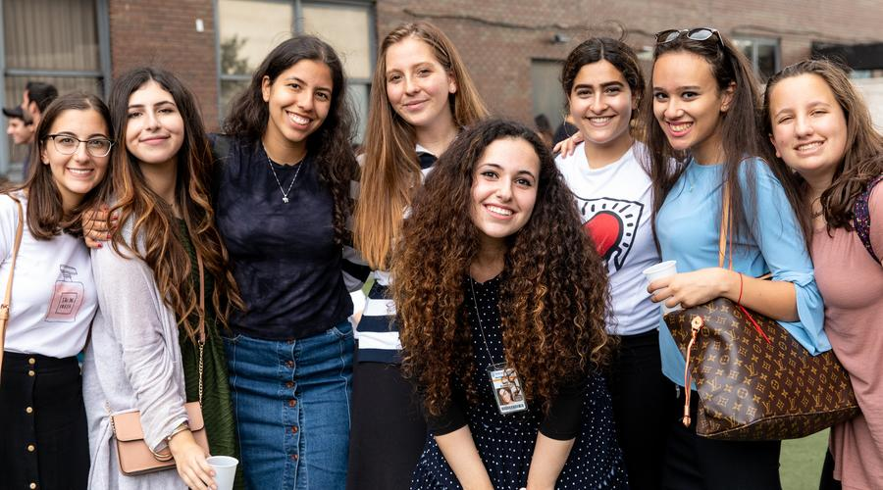-Yeshiva University enrolls approximately 6,400 undergraduate students, 3,500 graduate students, and 1,000 students at its affiliated high schools - Yeshiva University High School for Boys and Yeshiva University High School for Girls - and Rabbi Isaac Elchanan Theological Seminary

Availability of boarding

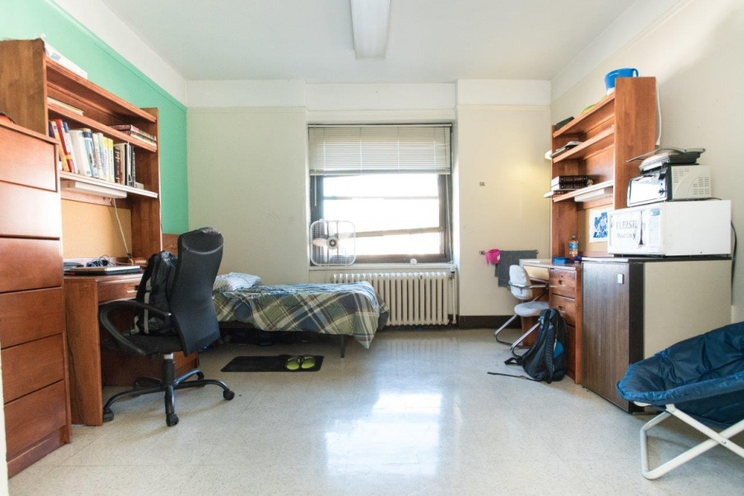

-Dormitories and student housing There are dormitory and dining facilities on each campus. Cardozo has a single dormitory building a block south of the classroom building, while Einstein has a number of student housing buildings on campus for single and married students.

Approximately 80% of the undergraduate student populations live on campus.

LOCATION

