Supplement and Fitness Shop

Vision Document

Version 1.0

Revision History

|  |  |  |  |
| --- | --- | --- | --- |
| **Date** | **Version** | **Description** | **Author** |
| 22/10/2024 | <1.0> | Initial Overview of the Project | Hồ Trương Viết Long |
| 22/10/2024 | <1.1> | Add Product Perspective | Nguyễn Trần Đức Thiện |
|  |  |  |  |
|  |  |  |  |

Table of Contents

**1. Introduction 4**

1.1 Purpose 4

1.2 Scope 4

1.3 References 4

**2. Positioning 4**

2.1 Business Opportunity 4

2.2 Problem Statement 4

2.3 Product Position Statement 4

**3. Stakeholder and User Descriptions 5**

3.1 Stakeholder Summary 5

3.2 User Summary 6

3.3 User Environment 6

3.4 Key Stakeholder / User Needs 6

3.5 Alternatives and Competition 7

**4. Product Overview 7**

4.1 Product Perspective 7

4.2 Assumptions and Dependencies 8

**5. Product Features 8**

**6. Non-functional Requirements 9**

Vision

# Introduction

## Purpose

The purpose of this document is to provide a comprehensive overview of the functionalities of Supplement and Fitness Shop in terms of the needs of the end users.

## Scope

This Vision Document applies to the Supplement and Fitness Shop web, which will be developed by the Nao Co Bap team. The team will develop this web-based system to facilitate the sale and promotion of supplements and fitness-related products, integrating with an existing product inventory database.

The Supplement and Fitness Shop will enable customers to purchase fitness supplements and products online, while allowing admins to manage the product catalog and maintain customer orders.

## References

Applicable references are

1. <https://www.youtube.com/watch?v=4NNOPOuePZw&list=PL3Bp9JDvkAra8rRrUPOpfKdKvJ6-okqaw&index=9>
2. <https://www.youtube.com/watch?v=FS125VoBlro&list=PL3Bp9JDvkAra8rRrUPOpfKdKvJ6-okqaw&index=10>
3. PA1 instruction file

# Positioning

## Business Opportunity

This project aims to create the Supplement and Fitness Shop, an online platform where customers can easily purchase fitness supplements and related products. Our new system will offer a simple and easy-to-use interface, allowing customers to browse products, participate in a fitness forum, and even connect with personal trainers.

## Problem Statement

|  |  |
| --- | --- |
| The problem of | Limited access to fitness supplements and a lack of community support in the current market |
| affects | Fitness enthusiasts, athletes, and individuals seeking to improve their health. |
| The impact of which is | A fragmented shopping experience, insufficient guidance, and missed opportunities for personal growth in fitness journeys. |
| A successful solution would | Provide a comprehensive online platform that offers easy access to products, fosters community engagement, and integrates tools for tracking nutrition and fitness goals. |

## Product Position Statement

|  |  |
| --- | --- |
| For | Fitness enthusiasts, athletes, and health-conscious individuals |
| Who | Seek convenient access to fitness supplements and community support |
| The Supplement and Fitness Shop | Is a comprehensive online platform |
| That | Enables easy purchasing of fitness products, access to a fitness forum, and personalized trainer services |
| Unlike | Traditional retail stores and fragmented online options |
| Our product | Provides a seamless shopping experience with integrated tools for tracking nutrition and fitness goals, accessible from any device connected to the internet. |

# Stakeholder and User Descriptions

This section illustrates the Users of “Supple and Fitness Shop”. In detail, there are 3 kinds of Users namely: Customer Users, Personal Trainer and Administrators of this website.

## Stakeholder Summary

|  |  |  |
| --- | --- | --- |
| **Name** | **Description** | **Role** |
| Project Manager | A stakeholder leading the system development. | Has responsibility for listing the requirements and assigning tasks for every member, and managing strictly the overall Project Management. During the project period, the Project manager must ensure no delays in each phase, and review all documents and source codes in each phase. |
| Administrator | A stakeholder has the authority to manage employees of the total system. | Responsible for managing the online platform, overseeing inventory, user accounts, and ensuring smooth operation of the website. |
| Personal Trainer | A stakeholder who provides fitness guidance and personalized workout plans to customers. | Responsible for offering fitness advice, creating customized training programs, and monitoring clients' progress. Has the authority to publish workout routines, share fitness-related content on the website, and communicate directly with users seeking personal training services. |
| QA/Tester | A stakeholder who tests the system when it is completed. | Responsible for testing including testing all functions of the system, execution, evaluation of test execution, and ensuring all errors are fixed. |
| Supervisor/Mentor | A stakeholder who observes and teaches the process of doing the project. | Responsible for observing the process of “Supplement and Fitness Shop”, giving some advice to improve, and assessing the results. |
| Customer | This is an end-user stakeholder who can purchase fitness supplements and products from the platform. | Has the need for buying supplements, fitness-related products, or exploring more about fitness routines, diet plans, and wellness tools. Can also engage with the community, post reviews, and participate in discussions on fitness topics. |

## User Summary

|  |  |  |
| --- | --- | --- |
| **Name** | **Description** | **Stakeholder** |
| Administrator | Manages the online store's product listings, user accounts, and overall functionality of the website, ensuring smooth operations and user satisfaction. | Self-represented |
| Personal Trainer | Manages personalized fitness programs, provides workout and nutrition advice, and interacts with users seeking fitness guidance. | Self-represented |
| Customer | Purchases fitness supplements and products, engages with community features, and seeks advice on fitness-related topics. | Self-represented |

## User Environment

There are 5 people involved in the project. It remained unchanged throughout this project.

Our website can be accessed using any browser such as: Firefox, Chrome, Opera, etc. and ensure the device has a good Internet connection to access and use our software smoothly.

Our website is for everyone who has needs, interests and passion for supplement and fitness. We only limit users to Vietnam because our project is new and small in scale.

## Key Stakeholder / User Needs

## 

|  |  |  |  |  |
| --- | --- | --- | --- | --- |
| **Need** | **Priority** | **Concerns** | **Current Solution** | **Proposed Solution** |
| Product Search and Filters | High | Users find it challenging to search for specific supplements or fitness products due to limited search functionality, leading to frustration and inefficiency. | The platform currently provides basic search options without advanced filters for product categories, ingredients, or health goals. | Improve search functionality by introducing advanced filters (e.g., by product type, fitness goal, brand, ingredients) and sorting options, paired with a user-friendly interface, to enhance the accuracy and speed of product searches. |
| Reviews, Suggestions, and Ratings | Medium | Users have limited information about the quality and effectiveness of supplements and fitness products, which may lead to uncertainty and uninformed purchasing decisions. | The platform currently lacks a review and rating system, leaving customers without insights from other users' experiences. | Implement a review and rating system that allows customers to share their experiences and provide feedback on supplements, fitness products, and personal trainers, ensuring better transparency and helping users make informed decisions. |
| Hiring Personal Trainers | High | Users may struggle to find qualified personal trainers who meet their specific fitness needs, leading to dissatisfaction or ineffective training experiences. | The platform currently lacks a feature to hire personal trainers, limiting users’ ability to access professional guidance. | Implement a dedicated section where users can browse profiles of available personal trainers, view their qualifications and specialties, and book sessions directly through the platform. |
| Personal Trainer Ratings and Reviews | Medium | Users lack insights into the effectiveness and quality of personal trainers, which can result in poor selection and reduced trust. | There is no existing rating or review system for personal trainers, leaving potential clients without critical feedback. | Introduce a rating and review system that allows users to share their experiences with personal trainers, helping others make informed decisions based on quality of service and effectiveness |
| Community Forum | High | Users may feel isolated in their fitness journeys without a supportive community for sharing experiences, tips, and advice. | The platform currently lacks a community forum, limiting users' ability to interact and engage with others. | Create a dedicated community forum where users can post questions, share their fitness journeys, offer tips, and connect with like-minded individuals, fostering a sense of belonging. |

## Alternatives and Competition

There are lots of similar websites that dominate the supplement and fitness market achieving a large number of users such as WheyStore.com, and Shopee, Lazada, …

Here are the strengths and weakness of those:

* Online Store (WheyStrore.com…):
* Strengths:
* Integrated Service: Many general shops provide additional services such as fast shipping, customer support, and loyalty programs.
* Diverse Product Range: Offer a broader selection of products across multiple categories.
* Weakness:
* Limited Community Engagement: Lack of targeted community through forums, personal trainer services, and fitness-related content.
* E-commerce Websites (Shopee, Lazada…):
* Strengths:
* Extensive Listings: These websites offer a vast selection of supplements from various sellers, providing users with a wide range of options.
* Price Comparison: Customers can easily compare prices between different sellers for the same product, allowing them to find the best deal, promoting transparency and helping customers make more informed purchasing decisions.
* Weakness:
* Ad Overload: Some users have reported that the platform can sometimes be cluttered with advertisements, which may disrupt the user experience.
* Limited Contact: Lack of direct customer contact, which can lead to a more impersonal shopping experience.

# Product Overview

## Product Perspective

Our product is a web-base application, a system that provides all of the features meticulously described in the Product Features section.

Server: It will be a machine running with sufficient configuration and services for a Web server with PostgreSQL Database installed out of the box.The application is decided to be used along with PostgreSQL (will be installed locally) that stores almost all the data we need for this application including the products information, feedbacks, user with associating information like user’s wishlist, purchase history, pending order…

Client: All users who have access to the internet could easily use our application on an up-to-date web browser (from a chromium-based browser like Edge, Google Chrome to an open source browser like Firefox, Brave and its variations…)

The following figure is the diagram to what our system expected to be in the future:

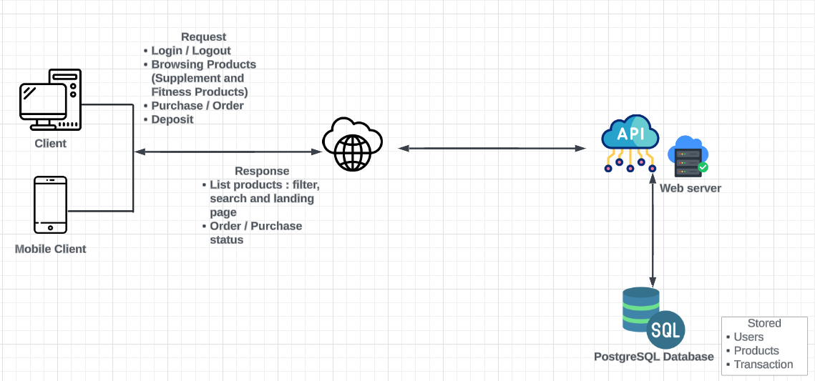

## Assumptions and Dependencies

There should not be any of the serious security vulnerabilities like zero-day occurs in the project timeline.

All predetermined parts of system and its alternatives will not be malfunctioning or becoming unusable at the same time

All the frameworks, libraries we should be using, still remain usable in production

Number of team members (5) still remain the same

The project’s deadlines still be on schedule

# Product Features

This section defines and describes the features of the Supplement and Fitness Shop. Features are the high-level capabilities of the system that are necessary to deliver benefits to users.

|  |  |  |  |  |
| --- | --- | --- | --- | --- |
| **No.** | **Feature** | **Description** | **Usability** | **Priority** |
| 1. | Login (User Permissions) | Users can log in with different permissions (admin/user). | Ensure a simple login process with clear user permission roles. | High |
| 2. | Place Order | Users can place orders for products. | Streamline the checkout process to make ordering quick and easy. | High |
| 3. | Shopping Cart | Users can add products to a cart and review them before purchasing. | Design the cart interface to be user-friendly and easily accessible. | High |
| 4. | Product Review | Users can review and rate products they have purchased. | Provide a simple interface for writing and submitting reviews. | Medium |
| 5. | Hire Personal Trainer | Users can hire personal trainers for customized fitness plans. | Create an easy-to-follow hiring process with trainer profiles. | High |
| 6. | Personal Trainer Review | Users can rate and review personal trainers. | Allow users to give feedback on their training experience. | Medium |
| 7. | Forum | Users can join discussions and share experiences in the forum. | Build a community-friendly forum with categories for fitness topics. | Medium |
| 8. | Chat | Users can chat with trainers or support staff for assistance. | Integrate a responsive chat feature for real-time communication. | Medium |

# Non-functional Requirements

This section defines the quality ranges for performance, robustness, fault tolerance, usability, and similar characteristics for the Supplement and Fitness Shop.

Responding speed: The website should respond to any of the user’s commands within 1 sec

System requirement: The website can run on any browser, any OS, or any device.

Availability: The website should be able to be visited 24/7

Downtime: Should there be any problem and the website has to be shut down for maintenance, downtime should not exceed 12 hours.

User-friendly: The website’s interface should be friendly to users, and eye-catching. All the features should be easy to understand and quickly get used to. The content must be legal and appropriate for any person.

Security: The website must have the ability to protect every customer's information.

Maintenance: The website should be easy to maintain, and repair.

Database: The website should have a large database to store the website’s data and users’ data.

Stability: The website should be able to handle 10 users browsing at a time.