**DeadLine Divine – Project Proposal**

**EXECUTIVE SUMMARY:**

Deadlines have always been a struggle for many. From professionals, students and anyone else who has things that need to be done for a specific time. We propose to design a user-friendly application named “DeadLine Divine” that will keep track of one’s deadlines to help facilitate keeping track of what needs to be done. This application will allow users to track, manage and prioritize their deadlines in a simple and effective manner. We wish for our clients to stay on top of their tasks and be able to complete everything on time.

**PROJECT BACKGROUND:**

People are always busy, they are required to juggle a multitude of tasks that have various due dates. These deadlines often have different degrees of priority and urgency; making it difficult to manage them properly without assistance.

The DeadLine Divine seeks to solve this problem, by providing the user with a simple, but efficient, tool that will aid them in managing the deadlines, and ensuring that they will consistently be able to reach their deadlines.

When the user opens the application, they are expecting a main page that shows four buttons which are: Add button, Edit button, View button, and Exit button. These buttons will allow them to do specific things like adding, removing or editing a deadline, viewing the user’s incoming deadline and to exit the application. Also, in the main page there will be a summary of the deadline of the current date. In the application, the user is required to login to their own accounts.

**SOLUTION AND APPROACH:**

**Main Page**

The main page will contain a set of boxes, which offer various options in terms of managing deadlines. The user can add, modify, or view existing deadlines. The page’s design aims to facilitate the process of accessing, and creating deadlines. There will also be a large box to the side, which presents all the tasks that are due today. In addition, there is a side box to the left, that contains all overdue deadlines, the user will need to check them for completion in order to remove.

**Today Deadline**

This box contains a list of tasks that are due today, ranging from the highest priority to the lowest, based on the user’s customization.

**Overdue Deadlines**

Meanwhile, this box contains a list of deadlines that have passed their original due dates, but haven’t been checked for completion. They will appear in a chronological order, with vibrant colors in order to notify the user.

**Add Page**

The add page will bring the user to a form. This form will ask for the info of the deadline. It will ask for the name, the time at which it is due and any extra comments that the user wishes to add for the deadline.

**Edit Page**

When the user clicks on the edit button in the main page, they will be brought into a new window. This page contains a form consisting of existing deadlines, and here, the user is free to modify the content of their deadlines, and remove any that are no longer of use.

**Viewing Page**

The view button will bring the user to a new page, which will present a list of deadlines they have created. They will be sorted in priority by date, which means the closer the date, the higher they appear on the list. They will also be color-formatted for visual, ranging from red to blue, or hot to cold. Each deadline will also have a checkmarker for completion, if it is checked, when the due date is passed, it will automatically be removed from the viewing page.

**Others**

* Sign in with username and password
* Jazz music in the background for enhanced user experience

**WHO WILL TAKE OWNERSHIP OF THE APPLICATION?**

Any user that has difficulty, or that dislikes their current deadline management system. We propose an easy and user-friendly application that will allow any user to keep track of their deadlines, whether they are a young student in elementary school or a working professional. Our goal is to be able to provide an easy solution to deadlines for everyone.

**ADDITIONAL DOCUMENTS:**Conceptual design idea:

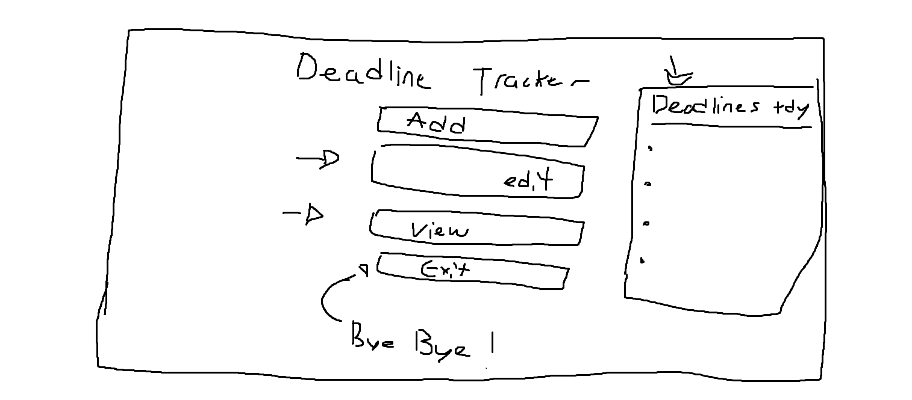

**TEAM MEMBERS:**

Gia Thien Bui (2156512)

Wayne De Leon (2179710)

Liam Webster (2265137)