**Thực hành buổi 1**

Câu 1:

Câu 2:

Câu 3:

Câu 4:

Câu 5:

Câu 6:

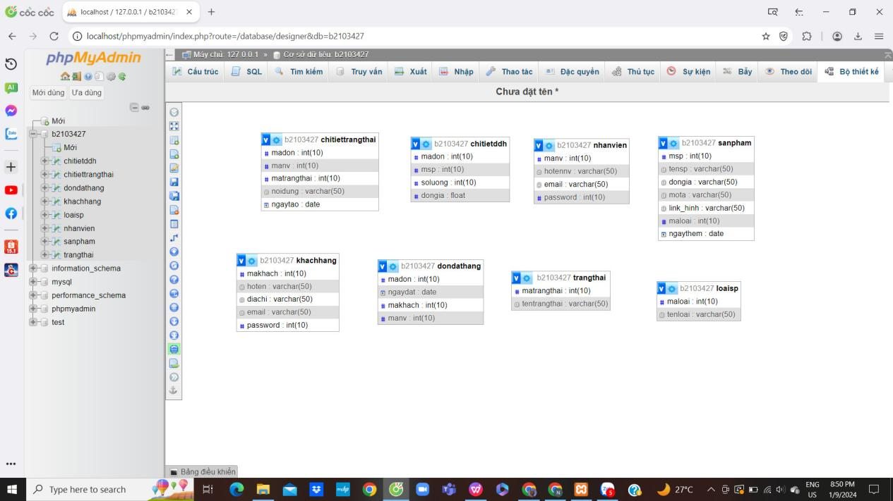

Câu 7:

Câu 8:

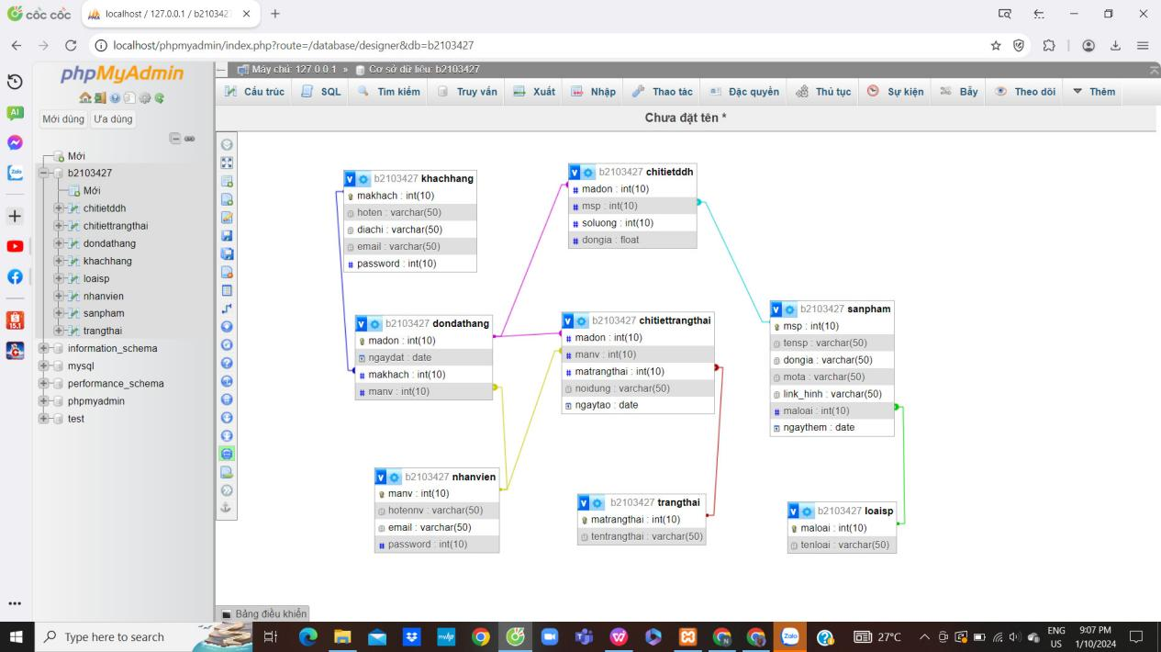

Câu 9:

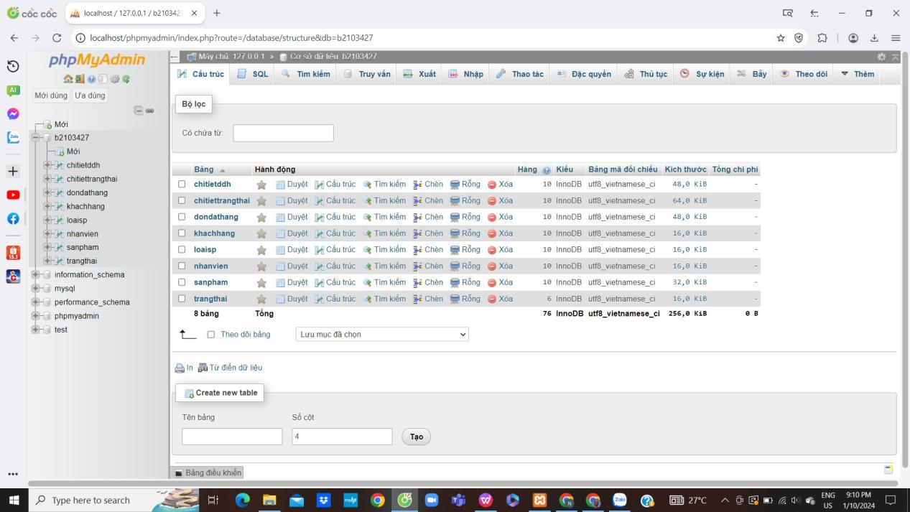

Câu 10:

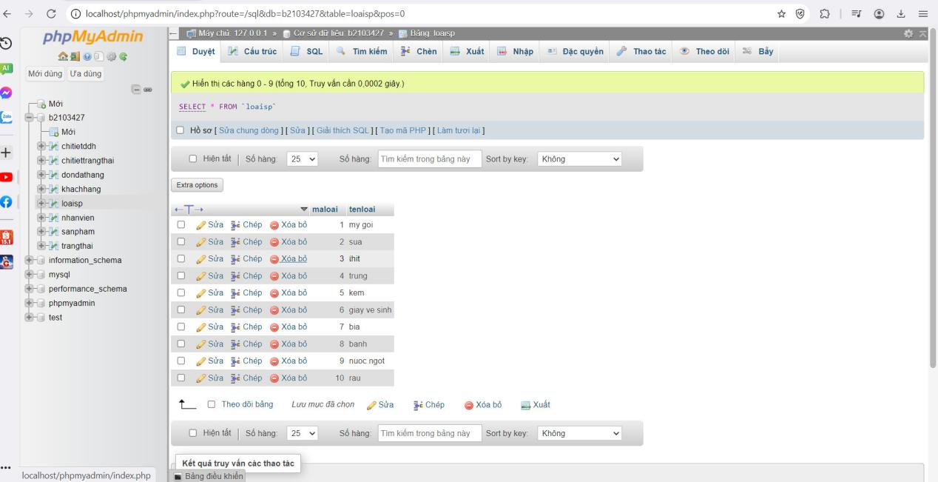

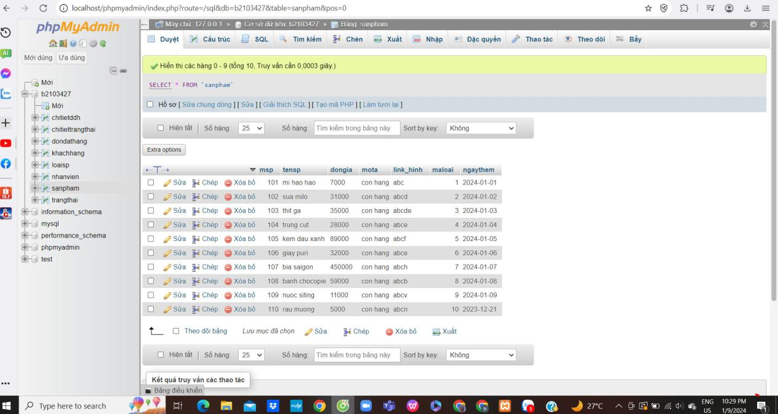

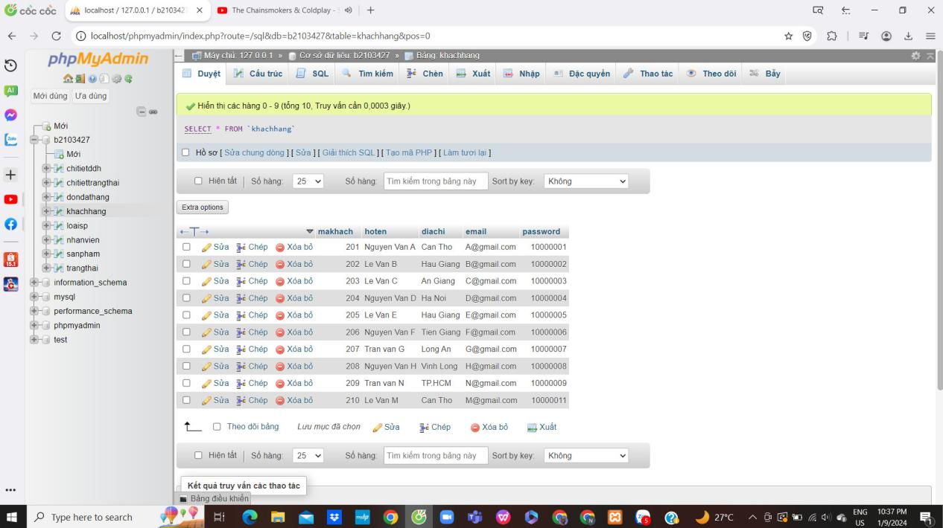

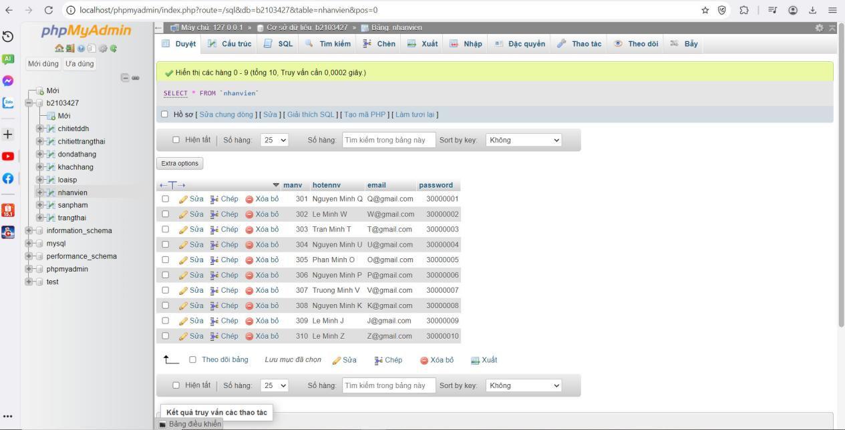

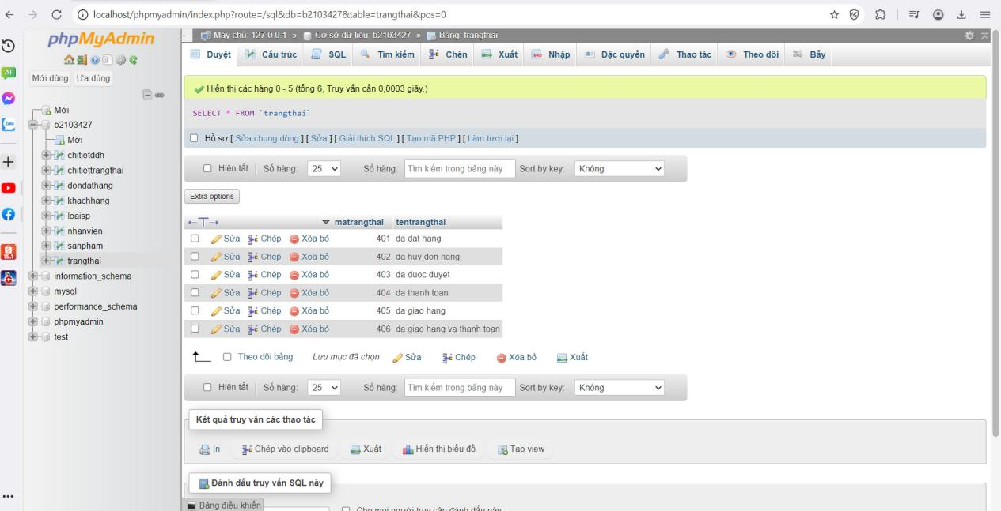

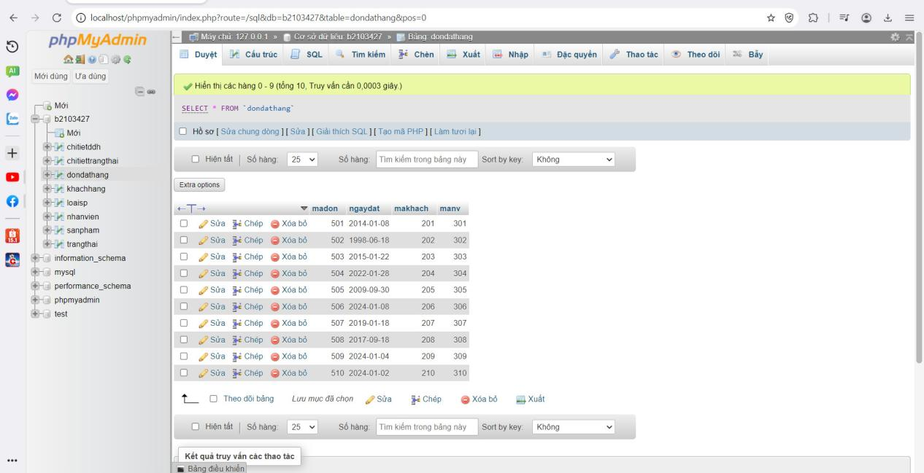

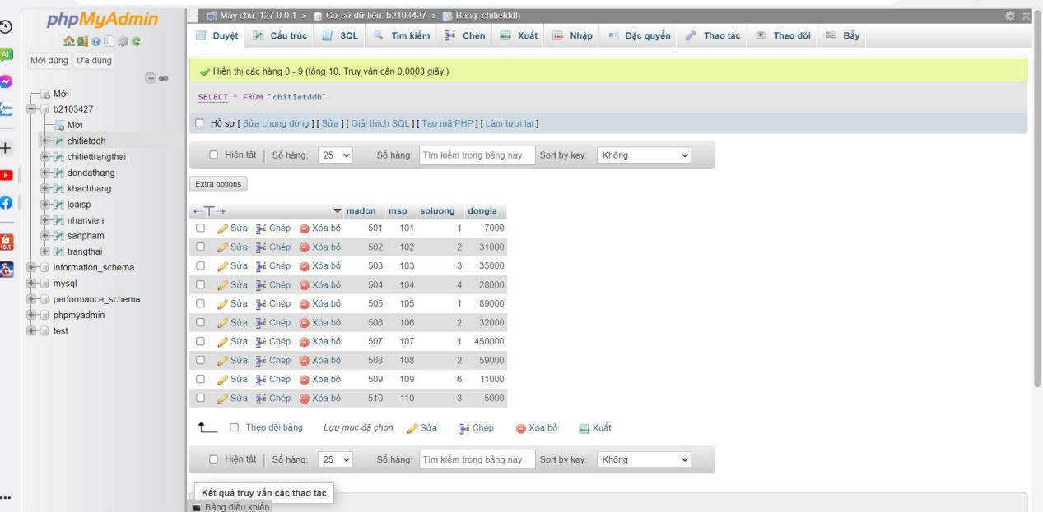

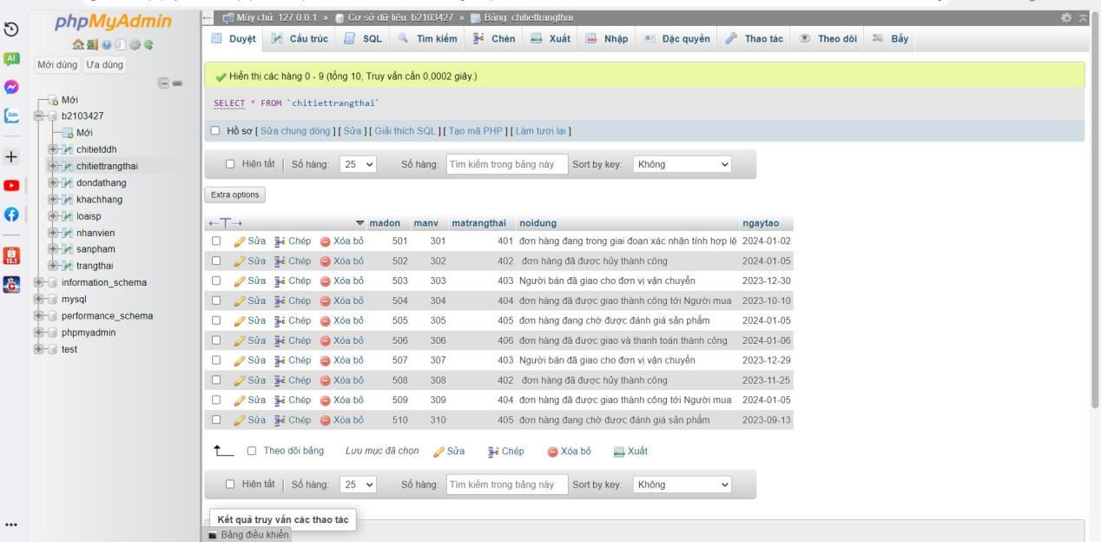

Câu 11

Câu 12

Câu 13

SELECT tensp

FROM sanpham

JOIN chitietddh ON sanpham.msp = chitietddh.msp

WHERE chitietddh.soluong > 5;

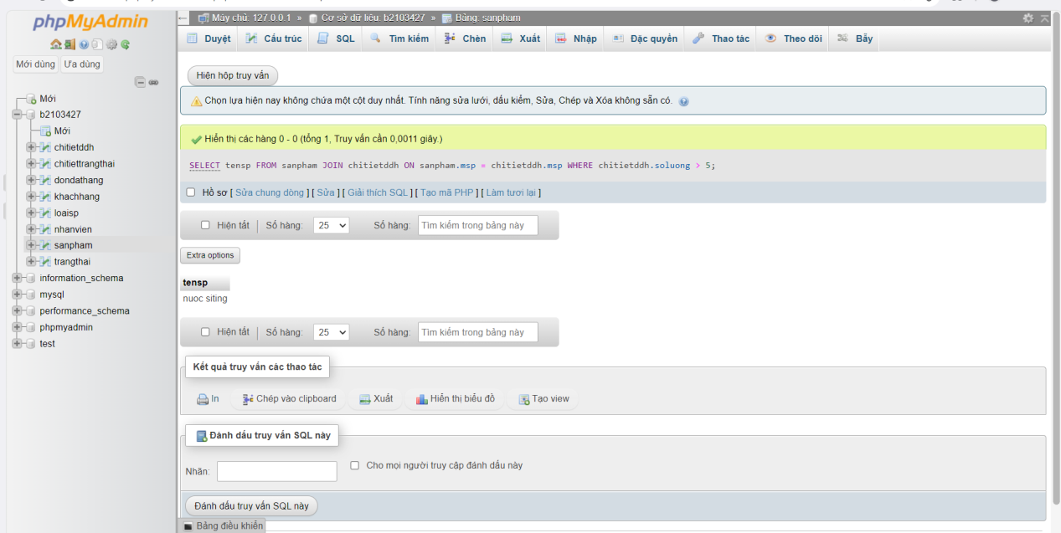

Câu 14

SELECT khachhang.makhach, khachhang.hoten

FROM khachhang

JOIN dondathang ON khachhang.makhach = dondathang.makhach

WHERE YEAR(dondathang.ngaydat) < 2000;

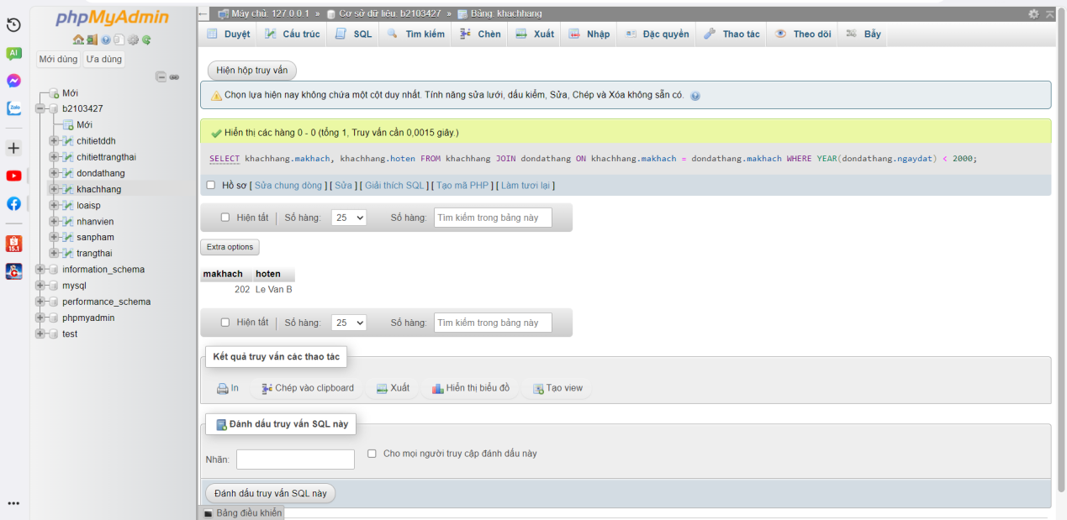

Câu 15

SELECT khachhang.makhach, khachhang.hoten

FROM khachhang

JOIN dondathang ON khachhang.makhach = dondathang.makhach

WHERE ngaydat BETWEEN '2010-01-01' AND '2023-01-01';

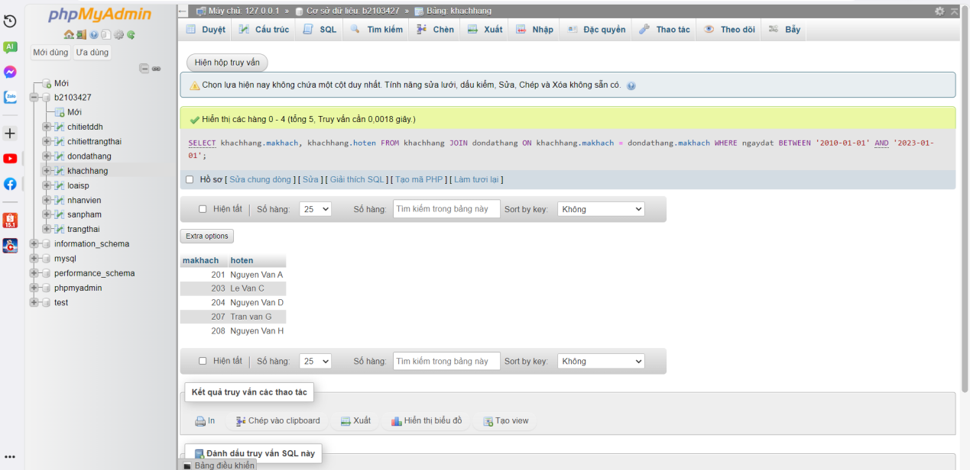

Câu 16

SELECT manv, hotennv

FROM nhanvien

WHERE hotennv LIKE 'Nguyen%';

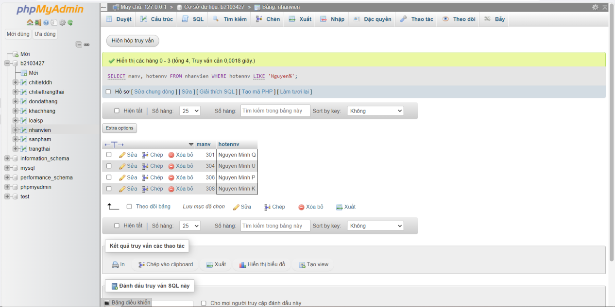

Câu 17

SELECT dondathang.madon, ngaydat, SUM(soluong * dongia) AS tongtien

FROM dondathang

JOIN chitietddh ON dondathang.madon = chitietddh.madon

GROUP BY madon, ngaydat;

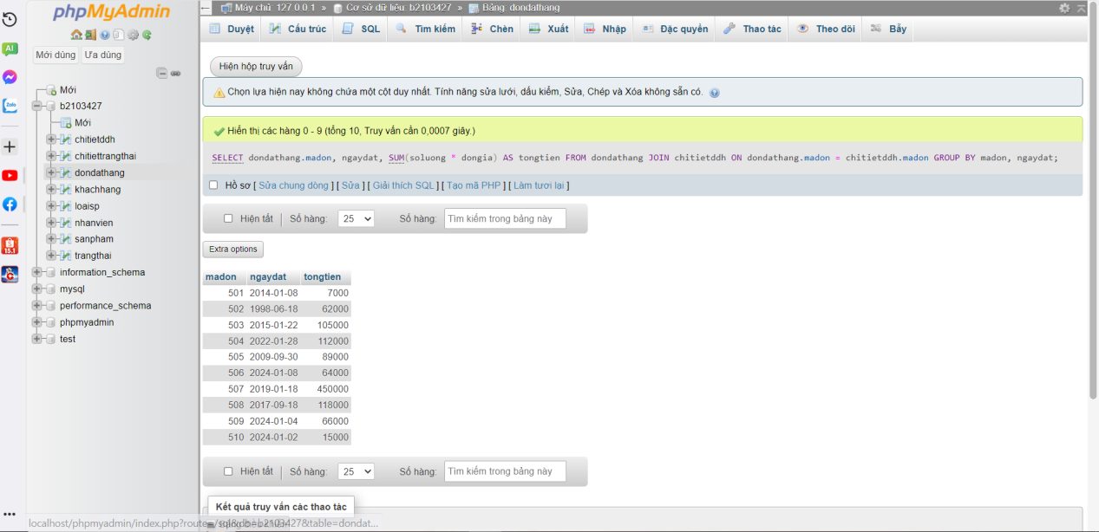

Câu 18

SELECT khachhang.makhach, khachhang.hoten, SUM(chitietddh.soluong * sanpham.dongia) AS tongtien

FROM khachhang

JOIN dondathang ON khachhang.makhach = dondathang.makhach

JOIN chitietddh ON dondathang.madon = chitietddh.madon

JOIN sanpham ON chitietddh.msp = sanpham.msp

GROUP BY khachhang.makhach, khachhang.hoten

ORDER BY tongtien DESC

LIMIT 1;

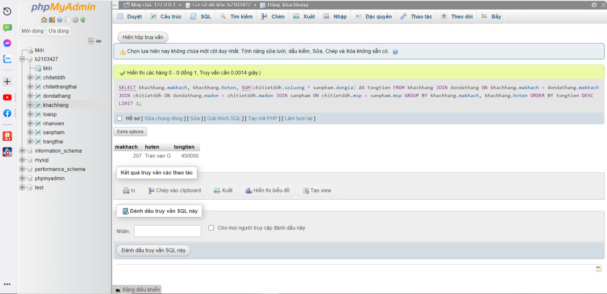

Câu 19

SELECT sanpham.msp, sanpham.tensp, SUM(chitietddh.soluong) AS tong_soluong

FROM sanpham

JOIN chitietddh ON sanpham.msp = chitietddh.msp

GROUP BY sanpham.msp, sanpham.tensp

ORDER BY tong_soluong DESC

LIMIT 1;

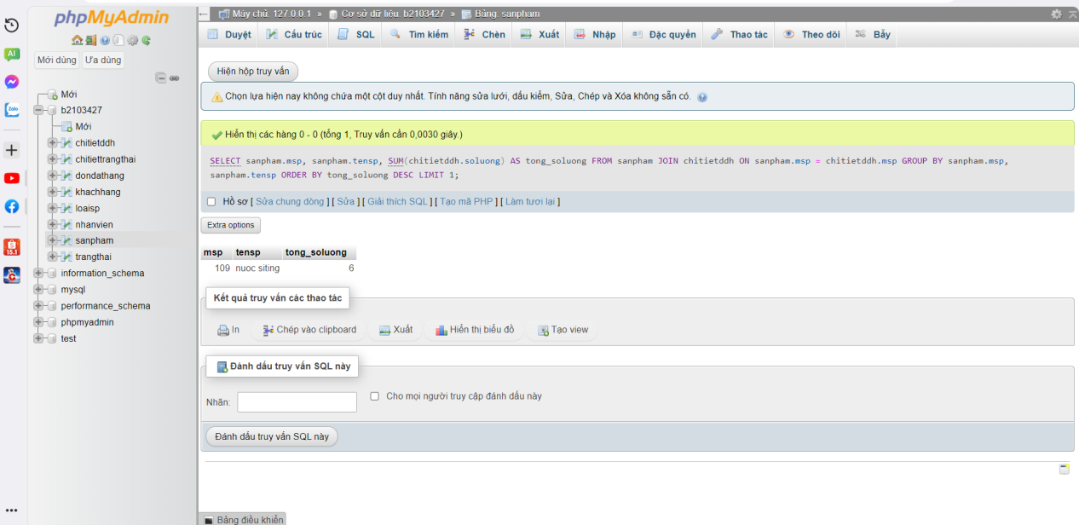

Câu 20

SELECT msp, tensp, ngaythem

FROM sanpham

WHERE ngaythem >= CURDATE() - INTERVAL 7 DAY

ORDER BY ngaythem;

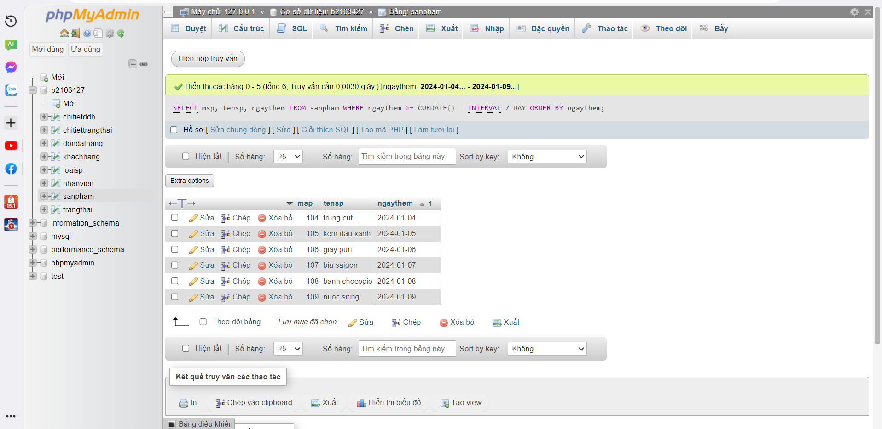

Câu 21:

Câu 22:

Câu 23:

Câu 24:

SELECT trangthai.matrangthai, tentrangthai, COUNT(dondathang.madon) AS so_don

FROM trangthai

LEFT JOIN chitiettrangthai ON trangthai.matrangthai = chitiettrangthai.matrangthai

LEFT JOIN dondathang ON chitiettrangthai.madon = dondathang.madon

GROUP BY trangthai.matrangthai, tentrangthai;

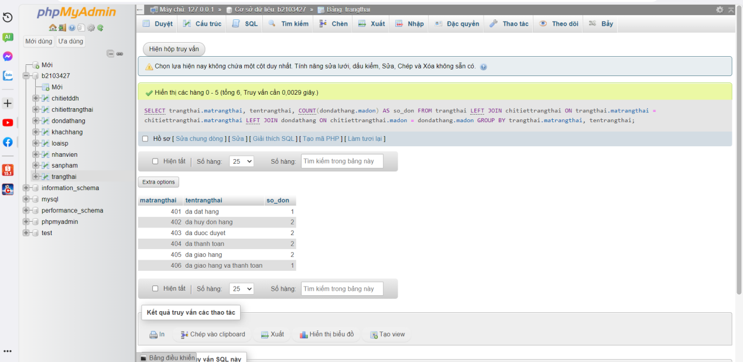

Câu 25