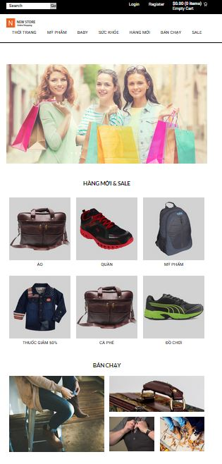

Logo Cong ty

Banner

6 Logo

LOGO cong ty: 165x50 px

banner: 1541x566 px

6 logo: 350x356px

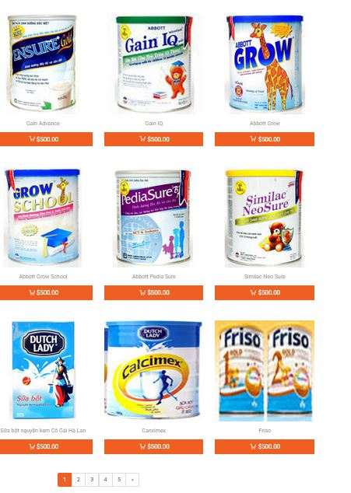

hinh san pham: 255x259px