This is the guide how to install the web tool Tier3 for researching data in Warehouses.

You need to download the file: ToolTier3.zip first. Then:

1. Extract the file .zip:

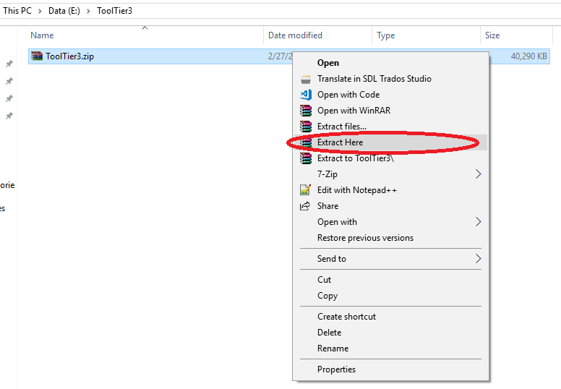

1. Open the folder extracted: ToolTier3

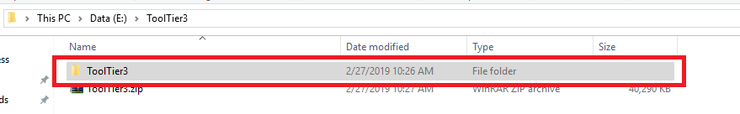

1. Then open file Tier3Tool.exe, a console will be appeared.

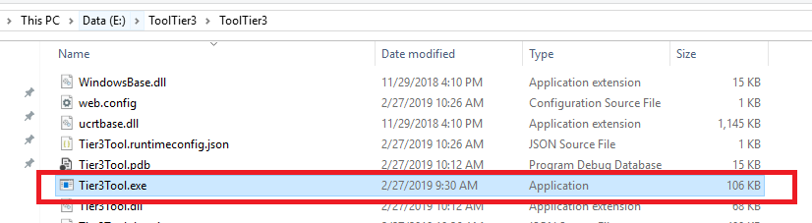

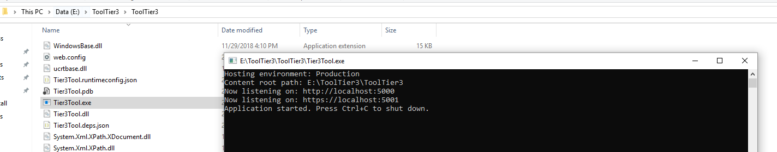

1. After the console appeared, please open browser and navigate to: <https://localhost:5001/login>

Thank you!