This is the guide how to install the web tool Tier3 for researching data in Warehouses.

You need to download the file: ToolTier3.zip first. Then:

1. Extract the file .zip:

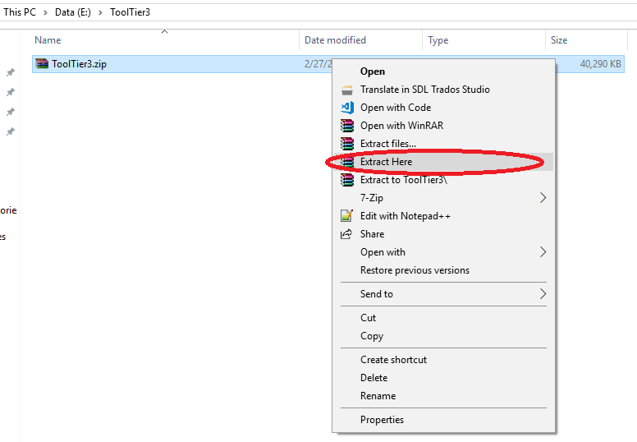

1. Open the folder extracted: ToolTier3

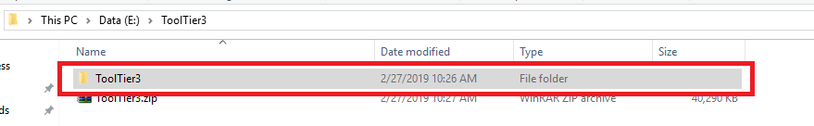

1. Then open file Tier3Tool.exe, a console will be appeared.

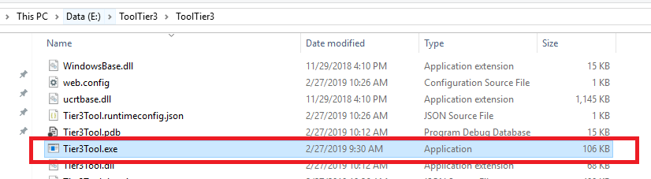

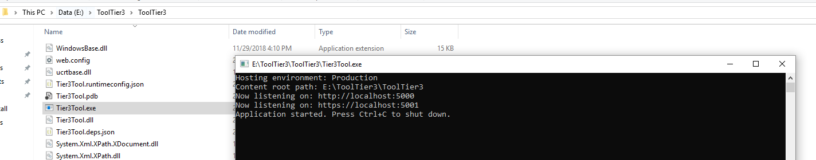

1. After the console appeared, please open browser and navigate to: <https://localhost:5000/login>. Then start using the tool.

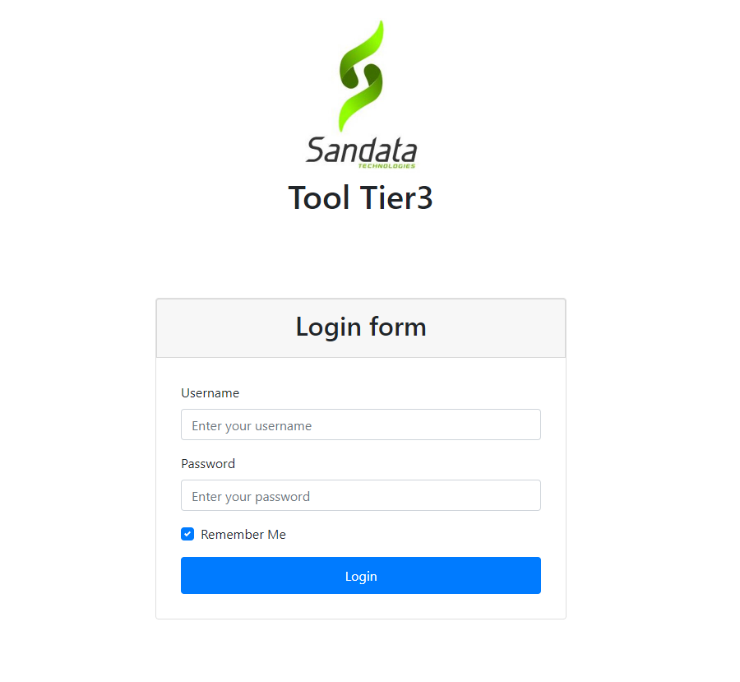

(We’re currently setup the port is 5000 by default. We will make the default ports as parameters if needed.)

Thank you!