This is the guideline how to use the web tool tier3 to search data in Warehouse and HHAX.

***PRE-CONDITIONS:*** *You are running the web tool tier3 successfully on your machine, followed by “Guide_Install.docx”, and running on:* [*http://localhost:5000*](http://localhost:5000)

There are 2 sections for 2 user types: Admin and Normal. The Normal User can use this web to search data in Warehouse and HHAX, but they can only use the connections that Admin User created.

* The Normal User: can only select the connection and search data.
* The Admin User: can search data and manage other users (create, edit, delete, set permissions to access tools), manage connections (create, edit, delete).

The first section will be for Normal User, and the second will be for Admin User with ability to manage users and connections.

SECTIONS

SECTION 1: For Normal User. 3

1. PAGE: Select tools as Normal Users 3

2. PAGE: Select connections to query database. 4

3. PAGE: Querying data in Warehouse. 8

4. PAGE: Query data in HHAX. 18

SECTION 2: For Admin User 24

5. PAGE: Login with Admin account. 24

6. PAGE: Select the managing pages by Admin Users. 25

7. PAGE: Manage users to use this web tool (add, edit, update). 25

8. PAGE: Manage connections to use to query databases in Warehouses and HHAX. 32

# **SECTION 1: For Normal User.**

1. **PAGE: Select tools as Normal Users**

If you logged as normal user, your header nav will be like this.

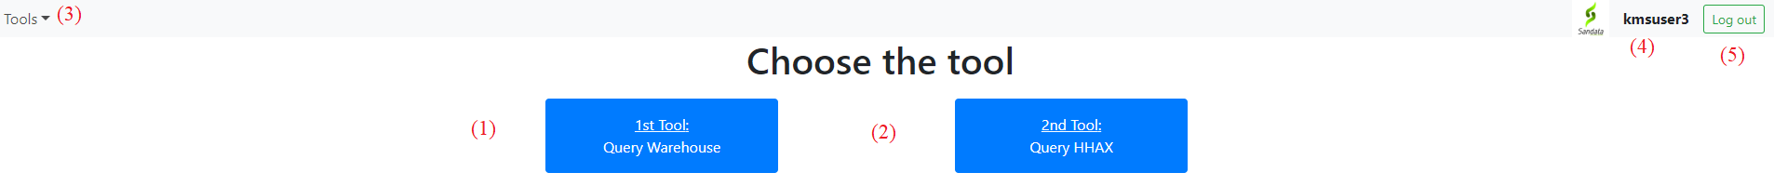

* If you want to use tool 1 to query data in Warehouse, please click (1) or click (3) and select option “Warehouse”.

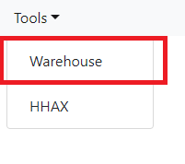

* If you want to use tool 2 to query data in HHAX, please click (2) or click (3) then select option “HHAX”.

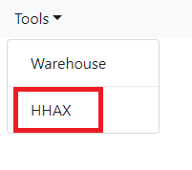

* If you want to logout, please click (5), then you will be returned the login page.

NOTE: The normal users are limited which tools they can access.

EX: If the user can only access the 1st tool, can not access the 2nd tool, the button and dropdown options will be disabled like this.

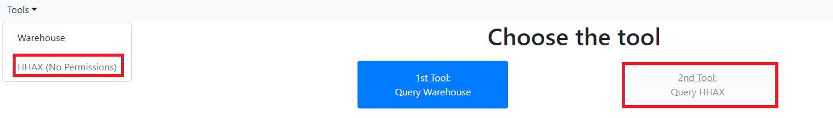

1. **PAGE: Select connections to query database.**

If you selected the 1st tool, you will see the connections of Warehouse.

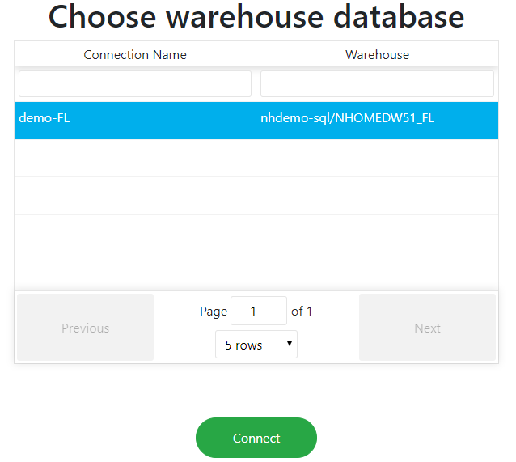

If you selected the 2nd tool, you will see the connections of HHAX.

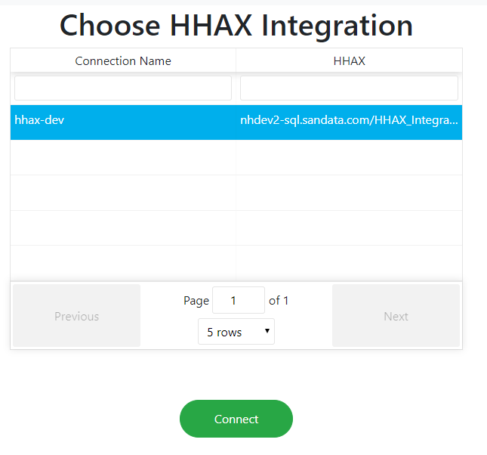

These two screens are only different the list of connections. Below is the guide if you selected the 1st tool to access. If you selected the 2nd tool to access, it is still as same as guides below.

**GUIDE:**

Now, you select the connection string to query database.

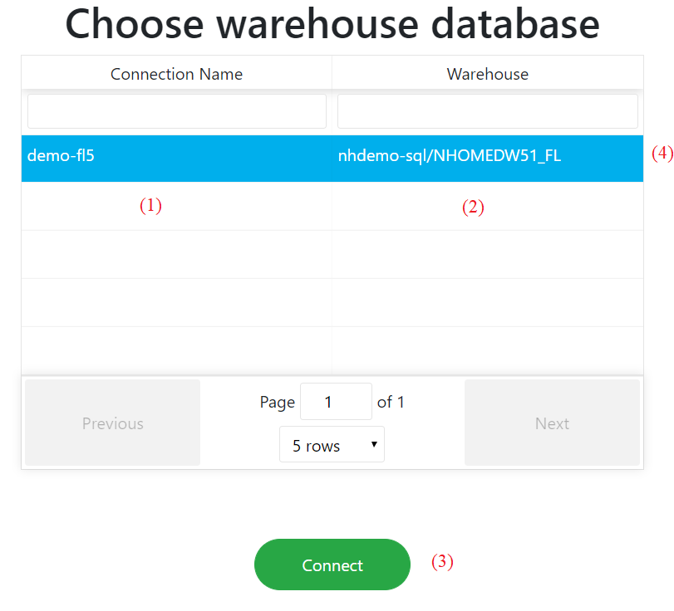

**UI elements:**

1. is the connection name
2. is the warehouse’s name, included server name and database name.

* EX: Warehouse: nhdemo-sql/NHOMEDW51_FL means that:
* Server name: nhdemo-sql
* Database name: NHOMEDW51_FL
* To select the connection, you can “double click” in that row (4) or select that row (4) and click “Connect” – (3)
* You can do the paging and filter here.

1. **PAGE: Querying data in Warehouse.**
   * After selecting the connection, you’ll be navigated to the searching page for clients and authorizations in Warehouse.
   * There’re 2 tabs for searching Clients and Authorizations here.

**TAB CLIENTS:**

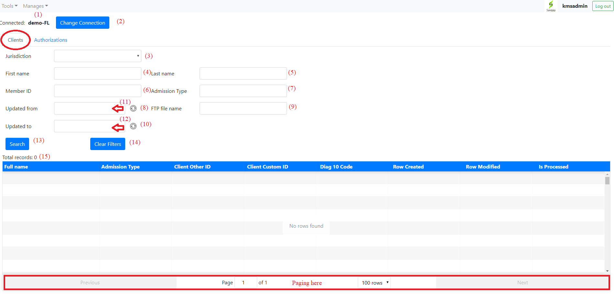

1. – display the connection name you have selected.
2. – If you want to change the connection, please click this to navigate back to screen 3.

Below is the area for input information to query clients in the warehouse.

1. – Dropdown to select the jurisdiction
2. – Input text to query for first name
3. – Input text to query for last name
4. – Input text to query for member id
5. – Input text to query for admission type
6. – Click to delete the selected date of (11)

* Example: Before click (8)

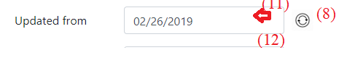

* After clicking (8), the (11) will be blank.



(9) – Input text to query for ftp file name.

(10) – Is as same as (8) but for the date time picker (12)

(11) – Datetime picker to select the updated from. You can click in that, then a new date picker will be shown like this.

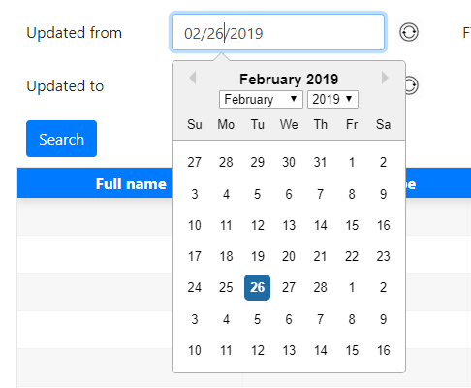

* You can select the month, year or date here.

1. Is as same as (11), but to query for updated from

* After filling information, you can click (13) to do the query.

Example: After clicking (13), the table will show the results. You can do the paging here.

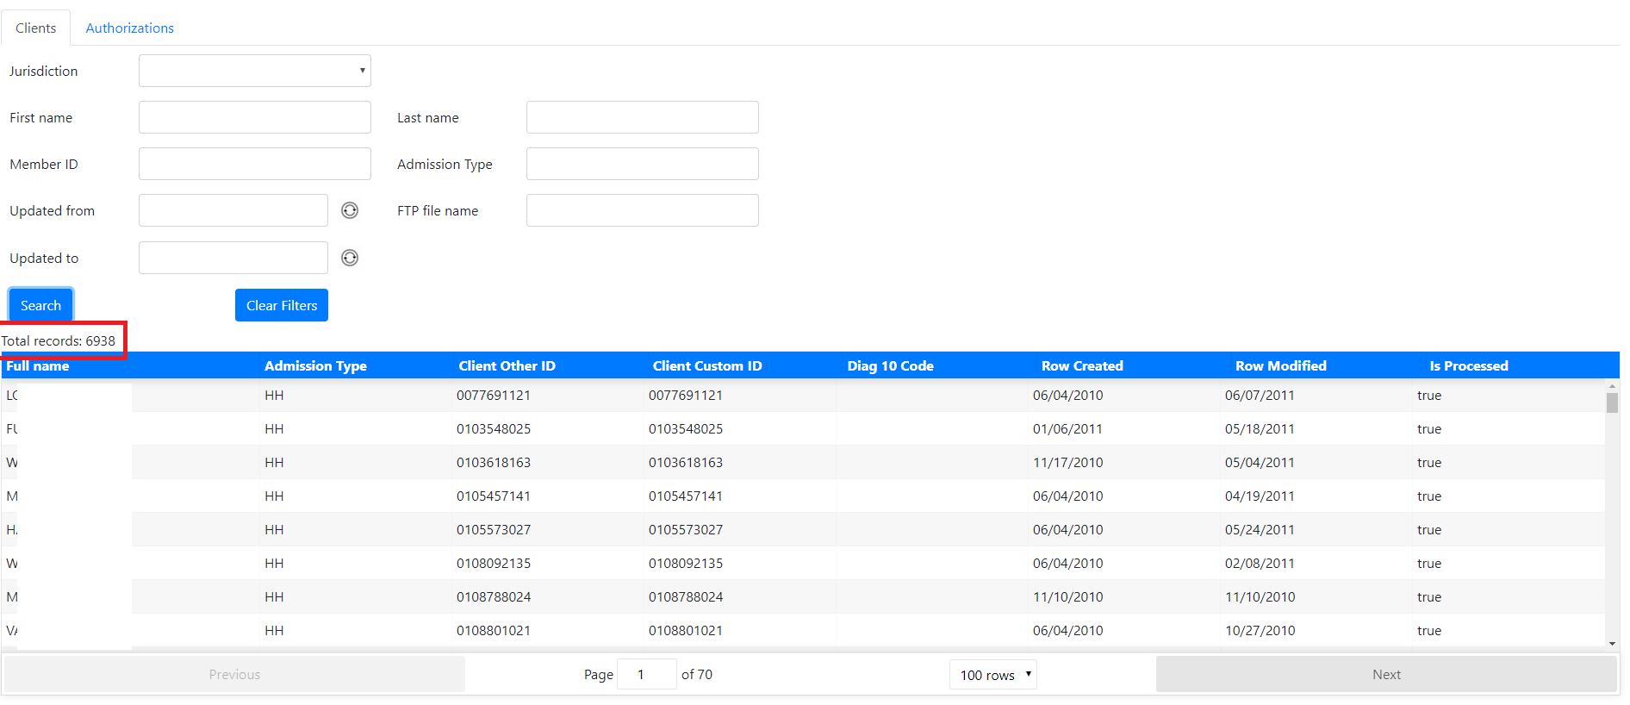

* You can click (14) to clear all filters from (3) to (12)
* EX: Before clicking button “Clear Filters”

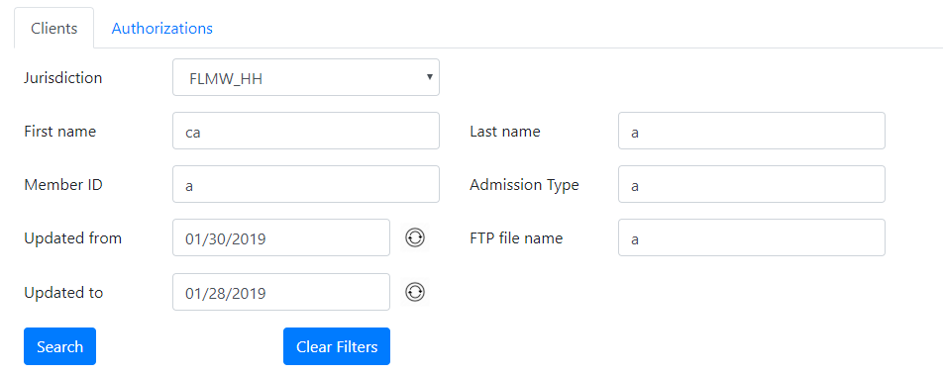

* After clicking button “Clear Filters”

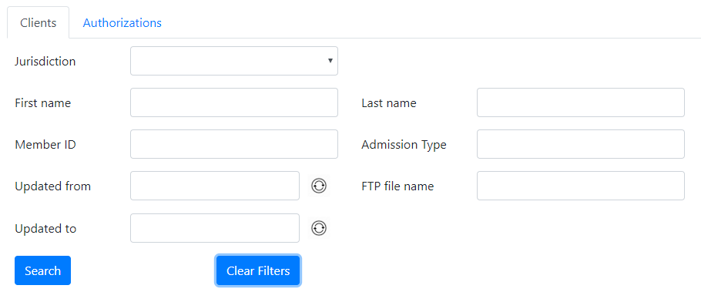

To query data, you first fill in (or not) filters in (3) -> (12), then click (13) to request then show results in the table below.

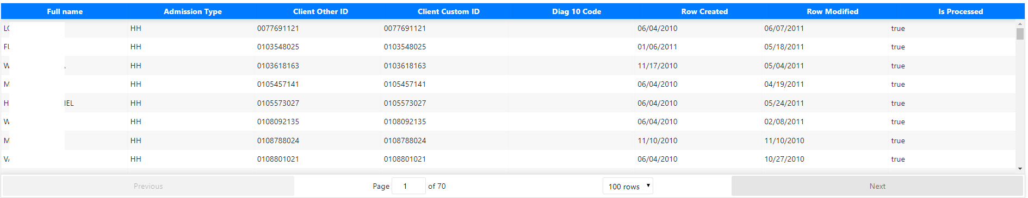

(15) – the total records.



**TAB AUTHORIZATIONS:**

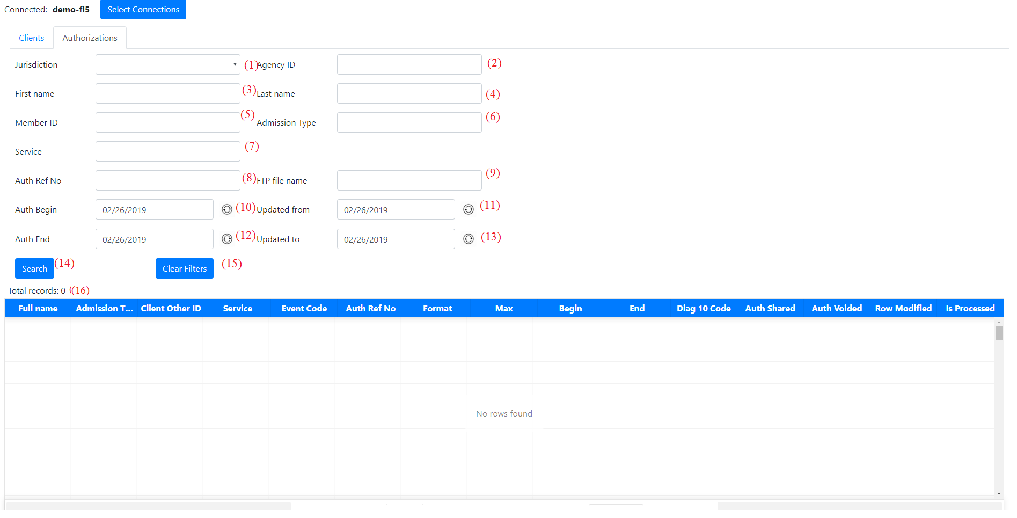

This tab is as same as the Client tab, with more filters and columns in table result.

UI elements:

1. – The dropdown of jurisdictions.
2. – The input text for agencyID.
3. – The input text for First Name.
4. – The input text for Last Name.
5. – The input text for MemberID.
6. – The input text for Admission Tyoe.
7. – The input text for Service.
8. – The input text for Auth Ref No.
9. – The input text for FTP File Name.
10. – The input date for the begin date of authorization.
11. – The input date for the start date range of updating.
12. – The input date for the end date of authorization.
13. – The input date for the end date range of updating.
14. – The button to query then show results.
15. – The button to clear all filters.
16. – The total records.

To query data, you please fill in (or not) the filters in (1) -> (13), then click (14) to request then show results in the table below.

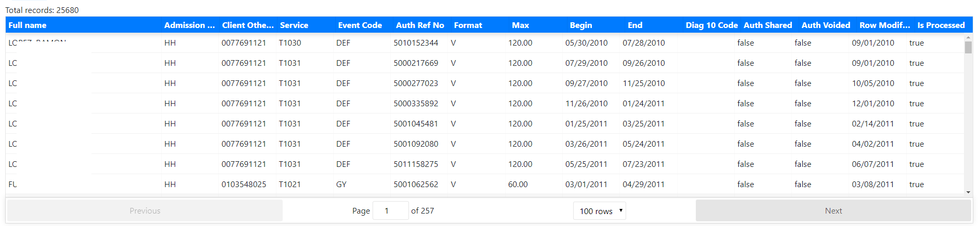

1. **PAGE: Query data in HHAX.**
   * After selecting the HHAX’s connection, you’ll be navigated to the searching page for Patients and Authorizations in HHAX.
   * There’re 2 tabs for searching Patients and Authorizations here.

**TAB PATIENTS:**

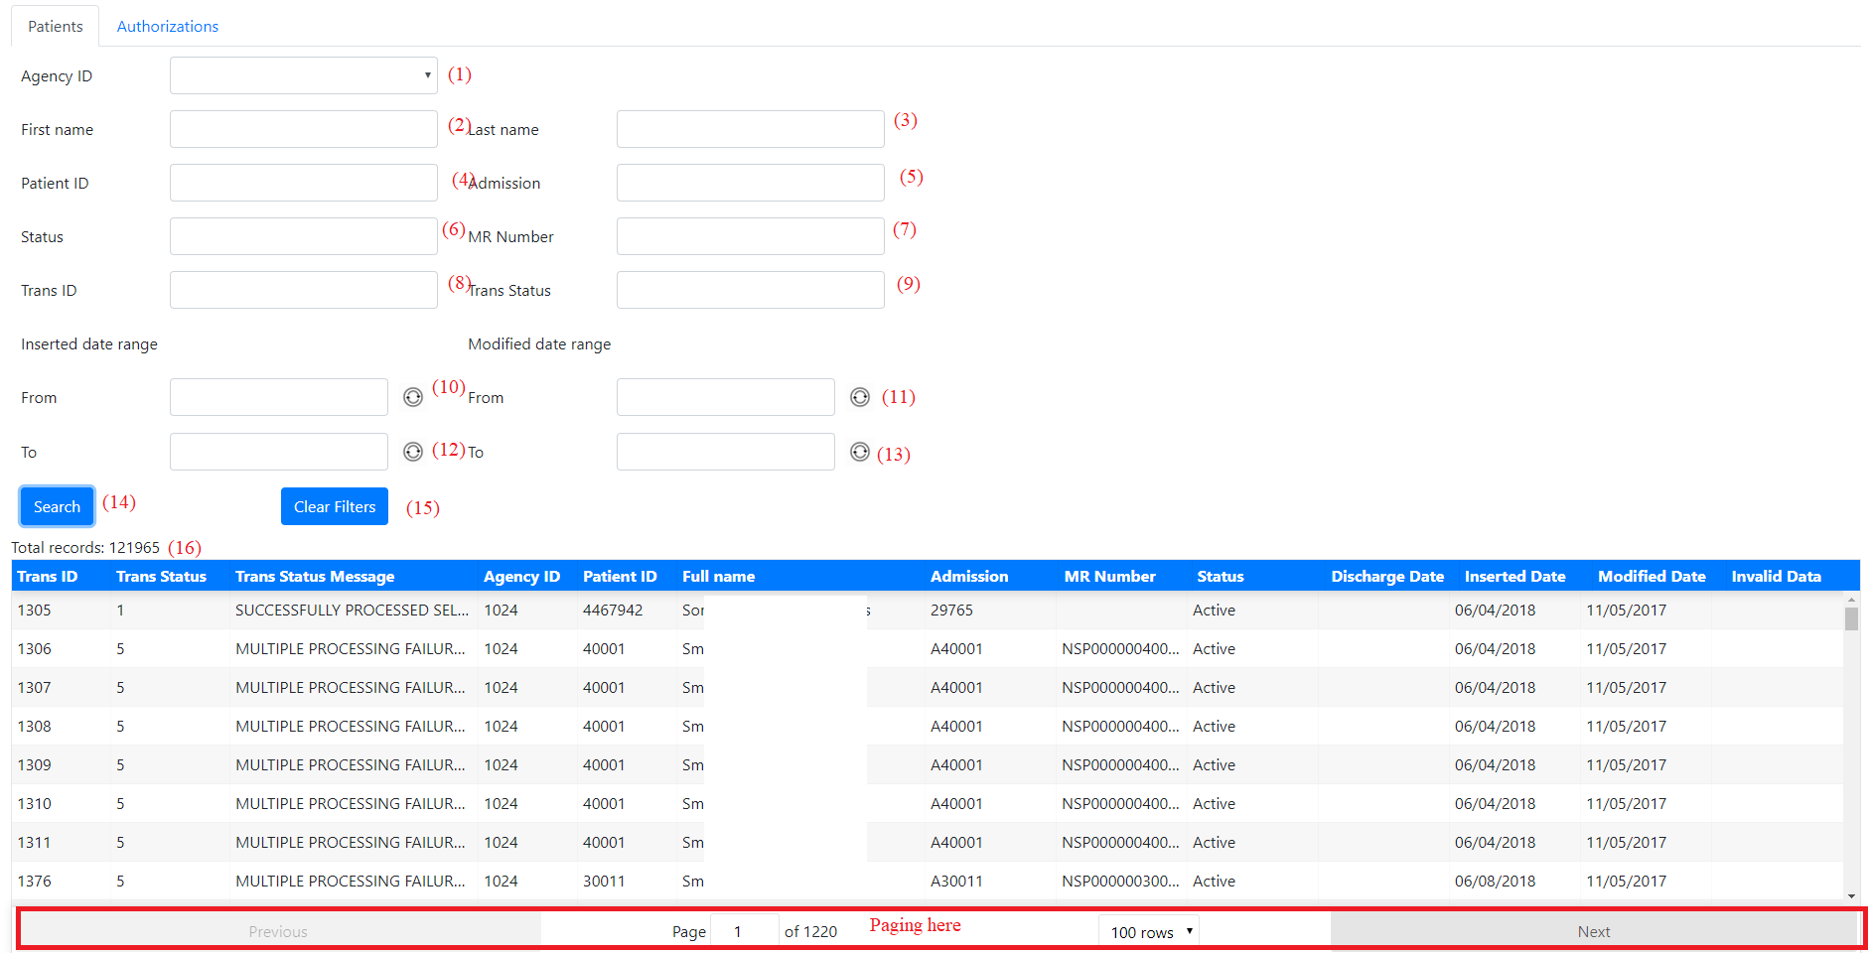

UI Elements:

1. – The dropdown of agencies. If you open the dropdown, you’ll see a list of agencies like below:

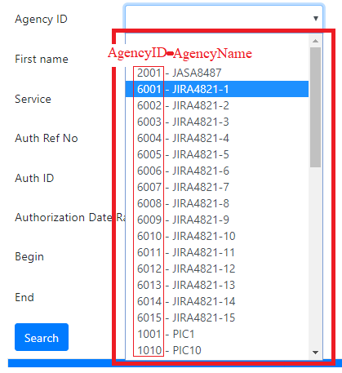

Each item in list of agencies includes AgencyID and AgencyName. Example: The item: “6001 – JIRA4821-1” means AgencyID: 2001 and AgencyName: JIRA4821-1.

1. – The input text for First Name.
2. – The input text for Last Name.
3. – The input text for PatientID.
4. – The input text for Admission Type.
5. – The input text for Patient Status.
6. – The input text for MR Number.
7. – The input text for TransID.
8. – The input text for TransStatusID.
9. – The input date for the begin date of Inserted date.
10. – The input date for the begin date of Modified date.
11. – The input date for the end date of Inserted date.
12. – The input date for the end date of Modified date.
13. – The button to query database then show results in the table below.
14. – The button to clear all filters above.
15. – The total records.

To query data, you can fill-in filters in (1) -> (11), then click (12).

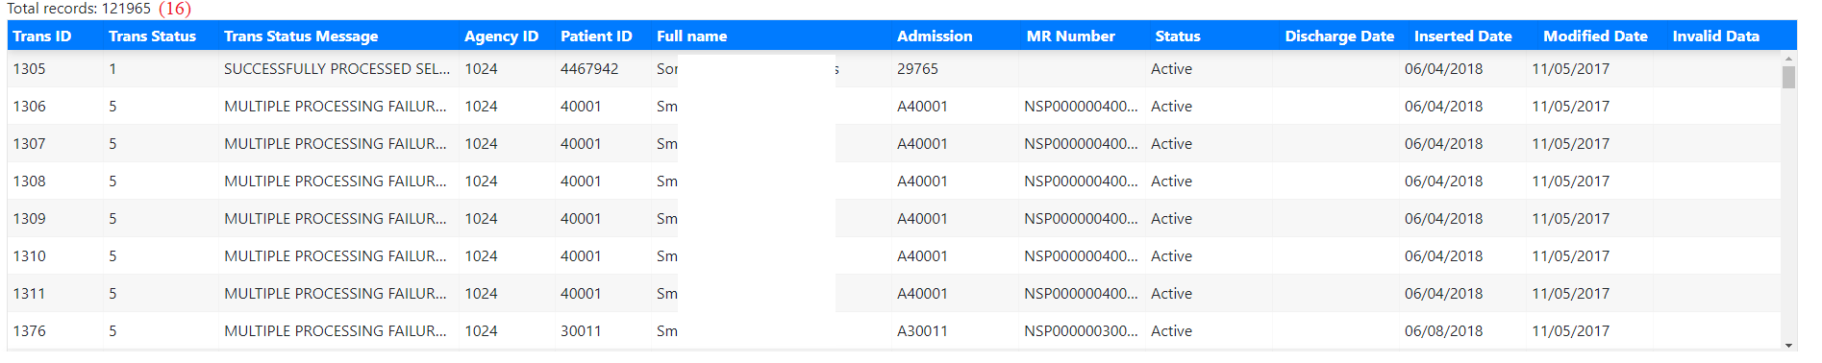

**TAB AUTHORIZATIONS:**

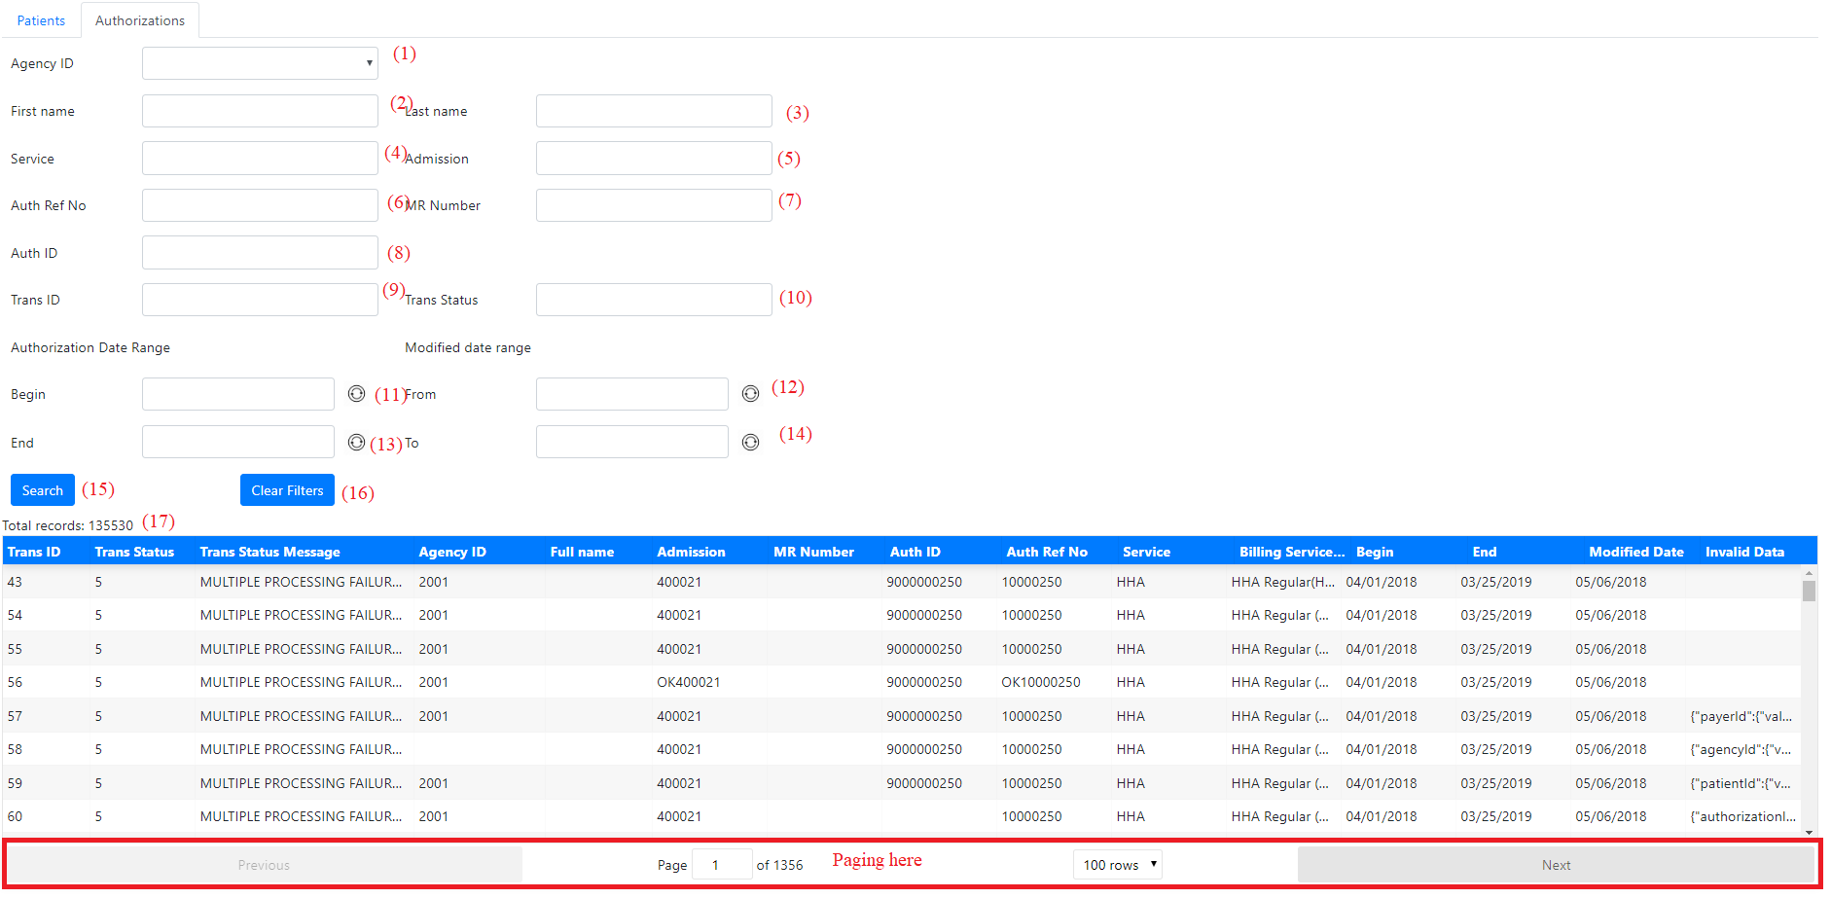

UI elements:

1. – The dropdown of agencies. If you open the dropdown, you’ll see a list of agencies like below:



Each item in list of agencies includes AgencyID and AgencyName. Example: The item: “6001 – JIRA4821-1” means AgencyID: 2001 and AgencyName: JIRA4821-1.

1. – The input text for First Name.
2. – The input text for Last Name.
3. – The input text for Service.
4. – The input text for Admission Type.
5. – The input text for Auth Ref No.
6. – The input text for MR Number.
7. – The input text for Auth ID.
8. – The input text for Trans ID.
9. – The input text for .
10. – The input date for the begin date of the authorization.
11. – The input date for the start date of modifying authorization.
12. – The input date for the end date of the authorization.
13. – The input date for the end date of modifying authorization.
14. – The button to call request then show results in the table below.
15. – The button to clear all filters above.
16. – The total records.

To query data, you can fill-in filters in (1) -> (12), then click (13).

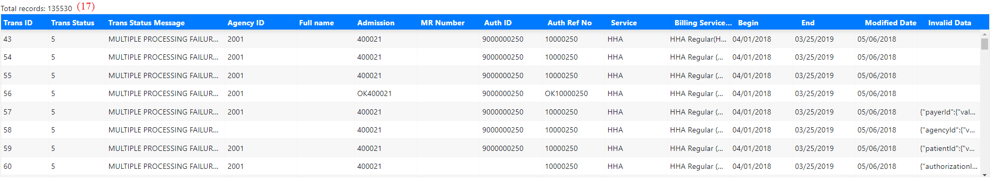

# **SECTION 2: For Admin User**

Admin User can also do all the searching data like Normal User – described in the Section 1. This is the guide for Admin User: how to manage users (create, edit, delete) and mange connections to query warehouses (create, edit, delete).

**NOTE**: The connections can only be created, edited, deleted by Admin User.

1. **PAGE: Login with Admin account.**

***NOTE****: Make sure you are running this web tool successfully on your machine, follow by “Guide_Install.docx”*

Login to the tool via: <http://localhost:5000/login>.

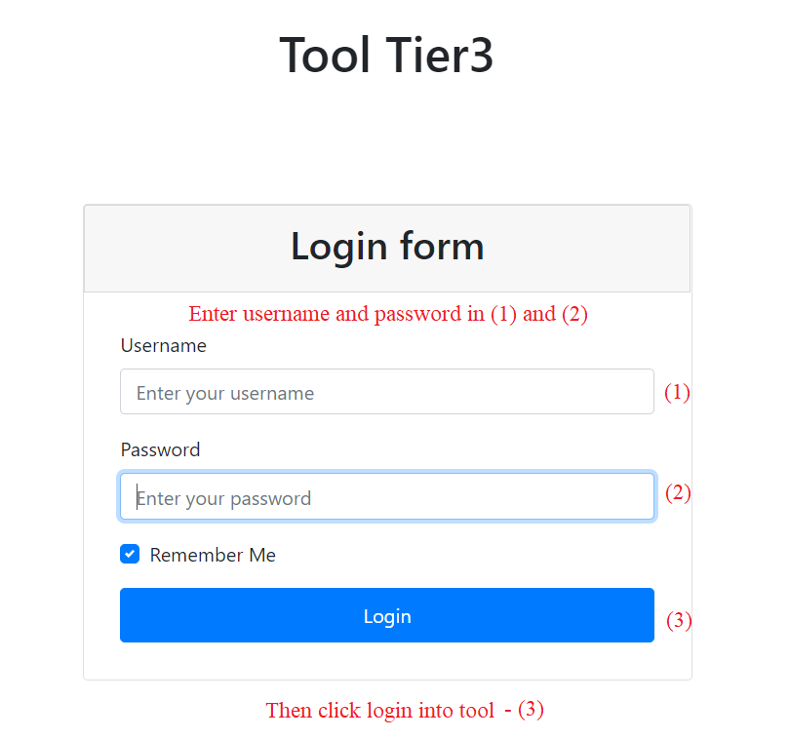

1. **PAGE: Select the managing pages by Admin Users.**

After you logged in, the header navbar of Admin User will have the option “Manage”.

**NOTE**: This option “Manage” can only be displayed if the current user is Admin. The Normal Users don’t have this option.

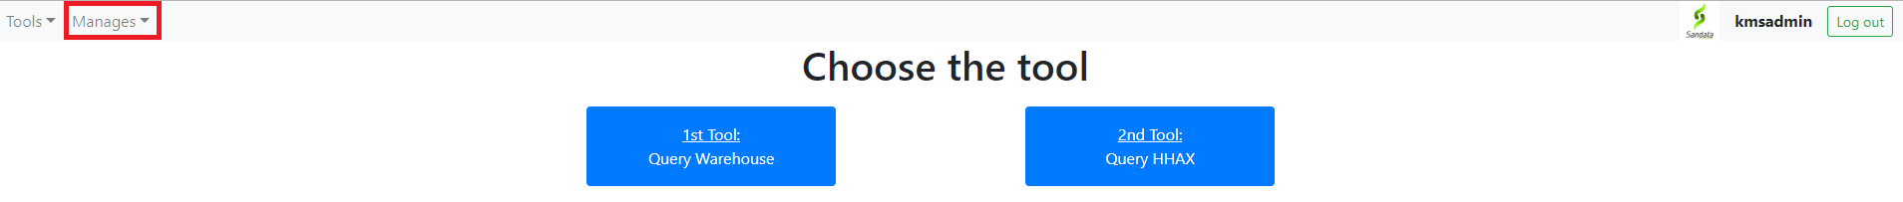

You can select the dropdown, it will be like this.

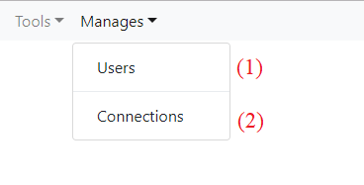

* If you want to manage users, please click (1) and you will be navigated the 3th screen.
* If you want to manage connections, please click (2) and you will be navigated the 4th screen.

1. **PAGE: Manage users to use this web tool (add, edit, update).**

This is the screen to manage the users in web.

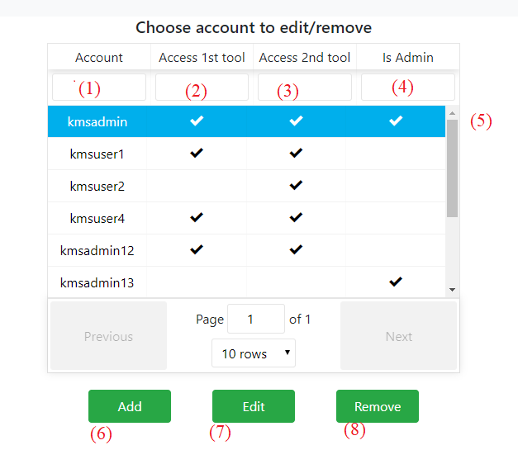

**UI elements:**

1. Is the username to log in this web.
2. Is the permission – that user can access the warehouse or not.
3. Is the permission that user can access the HHAX (will be developed next) or not?
4. Is that account Admin or not?

**Functions:**

**ADD:** To add an account, you please click the (6), a new popup will be shown

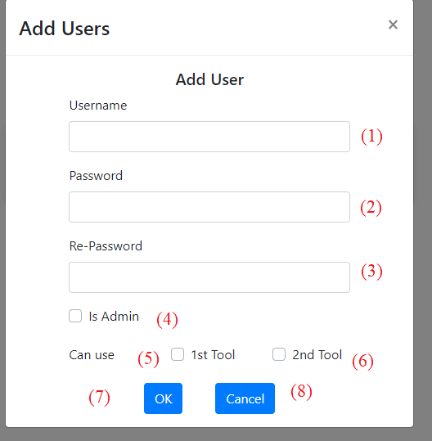

* If you don’t want to add user, you can click (8) to close this popup.
* If you want to add a user, please full full the information (1), (2), (3). The (2) (3) should be the same.
* Check (4) if that account is Admin account.
* Check (5) or (6) if you want that user can access warehouse or HHAX tool.
* Then click (7) to add the user.

**EDIT**: You can click (7) to open the account to edit, or double click that row like (5).



A new popup of that account will be shown like below.

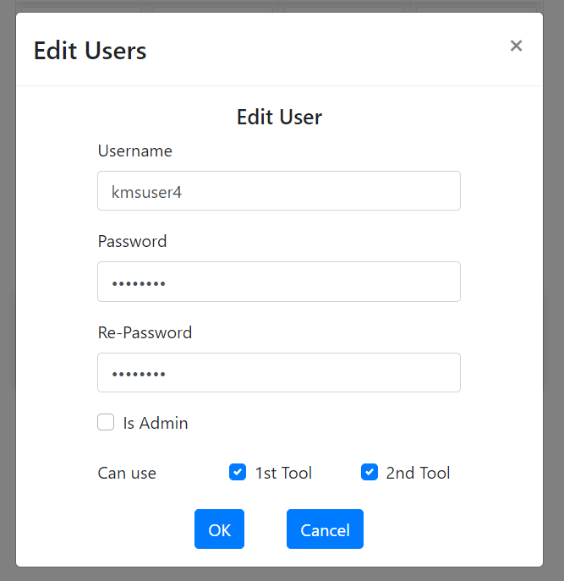

* This Edit popup is as same as Add popup, included the information of the selected user.
  + After editing, you can click OK to update.
* If you don’t want to update, please click “Cancel”.

**DELETE:**

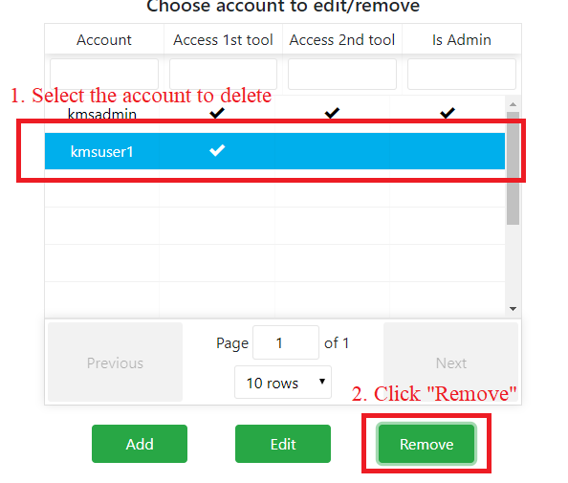

To delete, you please:

* Select the account to delete.
* Click “Remove”, then a popup to confirm will be prompted.

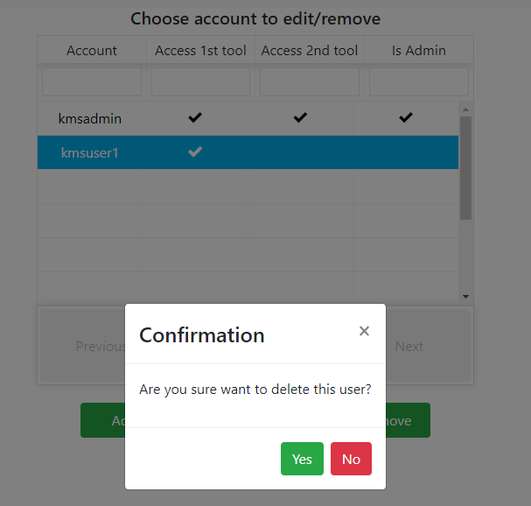

* Click “Yes” if you want to delete, or “No” if not.

**FILTERS**: You can filter by fill in the area below the header

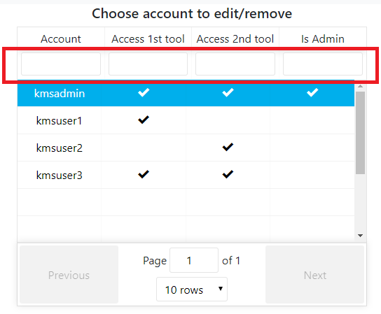

In Account Cell: You can type account name to filter.

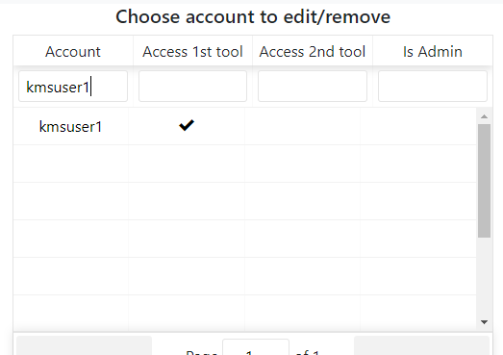

In Access 1st tool, Access 2nd tool, Is Admin: You fill in “t” (true) to filter checked, or “f” (false) to filter unchecked.

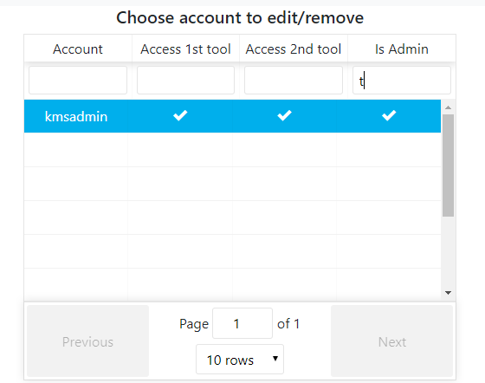

*NOTE: This filter is also applied to Page: Manage connections and Select connections.*

1. **PAGE: Manage connections to use to query databases in Warehouses and HHAX.**

This is the screen to manage connections. There are 2 tables for connections of Warehouse and HHAX.

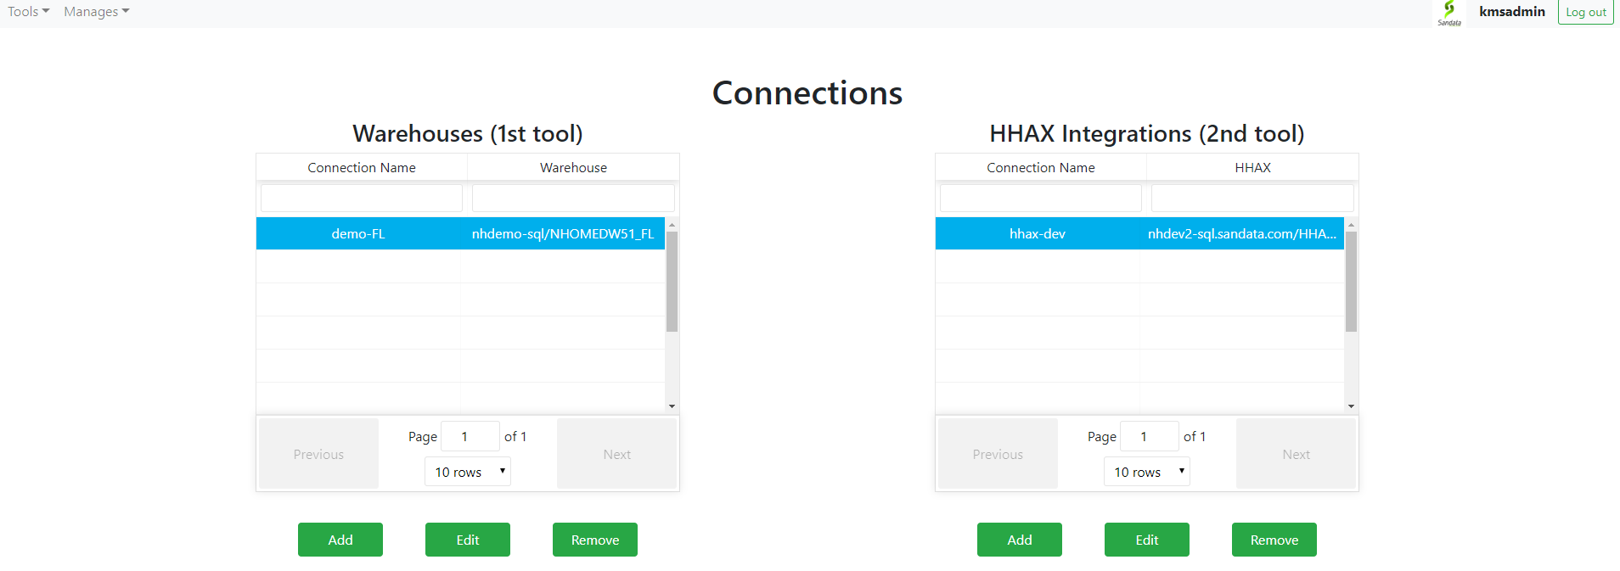

Firstly, we will manage the warehouse’s connections.

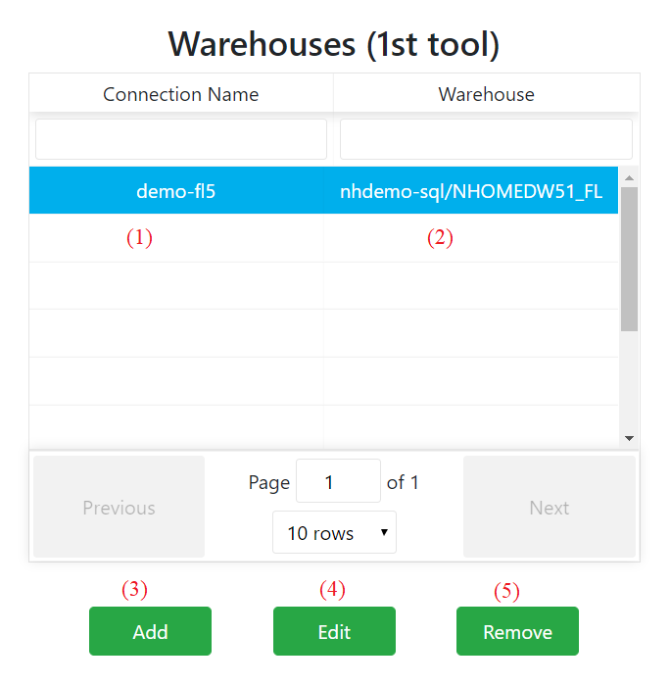

**UI elements:**

1. Displays the connection name – unique and can’t be duplicated.
2. Display the server name and database name of warehouse.

* EX: nhdemo-sql/NHOMEDW51_FL means
* Using server name: nhdemo-sql
* Database name: NHOMEDW51_FL

**FUNCTIONS:**

**ADD**: If you click Add, a popup will be shown like this.

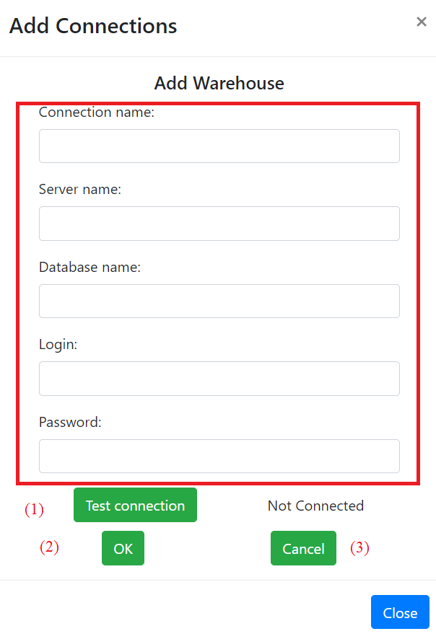

* Please full fill the information of the connection in red area.
* After that, please click (1) to test the connection. If the status is Connected like this, you can click “OK” to add this connection.

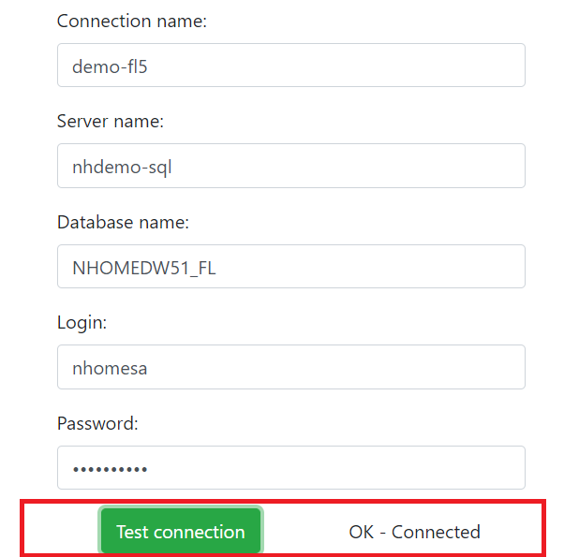

* You can click OK to create. But if the test connection status is NOT OK, an error will be shown.

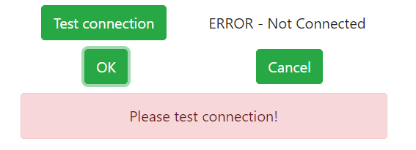

NOTE: With this error “Can’t connect successfully”, you can’t add this connection.

**EDIT**: If you click Edit, a popup as same as “Add” will be shown. This popup included the information of the connection.

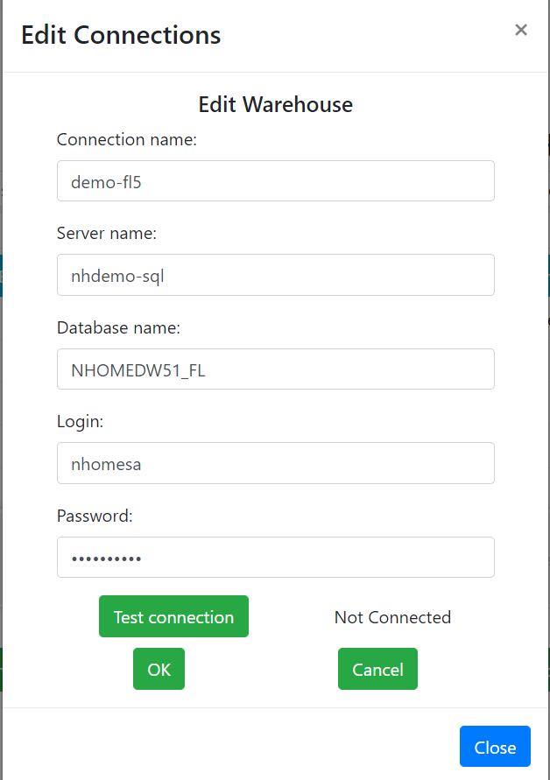

* You can edit the information of the connection. But to update, you first need to click “Test Connection”, and only if that status is “OK - Connected”, you then will be able to save by clicking “OK”.

**DELETE**: If you click Remove, a new popup to confirm again deleting the selected connection.

