This is the guideline how to use the web tool tier3 to search for data in warehouse.

***PRE-CONDITIONS:*** *You are running the web tool tier3 successfully on your machine, followed by “Guide_Install.docx”, and running on:* [*http://localhost:5000*](http://localhost:5000)

There are 2 sections for 2 user types: Admin and Normal. The Normal User can use this web to search data, but they can only use the connections that Admin User created.

* The Normal User: can only select the connection and search data.
* The Admin User: can search data and manage other users (create, edit, delete, set permissions to access tools), manage connections (create, edit, delete).

The first section will be for Admin User, and the second will be for Admin User with ability to manage users and connections.

SECTIONS

**SECTION 1: For Admin User** 3

1. PAGE: Login with Admin account 3

2. PAGE: Select the managing pages by Admin Users. 4

3. PAGE: Manage users to use this web tool (add, edit, update) 5

4. PAGE: Manage connections to use to query databases in Warehouses and HHAX 12

**SECTION 2: For Normal User** 20

5. PAGE: Select tools as Normal Users 20

6. PAGE: Select connections to query database. 20

7. PAGE: Querying data in Warehouse. 22

# **SECTION 1: For Admin User**

Admin User can also do all the searching data like Normal User – described in the Section 2. This is the guide for Admin User: how to manage users (create, edit, delete) and mange connections to query warehouses (create, edit, delete).

**NOTE**: The connections can only be created, edited, deleted by Admin User.

1. PAGE: Login with Admin account.

***NOTE****: Make sure you are running this web tool successfully on your machine, follow by “Guide_Install.docx”*

Login to the tool via: <http://localhost:5000/login>.

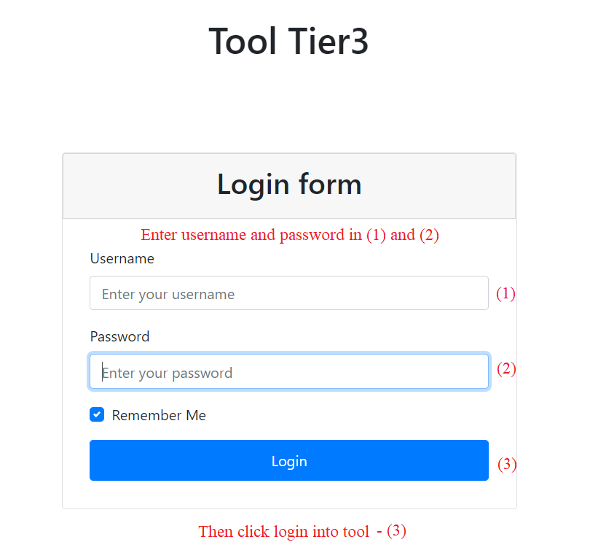

1. PAGE: Select the managing pages by Admin Users.

After you logged in, the header navbar of Admin User will have the option “Manage”.

**NOTE**: This option “Manage” can only be displayed if the current user is Admin. The Normal Users don’t have this option.

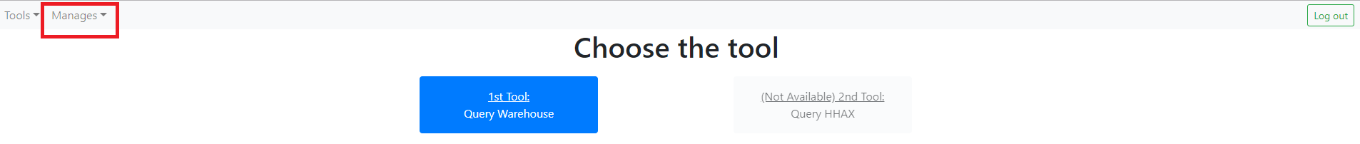

You can select the dropdown, it will be like this.

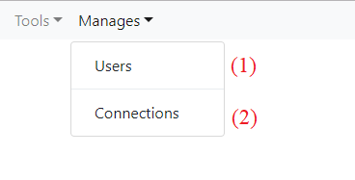

* If you want to manage users, please click (1) and you will be navigated the 3th screen.
* If you want to manage connections, please click (2) and you will be navigated the 4th screen.

1. PAGE: Manage users to use this web tool (add, edit, update).

This is the screen to manage the users in web.

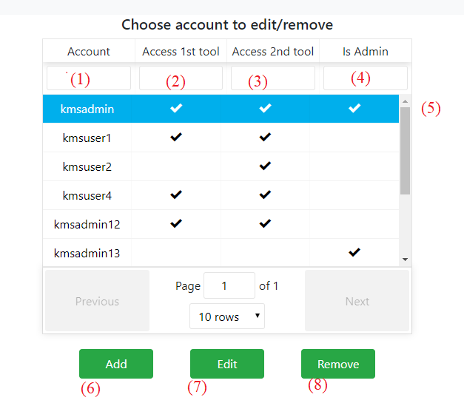

**UI elements:**

1. Is the username to log in this web.
2. Is the permission – that user can access the warehouse or not.
3. Is the permission that user can access the HHAX (will be developed next) or not?
4. Is that account Admin or not?

**Functions:**

**ADD:** To add an account, you please click the (6), a new popup will be shown

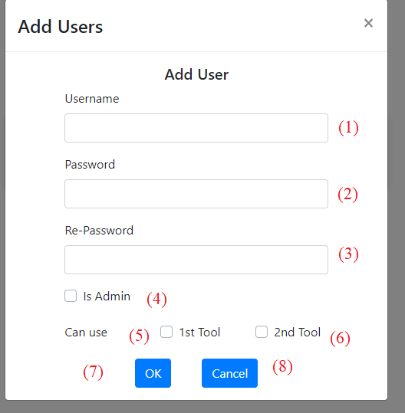

* If you don’t want to add user, you can click (8) to close this popup.
* If you want to add a user, please full full the information (1), (2), (3). The (2) (3) should be the same.
* Check (4) if that account is Admin account.
* Check (5) or (6) if you want that user can access warehouse or HHAX tool.
* Then click (7) to add the user.

**EDIT**: You can click (7) to open the account to edit, or double click that row like (5).



A new popup of that account will be shown like below.

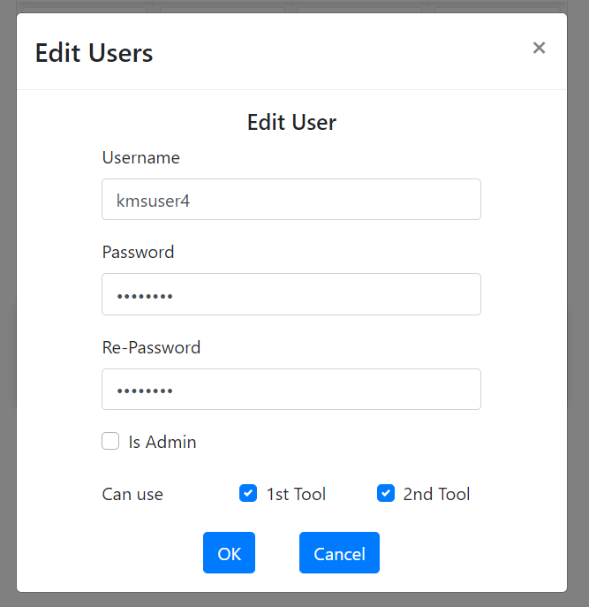

* This Edit popup is as same as Add popup, included the information of the selected user.
  + After editing, you can click OK to update.
* If you don’t want to update, please click “Cancel”.

**DELETE:**

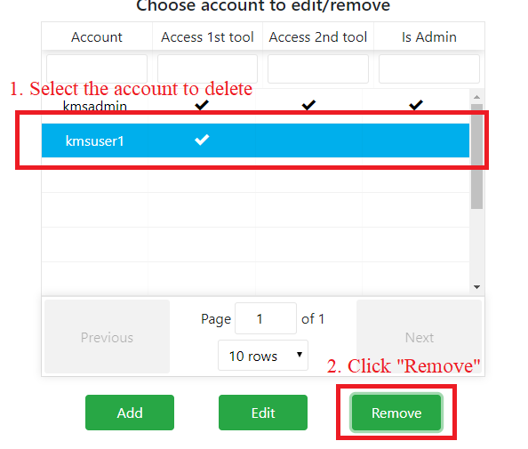

To delete, you please:

* Select the account to delete.
* Click “Remove”, then a popup to confirm will be prompted.

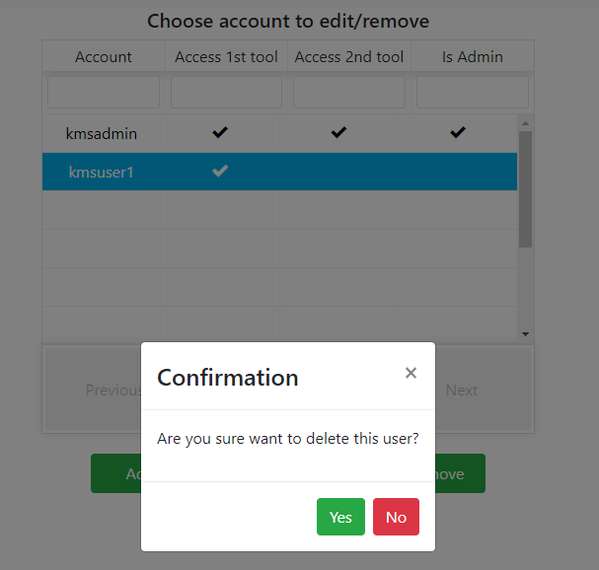

* Click “Yes” if you want to delete, or “No” if not.

1. PAGE: Manage connections to use to query databases in Warehouses and HHAX.

This is the screen to manage connections.

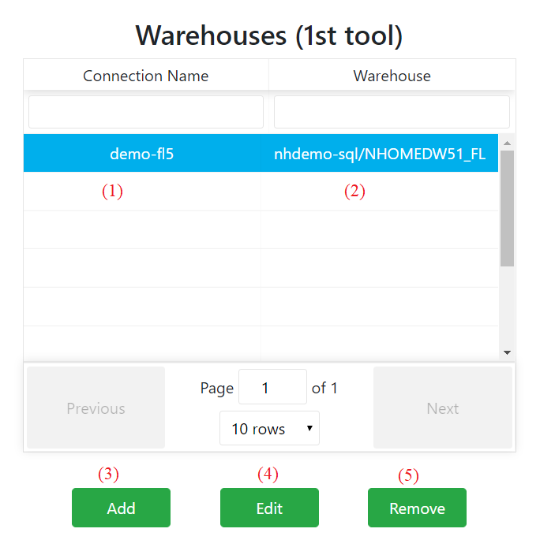

**UI elements:**

1. Displays the connection name – unique and can’t be duplicated.
2. Display the server name and database name of warehouse.

* EX: nhdemo-sql/NHOMEDW51_FL means
* Using server name: nhdemo-sql
* Database name: NHOMEDW51_FL

**FUNCTIONS:**

**ADD**: If you click Add, a popup will be shown like this.

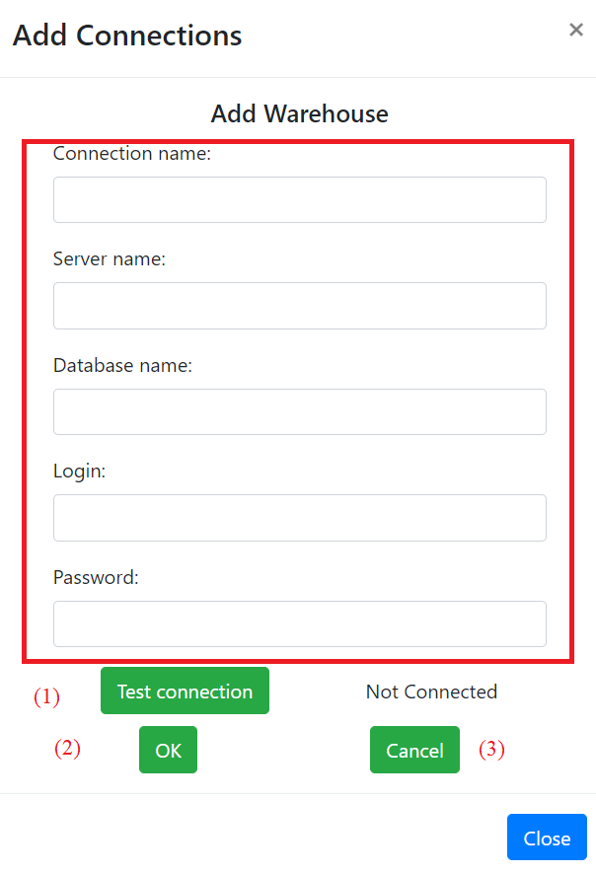

* Please full fill the information of the connection in red area.
* After that, please click (1) to test the connection. If the status is Connected like this

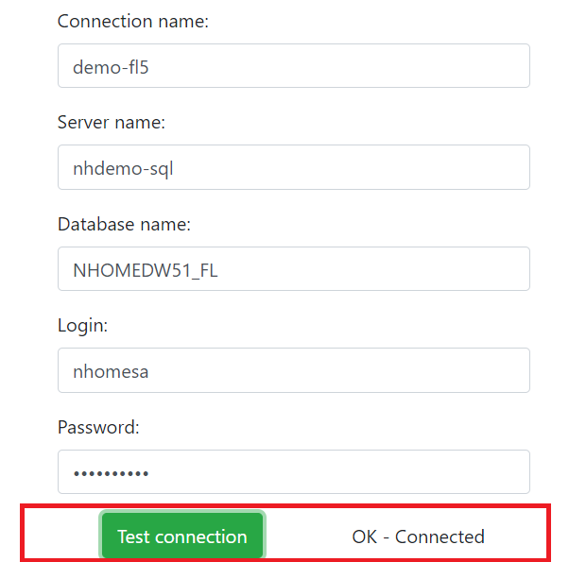

* You can click OK to create. But if the test connection status is NOT OK, an error will be shown.

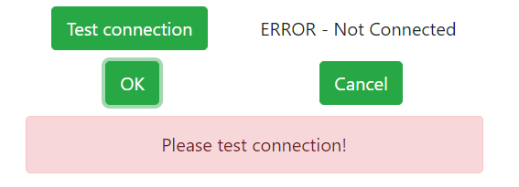

NOTE: With this error can’t connect successfully, you can’t add this connection.

**EDIT**: If you click Edit, a popup as same as “Add” will be shown. This popup included the information of the connection.

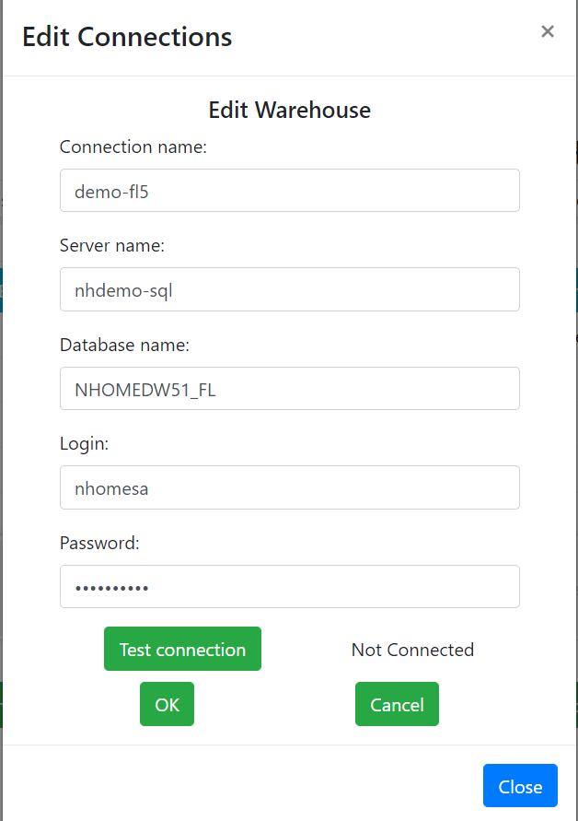

* You can edit the information of the connection. But to update, you first need to click “Test Connection”, and only if that status is “OK - Connected”, you then will be able to save by clicking “OK”.

**DELETE**: If you click Remove, a new popup to confirm again deleting the selected connection.

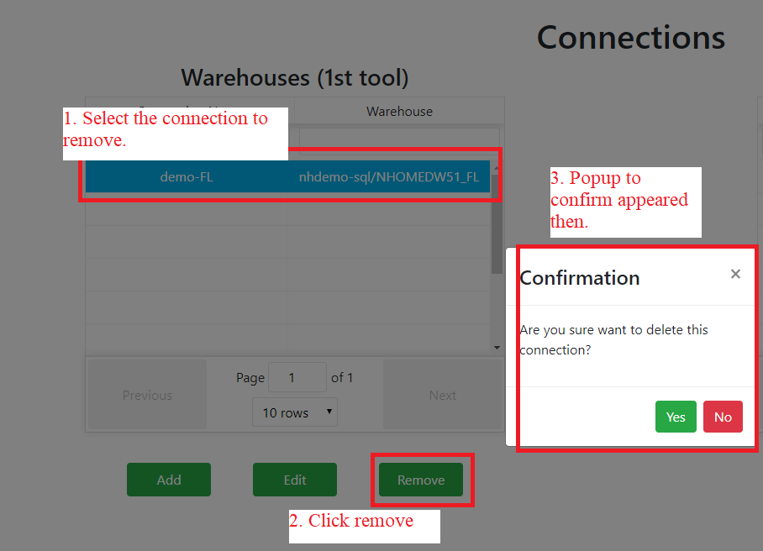

# **SECTION 2: For Normal User.**

1. PAGE: Select tools as Normal Users

If you logged as normal user, your header nav will be like this.

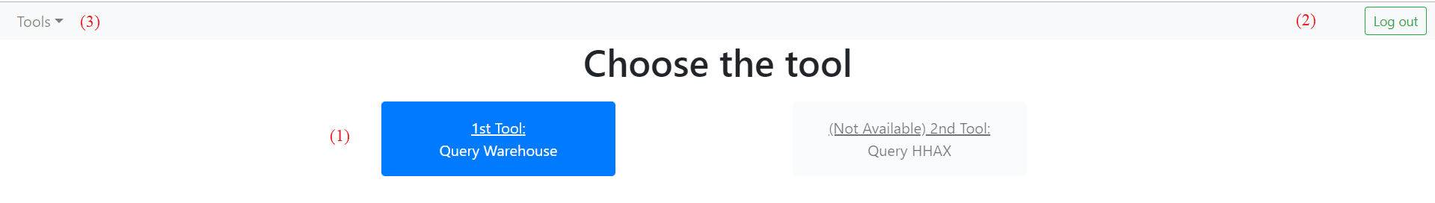

* If you want to logout, please click (2), then you will be returned the login page.
* You can click (1) or (3) to navigate to the screen select connection to query database in Warehouse. If you click (3), you then select the dropdown item.

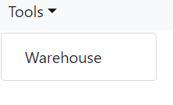

1. PAGE: Select connections to query database.

Now, you select the connection string to query database.

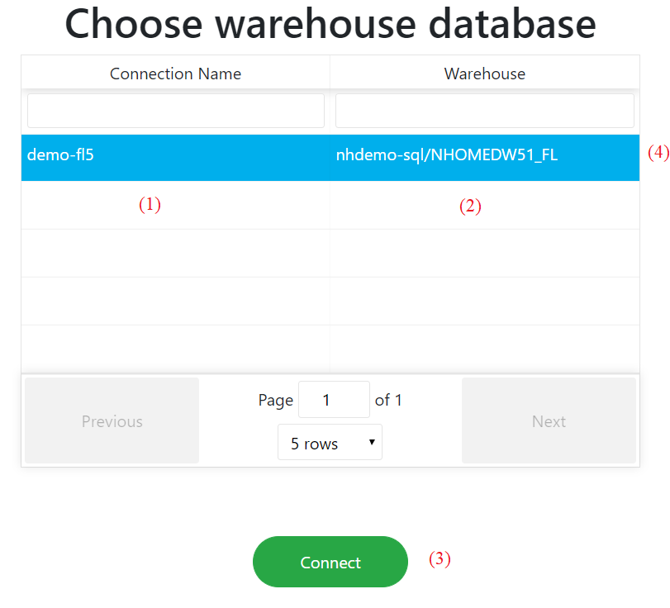

**UI elements:**

1. is the connection name
2. is the warehouse’s name, included server name and database name.

* EX: Warehouse: nhdemo-sql/NHOMEDW51_FL means that:
* Server name: nhdemo-sql
* Database name: NHOMEDW51_FL
* To select the connection, you can “double click” in that row (4) or select that row (4) and click “Connect” – (3)
* You can do the paging and filter here.

1. PAGE: Querying data in Warehouse.
   * After selecting the connection, you’ll be navigated to the searching page for clients and authorizations in Warehouse.
   * There’re 2 tabs for searching Clients and Authorizations here.

**TAB CLIENTS:**

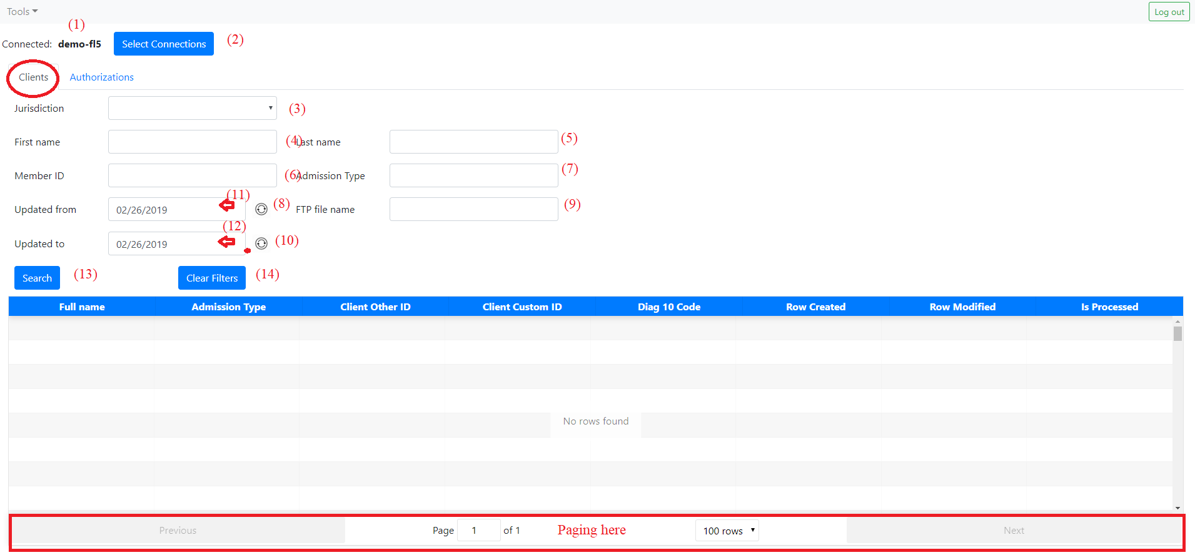

1. – display the connection name you have selected.
2. – If you want to change the connection, please click this to navigate back to screen 3.

Below is the area for input information to query clients in the warehouse.

1. – Dropdown to select the jurisdiction
2. – Input text to query for first name
3. – Input text to query for last name
4. – Input text to query for member id
5. – Input text to query for admission type
6. – Click to delete the selected date of (11)

* Example: Before click (8)

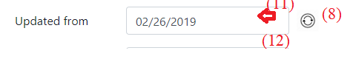

* After clicking (8), the (11) will be blank.



(9) – Input text to query for ftp file name.

(10) – Is as same as (8) but for the date time picker (12)

(11) – Datetime picker to select the updated from. You can click in that, then a new date picker will be shown like this.

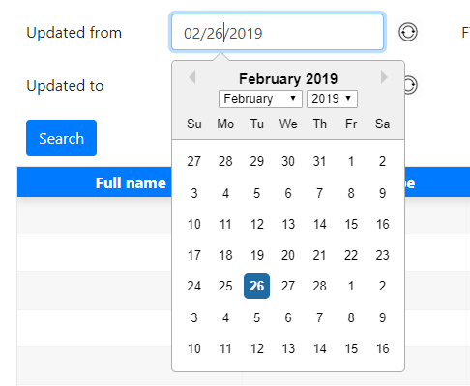

* You can select the month, year or date here.

1. Is as same as (11), but to query for updated from

* After filling information, you can click (13) to do the query.

Example: After clicking (13), the table will show the results. You can do the paging here.

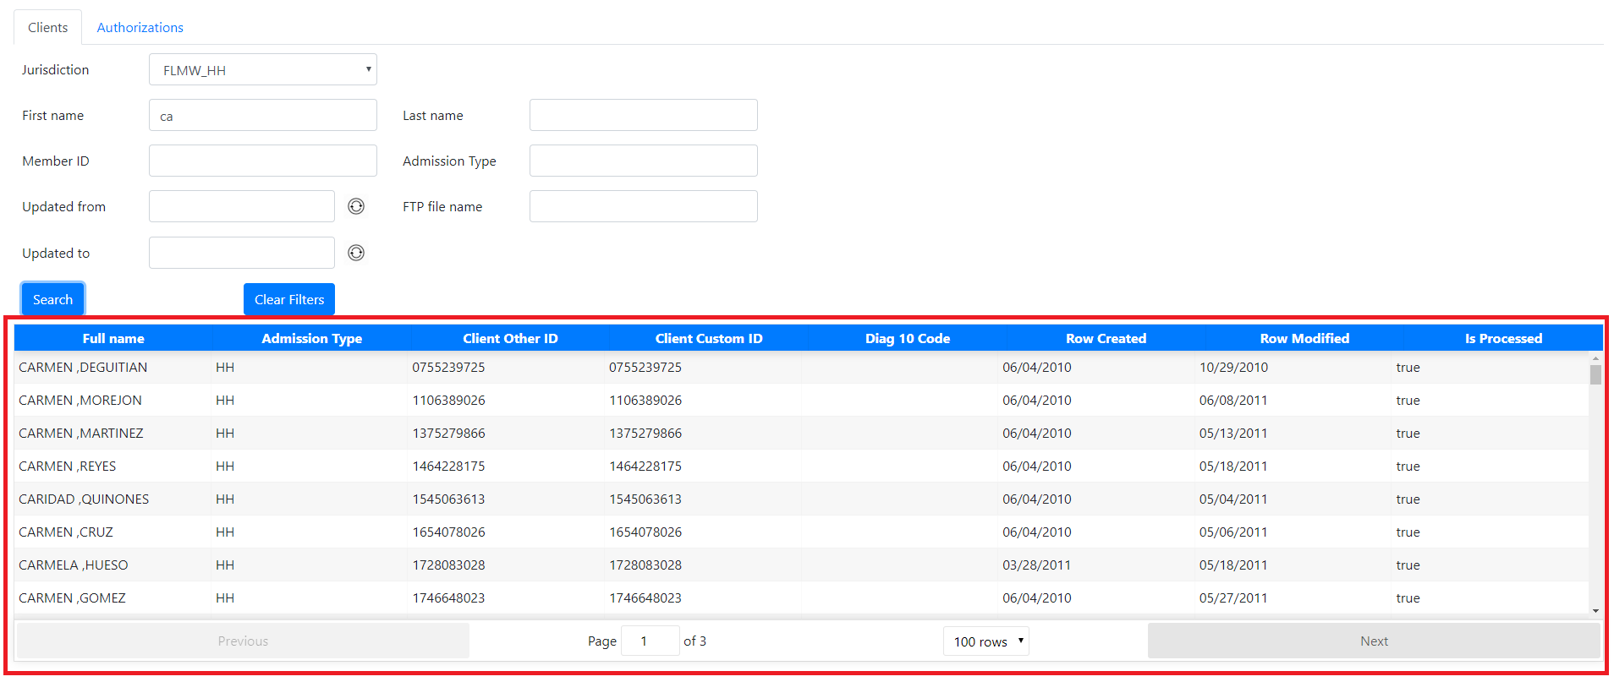

* You can click (14) to clear all filters from (3) to (12)
* EX: Before clicking (14)

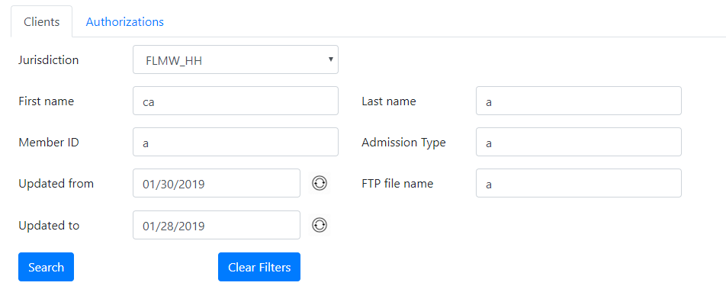

* After clicking (14)

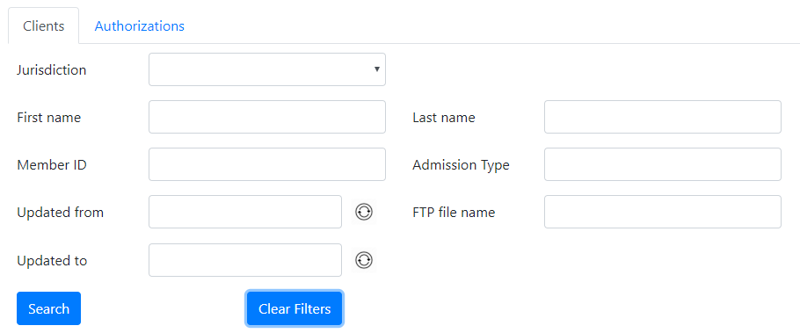

**TAB AUTHORIZATIONS:**

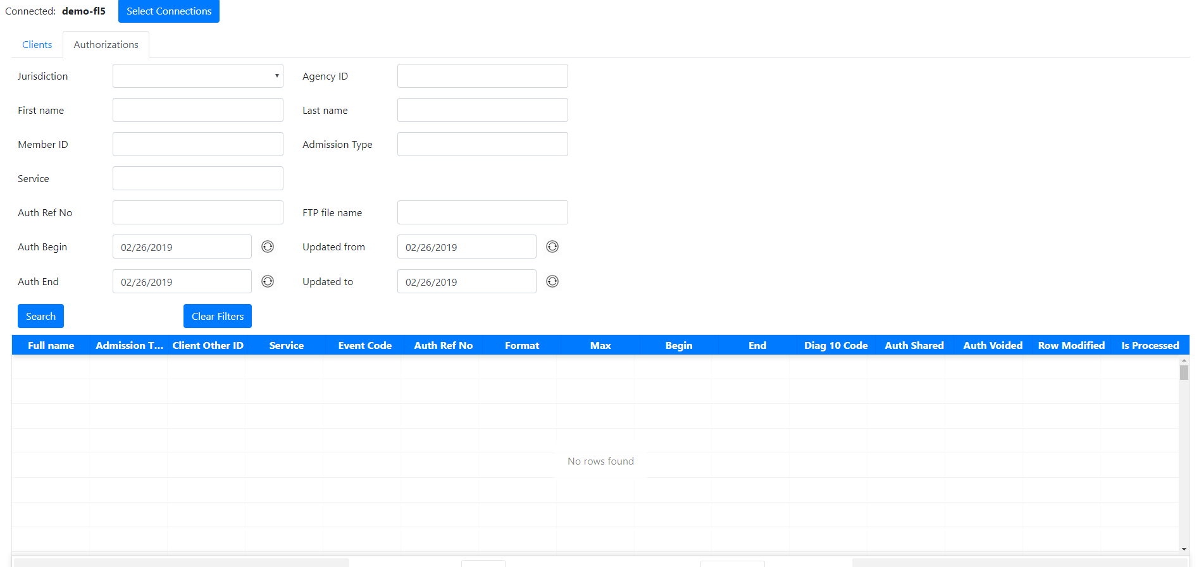

This tab is as same as the Client tab, with more filters and columns in table result.