Plan: **2 tools for Eric’s request**

This document is about the plan, requirements and details about 2 tools that Eric requested for team Tier 3 Support.

This is written by Tier3 – Nhan Thien Nguyen.

# **Table of Contents**

1. Overview the plan for both 2 tools 2

2. Connections to databases, security and permissions 6

3. The 1st tool - queries the warehouse database 12

4. The 2nd tool - queries the HHAX data feed 14

**Table of Figures**

Figure 1.1 Screen login 5

Figure 1.2 Screen choose the tool to access 6

Figure 1.3 Screen choose the warehouse database to connect 6

Figure 1.4 Screen choose the HHAX Integration database 7

Figure 1.5 Screen manage connections to databases 7

Figure 1.6 Popup Add/Edit warehouse database 8

Figure 1.7 Popup Add/Edit HHAX Integration database 8

Figure 1.8 Screen manage accounts and set permissions 9

Figure 1.9 Popup Add/Edit accounts 9

Figure 3.1 Screen reviewing clients in warehouse 11

Figure 3.2 Screen reviewing authorizations in warehouse 11

Figure 4.1 Screen review clients in HHAX responses 13

Figure 4.2 Screen review authorizations in HHAX responses 14

Figure 4.3 Screen review Schedules/Completed visits in HHAX responses 14

Figure 4.4 Screen review Billing Visits in HHAX responses 15

Figure 4.5 Screen review Caregivers in HHAX responses 15

**Table of Tables**

Table 1.1 Permissions and access rights 7

Table 3.1 Filters of reviewing clients - 1st tool 13

Table 3.2 Filters of reviewing authorizations in 1st tool 14

Table 4.1 Filters of reviewing patients in 2nd tool. 17

Table 4.2 Filters of reviewing authorizations in 2nd tool 18

Table 4.3 Filters of reviewing Schedules/Completed visits in 2nd tool 19

Table 4.4 Filters of reviewing Billings in 2nd tool 20

Table 4.5 Filters of reviewing Caregivers in 2nd tool 20

# **Overview the plan for both 2 tools**

**Tools:**

* 1st tool: Displaying member and authorization records, querying the warehouse accounts in production.
* 2nd tool: Displaying staged data from the HHAX data feed, able to review inbound member and authorization database and perform lookups against the responses HHAX sends back to Sandata for Schedules, Completed Visits, Billing, and Caregiver records.

**Total time for 2 tools:** 160 hours – 4 weeks (included self-testing)

* Self prepare for tech: 16 hours – 2 days.
* Login & connections, permissions: 40 hours – 1 week.
* Time for 1st tool: 40 hours – 1 week.
* Time for 2nd tool: 64 hours – 1 week 3 days.

**Total screens:** 13 screens and 3 popups.

* Login, choose the tool and choose the database: 4 screens.
* Manage connections to databases (Warehouse and HHAX Integration): 2 screens and 2 popups.
* Mange accounts: 1 screen and 1 popup.
* The 1st tool for querying the warehouse: 2 screens.
* The 2nd tool for querying the HHAX Integration: 5 screens.

**Spent time at least each week:** 20 hours.

**Time start coding tools:** (After accepting this plan)

**Date to release 1st tool:** (After accepting this plan)

**Date to release 2nd tool:** (After accepting this plan)

**Tech:**

* 2 tools in 1 website – built from
  + Front end: ReactJS v16 or VueJS v2.
  + Back end: .NET (Restful APIs) with language C#.
  + Database: MSSQL.
* Developer: 1 – Nhan Thien Nguyen.

For more detail about the security and requirements, screens, … of each tool, please read my information below.

1. **Connections to databases, security and permissions**

**Total time:** 40 hours – 1 week.

**Connections to database:**

* The connections to database can only be set by Admin account.
* Admin account can easily add/edit/remove connections to database with the information: server name, login, password.

**Security:**

* The accounts ’s passwords must be encrypted so that they can’t be seen easily in the database.
* The tool supports concurrent logins with a session timeout of 15 minutes of no-activity to keep connections down.

**Permissions and access rights:**

* There are 2 types of account:
* ***Admin:*** This is the ***full-control******and access*** account, is ***provided from KMS*** and there’s only one.
* ***Normal user:*** Can ***only be used to login and access*** the tools. Normal users can be created by Admin, and are ***limited which tools to access***. The normal user can only access to the 1st tool or the 2nd tool, or maybe both 2 tools by Admin set.

|  |  |  |
| --- | --- | --- |
| ***Permission & Access right*** | ***Admin*** | ***Normal user*** |
| Add/Edit/Remove connections to databases. | **YES** | **NO** |
| Choosing the database to connect. | **YES** | **YES** |
| Add/Edit/Remove normal accounts. | **YES** | **NO** |
| Set permission of normal accounts: which tools they can access. | **YES** | **NO** |
| Access and use the tools. | **YES** – both 2 tools | **YES** – but limited which tools can be accessed by Admin. |

*Table 1.1 Permissions and access rights*

**Screens:** Total 6 screens and 3 popups.

* Screen 2.1: Login page.

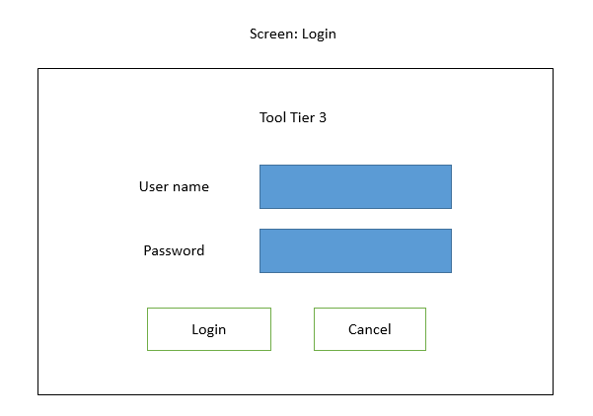

Figure 1.1 Screen login

* Screen 2.2: Choose the tool to use.

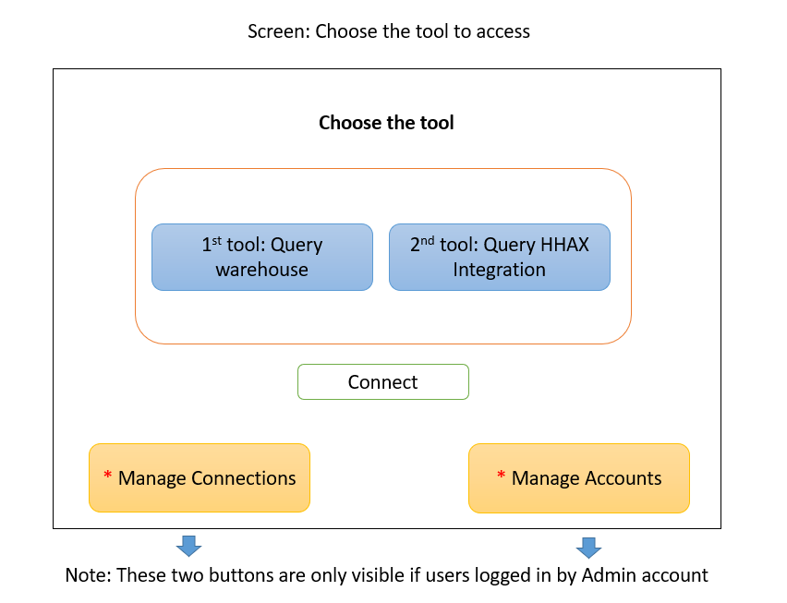

Figure 1.2 Screen choose the tool to access

* Screen 2.3: Choose the database to connect.
* If in screen 2.2: User selected the 1st tool to query in warehouse database

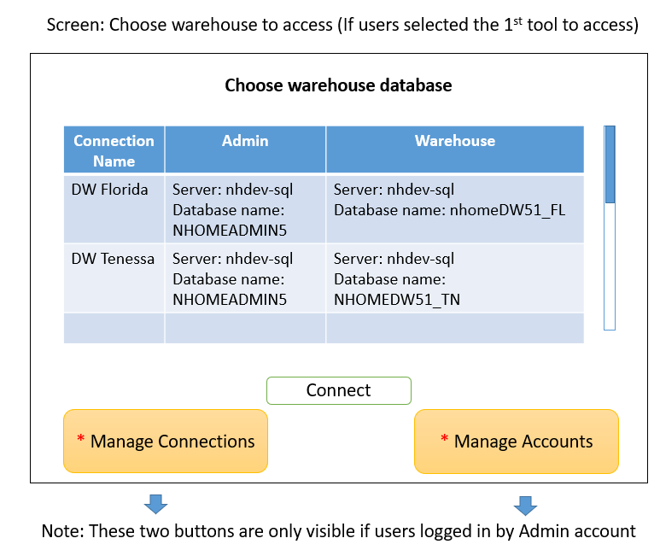

Figure 1.3 Screen choose the warehouse database to connect

* If users selected the 2nd tool to query in HHAX Integration.

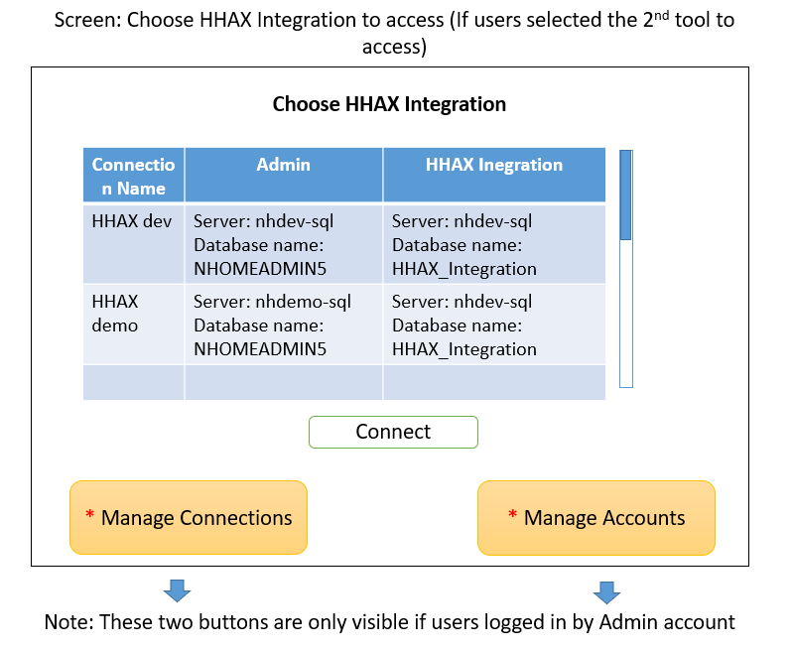

Figure 1.4 Screen choose the HHAX Integration database

* Screen 2.4: Manage connections to databases.
* From screen 2.3: If the user is Admin, then selected Manage Connections.

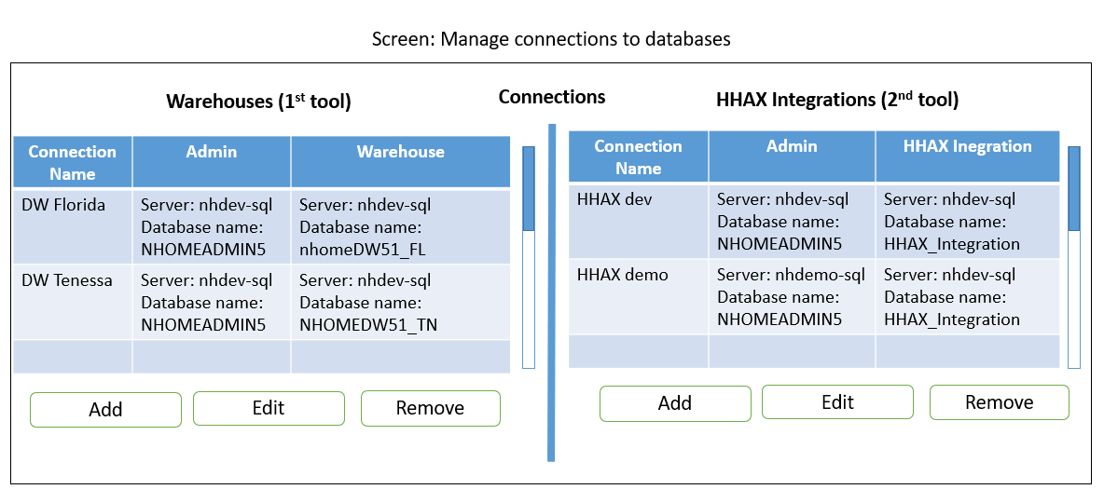

Figure 1.5 Screen manage connections to databases

* If Admin user selected Add/Edit in Warehouse, a popup will be opened like:

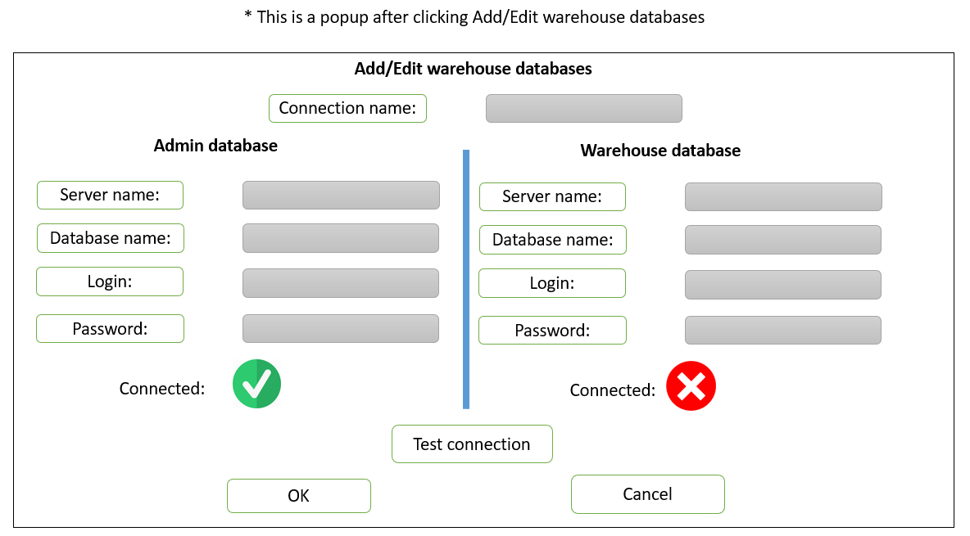

Figure 1.6 Popup Add/Edit warehouse database

* If Admin user selected Add/Edit in HHAX Integration, a popup will be opened like:

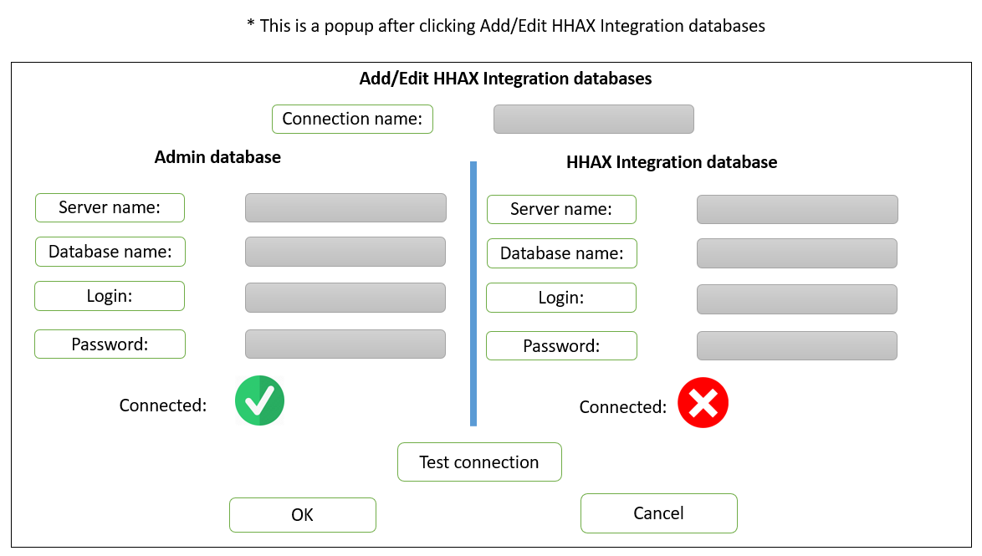

Figure 1.7 Popup Add/Edit HHAX Integration database

* Screen 2.5: Manage accounts.
* From screen 2.3: If the user is Admin, then selected Manage Accounts.

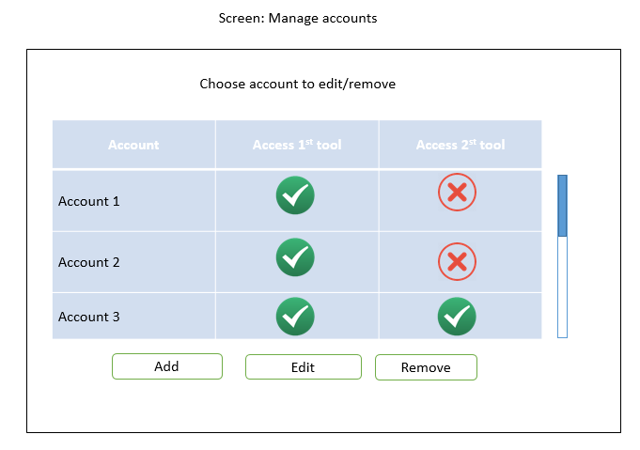

Figure 1.8 Screen manage accounts and set permissions

* When you click Add/Edit an account, a popup will be opened.

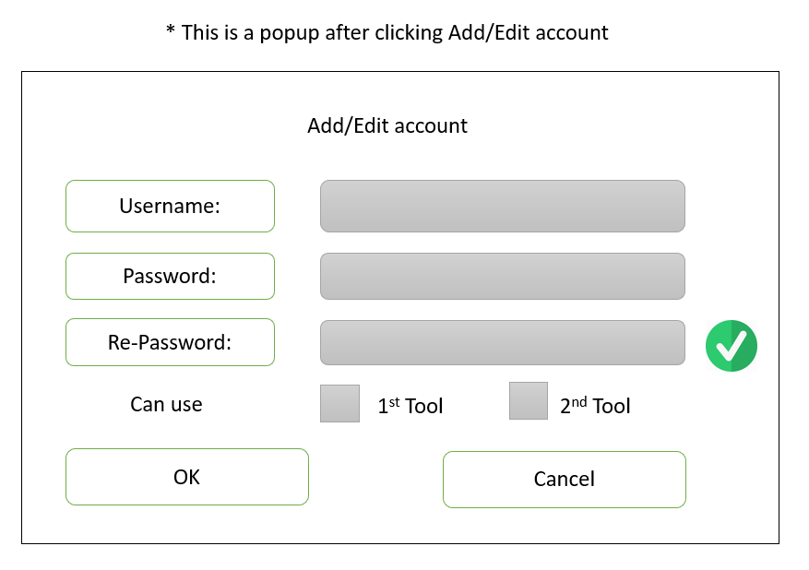

Figure 1.9 Popup Add/Edit accounts

# **The 1st tool - queries the warehouse database**

**Purpose:** A tool that can display member and authorization records for a specific jurisdiction, payer, combination. This tool queries the warehouse accounts in production to perform these lookups.

**Total time:** 40 hours – 1 week.

**Requirements:**

* Must use the valid accounts (the accounts are provided by KMS) and connected VPN to access, data accounts must be encrypted. ***(Included in 2nd chapter)***
* Provide way to set up the connection to the server of both warehouse database and HHAX integration, can be set on UI. ***(Included in 2nd chapter)***
* Have filters for reviewing imported Clients such as: Jurisdiction, Agency Name, First name, Last name, Client ID, Admission, Admissions Type, ftpFileName, Row updated date range.
  + Query then show the data: Full name, Admission Type, clientotherID, providerID (agencyID), clientCustomID, diag10Code, rowCreated, rowModified, IsProcessed.
* Have filters for reviewing imported client’s authorization such as: Jurisdiction, Agency Name, First name and last name, Client ID, Admission, Admissions Type, ftpFileName, Authrefno, Services, ProviderID, Date range of authorization, and Auth last updated (Date range filter).
* Authorization: Display the client’s full name, clientOtherID, admission type and client’s authorizations include: service, event code, authrefno, format, max, begin and end date, diag10Code, rowCreated, rowModified, isProcessed, authVoided, authShared.

**Screens:** There are 2 screens – in two tabs.

* Screen 3.1: Searching the imported client.

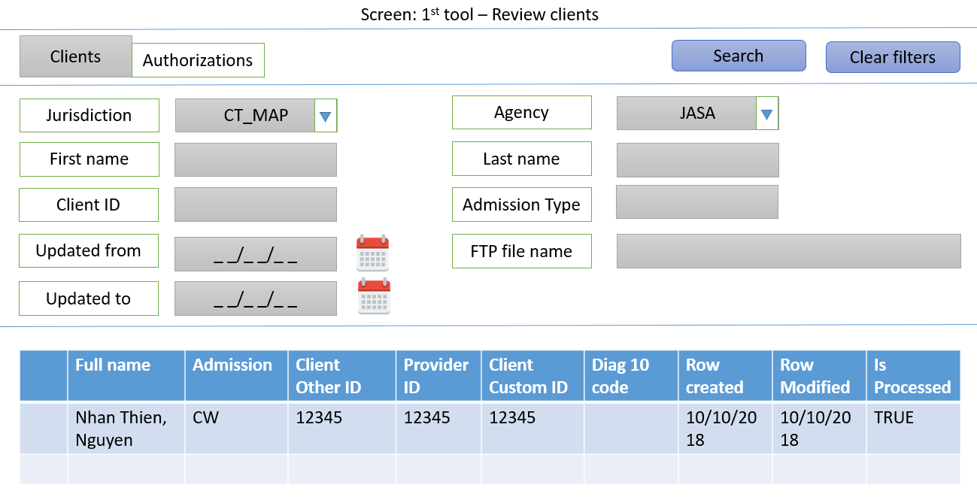

Figure 3.1 Screen reviewing clients in warehouse

|  |  |
| --- | --- |
| **Filter** | **From** |
| Jurisdiction | WarehouseDB/DataImportClient/JurisdictionID. |
| Agency | NHOMEADMIN51/Agency/AgencyName – filtered by AgencyGroupID (selected Warehouse DB) |
| First name | Warehouse DB/DataImportClient/entFirstName |
| Last name | Warehouse DB/DataImportClient/entLastName |
| ClientID | Warehouse DB/DataImportClient/ClientID |
| Admission Type | Warehouse DB/Admissions_Types |
| Update from | Warehouse DB/DataImportClient/RowUpdated |
| Update to | Warehouse DB/DataImportClient/RowUpdated |
| FTP File name | Warehouse DB/DataImportClient/FTPFileName |

*Table 3.1 Filters of reviewing clients - 1st tool*

* Screen 3.2: Searching the imported client’s authorization.

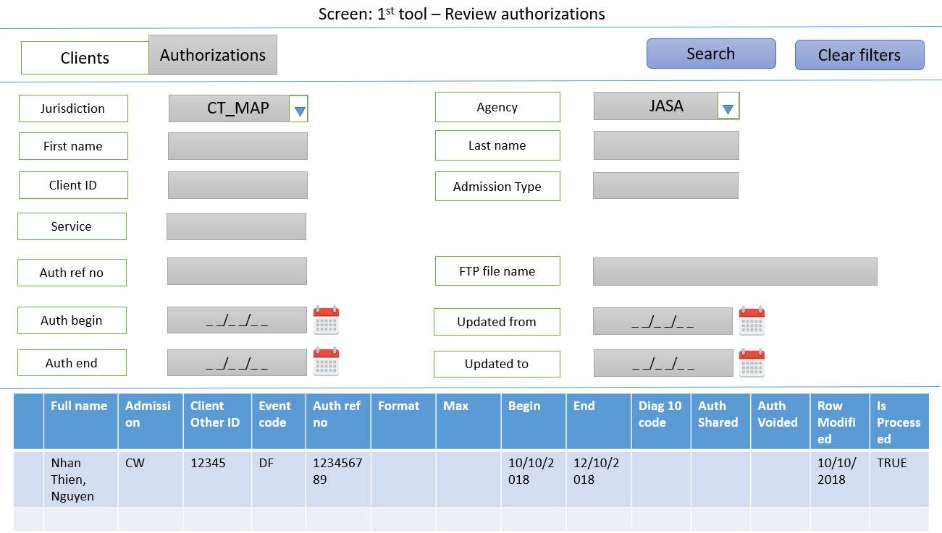

Figure 3.2 Screen reviewing authorizations in warehouse

|  |  |
| --- | --- |
| **Filter** | **From** |
| Jurisdiction | WarehouseDB/DataImport_Client/JurisdictionID. |
| Agency | NHOMEADMIN51/Agency/AgencyName. |
| First name | Warehouse DB/DataImport_Client/entFirstName |
| Last name | Warehouse DB/DataImport_Client/entLastName |
| ClientID | Warehouse DB/DataImport_Client/ClientID |
| Admission Type | Warehouse DB/Admissions_Types |
| Service | WarehouseDB/DataImport_Authorization/ServiceID |
| Auth ref no | WarehouseDB/DataImport_Authorization/authrefno |
| Auth begin | WarehouseDB/DataImport_Authorization/authDateFrom |
| Auth end | WarehouseDB/DataImport_Authorization/authDateTo |
| Update from | WarehouseDB/DataImport_Authorization/authUpdated |
| Update to | WarehouseDB/DataImport_Authorization/authUpdated |
| FTP File name | WarehouseDB/DataImport_Authorization/ftpFileName |

*Table 3.2 Filters of reviewing authorizations in 1st tool*

# **The 2nd tool - queries the HHAX data feed**

**Purpose:** A tool that can display staged data from the HHAX data feed. This provides the ability to review inbound member and authorization database and perform lookups against the responses HHAX sends back to Sandata for Schedules, Completed Visits, Billing, and Caregiver records.

**Total:** 64 hours – 1 week 3 days.

**Requirements:**

* Must use the valid accounts (the accounts are provided by KMS) and connected VPN to access, data accounts must be encrypted.
* Have filters for reviewing client: Agency Name, Admissions Type, Client ID, Client first and last name, Client status, Inserted date range, Modified date range.
  + Query then show the records include: Patient ID, Patient’s full name, Admission Type, Patient status, Discharge Date, Created date, Modified date, Invalid Data.
* Have filters for reviewing Patient’s authorization such as: Agency Name, Admissions Type, Patient first & last name, Authorization number, Service Type, Date range of authorization, Inserted date range and Modified date range.
  + Query then show the records of authorizations group by Patient: Patient full name, admission, authorization number, Service Type, Billing Service Code, Begin date, End date, Modified date and Invalid Data.
* Have filters for the Schedules and Completed Visits’s responses sends back to Sandata such as: Agency Name, First & last name of Patient, Staff’s full name, Schedule ID, Sched Date range, Sched Time range, Service Code, Date time inserted, Is Completed Visit.
  + Query then show the records include: Sched Date, Patient’s full name, Service Code, Staff’s full name, Sched time start, Schedule time end, Complete visit time start, Complete visit time end, Status Code, Import status and Original data.
* Have filters for the Billings’s responses HHAX sends back to Sandata such as: Agency Name, First & last name of Patient, Billing Schedule ID, Billing Date range, Billing Invoice Number.
  + Query then show the records include: Bill Invoice number, Bill Schedule date, Patient’s full name, Billing Service Code, Staff’s full name, Status Code, Import status, Original data.
* Have filters for Caregiver records (Staffs) such as: Agency Name, Caregiver ID, First & last name of Caregiver, Status, SSN.
* Query then show the data: Caregiver full name, Caregiver code, Start date, Rehire date, Is verified, Termination date, SSN, Status Code, Import status, original data.

**Screens:** there are 5 screens – 5 tabs. They all are responses from HHAX to SANDATA.

* Screen 4.1: Search for Patients.

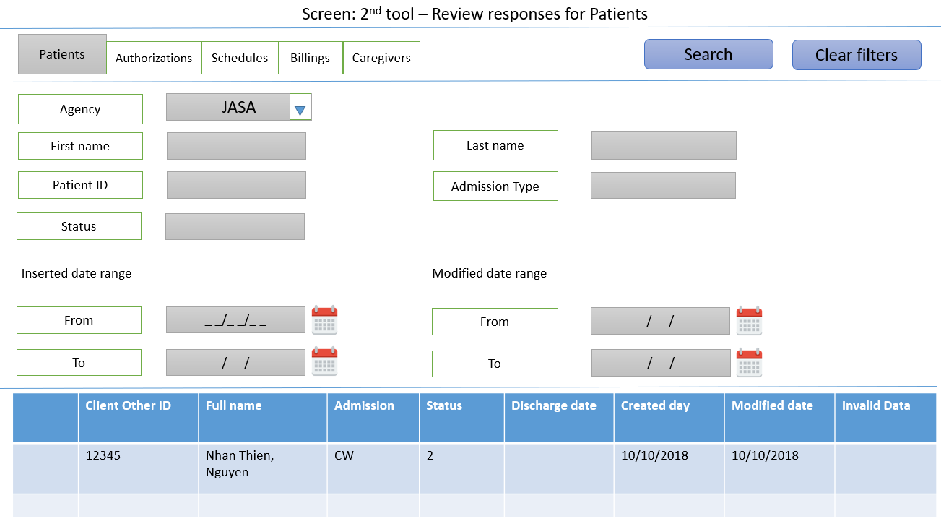

Figure 4.1 Screen review Patients in HHAX responses

|  |  |
| --- | --- |
| **Filter** | **From** |
| Agency | HHAX/Agency_Config/AgencyName |
| First name | HHAX/Patient_Demog/First_Name |
| Last name | HHAX/Patient_Demog/Last_Name |
| PatientID | HHAX/Patient_Demog/Patient_ID |
| Admission Type | HHAX/Patient_Demog/Admission_ID |
| Status | HHAX/Patient_Demog/Patient_Status |
| Inserted date from | HHAX/Patient_Demog/Datetime_Inserted |
| Inserted date from | HHAX/Patient_Demog/Datetime_Inserted |
| Modified date from | HHAX/Patient_Demog/Modified_date |
| Modified date to | HHAX/Patient_Demog/Modified_date |

Table 4.1 Filters of reviewing patients in 2nd tool.

* Screen 4.2: Search for Patient’s authorizations.

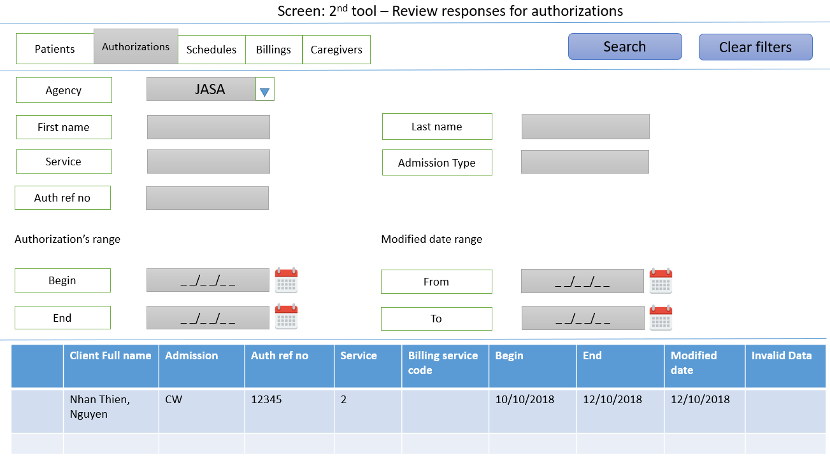

Figure 4.2 Screen review authorizations in HHAX responses

|  |  |
| --- | --- |
| **Filter** | **From** |
| Agency | HHAX/Agency_Config/AgencyName |
| First name | HHAX/Patient_Demog/First_Name |
| Last name | HHAX/Patient_Demog/Last_Name |
| PatientID | HHAX/Patient_Authorizations/Patient_ID |
| Admission Type | HHAX/ Patient_Authorizations/Admission_ID |
| Service | HHAX/ Patient_Authorizations/Service_Type |
| Auth ref no | HHAX/ Patient_Authorizations/Authorization_Number |
| Auth begin | HHAX/ Patient_Authorizations/From_Date |
| Auth end | HHAX/ Patient_Authorizations/End_Date |
| Modified date from | HHAX/ Patient_Authorizations/Modified_Date |
| Modified date to | HHAX/ Patient_Authorizations/Modified_Date |

Table 4.2 Filters of reviewing authorizations in 2nd tool

* Screen 4.3: Search for Schedules and Completed Visits.

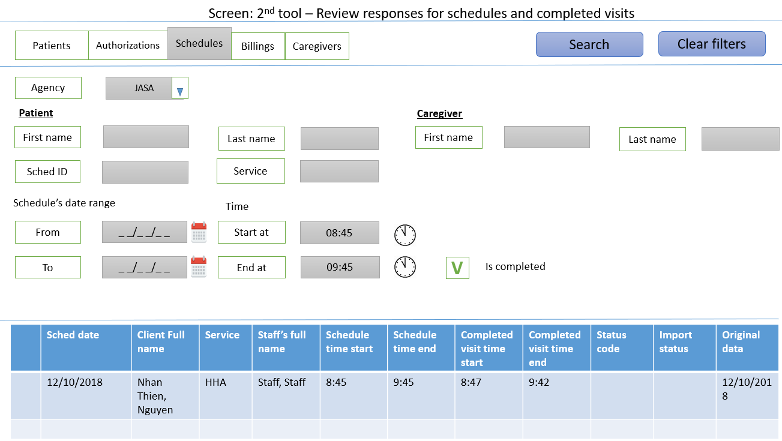

Figure 4.3 Screen review Schedules/Completed visits in HHAX responses

|  |  |
| --- | --- |
| **Filter** | **From** |
| Agency | HHAX/Agency_Config/AgencyName |
| Patient first name | HHAX/Patient_Demog/First_Name |
| Patient last name | HHAX/Patient_Demog/Last_Name |
| Patient ID | HHAX/ Schedules_export_response/Schedule_Patient_ID |
| Caregiver first name | HHAX/Caregiver_export_response/ExpCar_first_name |
| Caregiver last name | HHAX/Caregiver_export_response/ExpCar_last_name |
| Caregiver ID | HHAX/Caregiver_export_response/Schedule _Caregiver_Code |
| SchedID | HHAX/Schedules_export_response/ScheExp_Schedule_ID |
| Service | HHAX/Schedules_export_response/ScheExp_Service_Code |
| Schedule date from | HHAX/Schedules_export_response/ScheExp_Schedule_Date |
| Schedule date to | HHAX/Schedules_export_response/ScheExp_Schedule_Date |
| Time start | HHAX/Schedules_export_response/ScheExp_Schedule_Start_Date |
| Time end | HHAX/Schedules_export_response/ScheExp_Schedule_End_Date |
| Is completed | If checked, check if the schedule is in Completed Visits. |

Table 4.3 Filters of reviewing Schedules/Completed visits in 2nd tool

* Screen 4.4: Search for Billing visits.

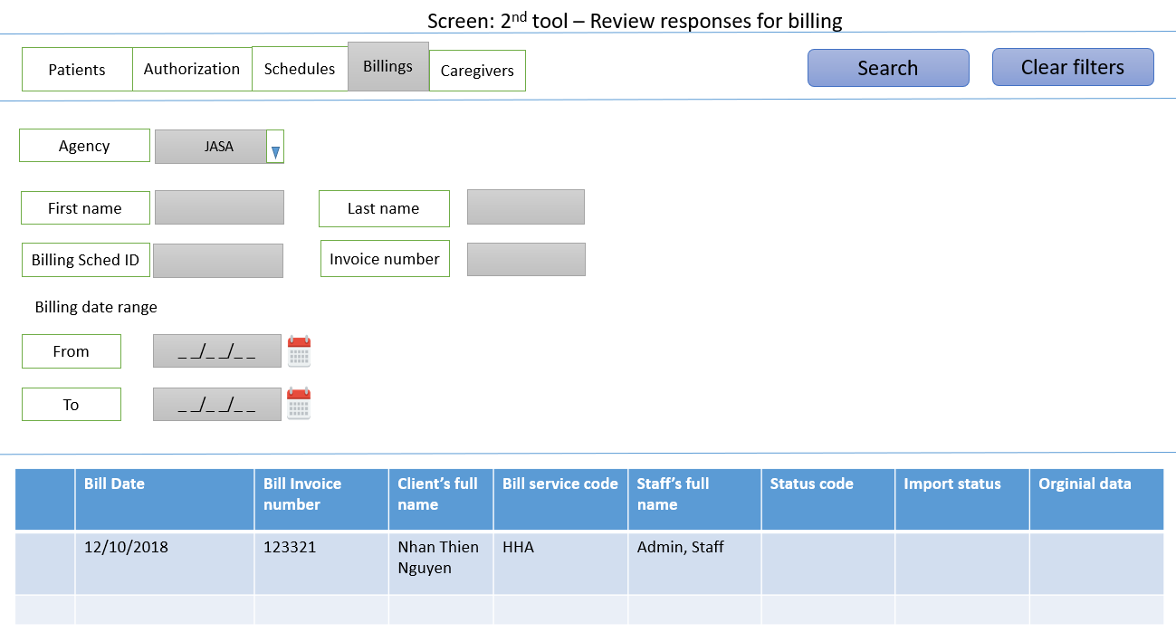

Figure 4.4 Screen review Billing Visits in HHAX responses

|  |  |
| --- | --- |
| **Filter** | **From** |
| Agency | HHAX/Agency_Config/AgencyName |
| Patient first name | HHAX/Patient_Demog/First_Name |
| Patient last name | HHAX/Patient_Demog/Last_Name |
| Patient ID | HHAX/BillingExports_Response/BilExp_Patient_ID |
| Billing SchedID | HHAX/BillingExports_Response/BilExp_Schedule_ID |
| Invoice number | HHAX/BillingExports_Response/BilExp_InvoiceNumber |
| Billing date from | HHAX/BillingExports_Response/Datetime_Inserted |
| Billing date to | HHAX/BillingExports_Response/Datetime_Inserted |

Table 4.4 Filters of reviewing Billings in 2nd tool

* Screen 4.5: Search for Caregivers (Staffs).

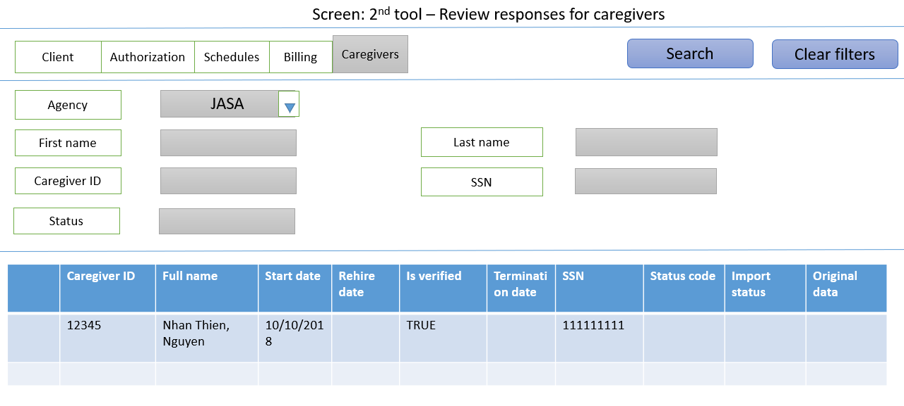

Figure 4.5 Screen review Caregivers in HHAX responses

|  |  |
| --- | --- |
| **Filter** | **From** |
| Agency | HHAX/Agency_Config/AgencyName |
| Caregiver first name | HHAX/Caregiver_export_response/ExpCar_first_name |
| Caregiver last name | HHAX/Caregiver_export_response/ExpCar_last_name |
| Caregiver ID | HHAX/Caregiver_export_response/ExpCar_Caregiver_Code |
| SSN | HHAX/Caregiver_export_response/ExpCar_SSN |
| Status | HHAX/Caregiver_export_response/ExpCar_Status |

Table 4.5 Filters of reviewing Caregivers in 2nd tool