* Account:
* Get dữ liệu: http://localhost:8080/rest/accounts

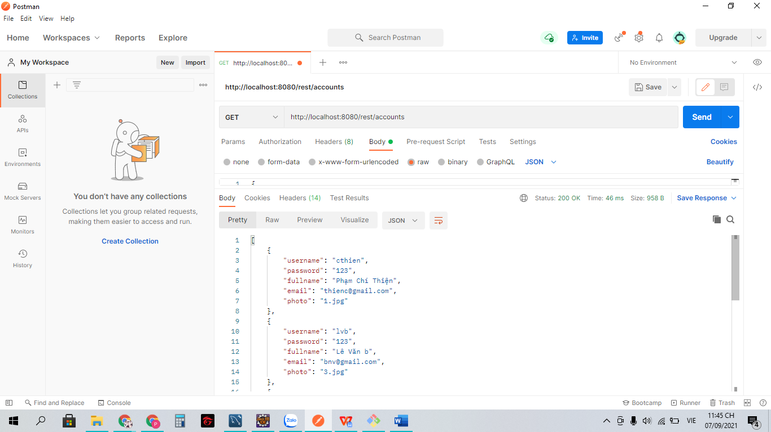

* Post dữ liệu: http://localhost:8080/rest/accounts

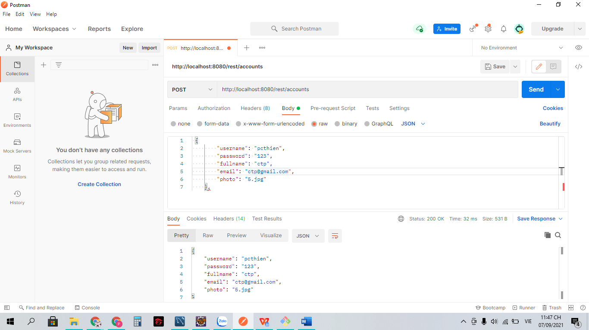

* Product:
* Get dữ liệu: http://localhost:8080/rest/products

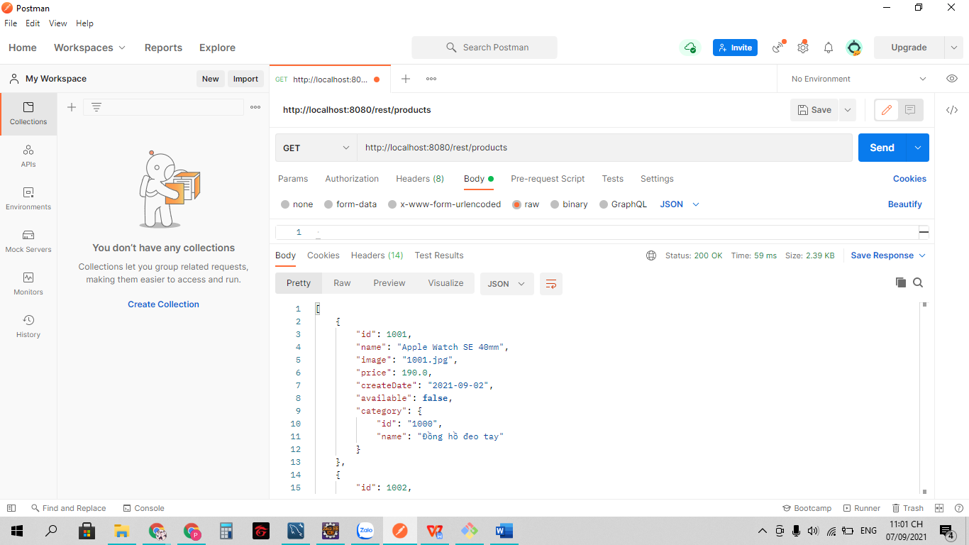

* Post dữ liệu: http://localhost:8080/rest/products

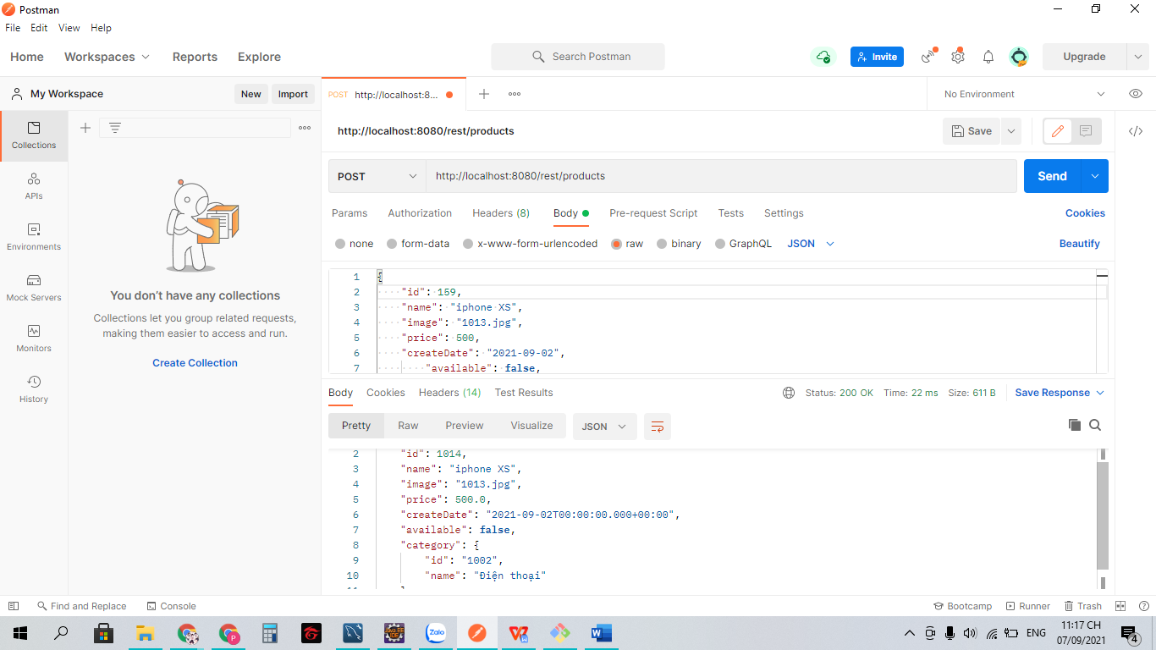

* PUT dữ liệu: http://localhost:8080/rest/products/1013

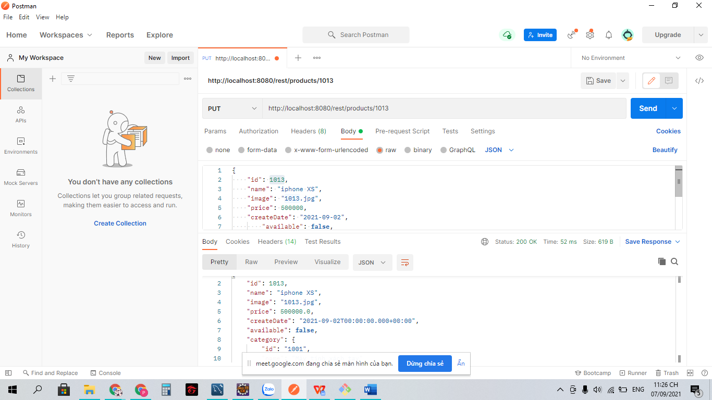

* Delete dữ liệu: http://localhost:8080/rest/products/1013

