



**AUT RESEARCH AND DEVELOPMENT PROJECT**

**PROJECT PROPOSAL**

**FOR**

**PREDICTIVE AWARD WEBSITE**

**Client: Mr. Lam Quang Vu**

**Version 01**

**September 30, 2016**

**Prepared by:** **Huy Vu and Quan Le**

**Team members: Huy Vu | Quan Le | Phuc Nguyen | Son Tran | Tan Vu**

# PROJECT STAKEHOLDERS

# http://nmcntt2nhom4.esy.es/wp-content/uploads/2016/04/Lam_Quang_Vu.jpg1. PROJECT SUPERVISOR

**Mr. Lam Quang Vu**

**Associate Professor**

**Doctor of Philosophy**

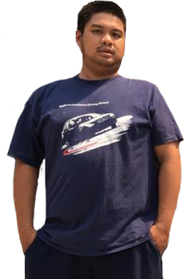2. OUR TEAM

**Vu Quang Nhat Huy**

**SCRUM master** 30, 2016

**Tran Long Son**

**Database Designer**

**Tester** er30, 2016

**Nguyen Trung Thien Phuc**

**Backend Developer**

er 30, 2016



**Vu Duy Tan**

**Frontend Developer**

**Tester**

er 30, 2016

**Le Minh Quan**

**Frontend Developer**

**UI Designer**

er 30, 2016

# SKILL AND KNOWLEDGE

|  |  |  |
| --- | --- | --- |
| **S K I L L S** | **K N O W L E D G E** | |
| **PROFESSIONAL SKILLS** | | * + **Leadership**   + **Project Management**   + **Team management**   + **Decision making**   + **Problem solving**   + **Teamwork**   + **Communication**   + **Time management**   + **Research and analysis**   + **Documenting** | |
| **TECHNICAL SKILLS** | * **Web Programing** * Java * PHP * CSS * HTML * **Database** * SQL Server * **Managing** * GitHub * Trello * Microsoft Project * **Interface Design** * Photoshop * Dreamweaver * Balsqmiq Mockups | |



# TERMS OF REFERENCE

# BACKGROUND INFORMATION

University of Science’s Human Resource Management Department need to have a new system in order to analyze and control their professor’s awards and titles such as “Chien si thi dua”, “Giao vien gioi”, etc. as well as govern the process of awarding these individuals.

Moreover, these processes will need to be supported from the lowest (individual) to the highest level (university). After that these data will be transmitted outside for other considerations.

# RATIONALE FOR THE PROJECT

Currently, there is no predictive award system in place within the University of Science in order to effectively assess their professors’ award which is a hugely missed opportunity to help professors having a clear understanding of their achievements as well as becoming material to bolster their potential to the maximum.

Therefore, a predictive award system will be integrated into the current interface of Professor Management program as a new feature.

**Issues:**

University of Science is not being able to effectively control their professors’ achievements as well as award these accomplishments each year. Normally, Human Resource Management will record every accomplishment of professor right when happening but they will need to wait at the end of each semester to asset and analyze these data person by person to award any qualified personnel.

These complicated processes will not only cost a considerable amount of expense in material and efforts but also might result in human errors which leads to many mistakes that could become too late to fix at that time.

Many different departments across University of Science do not have a uniformed system to control their respective number of professors. At a low number of personnel department this problem will not become apparent but it will be a towering order for such a workforce as University of Science. Obviously, expense will be an unneeded costly element which can be prevented easily with a productive award control system.

Moreover, wasting time is the main problem that needs to be solved because there will be time when it becomes unfixable mistakes. Repeating mistakes will gradually build up internal problems not only among personnel but also upon the system.

**Opportunities:**

Firstly, University of Science will have an efficient method to analyze awards in accordance with each professor which can be easily transferred across multiple levels and departments in order to publicize widely in the entire university. In addition, the new predictive award will set up a clear and concise guideline and methodology for future usage.

Moreover, University of Science will be able to save a hefty sum of expense on recurring material such as documents paper, space for storage and easy search when needed with a neat and user-friendly interface.

Next, this predictive award system will also provide professors, themselves, a much clearer look into their list of accomplishment which will definitely become a huge boost in their sense of recognition among colleagues and enhance working capabilities.

# CLIENT REQUIREMENTS

1. System to manage personnel’s achievements with many type of titles:
   * LDTT
   * LDXS
   * ….
2. Data will be handled under two units: individual and group. Moreover, data will be stored within history for many different usage.
3. Segregated level of moderation:
4. No constraint on type of language. Products need to be in web that compatible with both web and mobile versions.
5. Setting up system to filter data under checklist form that user will be able to completed and suggested on their own. These data will then be checked by admin account.
6. Account will be divided into many different types: normal user, head department, mod, and admin.

# PROJECT OBJECTIVES

As mention above, Predictive Award System (P.A.S) will be integrated into the current interface of Professor Management as a new tab and the whole thing might need to be renovated with a new look at the same time to most fit with this feature (take ITEC Student Management interface as an example). The scope of this project will be created a new feature within the existing Professor Management instead of a separated entity.

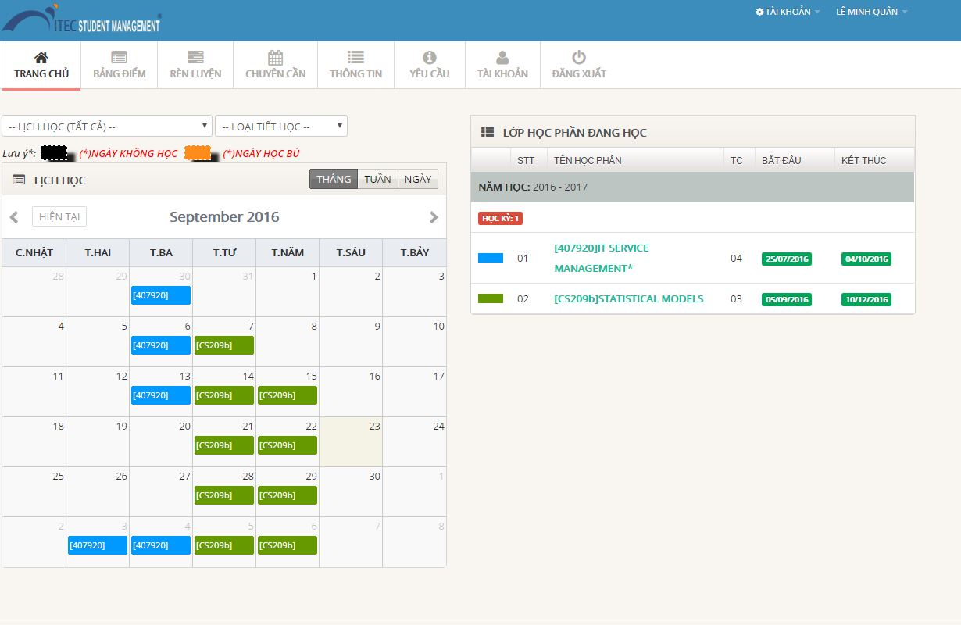

**P.A.S will be executed with a Scrum methodology due to some reasons:**

* There will be no fixed role where each person will be assigned and stuck with a same position throughout the whole project. This P.A.S project will be more like of a co-exist ecosystem with each person support one another in many different aspects. Developers might be better at coding and take the major role but they can assign the more simple coding part for others in order to speed up the entirety of project. This method will not only help others improving on their coding skill but might also deliver some fresh look and spark new ideas into developers.
* Secondly, workload will be divided into many different quantitative amounts with titles that signifies the nature of those works. These tasks will pose a various number of characteristics due to its nature. In the initiating phase, group leader will be the most important role who will handle analyzing project’s requirements as well as chalking up many different documents from project proposal, presentation, etc. But going into the executing phase, developers will take the leading role who focus mainly on setting up the front and back-end of coding the program. Finally, the closing will be the collaborate efforts of the entire group. As a result, a fixed project manager taking the lead throughout entire project is not appropriated instead we will use flexible scrum master who anybody can take the lead depending on the nature of work at the particular time.
* Scrum is an effective method for us to constantly provide customer, University of Science, with new and up-to-date prototype which will not only keeping them closely on track of project but also helping us to attune P.A.S to its maximum potential according to customer’s need. Sprint is also a way to segregate work clearly for each member within group in different phase basing on their role and abilities.

# IDENTIFYING COST INCURRED

|  |  |  |  |
| --- | --- | --- | --- |
|  | Initiating Phase | Executing Phase | Closing Phase |
| Huy Vu | 28 hours/week | 25 hours/week | 28 hours/week |
| Quan Le | 26 hours/week | 29 hours/week | 25 hours/week |
| Phuc Nguyen | 24 hours/week | 30 hours/week | 25 hours/week |
| Tan Vu | 27 hours/week | 28 hours/week | 25 hours/week |
| Son Tran | 25 hours/week | 27 hours/week | 29 hours/week |

# PROJECT MANAGEMENT PLAN

**Final review and confirm product with client (A8)**

**Host Deployment, checking prototype and optimize for mobile usage (A6)**

**Project proposal, requirements, interview**

**(A1)**

er 30, 2016

**Implement and Design user level**

**(A5)**

**Design Database, Web Template and UI**

**(A2)**

**Mid review, edit and fix bugs**

**(A7)**

**Finish and Presentation**

**(A9)**

**Testing and Debugging**

**(A7)**

**Learning Python and code basic features**

**(A3)**

**(A3)**

**Continue on January work, touching up for perfection (A5)**

**Sep Oct Nov Dec Jan Feb Mar Apr May June**



# LIST OF ACTIVITIES FOR COMPLETION

* **A1**: Doing proposal, requirement and finishing interview.
* **A2:** Completing database, CSS, User Interface.
* **A3:** Learning Python, starting on basic features.
* **A4:** Designing and sketching up website.
* **A5:** Getting on advancement coding.
* **A6:** Deploying host online, showing prototype for checking up.
* **A7:** Mid review and testing + debugging.
* **A8:** Final review
* **A9:** Presentation

# APPENDIX

# DISCLAIMER

While all due care and diligence will be expected to be taken by the students, (acting in software development, research or other IT professional capacities), and the Auckland University of Technology, and student efforts will be supervised by experienced AUT lecturers, it must be recognized that these projects are undertaken in the course of student instruction. There is therefore no guarantee that students will succeed in their efforts.

This inherently means that the client assumes a degree of risk. This is part of an arrangement, which is intended to be of mutual benefit. On completion of the project it is hoped that the client will receive a professionally documented and soundly constructed working software application, some part thereof, or other appropriate set of IT artefacts, while the students are exposed to live external environments and problems, in a realistic project and customer context.

In consequence of the above, the students, acting in their assigned professional capacities and the Auckland University of Technology, disclaim responsibility and offer no warranty in respect of the “technology solution” or services delivered, (e.g. a “software application” and its associated documentation),both in relation to their use and results from their use.

# PROJECT ASSESSMENT FORM

1. What coding language will be used in this project?
2. Will there be a compatible mobile version?
3. How many sprints within the project?
4. How much the completion will be?