**MAKING DIGITAL STORY**

**Project: Digital Story for Starbucks**

**Group members:**

1. Duong Thi Diem My
2. Ly Quoc Viet
3. Tran Lan Anh
4. Ngo Thi Phuong Khanh
5. Nguyen Thi Thuy Tram
6. Nguyen Thao Ngan
7. Nguyen Lam My Vy
8. Nguyen Phi Hao

**Step 1: Develop Idea:**

**Sharing idea:**

* Customers who drink Starbucks coffee will feel instantly energized.
* When utilizing Starbucks goods, you should feel at ease and awake.
* Customer Experience at Starbucks.

**Purpose:** **Feelings, customer experience.**

**Type of story:** Figure out the feelings associated with product/service.

**Is it motivating to an audience?**

Amidst the hustle and bustle of life, the hustle and bustle of the city. Meeting among friends after tiring working days, sipping a cup of coffee on the weekend will help us feel relaxed.

And finding a place that brings a sense of relaxation and comfort is really necessary.

**Is it relatable?**

Most people in many parts of the world.

**Can you tell this story in just a few minutes?**

The first location will be a cafe.

The frame will then go on to a clip depicting a group of individuals chatting and sipping coffee (including many people from many different places).

The following scenario will feature a different group of people, but this time it will be a group of business professionals discussing contracts with partners while maintaining a relaxed expression on their faces.

Following that, there will be a group of pupils seated in front of a computer screen, but not forgetting to enjoy their coffee and the comfort on their faces.

Finally, there is a group of middle-aged people seated together, smiling and relaxing.

The content will appear in the last paragraph, followed by the Starbucks logo.

Starbucks is a location where people of all ages, genders, industries, countries, and skin colors can socialize and make new acquaintances. Starbucks is also present in a large number of nations. Starbucks is known for its excellent customer service and experience.

**What sort of preparation do you need to do to be able to tell this story? (E.g., do you need to gather details from other people or conduct**

**any background research?)**

We collect basic information such as Starbucks' vision and mission, as well as the company's future objectives.

**Is there supporting material (e.g., photos, data, video) that you can use to help tell your story?**

We will provide images to convey the message

**What is your topic?**

My topic is about the experiences of customers at Starbucks.

**Step 2: Plan**

Identify audiences: Most people in many parts of the world.

**Purpose: Why are you telling this story?**

For many people, the only way to get through a rough day is with a pick-me-up from their morning coffee. But did you know that drinking Starbucks coffee will make you feel an instant burst of energy, too? That's because caffeine consumption has been found to not only give your body a jolt of powerful wakefulness and alertness; it also releases nerve growth factors that can increase your mood and help improve brain function.

Not only do the ingredients in our drinks like guarana and yerba mate help us stay awake longer during the day; they also allow us to experience more mental clarity and focus while we’re working or studying.

**What impact might your story have on other people?**

Everything, the exciting pace of modern life urges each of us to move every minute, every hour. The busier and faster people are, the more they have to have "quiet notes" to help balance in life. However, finding yourself a relaxing place to relax, a peaceful moment in the midst of a life of regret has also become rare for many people. Strabucks always wants to bring the most comfortable and satisfied feeling to customers after days of racing with work.

**Goals: What do you want to achieve by telling this story?**

Sometimes working from home due to many objective factors without concentration, you can go to the shop. At a quiet pub, enjoying a cup of coffee and working, the speed of completion is much faster and more efficient

When you want to sip a cup of coffee with friends, relatives, partners or especially when you are most tired, sipping a cup of coffee will help you feel more comfortable and have more energy.

**Audience: Who must you reach to achieve your goals?**

Young people, have a decent income, are busy (usually office workers) and especially (but not required) should focus on the female customer segment.

Teens and young adults, young people easily integrate with new trends and love an active and fashionable life.

**Permission: Step back and ask yourself if you’re ready to share your story publicly. Make a list of the benefits and drawbacks if you’re not sure.**

Starbucks is chosen by many groups of customers to relax, enjoy a cup of coffee after a tiring day of work or meet friends on the weekend, and here are the 4 basic groups of Starbucks.

|  |  |  |  |  |
| --- | --- | --- | --- | --- |
|  | Student | Individual | Business | Take away |
|  | 253282706_472332390837355_3379490426539917424_n | Thiết kế không tên | 252565831_948944169360939_3363885706681713377_n |  |
| **Benefits:** | - Comfortable space to study and work in groups. | - There is a comfortable space to rest and recharge for the next work. | - A luxurious place helps the opposite person feel more appreciated.  - Work done faster | - Save costs such as electricity, water, wifi, ... |
| **Drawbacks:** | - Sitting time is too long.  - Arguing, making noise  - Using a charging cable is unsightly. | - Will take a seat. | - Sometimes a crowded restaurant will distract.  - The influence of noise. | - Increase the amount of waste.  - Increase the cost of printing and packaging. |

**Resources: What do you need to complete this project?**

* Develop idea
* Make a script
* Paint storyboard
* Film & Record
* Editing
* Final & feedback
* Evaluate

**Timeline: By when do you want to complete this project? List your target deadlines for each step:**

Step 1: Develop Idea: 27/11/2021

Step 2: Plan: 27/11/2021

Step 3: Outline/script: 27/11/2021

Step 4: Storyboard: 28/11/2021

Step 5: Film and Record: 28/11/2021

Step 6: Finalize: 28/11/2021

Step 7: Publish and Share: 28/11/2021

Step 8: Evaluate: 28/11/2021

Step 3: Outline/ Script:

***Everyone feels good at Starbucks.***

**Scene 1 - 11s**

A common space with many people, this shot shows the sophistication, elegance and simplicity of the design of the space here.

**Scene 2 - 10s**

Next will be a scene of very happy conversation and satisfied faces with fully stretched facial muscles of a group of 4-5 people sitting together. In it, there are black people, white people, and Asians, Europeans, and Africans.

**Scene 3 - 8s**

Next to the group of people above will be a group of young people (4-5 people) running deadline, by taking close-up shots of the things they carry such as books, pens, computers... and this scene captures their hustle. by fast-forwarding gestures such as typing on a computer or communicating directly with each other but still seeing their focus and serious teamwork.

**Scene 4 - 8s**

People are sitting, working, and entertaining with their laptops. With this scene, the scene will be filmed with their sitting posture, to show the comfort of sitting at work or playing computer games.

**Scene 5 -5s**

Somewhere, in a rather quiet corner in all that crowded space, there is only one person sitting and looking out, maybe that person is thinking about something, or just simply being silent and observing things. and has no specific purpose, it's shown by close-up footage of what action their eyes and hands are showing and where they are placed. Shown, this is where a person most in need of privacy and comfort needs to go.

**Scene 6 -5s**

Right next to it is a couple in love, shown by looking at each other affectionately. The boy is stroking the hair of the one he loves and kissing the girl's hand. To see the care and love shown not only in a place where there are only two people, they feel safe and respectful when sitting here. Don't be afraid to show affection honestly and be happy to do so at this place.

**Scene 7 -8s**

Showcases typical scenes of all the countries where Starbucks is present in the world (The coffee company is present in 64 countries). This scene will fast forward to show the wide and fast coverage of the brand.

**Scene 8 -3s**

A globe appears and the Starbucks Logo appears and ends.

***What are the most  important points to tell  in just a few minutes?***

Whoever it is, wherever it is, can drink coffee at Starbucks. Here, no matter what state people are in, whatever the purpose of coming here is, this place will bring you a great experience and a sense of eternity with fun and happiness mixed with rewards. coffee here. Give your customers a perfect Starbucks experience.

**Step 4: Storyboard**

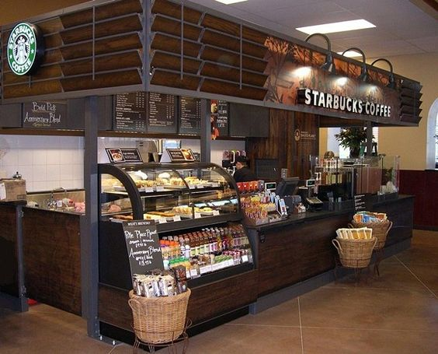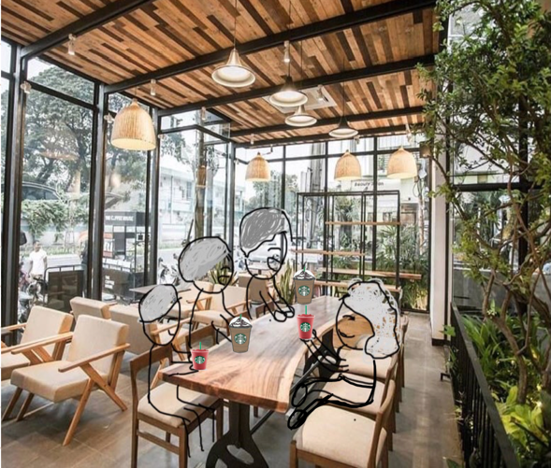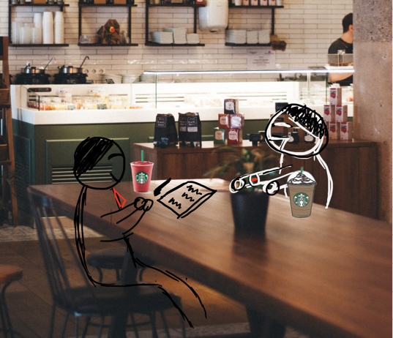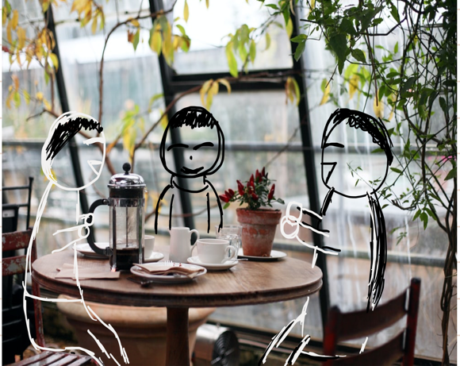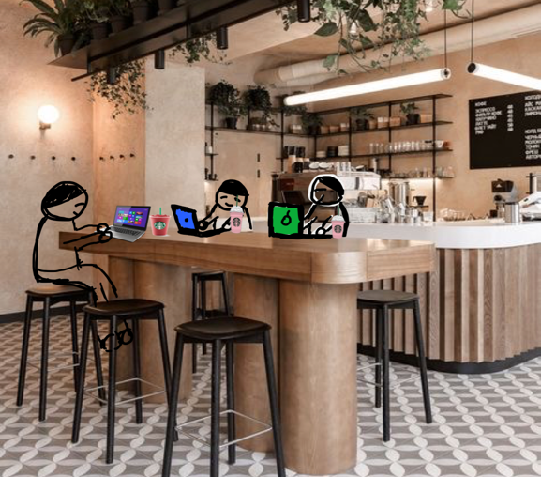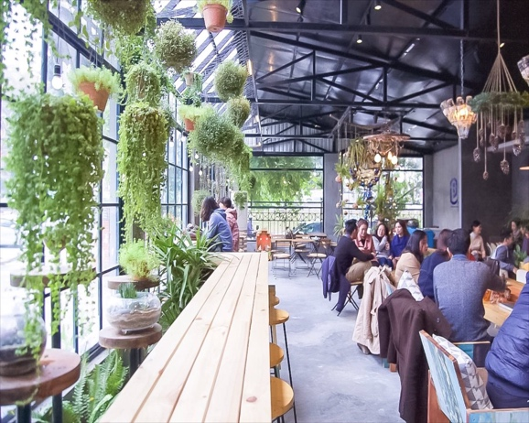

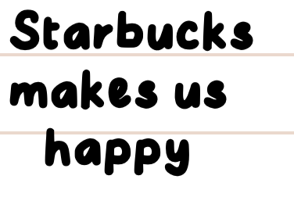

**Step 5: Film and Record**

**Resources:**

Tools already available:

* Adobe Photoshop
* Adobe After Effect
* Paint

Need the following tools:

* Camtasia Studio
* CorelDRAW X7
* Adobe Premiere Clip
* Adobe Audition

**Visual and audio parts:**

Of course, we have included all audio clips, photos, and music.

We will be using video and photos that we built and shot from Camtasia Studio. Then through Adobe Premiere Clip and Adobe After Effect to edit and cut the story to suit the criteria we give.

We bring story to life with melodious music that best suits the story, we pull music from the free music web or recorded audio. We use Adobe Audition to incorporate music into the story and create a complete story.

**Prepare and test:**

We shoot some scenes in step 3, specifically scene 2, to check the quality of video, images, and sound that the tools bring us. Make sure our stories are as complete as possible

**Step 6: Finish**

|  |  |
| --- | --- |
| **Video Editing Software** | **Description** |
| iMovie | Free video editing software for Mac Operating Systems. |
| Adobe Premiere Pro | This editor is not only powerful, but also has a clean and familiar interface. The best part is the ecosystem it supports. |
| Final Cut Pro X | Final Cut Pro X is suitable for people who are using Mac. Apple's software is too in sync with the hardware of this application, giving users the best performance possible. However, performance is not the only commendable issue here, as Final Cut Pro X is the most powerful and easiest video editing tool for beginners. |
| **Audio Recording and Editing Software** | **Description** |
| Adobe Audition | Adobe Audition is professional music cutting software from Adobe Systems. Adobe Audition CC 2021 supports high-quality recording, audio file editing such as inserting, cutting audio clips, adding and removing effects ... and saving as audio files in many popular formats. |
| Audacity | A flexible and powerful audio editing software - the best free audio editor. |
| **Photo editing software** | **Description** |
| Avidemux | Avidemux is a completely free and open source video editing software for both Windows, Linux and MacOS. This is a software that has been released for a long time, but is still being continuously updated until now. |
| Canva | Canva is a Web-based photo editing tool with built-in tools and templates, with just a few simple steps, you can create impressive photos to share on social networks. |

**Step 7: Publish and Share**

**Video home**:  Google drive, Facebook fanpage, Youtube

**Sharing**: Facebook, Website, Tiktok, Twitter, Instagram

**How did it feel to tell your story?**

We are happy that we spread positive energy to everyone.  We give everyone happiness and relaxation after hard working days, make everyone feel better and provide them with the greatest possible experience.

**How do you feel about responses from others?**

We feel joyful, sad,  empathetic  when we know that everybody need a place to share their own feelings, their stories. They don't just drink, they want to find a place where they can release their emotions, stresses.

**How will you use this experience to move forward in your recovery journey?**

We will continue to do exactly what we says in our mission and vision.  We will go on bringing our value to customers , make them feel  happy and unstressed everyday.

**Step 8: Review**

**What were your original goals for this project?**

Feelings, customer experience at Starbucks.

**Reach:** What we need to understand first is whether our story is reaching the right people. To evaluate the effectiveness of the message against the target, the whole team must develop a plan to collect information through online channels using measurement tools. As well as the overall discussion and conduct Traffic Stats to directly measure audiences then answer the following questions:

• Is our digital story being viewed?

• Is it getting to people in a timely manner?

• Is it reaching the right people?

**Tool for measuring:**

Social media data (Facebook, instagram)

likes, follows, comments, shares on social networks

Statistical chart

URL link

Google Analytics/WebTrends.

**Measurement method:**

1. Measure on social media

• Social media reach, Frequency, Impression, Traffic

• Engagement on social media

• Social media discussions: Create topics to discuss topics, level and frequency of discussion.

2.Traffic Stats: Track traffic on personal or organizational website using tools like Omniture, Google Analytics, or WebTrends.

* Are people clicking on stories posted on our site?
* How long are they watching videos?
* Are they downloading, commenting, sharing, etc.?
* Are they clicking into other areas of our site?

**Result**

After collecting information sources, classifying and processing information and making judgments about information, therefore evaluate the effectiveness of communication around topics and questions:

• How did the audience understand the message, and did they understand it correctly?

• How did the message change their feelings, habits, opinions, etc.?

• How did the story impact the way they think about something (e.g., recovery, behavioral health)?

From the information gathered about the number of people the storytelling has reached, it is possible to know how many people have watched the video, where those people are located, and many other insights. Social media helps we review comments (if available) to see how the story is being received and shared. This helps us figure out what people after viewing our story of recovery. It can be an interesting look at whether the story is in people's minds in the ways that matter to us. Thereby determining:

• The level of customer awareness/identification with the product

• The extent to which customers empathize/understand with the story

• The level of urge customers to discover the product/service advertised through the media.

**Action**

When we shared our story, we want to know what people will do with what they learn. As a storyteller, not only can we take someone on a journey by having them listen to our story, but also we can inspire them to reflect, change, and act.

Some questions to consider:

• In viewing our story, do people feel recovery is possible?

• Are they changing their thoughts on recovery or making life changes towards recovery?

• Do people feel connected to our story, and does this help them feel supported in their recovery?

• Do people feel hope for their loved ones who may have behavioral health conditions?

A call-to-action is an instruction to the audience that inspires a response, to issue a call-to-action that best fits Starbucks's messages. For example, if we want to get more information about our customers we have to increase the audience's awareness of the Starbucks brand by inspiring them to visit a page on website and inspire audience members to share their own story of recovery with Starbucks or with others.

With the Starbucks website, how much time is spent on a page can show us what viewers find most interesting or where they find helpful information. The number of downloads or shares can show whether Starbucks have made it easy for people to do these things. Thereby, we can see how the impact of the story affects the customer's experience and behavior.