

**Capstone Project Report**

**Report 1 – Project Introduction**

– HoChiMinh, September 2020 –

**Table of Contents**

I. Project Report 3

1. Status Report 3

2. Team Involvements 3

3. Issues/Suggestions 3

II. Project Introduction 4

1. Overview 4

1.1 Project Information 4

1.2 Project Team 4

2. Product Background 4

3. Existing Systems 5

3.1 WeHelp 5

3.2 vLance 5

4. Business Opportunity 6

5. Software Product Vision 6

6. Project Scope & Limitations 7

6.1 Major Features 7

6.2 Limitations & Exclusions 7

**Table of Figures**

Figure 1 - Major features 1 7

# I. Project Report

## 1. Status Report

|  |  |  |  |
| --- | --- | --- | --- |
| **#** | **Work Item** | **Status** | **Notes (Work Item in Details)** |
| 1 |  | Pending |  |
| 2 |  | In Progress |  |
| 3 |  | Completed |  |

## 2. Team Involvements

|  |  |  |  |
| --- | --- | --- | --- |
| **#** | **Task** | **Member** | **Notes (Task Details, etc.)** |
| 1 |  | Thaott |  |
| 2 |  | Datbc |  |
| 3 |  | Kiendst |  |
| 4 |  | Mytn |  |

## 3. Issues/Suggestions

|  |  |  |  |
| --- | --- | --- | --- |
| **#** | **Issue** | **Status** | **Notes (Solution, Suggestion, etc.)** |
| 1 |  | Pending |  |
| 2 |  | In Progress |  |
| 3 |  | Completed |  |

# II. Project Introduction

## 1. Overview

### 1.1 Project Information

* Project name: Photographer Booking System
* Project code: PBS
* Group name: FA20SE21
* Software type: Mobile App

### 1.2 Project Team

#### a. Supervisor

|  |  |  |  |
| --- | --- | --- | --- |
| **Full Name** | **Email** | **Phone Number** | **Title** |
| Lại Đức Hùng | Hungld5@fe.edu.vn |  | Lecturer |

#### b. Team Members

|  |  |  |  |
| --- | --- | --- | --- |
| **Full Name** | **Email** | **Mobile** | **Role** |
| Trần Thiên Thảo | Thaottse62888@fpt.edu.vn | 0903917982 | Leader |
| Đào Sỹ Trung Kiên | Kiendstse63208@fpt.edu.vn | 0769606867 | Member |
| Bồ Công Đạt | Datbcse63154@fpt.edu.vn | 0915223623 | Member |
| Trương Ngọc Mỹ | Mytnse62050@fpt.edu.vn | 0906969071 | Member |

## 2. Product Background

Despite the ever-increasingly fast-paced development of science and technology, there are still difficulties in the connections between customers and photographers.

As for customers:

* They find it difficult to contact skillful photographers living nearby or near where they want to shoot.
* They cannot view photographers’ working schedule, so they are not able to book the ones they want.
* Without viewing photographers’ album beforehand, they are not sure if photographers’ style meets their requirements before booking.
* They are unlikely to find the appropriate rates quickly.

As for photographers:

* They are likely to miss potential customers living nearby or near their current shooting sites because customers do not know where they are and how to contact them.
* Applications that allow them to arrange a working schedule and receive bookings from customers are scarce.

## 3. Existing Systems

Currently, there is a myriad of platforms that help connect freelancers from various industries to the customers. However, there is no platform specialising in photography. In additions, there are no systems or applications that provide photographers with time and business management.

Below are some employment and job-search systems that the team takes into consideration while doing research. Learning from their strengths and weaknesses can help better the team’s product/system.

### 3.1 WeHelp

WeHelp is a platform which allows freelancers from a wide range of industries to market their skills and services that companies, organizations and others may need.

Link:

<https://wehelp.vn/>

https://apps.apple.com/us/app/wehelp-tìm-người-tìm-việc/id1447795502/

System actors:

* Customer.
* Freelancer.
* Admin.

Features:

* Allow freelancers to market their skills and services.
* Allow customers to state their requirements and book photographers.

Pros

* Good design, user-friendly

Cons

* Covering a wide range of job sectors, hence not well-support any sector.
* No time management for freelancers.
* No payment method.

### 3.2 vLance

A job-search website for freelancers, which helps companies or individuals reach the ones that can fulfil their needs.

Link: https://www.vlance.vn/

System actors:

* Customer.
* Freelancer.
* Admin.

Features:

* Allow customers to add job postings and desired commissions.
* E-wallet is supported.

Pros

* Allow freelancers to propose competitive commissions.
* E-wallet helps ensure both sides’ benefits.

Cons

* Complex layouts, not user-friendly.

## 4. Business Opportunity

The model that we want to build is not the one emerging in the current market, which freelancer seeking websites such as vLance, FreeLancerViet in Vietnam or foreign ones such as Upwork, PeoplePerHour and so on. Despite their long-time existence, they still have limitations, which is a huge opportunity for the research team. Researching comparison websites and users’ feedback, the team realize that most of job search websites allow customers to hire photographers, but they cannot arrange shooting time effectively. In additions, photography has various branches such as cosplay photography, portrait photography, product photography, etc. Each of these branches would have its techniques, which means that shooting prices vary. The team would like to improve the drawbacks of those job-seeking websites via this project.

In fact, there is also a need of contacting between customers and photographers to help minimize difficulties in finding the most appropriate one. With the team’s product, customers could save a lot of time in searching and thanks to other users’ feedback, they no longer need to ask for advice from friends, family or social networks. Customers would be able to view photographers’ working schedule and then easily arrange desired shooting time. Photographers would not miss potential customers and have the chance to market their abilities via profile and users’ feedback. They could also be more flexible in their working time management.

## 5. Software Product Vision

Intending to help customers easily contact skillful photographers, the researchers came up with the idea of building two mobile applications, which serve as a platform for connecting customers and photographers and vice versa.

All things considered, this project is conducted to provide customers with a faster, more convenient and effective way to contact photographers. They now can view photographers’ working schedule and make their reservations easily without double-booking. Similarly, photographers can also efficiently arrange their schedule and manage their bookings.

Thanks to those applications, customers can reach the most appropriate photographers based on criteria such as shooting time, rates, and feedback from other users. Customers would also be provided with pricing list and can avoid being overcharged. On the other hand, photographers can easily get booked, upload their album, efficiently manage their working schedule and develop their brand thanks to users’ feedback.

## 6. Project Scope & Limitations

### 6.1 Major Features

FE-01: Search for photographers based on requirements

FE-02: View photographers’ album, services and profile

FE-03: Book photographers that meet requirements and be able to cancel bookings due to inconvenient time and weather

FE-04: View booking history

FE-05: Customers can rate and write review for photographers

FE-06: Photographers can view their shooting schedule and make changes

FE-07: Photographers can create and edit their album

FE-08: photographers can manage services they provide

FE-09: Photographers can accept or decline customers’ request

FE-10: Photographers can view customers’ review

FE-11: Sign up and sign in

FE-12: Add, delete and edit profile and change password

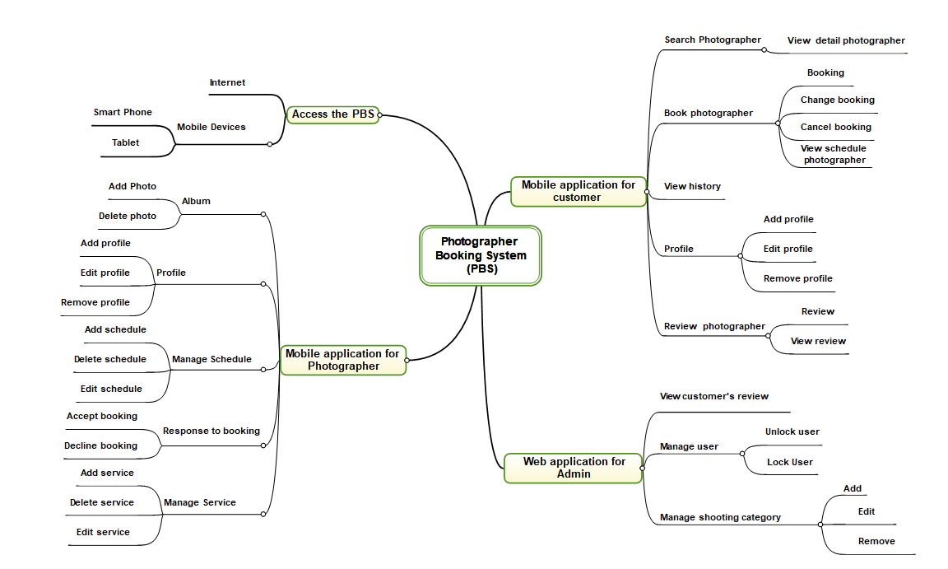

Figure 1 - Major features 1

### 6.2 Limitations & Exclusions

LI-01: The application has not supported payment.

LI-02: The system has not had photo verification feature.

LI-03: The system has not provided website version to both customers and photographers. Users may find it uncomfortable to use application.

LI-04: The system has not had chat box for communication between customers and photographers.