

**Capstone Project Report**

**Report 2 – Project Management Plan**

– HoChiMinh, September 2020 –

**Table of Contents**

I. Project Report 3

1. Status Report 3

2. Team Involvements 3

3. Issues/Suggestions 3

II. Project Management Plan 4

1. Overview 4

1.1 WBS & Estimation 4

1.2 Project Objectives 6

1.3 Project Risks 6

2. Management Approach 7

2.1 Project Process 7

2.2 Quality Management 7

2.3 Training Plan 7

3. Master Schedule 8

4. Project Organization 9

4.1 Team & Structures 9

4.2 Roles & Responsibilities 9

5. Project Communication 9

5.1 Communication Plan 9

5.2 External Interface 10

6. Configuration Management 10

6.1 Tools & Infrastructures 10

6.2 Document Management 11

6.3 Source Code Management 11

# I. Project Report

## 1. Status Report

|  |  |  |  |
| --- | --- | --- | --- |
| **#** | **Work Item** | **Status** | **Notes (Work Item in Details)** |
| 1 |  | Pending |  |
| 2 |  | In Progress |  |
| 3 |  | Completed |  |

## 2. Team Involvements

|  |  |  |  |
| --- | --- | --- | --- |
| **#** | **Task** | **Member** | **Notes (Task Details, etc.)** |
| 1 |  | Thaott |  |
| 2 |  | Datbc |  |
| 3 |  | Kiendst |  |
| 4 |  | Mytn |  |

## 3. Issues/Suggestions

|  |  |  |  |
| --- | --- | --- | --- |
| **#** | **Issue** | **Status** | **Notes (Solution, Suggestion, etc.)** |
| 1 |  | Pending |  |
| 2 |  | In Progress |  |
| 3 |  | Completed |  |

# II. Project Management Plan

## 1. Overview

### 1.1 WBS & Estimation

|  |  |  |  |
| --- | --- | --- | --- |
| **#** | **WBS Item** | **Complexity** | **Est. Effort**  **(man-days)** |
| ***1*** | ***Initiating*** |  | ***21*** |
| 1.1 | Kick-off project | Simple | 4 |
| 1.2 | Develop business case | Medium | 7 |
| 1.3 | Assign Project Manager |  |  |
| 1.4 | Identify stake-holder |  |  |
| ***2*** | ***Planning*** |  |  |
| 2.1 | Create business plan |  |  |
| 2.2 | Collect requirement |  |  |
| 2.3 | Define scope |  |  |
| 2.4 | Define vision |  |  |
| 2.5 | Create WBS |  |  |
| 2.6 | Create Risk Management Plan |  |  |
| 2.7 | Create Human Resource Plan |  |  |
| ***3*** | ***Executing*** |  |  |
| **3.1** | **Analysis** |  |  |
| 3.1.1 | Analyze Requirements |  |  |
| 3.1.2 | Create Use case diagram |  |  |
| 3.1.3 | Create Use case specification |  |  |
| 3.1.4 | Create SRS |  |  |
| **3.2** | **Design** |  |  |
| 3.2.1 | Design System Architecture |  |  |
| 3.2.2 | Design System Detail (Diagrams) |  |  |
| 3.2.3 | Design Database |  |  |
| 3.2.4 | Design User Interface |  |  |
| **3.3** | **Prototype** |  |  |
| 3.3.1 | Define storyboard |  |  |
| 3.3.2 | Create paper prototype |  |  |
| 3.3.3 | Create digital prototype |  |  |
| **3.4** | **Implementation** |  |  |
| 3.4.1 | Coding/ implement every module defined in SRS |  |  |
| **3.5** | **Perform quality assurance** |  |  |
| 3.5.1 | Perform unit testing |  |  |
| 3.5.2 | Perform integration testing |  |  |
| 3.5.3 | Perform system testing |  |  |
| 3.5.4 | Perform acceptance testing |  |  |
| **3.6** | **Support** |  |  |
| 3.6.1 | Training |  |  |
| 3.6.2 | Documentation |  |  |
| 3.6.3 | User Support |  |  |
| 3.6.4 | Enhancement |  |  |
| ***4*** | ***Monitoring*** |  |  |
| 4.1 | Validate Scope |  |  |
| 4.2 | Monitor project work |  |  |
| ***5*** | ***Controlling*** |  |  |
| 5.1 | Control scope |  |  |
| 5.2 | Control quality |  |  |
| 5.3 | Control risks |  |  |
| 5.4 | Control schedule |  |  |
| 5.5 | Control communication |  |  |
| ***6*** | ***Closing*** |  |  |
| 6.1 | Close project |  |  |
| ***Total Estimated Effort (man-days)*** | | | FINAL PRESENTATION |
|  | | | ***94*** |

### 1.2 Project Objectives

|  |  |  |  |  |
| --- | --- | --- | --- | --- |
| **#** | **Quality Stage** | **No. of Defects** | **% of Defect** | **Notes** |
| 1 | Initiating |  | 100 | Must be completed in the first stage. |
| 2 | Planning |  | 80 | Plan to complete at least 80% of the project, and time distribution. |
| 3 | Analysis |  | 80 | Detailed project analysis. |
| 4 | Design |  | 92 | Design diagram and database. |
| 5 | Prototype |  | 70 | Make a prototype of a project |
| 6 | Implementation |  | 70 | Implementation of the plans. |
| 7 | Perform quality assurance |  | 69 | Write test cases to check the quality of the project. |
| 8 | Support |  | 80 | Discuss unclear issues with the instructor. |
| 9 | Monitoring |  | 80 | Monitoring the steps taken. |
| 10 | Controlling |  | 90 | Track the progress of the project |
| 11 | Closing |  | 100 | Review code and document. |
| ***Total*** | | ***Xxx*** | ***100%*** |  |

### 1.3 Project Risks

|  |  |  |  |  |
| --- | --- | --- | --- | --- |
| **#** | **Risk Description** | **Impact** | **Possibility** | **Response Plans** |
| 1 | Most members find it unfamiliar to use flutter or spring framework | High | 100% | Hold training session to get familiar with them |
| 2 | Scrum model is applied for the first time hence there may be difficulties in system development | High | 80% | Hold daily meeting to avoid misunderstandings among members |
| 3 | Wrong estimation of time needed | Medium | 60% | Regularly track progress and update time estimation |
| 4 | Unexpected scope change | High | 60% | Be careful in planning to minimize impact of scope change |
| 5 | Poor code quality | High | 60% | Strictly follow code convention, carry out acceptance test to ensure quality source code |

## 2. Management Approach

Scrum model would be implemented in the development of this project because it is appropriate for the process.

### 2.1 Project Process

We choose Scrum model to do this project because of the following reasons:

* The feature can be changed during the developing process to suitable with Scrum model we can adapt to change it easily and help reduce risk.
* Scrum allows us to learn new frameworks or technology and develop project at the same time.
* Because dividing the project allows the team to check partial inspection, identify and fix problems faster.

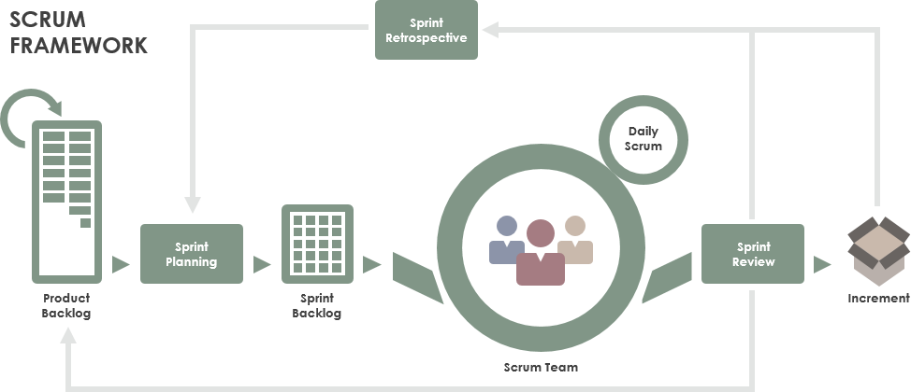*Reference:* [*https://www.scrum.org/resources/what-is-scrum*](https://www.scrum.org/resources/what-is-scrum)

**Figure 1-Scrum Framework**

### 2.2 Quality Management

To increase the pace of the project, the team take following measures:

* Observe similar available applications.
* Discuss all requirements together to achieve the best quality.
* Hold daily meeting so that all members are acknowledged of the progress and others’ ability.

### 2.3 Training Plan

|  |  |  |  |
| --- | --- | --- | --- |
| Training Area | Participants | When, Duration | Waiver Criteria |
| Java Spring Boot | All team members |  | Mandatory |
| Reactjs | All team members |  | Mandatory |
| Dart, Flutter | All team members |  | Mandatory |
| Staruml | All team members |  | Mandatory |
| MySql | All team members |  | Mandatory |
| Git, Github | All team members |  | Mandatory |

## 3. Master Schedule

|  |  |  |  |
| --- | --- | --- | --- |
| **#** | **Deliverable** | **Due Date** | **Deliverable Scope** |
| 1 | Project Plan |  | Make a goal plan, list tasks to do, time distribution. |
| 2 | Use case diagram |  | Design use case diagram |
| 3 | Conceptual diagram |  | Design conceptual diagram |
| 4 | ER diagram |  | Design ER diagram |
| 5 | Database |  | Design database |
| 6 | Design |  | Architecture Design, Detailed Design |
| 7 | Screen prototype |  | Design screen of application |
| 8 | Report 1 |  | Project introduction |
| 9 | Report 2 |  | Project management plan |
| 10 | Report 3 |  | Software requirement specification |
| 11 | Report 4 |  | Software design document |
| 12 | Report 5 |  | Test case document, test documentation |
| 13 | Report 6 |  | Software user guides |
| 14 | Report 7 |  | Final project report |
| 15 | Code package 1 |  | Code & Unit test, System test cases |
| 16 | Code package 2 |  | Code & Unit test, System test cases |
| 17 | Code package 3 |  | Code & Unit test, System test cases |
| 18 | Code front-end 1 |  | Code & design screen |
| 19 | Code front-end 2 |  | Code & design screen |
| 20 | Code front-end 3 |  | Code & design screen |
| 21 | Final Package |  | Final Codes & documents, User manual |

## 4. Project Organization

### 4.1 Team & Structures

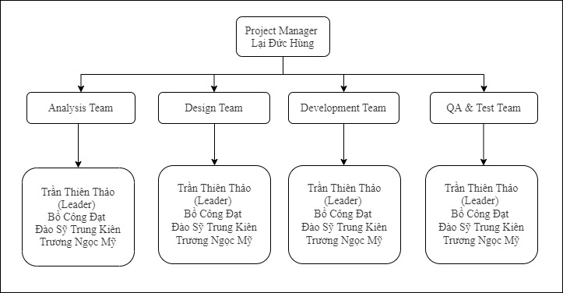

**Figure 2- Team & Structures**

### 4.2 Roles & Responsibilities

|  |  |
| --- | --- |
| **Role** | **Responsibility** |
| Project Manager | Give guidance, check, and help correct mistakes in project |
| Analysis Leader | Give guidance and adjust projects’ requirement |
| Analysis Member | Create and update projects’ requirement |
| Design Leader | Give guidance, design and write code for website layouts |
| Design Member | Design and write code for website layouts |
| Technical Leader | Introduce new techniques to the team |
| Test Leader | Write test case and test plan for the project |
| Test Member | Write test case and test plan for the project |

## 5. Project Communication

### 5.1 Communication Plan

|  |  |  |  |  |
| --- | --- | --- | --- | --- |
| **Communication Item** | **Who/ Target** | **Purpose** | **When, Frequency** | **Type, Tool, Method(s)** |
| Kick off meeting | Project supervisor, project team | Introduce the project | Once | Meeting |
| Project status report | Project supervisor ,Project team | Discuss project status, resolve potential issues or delays | Weekly | Meeting |
| Daily standup meeting | Project team | Review each member work status or any happening problems | Daily | Meeting |
| Meeting minute reports | Project supervisor | Inform supervisor about meeting content | Weekly | Email |

### 5.2 External Interface

#### a. FU Contacts

|  |  |  |  |
| --- | --- | --- | --- |
| Function | Contact Person  (name, position) | Contact address  (email, telephone) | Responsibility |
| Supervisor | Lại Đức Hùng | Hungld5@fe.edu.vn | - Provide document template - Give instruction to project team - Review deliverables - Supervise project status  - Answer questions about the project |

#### b. Customer Contacts

|  |  |  |  |
| --- | --- | --- | --- |
| Function | Contact Person  (name, position) | Contact address  (email, telephone) | Responsibility |
| Supervisor | Lại Đức Hùng | Hungld5@fe.edu.vn | - Provide document template - Give instruction to project team - Review deliverables - Supervise project status  - Answer questions about the project |

## 6. Configuration Management

### 6.1 Tools & Infrastructures

|  |  |
| --- | --- |
| **Programming languages** | Java |
| **Framework** | Spring framework |
| **API** | API |
| **DBMS** | MySQL |
| **IDEs/Editors** | Visual Studio Code, Android Studio, IntelliJ |
| **UML tools** | StarUML |
| **Version Control** | Github, Git |
| **Deployment server** | AWS EC2 |
| **Project management tool** | Microsoft Excel |

### 6.2 Document Management

*https://github.com/thienthao/pbs/tree/master/Documents*

### 6.3 Source Code Management

*https://github.com/thienthao/pbs*