PRN221PE_SU23_TrialTest
SUMMER 23
Subject: PRN221
Duration: 90 minutes

INSTRUCTIONS
Please read the instructions carefully before doing the questions.
- You are NOT allowed to use any other materials. You are NOT allowed to use any device to share data with others.
- You must use Visual Studio 2019 or above, MSSQL Server 2008 or above for your development tools.
IMPORTANT – before you start doing your solution, MUST do the following steps:
- To do your program, you must use ASP.NET Core Razor Pages. Note that you are not allow to connect direct to database from Razor Pages, every database connection must be used through Repository and Data Access Objects. The database connection string must get from appsettings.json file.
In the case your code connects directly to database from ASP.NET Core Razor Pages, you will get 0 mark.
- If there are syntax errors or compilation errors in your PE program, you will not pass the PE requirements, the mark will be 0.
- Create Solution in Visual Studio named PRN221PE_SU23_TrialTest_StudentName. Inside your Solution, the Project ASP.NET Core Razor Page must be named: AuthorInstitution_StudentName.
- Create your MS SQL database named AuthorInstitution2023DB by running code in script AuthorInstitution2023DB.sql.
- Set the default user interface for your project as Login page.

Create an application using ASP.NET Core Razor Pages with .NET Core (.NET 5 or .NET 6), C#, and ADO.NET (or Entity Framework Core). A MS SQL Server database will be created to persist the data and it will be used for reading and managing data.
A part of AuthorInstitution2023DB database.
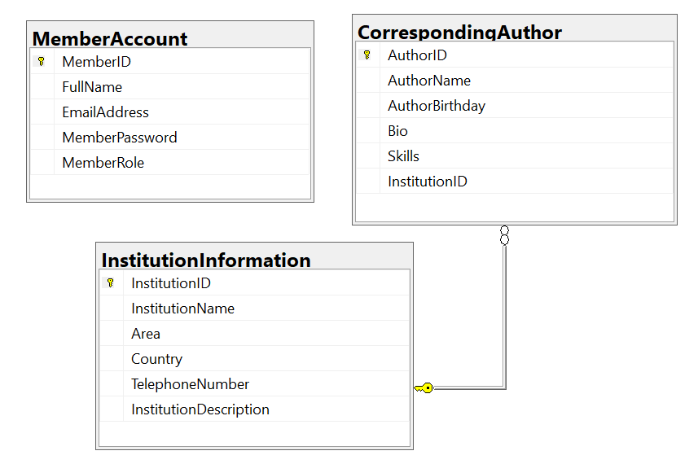
Member role: Administrator = 0; Manager = 1; Staff = 2

- (1.0 mark) Authentication function
If user with a manager role logs in successfully, save this information to a temporary parameter. All CRUD actions are required with authentication. In the case login unsuccessfully, display “You do not have permission to do this function!”.
- (2.0 marks) Check if login successfully, list all corresponding authors in CorrespondingAuthor table (pagging is required for this function, 4 records/1page).
- (1.0 mark) Check if login successfully, search all corresponding authors with 2 conditions: Name, Skills (OR option for this case and using relative search).
- (1.0 mark) Check if login successfully, delete the selected item with the confirmation then update the list of corresponding authors.
- (3.0 marks) Check if login successfully, add new item with the requirements:
- The new item will display in top of the corresponding author’s list.
- The InstitutionID/InstitutiontName will come from the InstitutionInformation table (you can use ComboBox UI control in this case)
- All fields are required.
- Value for AuthorBirthday <= this year (2023) and >1901.
- Value for corresponding author’s name from 6 to 100 characters. Each word of the corresponding author name (AuthorName) must begin with the capital letter.
- (2.0 mark) Check if login successfully, update the selected existing item.
- With update function, the same validation requirements with Add function.

