**PRN231 Assignment 01 - Fall 2023 HCM**

**Building a Car Renting Management System with ASP.NET Core Web API**

# 1. Introduction

A Car Rental Management System is a software solution that helps car rental companies manage and streamline their business operations. It provides an end-to-end platform to handle various aspects of the car rental process, from booking and reservation management to vehicle maintenance, invoicing, and customer relationship management. Here are some key components and functions of a Car Rental Management System:

* Online Booking and Reservation: The system allows customers to make bookings and reservations online through a user-friendly interface. It provides real-time availability of vehicles, rental rates, and booking confirmations.
* Vehicle/Car Management: The system keeps track of the available fleet of vehicles, including their models, make, year, mileage, and condition. It helps manage vehicle allocation, availability, and scheduling.
* Customer Management: The system maintains a database of customer information, including contact details, identification documents, and rental history. It enables easy retrieval of customer records, communication, and personalized service.

Imagine you're a developer of a FU Car Renting Management System named **FUCarRentingSystem**. To implement a part of this system your tasks include:

* Manage customer information.
* Manage car information.
* Manage car renting transaction.

The application has a default account (admin account) whose email is “**admin@FUCarRentingSystem.com**” and password is “**@@admin@@**” that stored in the **appsettings.json**.

This assignment explores creating an ASP.NET Core Web API with C#, and ADO.NET or Entity  
Framework Core, the client application can be used as Desktop Application (Windows Forms,  
WPF) or Web Application (ASP.NET Core Web MVC or Razor Pages). An MS SQL Server  
database will be created to persist the data and it will be used for reading and managing data.

# 2. Assignment Objectives

In this assignment, you will:

* Use the Visual Studio.NET to create a Desktop/Web application and ASP.NET Core Web  
  API project.
* Perform CRUD actions using Entity Framework Core.
* Use LINQ to query and sort data.
* Apply passing data in the WPF application.
* Apply 3-Layers architecture to develop the application.
* Apply Repository pattern and Singleton pattern in a project.
* Add CRUD and searching actions to the Client Application (Desktop/Web Application) with ASP.NET Core Web API.
* Apply to validate data type for all fields.
* Run the project and test the API and Client application actions.

# 3. Database Design

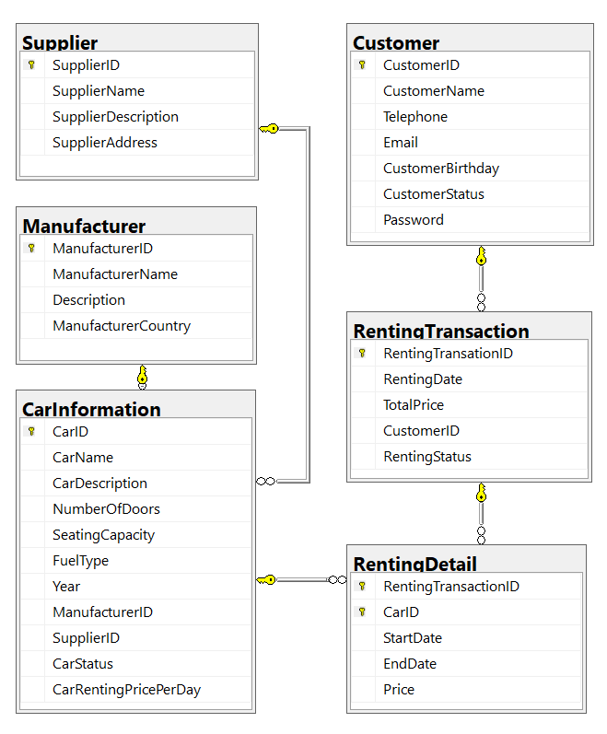

A car will belong to only one manufacturer and only one supplier.

A customer can make renting transaction in this system many times. A renting transaction will have one or many car information. A car information will belong to many renting transactions.

# 4. Main Functions

* Member (Admin/Customer) authentication by Email and Password.
* Create Web API with Customer management, Flower Bouquet management, and Order  
  management: Read, Create, Update and Delete actions.
* Create Client application (with Desktop/Web application) interactive with Web API to  
  perform these functions:
  + If the user is an “**Admin**” then his/her is allowed
    - Manage customer information.
    - Manage car information. (The delete action will delete car information in the case this information is not belong to any renting transaction. If the car information is already stored in a renting transaction, just change the status.)
    - Manage renting transaction (includes renting details)
    - Create a report statistic by the period from StartDate to EndDate, and sort data in descending order.
  + If user is a “**Customer**”, this customer role is allowed to:
    - Register an account
    - Create an online order with one or many cars’ information.
    - Manage his/her the profile.
    - View renting transaction history.
  + Note that: Customer management, Car information management, and Renting transaction management: Read, Create, Update, Delete and Search actions. Creating and Updating actions must be performed by popup dialog. Delete action always combines with confirmation.

# 5. Note

* You must use **Visual Studio 2019 or above (.NET5/.NET6/.NET7), MSSQL Server 2012 or above** for your development tools.
* To do your BE program, you must use **ASP.NET Core Web API. Note that** *you are not  
  allow to connect direct to database from ASP.NET Core Web API, every database  
  connection must be used through Repository and Data Access Objects. The database  
  connection string must get from appsettings.json file.*
* Create Solution in Visual Studio named **StudentName_ClassCode_A01.sln**.
* Create your MS SQL database named **FUCarRentingManagement** by running code in script **FUCarRentingManagement.sql.**
* Run and test ASP.NET Core Web API using Postman.
* Set the default user interface for your Client project as **Login** window.