**PRN231 Assignment 03 - Fall 2023 HCM**

**Apply security, Ajax request with RESTful API and  
Web Application**

# 1. Introduction

A Car Rental Management System is a software solution that helps car rental companies manage and streamline their business operations. It provides an end-to-end platform to handle various aspects of the car rental process, from booking and reservation management to vehicle maintenance, invoicing, and customer relationship management. Here are some key components and functions of a Car Rental Management System:

* Online Booking and Reservation: The system allows customers to make bookings and reservations online through a user-friendly interface. It provides real-time availability of vehicles, rental rates, and booking confirmations.
* Vehicle/Car Management: The system keeps track of the available fleet of vehicles, including their models, make, year, mileage, and condition. It helps manage vehicle allocation, availability, and scheduling.
* Customer Management: The system maintains a database of customer information, including contact details, identification documents, and rental history. It enables easy retrieval of customer records, communication, and personalized service.

Imagine you're a developer of a FU Car Renting Management System named **FUCarRentingSystem**. To implement a part of this system your tasks include:

* Manage customer information.
* Manage car information.
* Manage car renting transaction.

The application has a default account (admin account) whose email is “**admin@FUCarRentingSystem.com**” and password is “**@@admin@@**” that stored in the **appsettings.json**.

The application has to support adding, viewing, modifying, and removing information - a  
standardized usage action verb better known as Create, Read, Update, Delete (CRUD) and Search.  
*This assignment explores creating an ASP.NET Core Web API with C#, JWT and Entity Framework Core, the client application can be used as Web Application (ASP.NET Core  
Web MVC or Razor Pages) combination with AJAX request.* An MS SQL Server database will be  
created to persist the data and it will be used for reading and managing data.

# 2. Assignment Objectives

In this assignment, you will:

* Use the Visual Studio.NET to create ASP.NET Core Web API with JWT and Class Library (.dll) projects.
* Perform CRUD actions using Entity Framework Core.
* Use LINQ to query and sort data.
* Apply 3-Layers architecture to develop the website.
* Apply Repository pattern and Singleton pattern in a project.
* Add CRUD and searching actions to the website.
* Apply to validate data type for all fields.

# 3. Database Design

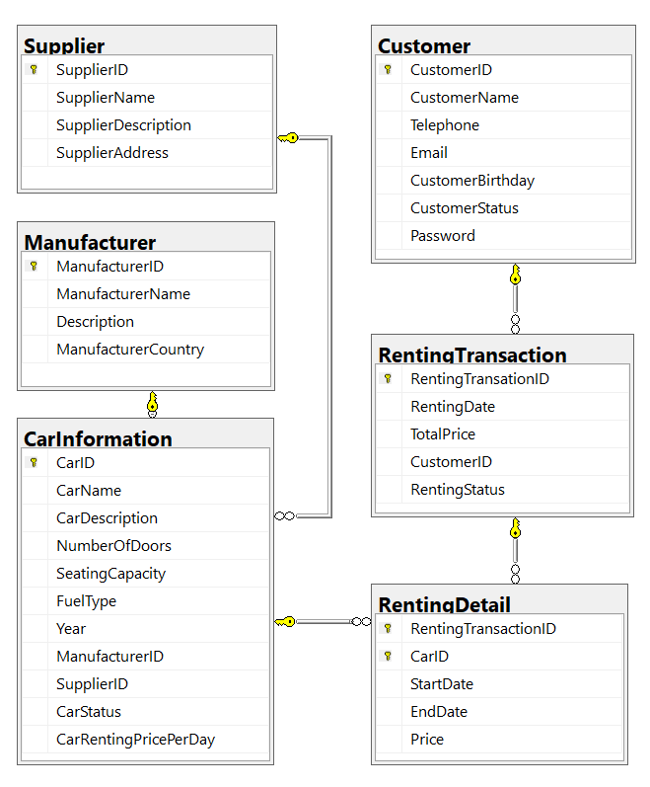

A car will belong to only one manufacturer and only one supplier.

A customer can make renting transaction in this system many times. A renting transaction will have one or many car information. A car information will belong to many renting transactions.

# 4. Main Functions

* Member (Admin/Customer) authentication by Email and Password.
* Create Web API with JWT for car management, and customer management: Read,  
  Create, Update and Delete actions.
* Create Client application (Web application) interactive with ASP.NET Core Web API  
  using AJAX techniques to perform these functions
  + If the user is an “**Admin**” then his/her is allowed to:
    - Manage customer information.
    - *Manage (CRUD) car information.*
    - Create a report statistic by the period from StartDate to EndDate, and sort data in descending order.
  + If user is a Customer, this customer role is allowed to:
    - *Register an account.*
    - Manage his/her the profile
    - Create a renting transaction (with renting details).
    - View renting transaction history.
  + Note that: Customer management, Car information management, and Renting transaction management: Read, Create, Update, Delete and Search actions. Creating and Updating actions must be performed by popup dialog. Delete action always combines with confirmation.

# 5. Note

* You must use **Visual Studio 2019 or above (.NET5/.NET6/NET7), MSSQL Server 2008 or above** for your development tools.
* To do your BE program, you must use **ASP.NET Core Web API with JWT**. Note that *you are not allow to connect direct to database from API Controller, every database connection must be used through Repository and Data Access Objects. The database connection string must get from appsettings.json file.*
* Create Solution in Visual Studio named **StudentName_ClassCode_A03.sln**.
* Create your MS SQL database named **FUCarRentingManagement** by running code in script **FUCarRentingManagement.sql.**
* Set the default user interface for your project as **Login** page.