PE_PRN231_FA23_TrialTest Note
Please read the instructions carefully before doing the questions.
- You are NOT allowed to use any device to share data with others.
- You must use Visual Studio 2019 or above, MSSQL Server 2012 or above for your development tools.

IMPORTANT – before you start doing your solution, MUST do the following steps:
- Create Solution/Project in Visual Studio named PE_PRN231_FA23_TrialTest_StudentCode.
- Client Project named: PE_PRN231_FA23_TrialTest_StudentCode_Client.sln (set the default Client application for your project as Login page) or PE_PRN231_FA23_TrialTest_StudentCode_PostmanScript.json
- Create your MS SQL database named RoseTattoo2023DB by running code in script RoseTattoo2023DB.sql.
- You are not allowed to connect direct to database from ASP.NET Core Web API, every database connection must be used with Repository and Data Access Objects.
- The database connection string must get from appsettings.json file.
- Note: Please check before you submit your work, no syntax error(s) in the submitted PE. If there are syntax errors or compilation errors in your PE program, you will not pass the PE requirements, the mark will be 0.

Implement a part of Tattoo Sticker Store Application. The below Figure is a part of RoseTattoo2023DB database.
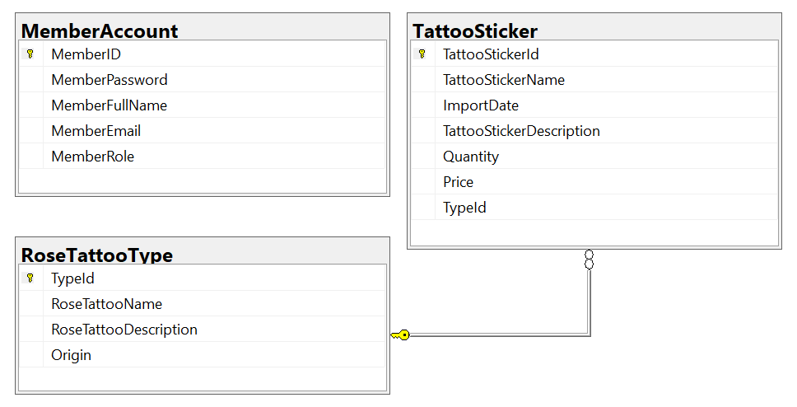
Note that: Member role: Administrator = 1; Staff = 4; Member = 2, Manager=3. A rose tattoo type will have many tattoo stickers, one tattoo sticker will belong to only one rose tattoo type.
Note that the permission for Login process is using MemberEmail and MemberPassword.

