**BUOYANT FORCE SIMULATION**

1. **ANALYSIS.**
2. *Basic knowledge:*

* Archimedes’ principle:

When a body is completely or partially immersed in a fluid, the fluid exerts an upward force on the body equal to the weight of the fluid displaced by the body.

* Notation:

Fb the buoyant force exerting on the block (N).

Fg gravity force exerting on the block

m mass of the block (kg).

g gravity (9.81 m/s2).

density of the liquid

$ρ_{object}$ density of the block

Vdisp volume of part of object immersed in the fluid

Vobject volume of part of object immersed in the fluid

Vratio fraction submerged

1. *Analyze 2 situations:*

* $ρ_{object}$ < $ρ_{liquid}$

Object will float (partly immersed).

* $ρ_{object}$ > $ρ_{liquid}$

Object will float be totally immersed in the liquid.

In this case, we have Fb = Fg and:

FB = mdisp g = $ρ_{fluid}$ Vdisp g

F_g = mg = $ρ_{object}$ Vobject g

Then, we will get the fraction submerged: V­ratio = V­disp / V­object = /

1. *More analysis on how to get the distance from the surface of the liquid to the deepest point of the object (for sphere and cube in the scope of this project):*

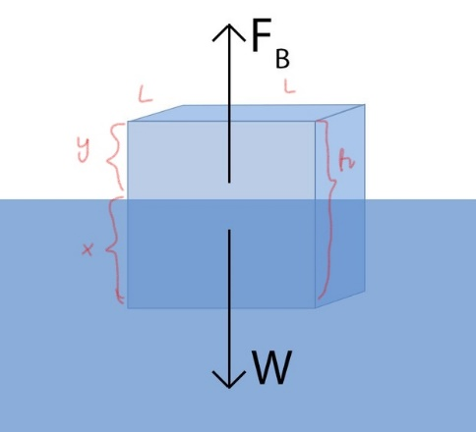**CUBE:**

For a floating cube with dimension as below:

Because $ρ_{fluid}$ Vdisp = Vobject

L2x = L2h

x = h

Then, x = $\frac{ρ_{object}h}{ρ_{fluid}}$

Therefore, the cube will submerged x (m) in the fluid.

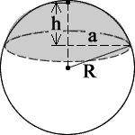**SPHERE:**

Since ρliquidVdisp = Vobject,

We can calculate percentage of the sphere submerged in water:

Vdisp = Vobject * 100 $\%$

Where the volume of the sphere is Vs= R3.

For example, in the case the most of the sphere is submerged in water

The volume of the spherical cap above fluid level is V­c = h2(3R-h)

Vdisp = Vobject

h2(3R-h)= R3

h2(3R-h) = R3  with given radius, density of object and fluid

We can find h. Then, The sphere will submerged (2R-h) in the fluid.