1. **Task 1**

* Firstly, apply CSS to check media query max-width, addressing attributes such as font, padding, margin, and other necessary fixes.
* The logo ‘WIKI’ and the navigation bar should be positioned at the top and transition to a scaled-down icon on mobile or tablet devices. Upon clicking the icon, the navigation bar content will be revealed.





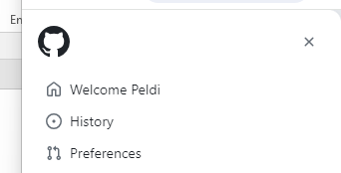

* Move the 'Search' icon from the left of the search text box. Enable search functionality by pressing 'Enter' on the keyboard or clicking the 'Search' icon. For mobile or tablet devices, consider displaying the search input as a compact 'Search' icon. When the icon is clicked, expand the input width to facilitate text entry.





* Transition the tabs from a vertical orientation to a horizontal layout

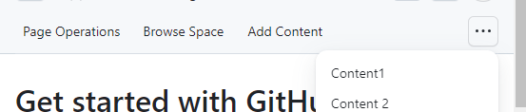

* Push the link navigation to under



1. **Task 2**

