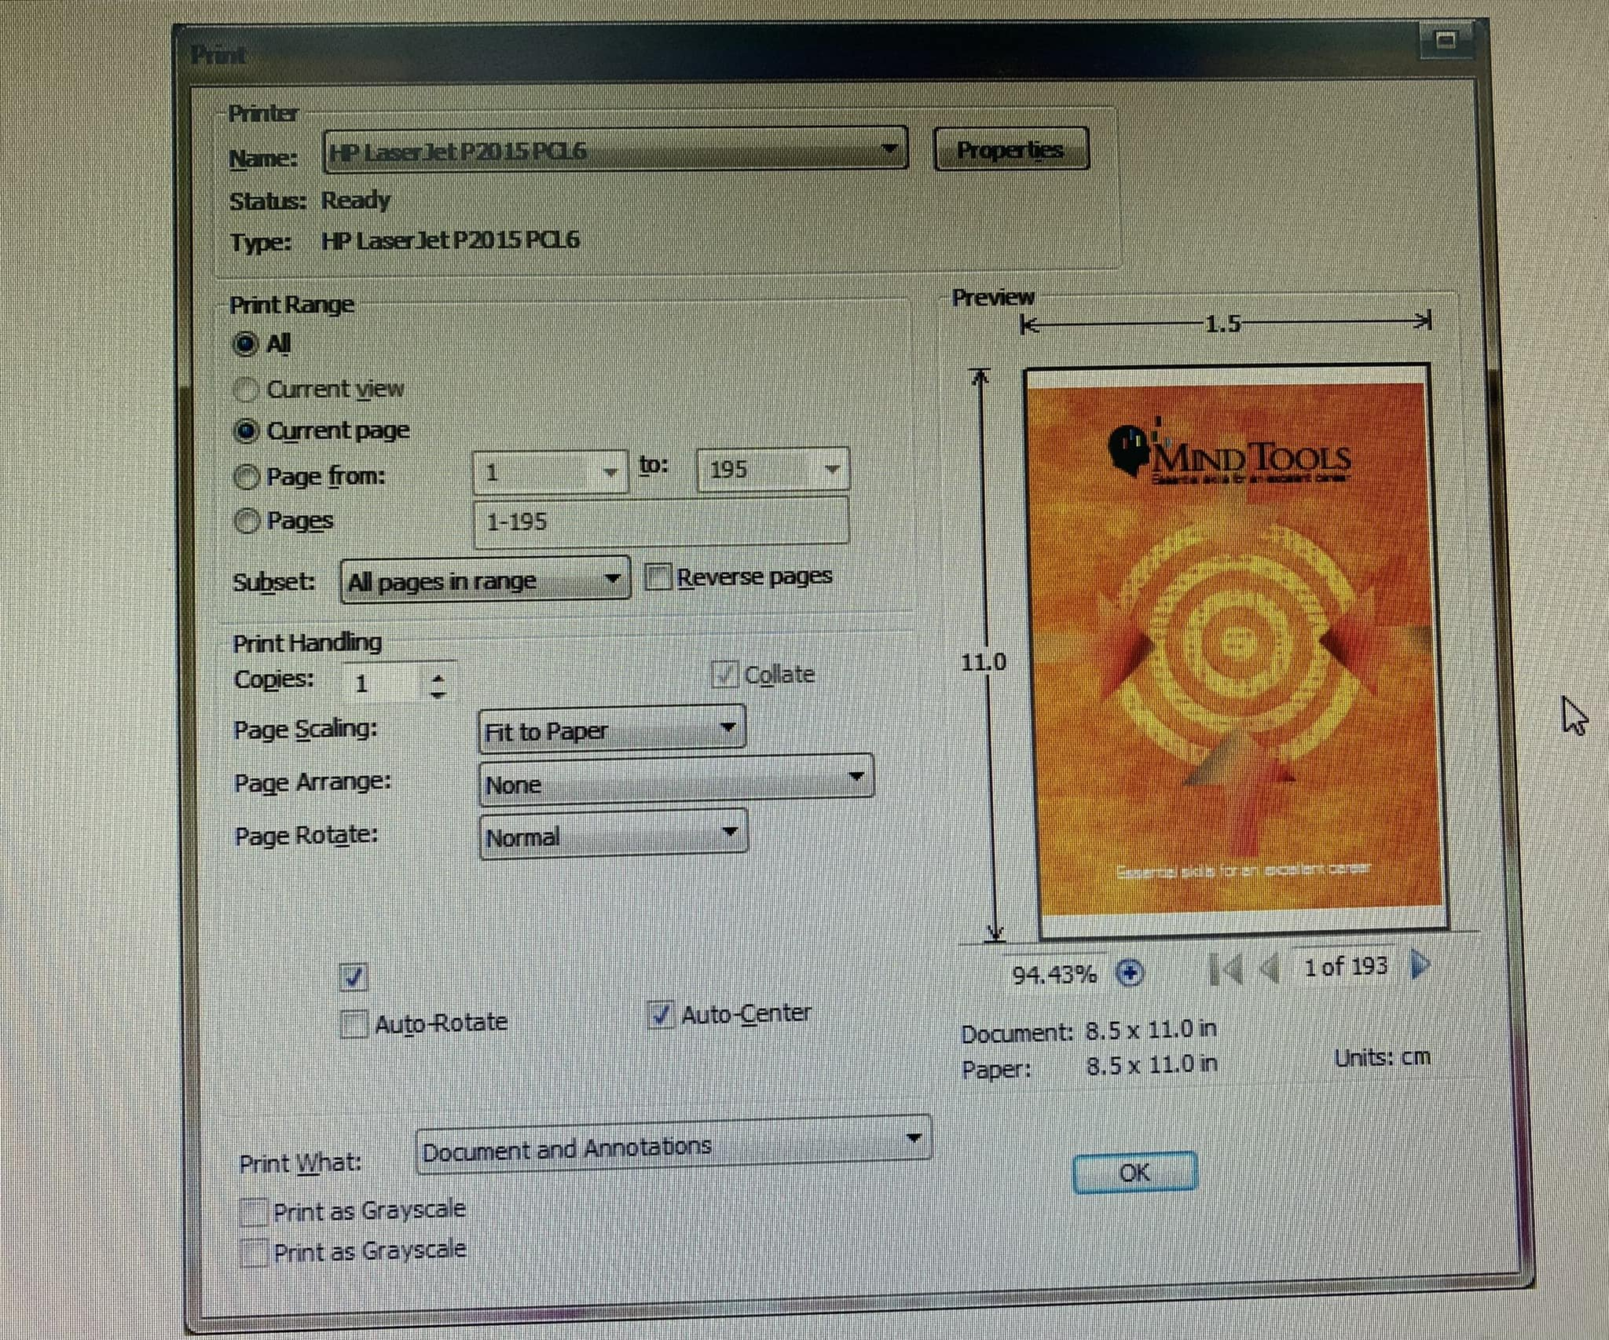

1. **The 'Minimize' and 'Close' buttons are missing.**
2. **In the 'Print Range' field, radio buttons should allow only one selection at a time; however, it selected multiple values(2).**
3. **'1 to: 195': The label 'to:' should be slightly moved down to align with 'Page from:'**
4. **'Copies:' should be 'Number of copies.'**
5. **The checkbox 'Collate' should be unchecked by default.**
6. **Have a checkbox missing the label, it is above the checkbox ‘Auto-Rotate’.**
7. **Three checkboxes in the center are not properly aligned within the field.**
8. **There are two checkboxes with the same label, 'Print as Grayscale.'**
9. **The checkbox 'Print as Grayscale' is missing an underline for the shortcut key.**
10. **The 'Zoom-in' button is missing under the picture.**
11. **The 'Move-to-end' button is missing under the picture.**
12. **The 'OK' button needs to be moved to the bottom.**
13. **I think it should add a 'Cancel' button next to the 'OK' button.**