|  |  |  |
| --- | --- | --- |
|  | Average path length | Average clustering coeffcient |
| Part b | 6.04186734794 | 0.741230614293 |
| ER | 3.94220379445 | 0.0213711383896 |
| SW | 7.96138543368 | 0.397625329815 |
| Config | 3.78595859335 | 0.0247152744429 |
| BA model | 3.59714369477 | 0.0600561973557 |

Below is the picture for 1b this is the graph for ER graph

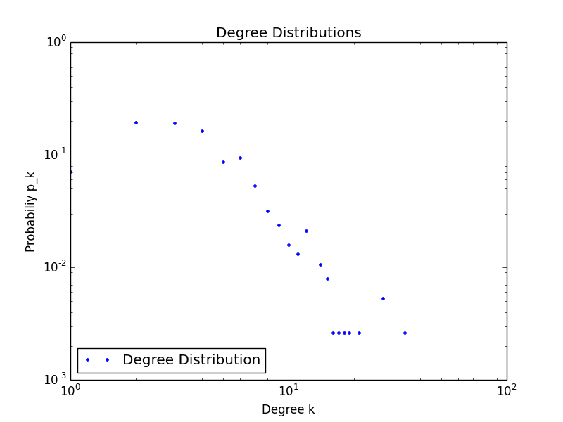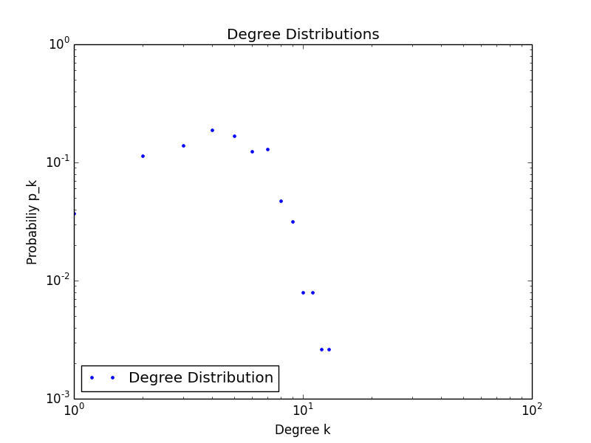

This is for small world This is for configuration

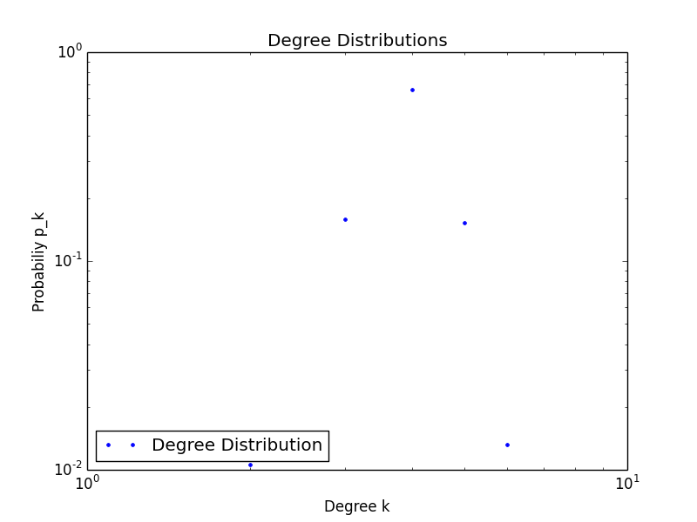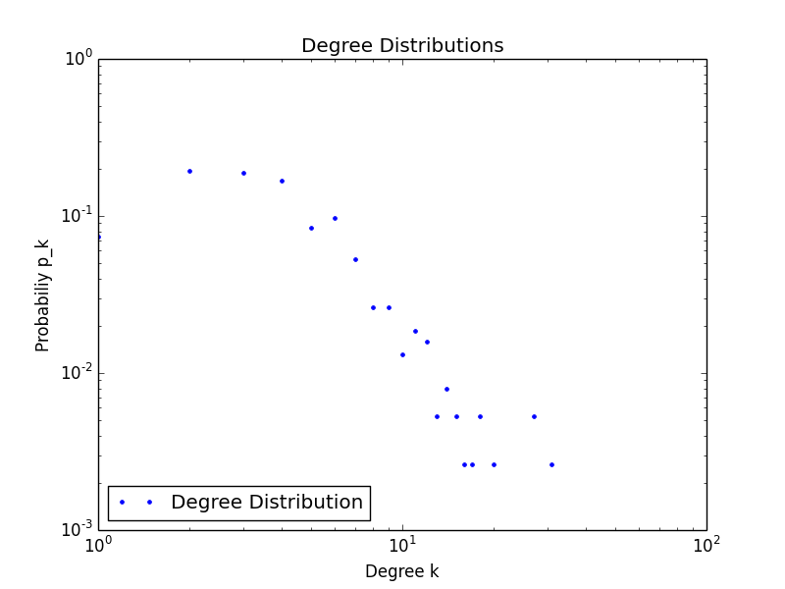

The last one is for Ba

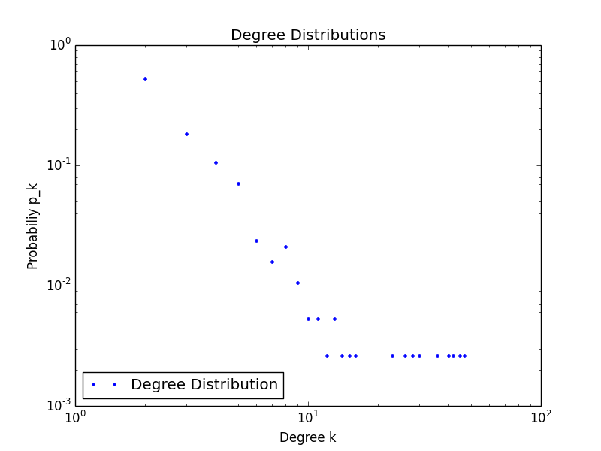

Question 4 part a

<https://github.com/MarionWashU/homework-5-terrylu_kinaanpatel>

Bonus portion

The statistics for bonus part , part b

|  |  |  |  |  |  |  |
| --- | --- | --- | --- | --- | --- | --- |
|  | Percent of epidemics | Mean percent of people infected in epidemics | CHI square for likelihood of epidemics | P value for likelihood of epidemics | U stat for proportion of people infected | P value for proportion of people infected |
| ER Graph | 82% | 91.4% | 1.835 | 0.176 | 199 | 6*10-24 |
| BA graph | 73% | 82.2% |

i)

Because the p value for the chi square estimate of likelihood to get epidemics is so high, it is insignificant to conclude the difference in susceptibility to epidemics.

ii)

because p value for U test is close to zero, we are confident to conclude that ER graph has larger final percentage infected.

iii)

The likelihood of becoming an epidemic depends heavily on node degrees and which node is infected, and the probability of infection. Since the starting infected node is random in part b, we are unable to conclude which graph leads to an epidemic.

Part c of bonus part

|  |  |  |  |
| --- | --- | --- | --- |
|  | Mean percent of people infected in epidemics | U stat for proportion of people infected | P value for proportion of people infected |
| ER Graph rand | 90.8% | 3324 | 0.326 |
| ER graph  High node | 91.0% |

Part c : so the relative increase of percentage of people infected in epidemic compared to part b is. 1) for ER graph, the increase is 91% - 90.8% = 0.2%. , but it has a p value of 0.326, much larger than 0.10, so the result is not significant. 2) The relative increase for BA model graph is 81.864% - 81.003% = 0.861%. And the p value is about 0.0986, very close to 0.10. The result is statistically significant.

|  |  |  |  |
| --- | --- | --- | --- |
|  | Mean percent of people infected in epidemics | U stat for proportion of people infected | P value for proportion of people infected |
| BA  Graph rand | 81.003% | 3258 | 0.0985998680957 |
| BA graph  High node | 81.864% |

As a result, below is our answer for q4 part c

1. BA model graph seems to be more impacted by the targeting of the highest degree node.
2. The nodes in BA model graph , compared to nodes in ER model graphs, have several nodes with extremely high degrees, serving as hubs. So if we infect hub nodes in the BA model graph, clearly it is much more susceptible to epidemic.

Question 4 part d

|  |  |  |  |  |  |  |
| --- | --- | --- | --- | --- | --- | --- |
|  | Percent of epidemics | Mean percent of people infected in epidemics | CHI square for likelihood of epidemics | P value for likelihood of epidemics | U stat for proportion of people infected | P value for proportion of people infected |
| ER Graph | 85% | 91.1% | 2.04 | 0.153 | 25.5 | 9.4*10-28 |
| Jazz graph | 76% | 78.6% |

|  |  |  |  |  |  |  |
| --- | --- | --- | --- | --- | --- | --- |
|  | Percent of epidemics | Mean percent of people infected in epidemics | CHI square for likelihood of epidemics | P value for likelihood of epidemics | U stat for proportion of people infected | P value for proportion of people infected |
| BA Graph | 66% | 82.1% | 1.97 | 0.16 | 1179.5 | 2.7*10-8 |
| Jazz graph | 76% | 78.6% |

The real network seems to be less susceptible than BA graphs, but more susceptible than ER graphs.

????