Technical Note :

View of the board without the Battery to power up but RTC battery can be seen :

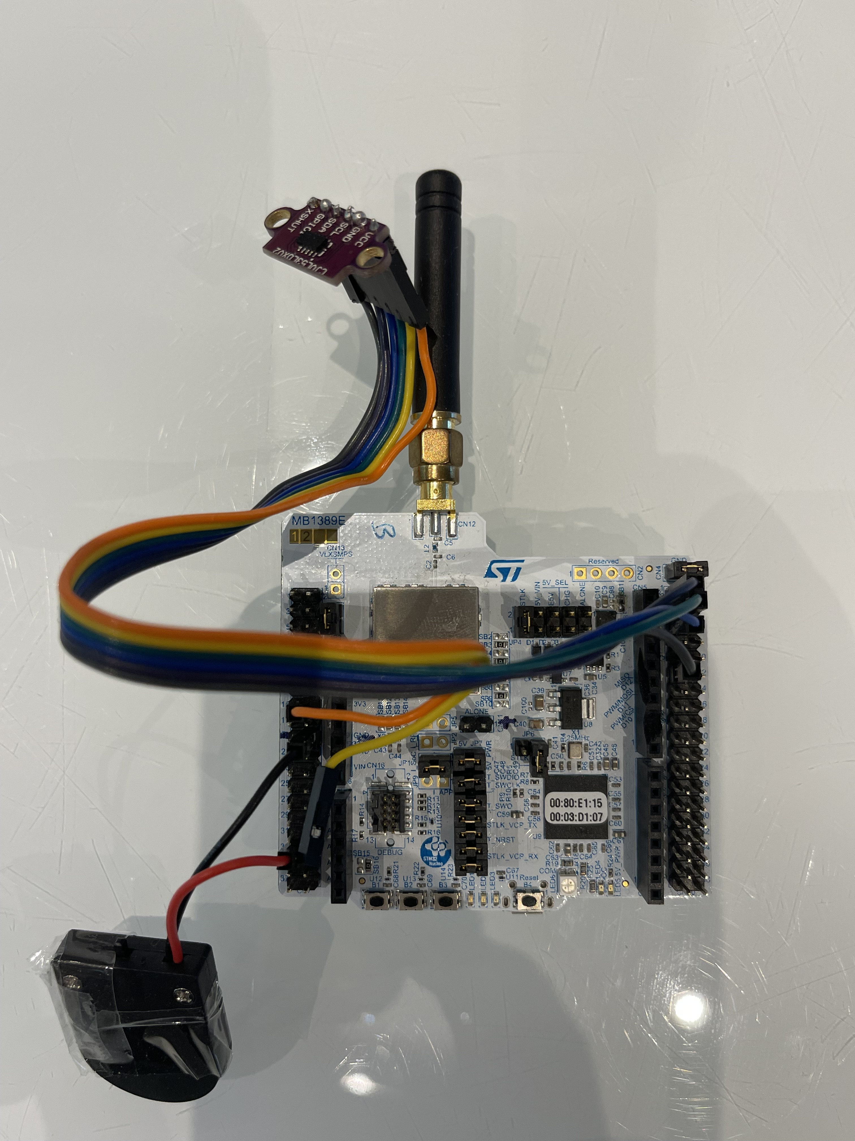

A) To update date and time on LoRa Node

1, Get Epoch time

https://www.epochconverter.com/

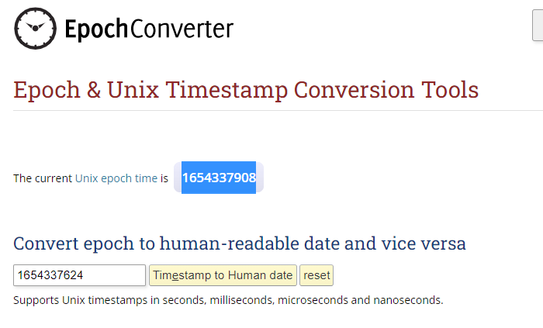
2, Convert number in Hex using a calculator

Exemple Epoch = 1654337629

=> 629B305D

3, Send Command using TTN

Syntax = Byte 0 Byte 1 Byte 2 Byte 3 Byte 4

Byte 0 = Command update date and time
Byte 1 to 4 = Epoch
Thus « 00 62 9B 30 5D » to be send

Exemple using : https://eu1.cloud.thethings.network/console/applications/letter-box-1/devices/eui-70b3d57ed0046e5b/messaging/downlink
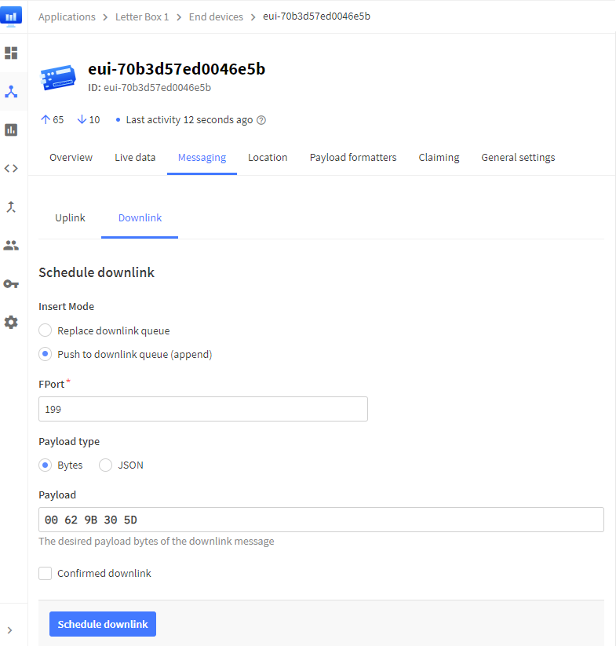
Warning : It's mandatory to activate Confirmed downlink !!!! and to avoid losed packet to send 2 same downlink packets

I recommand to check after that time is set correctly using read epoch command : mandatory because sometimes the packet sent to node is lost !!!!

In any cases command will be answered after 2 cycles of send of datas

B) To read Epoch by distance

Syntax = Byte 0 = 01

Thus epoch will be provided at next Transmit

Warning : It's mandatory to activate Confirmed downlink !!!! and to avoid losed packet to send 2 same downlink packets

In any cases command will be answered after 2 cycles of send of datas

Exemple of answser : 00 00 55 63 14 F3 DE

6314F3DE is epoch time to be converted

Hex to Dec then we get Sunday 4 September 2022 18:52:14 for this time

