Voting System on Ethereum
Components are displayed according to the user and the state of the voting system.
State | Admin(owner) | Voters
Registering Voters  Admin add adrdress to whitelist and start proposal session.  Voters have a whitelist indication, | 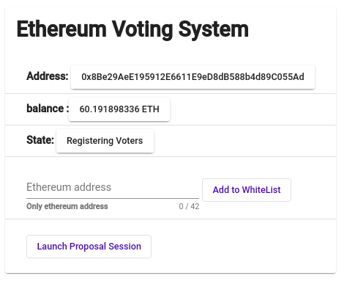  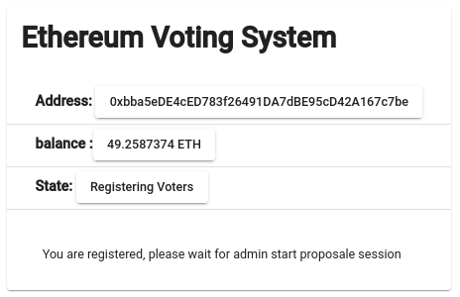 | 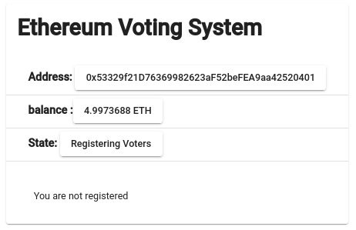
Proposals Registration Started  Admin can stop proposal session.  Voters give their proposals | 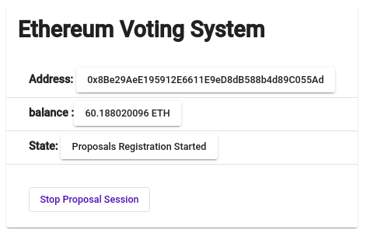 | 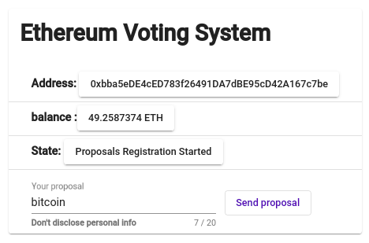
Proposals Registration Ended  admin can start voting session.  Voters must wait for voting session. | 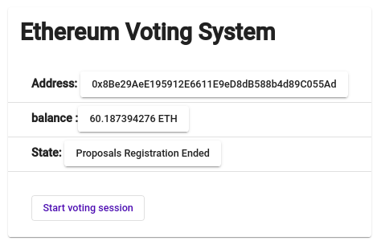 | 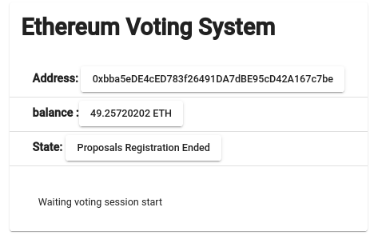
Voting Session Started  admin can stop voting session,  Voters voting for proposal. | 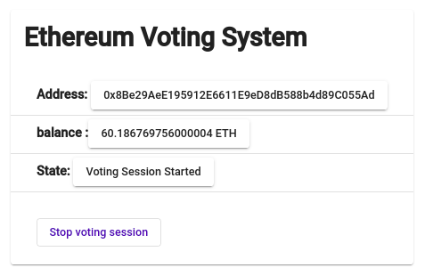 | 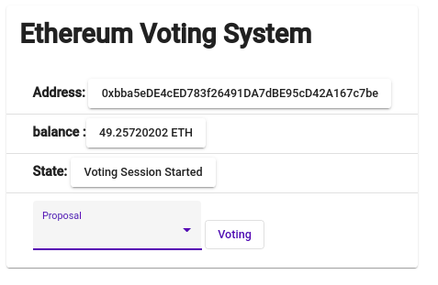
Voting Session Ended  Admin must compute voting result.  Voters must wait voting compute. | 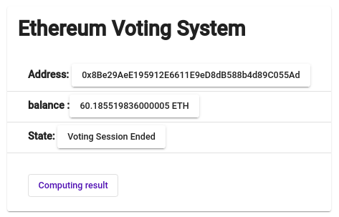 | 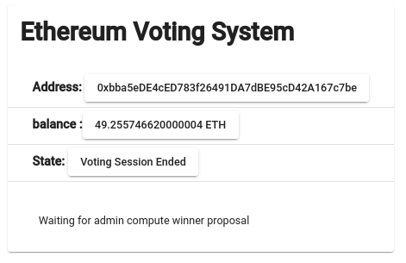
Votes Tallied  admin and voters can see voting result. | 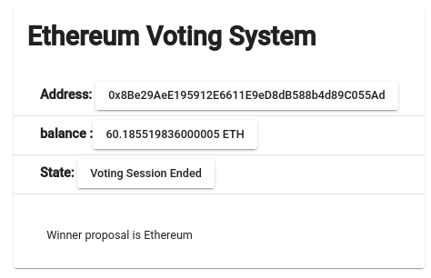 | 