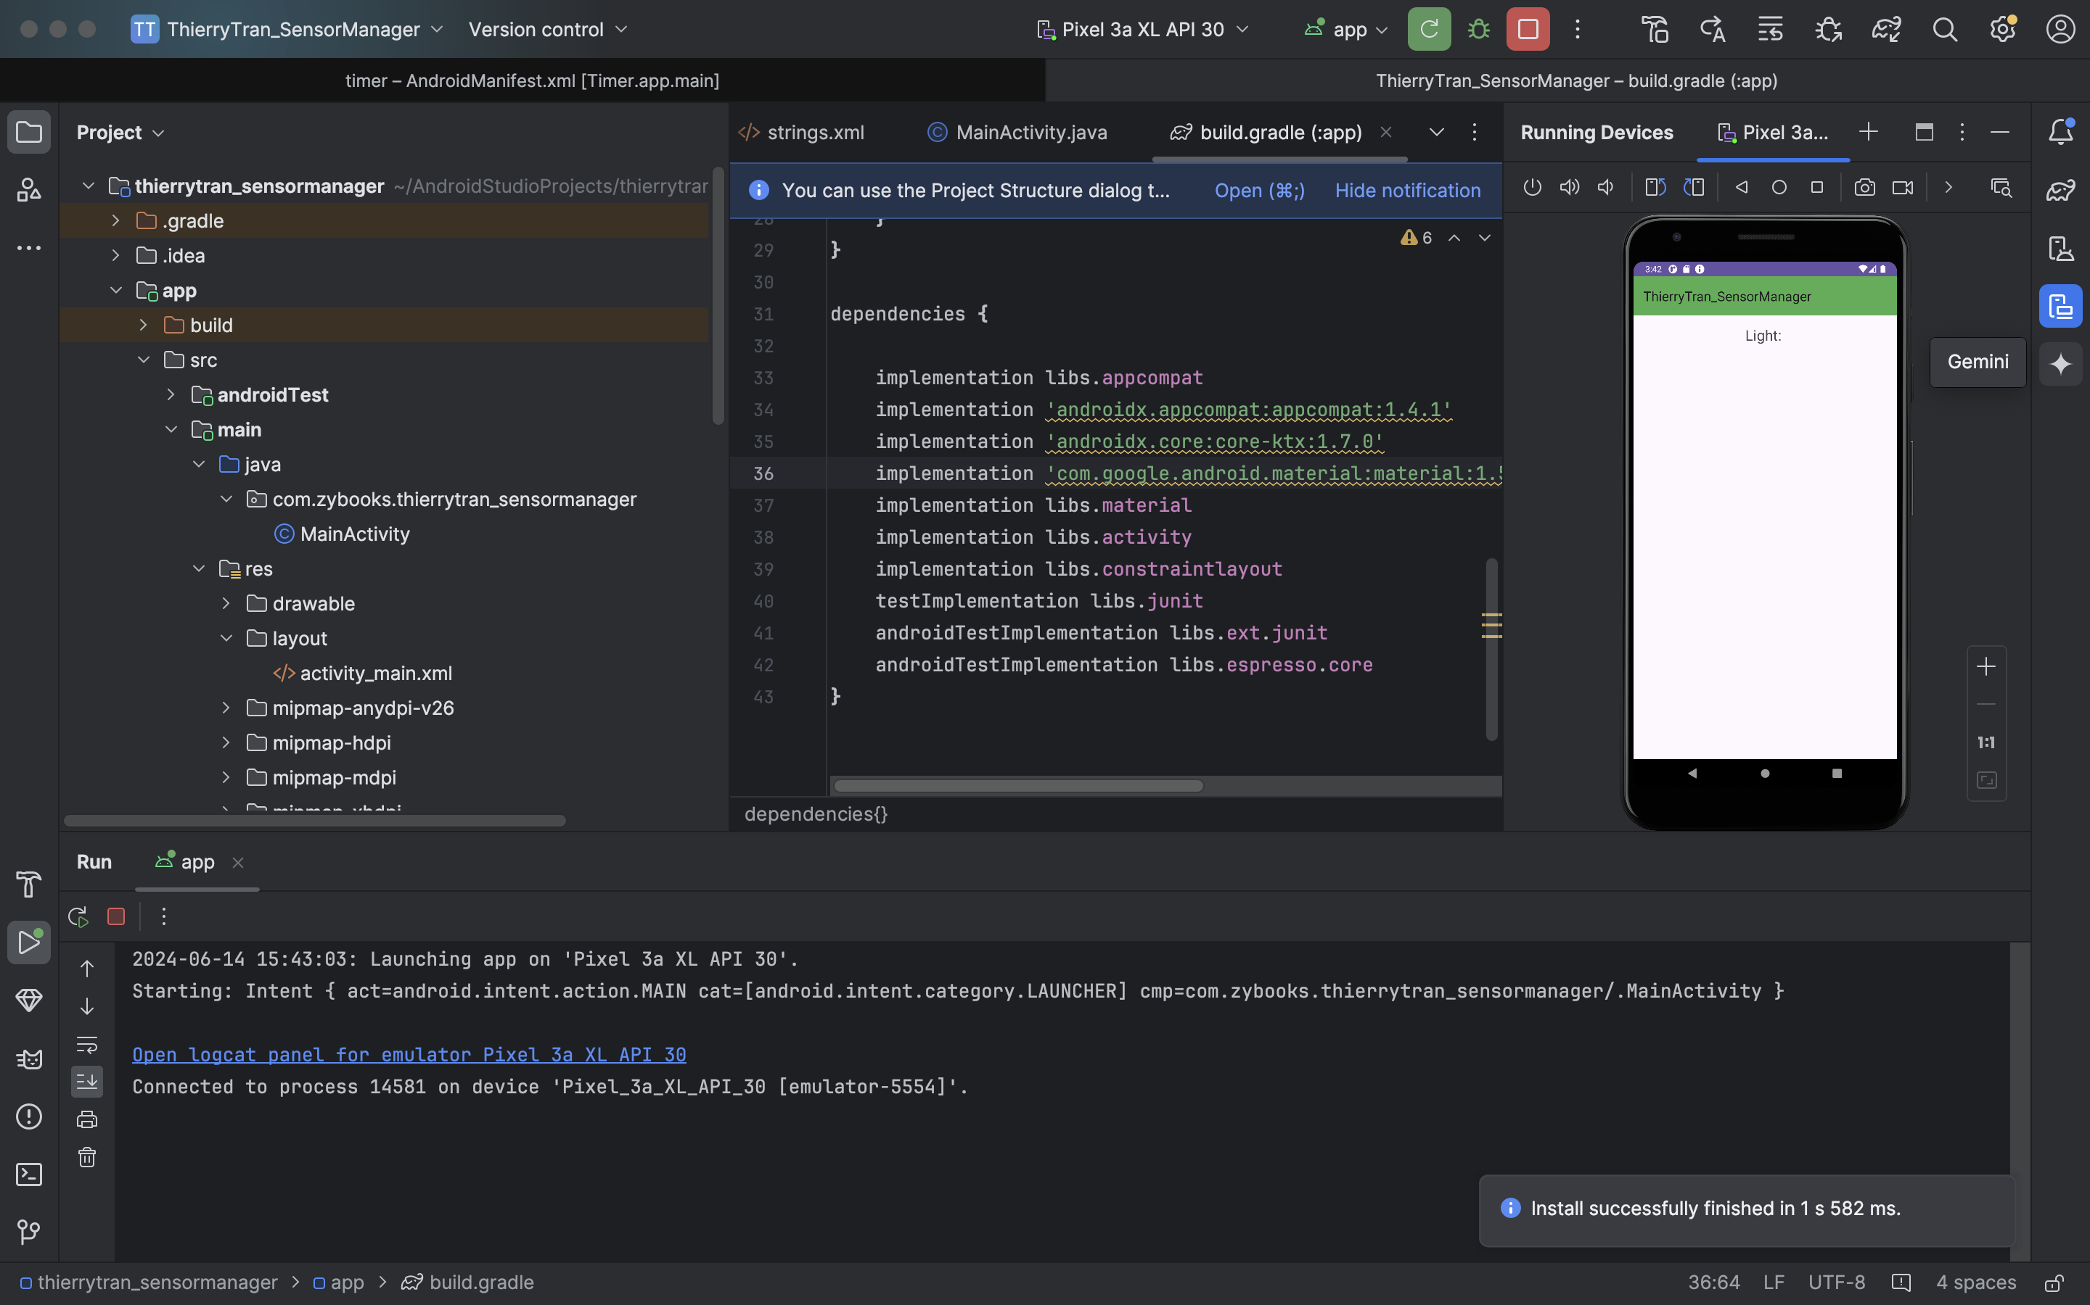

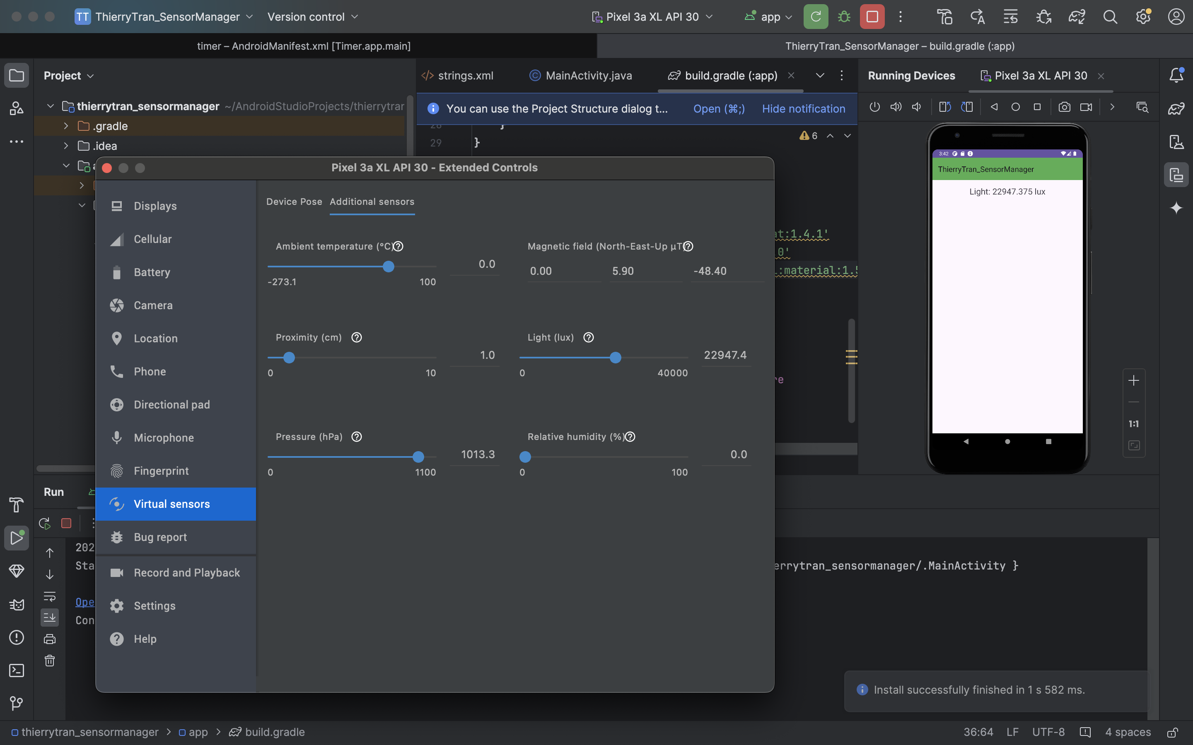

* **Purpose of SensorManager**

SensorManager is a vital service in Android that facilitates interaction with the device's sensors, such as accelerometers, gyroscopes, and light sensors. Its primary role is to manage these sensors, providing a standardized interface for apps to access and utilize sensor data efficiently. This management includes registering and unregistering sensor listeners, setting sampling rates, and ensuring optimal performance and battery usage.

### **From Readings**

* + From the readings, I learned that SensorManager abstracts the complexities of direct hardware interactions, making it easier for developers to incorporate sensor data into their applications. It supports various sampling rates and can handle high-frequency data collection if the necessary permissions are declared in the AndroidManifest.xml. SensorManager also offers numerous methods to retrieve sensor data, manage sensor events, and handle sensor-related callbacks efficiently.

### **From Experience**

* + While developing the SensorManager app, I experienced firsthand how it simplifies sensor data access. By registering a SensorEventListener, I could continuously receive updates from the light sensor and display the data on the screen. This real-time data collection was straightforward to implement, thanks to SensorManager's consistent API. Additionally, I observed the importance of managing sensor listeners correctly to ensure the app remains responsive and conserves battery life, aligning with best practices highlighted in the readings.

### **Specific Uses for SensorManager**

* + **Navigation and Orientation:**
    - **Context:** Navigation apps rely on SensorManager to enhance location accuracy and provide orientation information.
    - **Example:** Google Maps uses magnetometers and accelerometers to determine the device's orientation, improving the navigation experience by offering precise directional guidance.
  + **Gaming:**
    - **Context:** Many mobile games utilize SensorManager to create immersive and interactive experiences through motion-based controls.
    - **Example:** Racing games use the accelerometer to allow players to steer vehicles by tilting their devices, enhancing gameplay.