LAB13_PhamHuyThanhThiet_PS28548

Bài 1:

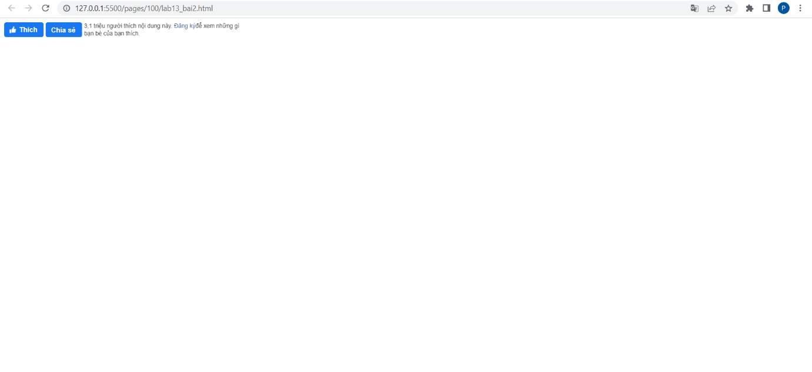

Bài 2: https://codepen.io/Phm-Huy-Thanh-Thit/pen/qBMEzRO

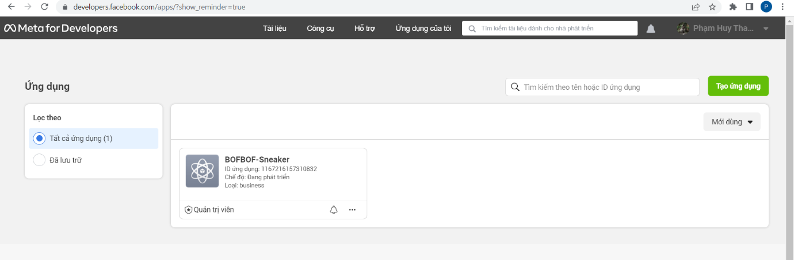

<!DOCTYPE html>

<html lang="en">

<head>

    <meta charset="UTF-8">

    <meta http-equiv="X-UA-Compatible" content="IE=edge">

    <meta name="viewport" content="width=device-width, initial-scale=1.0">

    <title>Document</title>

</head>

<body>

    <div id="fb-root"></div>

<script async defer crossorigin="anonymous" src="https://connect.facebook.net/vi_VN/sdk.js#xfbml=1&version=v16.0&appId=1167216157310832&autoLogAppEvents=1" nonce="b5frGhFC"></script>

<div class="fb-like" data-href="https://developers.facebook.com/docs/plugins/" data-width="" data-layout="standard" data-action="like" data-size="large" data-share="true"></div>

</body>

</html>

Bài 3: https://codepen.io/Phm-Huy-Thanh-Thit/pen/RwYNzpp

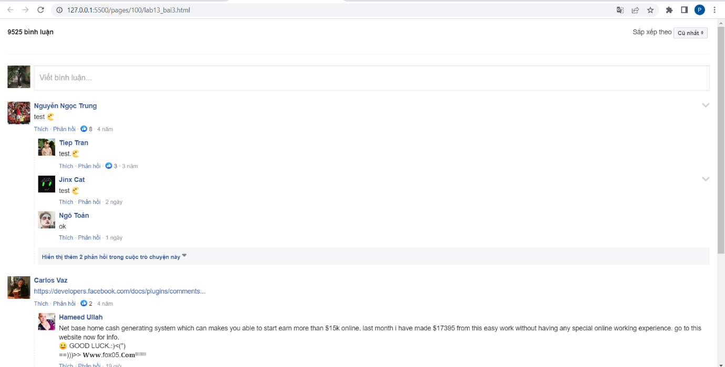

<!DOCTYPE html>

<html lang="en">

<head>

    <meta charset="UTF-8">

    <meta http-equiv="X-UA-Compatible" content="IE=edge">

    <meta name="viewport" content="width=device-width, initial-scale=1.0">

    <title>Document</title>

</head>

<body>

    <div id="fb-root"></div>

<script async defer crossorigin="anonymous" src="https://connect.facebook.net/vi_VN/sdk.js#xfbml=1&version=v16.0&appId=1167216157310832&autoLogAppEvents=1" nonce="9Tw3IULu"></script>

<div class="fb-comments" data-href="https://developers.facebook.com/docs/plugins/comments#configurator" data-width="100%" data-numposts="5"></div>

</body>

</html>