LAB14_PhamHuyThanhThiet_PS28548

Bài 2: https://codepen.io/Phm-Huy-Thanh-Thit/pen/YzOXKMy

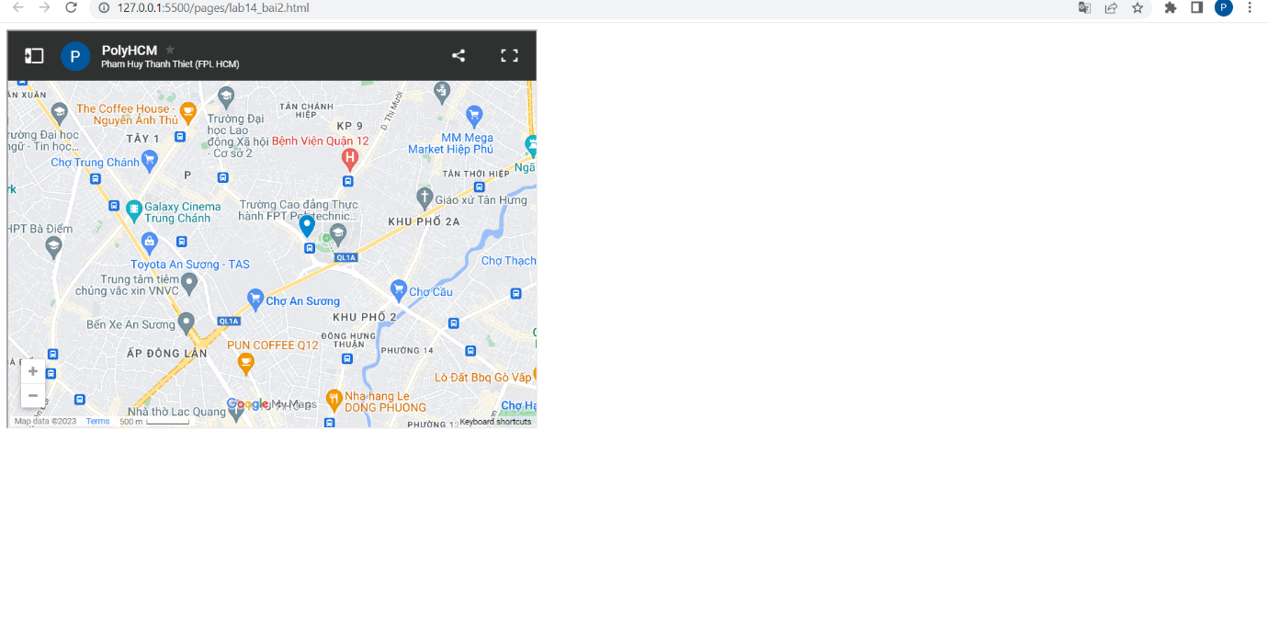

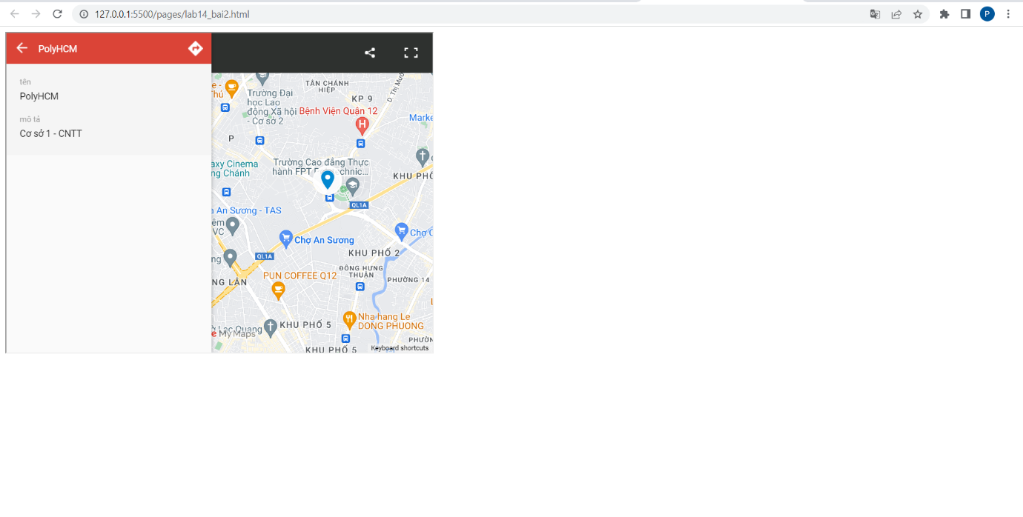

<!DOCTYPE html>

<html lang="en">

<head>

    <meta charset="UTF-8">

    <meta http-equiv="X-UA-Compatible" content="IE=edge">

    <meta name="viewport" content="width=device-width, initial-scale=1.0">

    <title>Document</title>

</head>

<body>

    <iframe src="https://www.google.com/maps/d/u/0/embed?mid=1vvKPpe2-eEO4S5hBChZVIzCf-HA4b-E&ehbc=2E312F" width="640" height="480"></iframe>

</body>

</html>

Bài 3: https://codepen.io/Phm-Huy-Thanh-Thit/pen/KKxpPLo

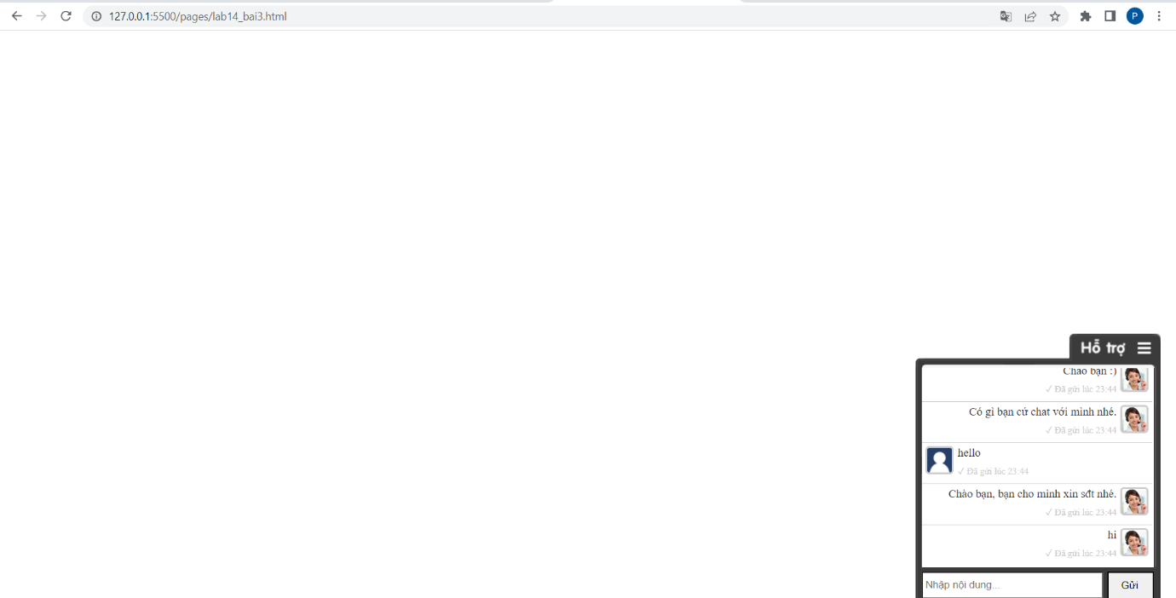

<!DOCTYPE html>

<html lang="en">

<head>

    <meta charset="UTF-8">

    <meta http-equiv="X-UA-Compatible" content="IE=edge">

    <meta name="viewport" content="width=device-width, initial-scale=1.0">

    <title>Document</title>

</head>

<body>

    <script src="https://uhchat.net/code.php?f=4ba602"></script>

</body>

</html>

Bài 1: https://codepen.io/Phm-Huy-Thanh-Thit/pen/gOdpYNg

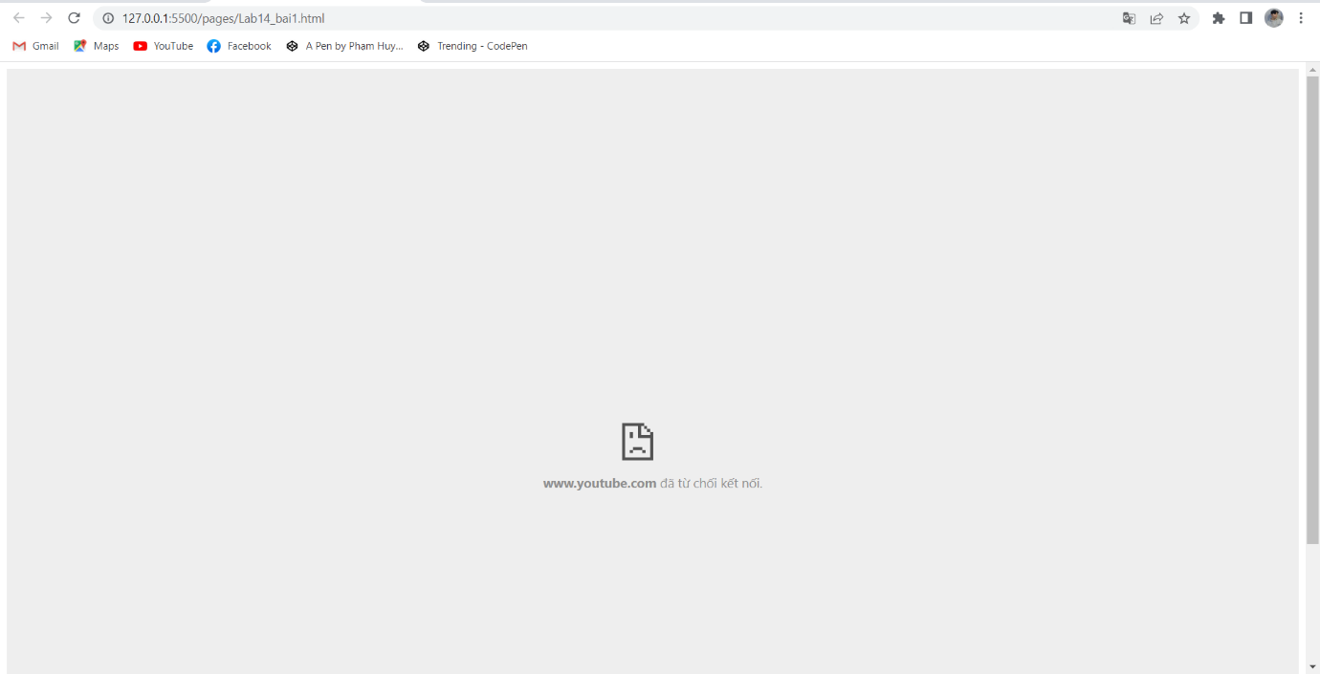

<!DOCTYPE html>

<html lang="en">

<head>

    <meta charset="UTF-8">

    <meta http-equiv="X-UA-Compatible" content="IE=edge">

    <meta name="viewport" content="width=device-width, initial-scale=1.0">

    <title>Document</title>

    <style>

        .video-container{

            position: relative;

            padding-bottom: 56.25%;

            padding-top: 30px;

            height: 0;

            overflow: hidden;

        }

        .video-container>iframe{

            position: absolute;

            top: 0;

            left: 0;

            width: 100%;

            height: 100%;

        }

    </style>

</head>

<body>

    <div class="video-container">

        <iframe

        width="560"

        height="315"

        src="https://youtu.be/VcGnT9f4_-w" frameborder="0"

        frameborder="0"

        allowfullscreen>

    </iframe>

    </div>

</body>

</html>