Lab 2

Bài 1:

-Phương trình: https://codepen.io/Phm-Huy-Thanh-Thit/pen/VwBpMEV

<!DOCTYPE html>

<html lang="en">

<head>

    <meta charset="UTF-8">

    <meta http-equiv="X-UA-Compatible" content="IE=edge">

    <meta name="viewport" content="width=device-width, initial-scale=1.0">

    <title>Document</title>

</head>

<body>

    <h3 style="font-size: 50px;">PHƯƠNG TRÌNH</h3>

    <br>

    <strong style="font-size: 30px;">a<sub>0</sub>x<sup>N</sup> + a<sub>1</sub>x<sup>N+1</sup> ... a<sub>N</sub>x<sup>0</sup> = 0</strong>

</body>

</html>

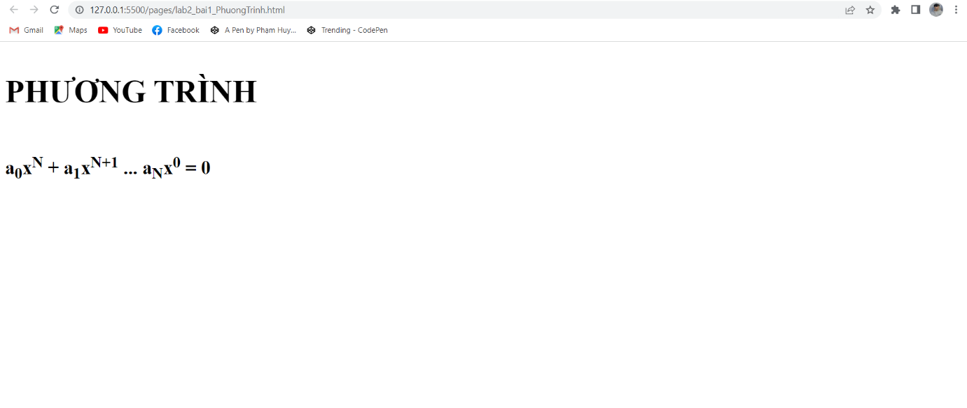

-Thơ Tím: https://codepen.io/Phm-Huy-Thanh-Thit/pen/YzjZExK

<!DOCTYPE html>

<html lang="en">

<head>

    <meta charset="UTF-8">

    <meta http-equiv="X-UA-Compatible" content="IE=edge">

    <meta name="viewport" content="width=device-width, initial-scale=1.0">

    <title>Document</title>

</head>

<body>

    <h3 style="font-size: 50px;">BÀI THƠ</h3>

    <br>

    <em style="font-size: 30px;">

    Màu <strong>tím</strong> hoa sim màu <strong>tím</strong> nhớ<br>

    Màu <strong>tím</strong> lòng người <strong>tím</strong> ước mơ<br>

    Ôi <strong>tím</strong> thủy chung màu đẹp quá<br>

    Màu <strong>tím</strong> chiều tà <strong>tím</strong> uớc mơ<br><br>

    Màu <strong>tím</strong> hoa sim tim <strong>tím</strong> <mark>Huế</mark> <br>

    Bầu trời tim <strong>tím</strong> <strong>tím</strong> tim tôi

    </em>

</body>

</html>

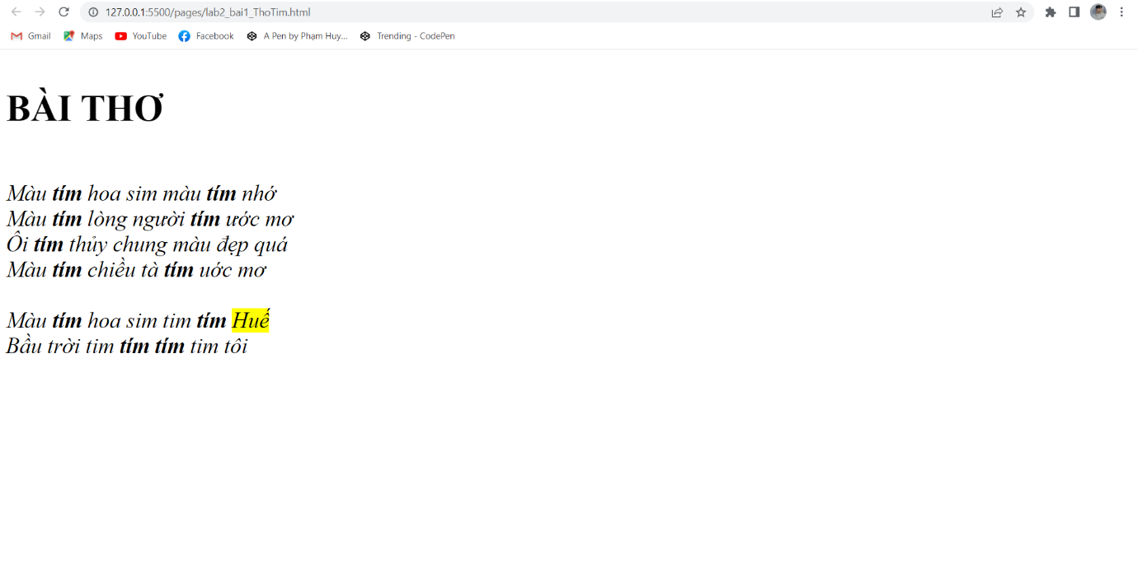

Bài 2: https://codepen.io/Phm-Huy-Thanh-Thit/pen/yLqMPop

<!DOCTYPE html>

<html lang="en">

<head>

    <meta charset="UTF-8">

    <meta http-equiv="X-UA-Compatible" content="IE=edge">

    <meta name="viewport" content="width=device-width, initial-scale=1.0">

    <title>Document</title>

</head>

<body>

   <img src="./logo.webp" alt="" width="200px">

   <hr>

   <p>

    <a href="http://127.0.0.1:5500/pages/lab2_bai2.html">Hello</a>

    <a href="http://127.0.0.1:5500/pages/lab2_bai1_ThoTim.html">Bài thơ</a>

    <a href="http://127.0.0.1:5500/pages/lab2_bai1_PhuongTrinh.html">Phương trình</a>

   </p>

</body>

</html>

