PhamHuyThanhThiet_PS28548_Lab9

Bài 1: https://codepen.io/Phm-Huy-Thanh-Thit/pen/LYBwEaV

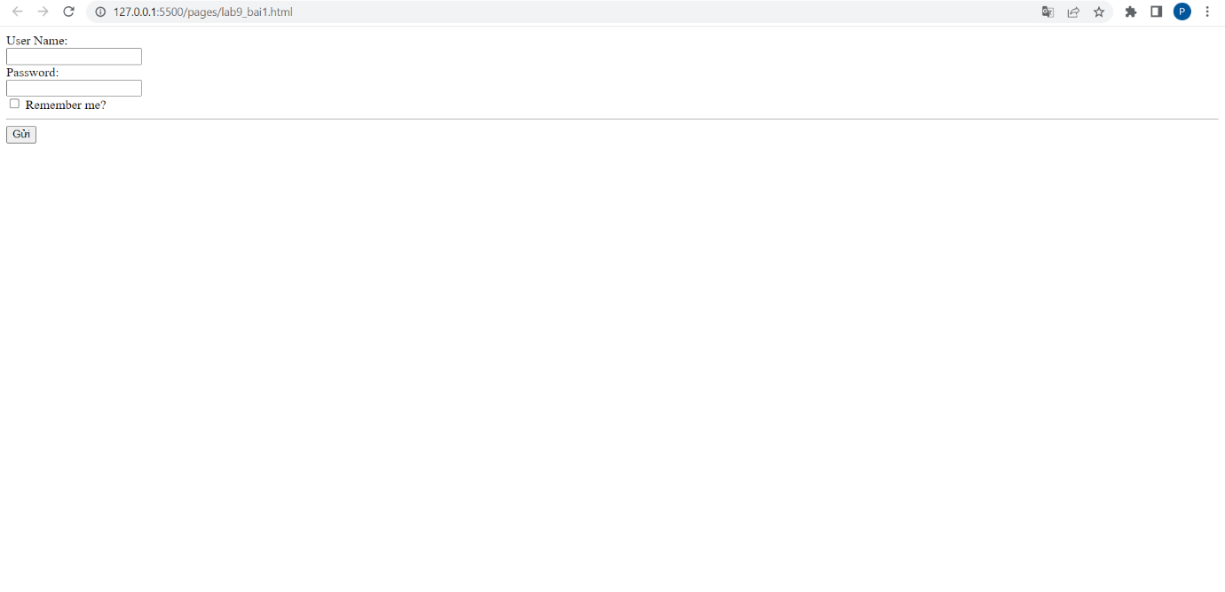

<html lang="en">

<head>

    <meta charset="UTF-8">

    <meta http-equiv="X-UA-Compatible" content="IE=edge">

    <meta name="viewport" content="width=device-width, initial-scale=1.0">

    <title>Document</title>

</head>

<body>

    <form action="">

        <div class="form-group">

            <div>User Name:</div>

            <input type="text" name="username" class="form-control">

        </div>

        <div class="form-group">

            <div>Password:</div>

            <input type="password" name="password" class="form-control">

        </div>

        <div class="form-group">

            <label for="checkbox">

                <input type="checkbox" id="checkbox"> Remember me?

            </label>

        </div>

        <hr>

        <div class="form-group">

            <input type="submit">

        </div>

    </form>

</body>

</html>

Bài 2: https://codepen.io/Phm-Huy-Thanh-Thit/pen/zYLgxbQ

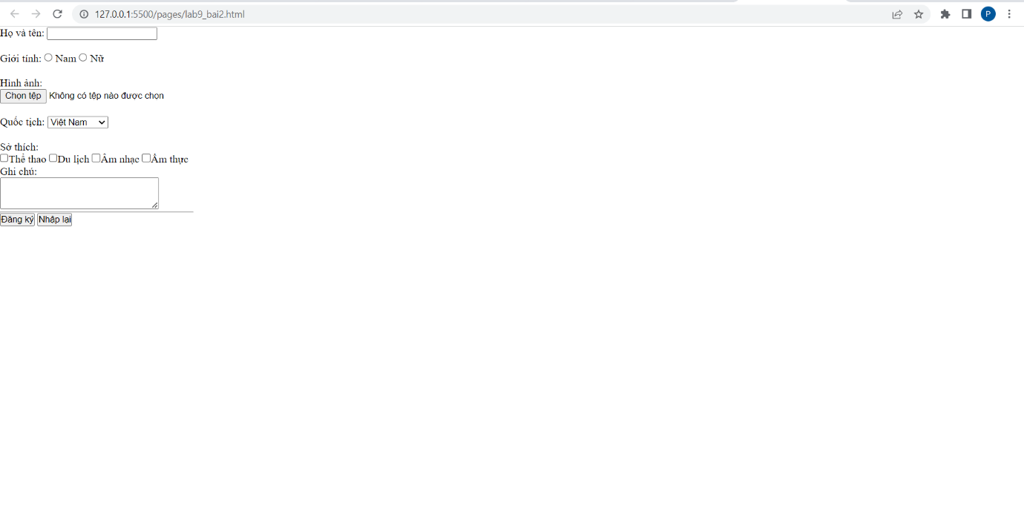

<!DOCTYPE html>

<html lang="en">

<head>

    <meta charset="UTF-8">

    <meta http-equiv="X-UA-Compatible" content="IE=edge">

    <meta name="viewport" content="width=device-width, initial-scale=1.0">

    <title>Document</title>

    <style>

        *{

            margin: 0;

            padding: 0;

            box-sizing: border-box;

        }

        hr{

            width: 290px;

            left: 0;

        }

    </style>

</head>

<body>

    <label for="">Họ và tên:</label>

    <input type="hidden">

    <input type="search"><br><br>

    <label for="">Giới tính: <input type="radio"> Nam <input type="radio"> Nữ </label><br><br>

    <label for="">Hình ảnh:</label><br>

    <input type="file"><br><br>

    <label for="">Quốc tịch:</label>

    <select>

        <option value="">Việt Nam</option>

        <option value="">Lào</option>

        <option value="">Campuchia</option>

    </select><br><br>

    <label >Sở thích:</label><br>

    <input type="checkbox"><label for="">Thể thao</label>

    <input type="checkbox"><label for="">Du lịch</label>

    <input type="checkbox"><label for="">Âm nhạc</label>

    <input type="checkbox"><label for="">Ẩm thực</label>

    <p>Ghi chú:</p>

    <textarea name="" id="" cols="30" rows="3"></textarea>

    <hr>

    <input type="hidden" >

    <button>Đăng ký</button>

    <button>Nhập lại</button>

</body>

</html>