BUSINESS

**Gyms and at-home fitness battle for prominence this holiday season**

**PUBLISHED FRI, NOV 11 20221:35 PM EST**

thumbnail

[**Jack Stebbins**](https://www.cnbc.com/jack-stebbins/)[**@JACKSTEBBS**](https://twitter.com/jackstebbs)

**SHARE**Share Article via FacebookShare Article via TwitterShare Article via LinkedInShare Article via Email

**KEY POINTS**

* The fitness industry appears headed for a strong holiday season, but not everyone will see a boost.
* Inflationary pressures and a post-lockdown reset are poised to benefit traditional gyms and trade-down options — threatening connected at-home fitness equipment like Peloton and Mirror.
* Apparel retailers are hoping the resiliency in fitness will continue to spill over.



**Brody Longo works out on his Peloton exercise bike on April 16, 2021 in Brick, New Jersey.**

*Michael Loccisano | Getty Images*

The fitness industry appears headed for a strong holiday season, but not everyone will see a boost.

The category has been on a rollercoaster for more than two years, with the Covid pandemic shifting workout routines and minting new sector winners. Now inflationary pressures and a post-lockdown reset look poised to benefit traditional gyms and trade-down options — threatening connected at-home fitness equipment like the products made by [Peloton](https://www.cnbc.com/quotes/PTON/) and [Lululemon](https://www.cnbc.com/quotes/LULU/)-owned Mirror.

Inflation remains a top concern for consumers, though October data [showed slight easing](https://www.cnbc.com/2022/11/10/consumer-prices-rose-0point4percent-in-october-less-than-expected-as-inflation-eases.html). Holiday spending projections [show that rising costs may result in more muted gift-giving](https://www.cnbc.com/2022/09/13/holiday-shopping-season-expected-to-be-muted-as-inflation-squeezes-shoppers.html) this year.

Demand appears to be stronger for [experiences rather than things.](https://www.cnbc.com/2022/11/04/travel-has-edge-over-shopping-holiday-season-amid-inflation.html) The fitness category has a history of surviving pricing pressures, and it usually enjoys a bump from New Year’s resolutions.

“In ’08 and ’09 fitness industry revenues and membership actually ticked up versus much of retail,” Jefferies analyst Corey Tarlowe told CNBC, referring to the financial crisis and recession of that era.

Tarlowe, who covers [Planet Fitness](https://www.cnbc.com/quotes/PLNT/) and Lululemon, said fitness spending remains steady, even among lower-income, inflation-squeezed consumers. But he sees gyms winning out over more expensive, at-home equipment. People are trading down and shifting more toward value, he said, “and that bodes well for Planet Fitness.”

**Return to gyms**

[Planet Fitness](https://www.cnbc.com/quotes/PLNT/) posted record membership and expanded its full-year guidance when it reported third-quarter earnings Nov. 8. The company said it had 16.6 million members at the end of the quarter, an all-time high – even compared to the pre-pandemic era – and said it added 29 new locations during the period.

Planet Fitness CEO Chris Rondeau said members are exercising more, too: six times a month versus five times a month when Planet Fitness went public in 2015. The company also reported a decline in its cancellation rate.

Rondeau said engagement for all age groups is near or above pre-pandemic levels. The company, known for its affordable memberships compared to more luxurious gyms like Life Time and Equinox, boasted strong customer acquisitions through its discounted offerings.

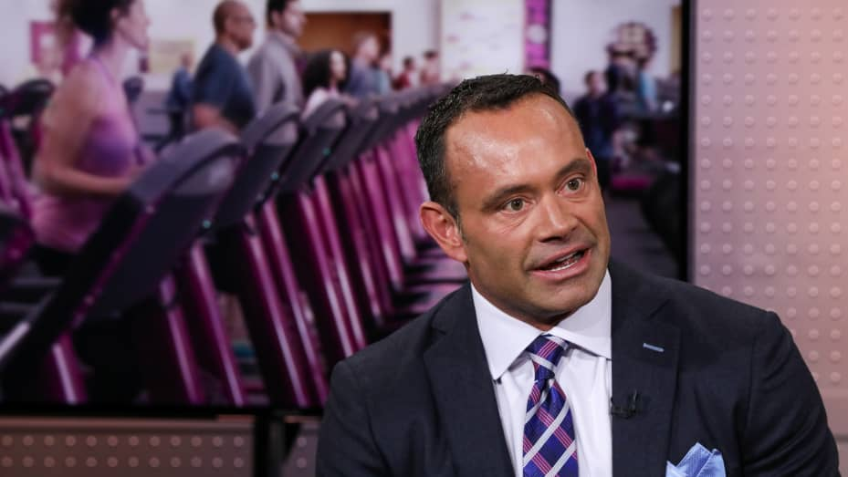

**Chris Rondeau, CEO of Planet Fitness.**

*Adam Jeffery | CNBC*

Luxury gyms are seeing positive trends, too. [Life Time](https://www.cnbc.com/quotes/LTH/) on Nov. 9 reported a 9% increase in members from 2021, and 4,000 additional members compared with the prior quarter.

The cadence of additions is slower than from 2020 to 2021, but the luxury fitness brand continues to lure its higher-income customer base with in-person experiences such as [the increasing popular sport pickleball](https://www.cnbc.com/2022/11/09/major-league-pickleball-merges-with-ppa-vibe-league.html).

**Is fitness on the wish list?**

Apparel retailers hope to continue benefiting from the resiliency in fitness.

[Lululemon](https://www.cnbc.com/quotes/LULU/) in September showed strong demand for athleticwear from its higher-income consumer base. The company said it was “not seeing any meaningful variation” in consumer behavior despite the macroeconomic environment and actually raised its 2022 guidance range by about $200 million to between $7.87 billion and $7.94 billion.

The company will report its third-quarter results in December.

Other retailers are hoping home fitness will continue to be on wish lists in the coming months. [Dick’s Sporting Goods](https://www.cnbc.com/quotes/DKS/) and [Lowe’s](https://www.cnbc.com/quotes/LOW/) — which recently expanded its assortment of exercise equipment and accessories — have both touted the stability of the sector, even despite inflation.

But, as Jefferies’ Tarlowe notes, there’s more risk with capital-intensive, lower-margin equipment versus higher-margin products like athleticwear. Nevertheless, retailers like Lowe’s are confident that demand will hold.

“The demand for home fitness equipment has maintained since the pandemic,” Lowe’s executive vice president of merchandising, Bill Boltz, said in a statement to CNBC. “Especially during the holiday gifting season, we are offering an increased selection of fitness accessories in stores.”

**Can Peloton peddle bikes?**

Luxury at-home products like [Peloton](https://www.cnbc.com/quotes/PTON/), however, have struggled in recent months as consumers get out of the house and back to offices and gyms. The stationary bike maker [reported first-quarter results earlier this month that came in well below Wall Street’s expectations,](https://www.cnbc.com/2022/11/03/peloton-pton-reports-q1-earnings.html) logging a quarterly loss in subscribers and, according to calculations from UBS, a parallel drop in engagement — 16% year over year.

Even as the company looks to drive new customers —[selling its Bikes on Amazon](https://www.cnbc.com/2022/08/24/peloton-to-sell-fitness-equipment-apparel-on-amazon.html) and [at Dick’s Sporting Goods](https://www.cnbc.com/2022/09/29/peloton-to-sell-bikes-treads-at-dicks-sporting-goods-stores-.html), launching [a rental program](https://www.cnbc.com/2022/09/13/peloton-expands-bike-rental-program-nationwide.html) and putting bikes in hotels across the country — analysts don’t think the value proposition is attracting more subscribers.

“It took a global pandemic to get from 1 million subscriber to 2 million. Can you actually grow that base?” Arpiné Kocharyan, a leisure, gaming and lodging analyst with UBS, said in an interview with CNBC. “We have seen churn rates double year over year.”

Peloton forecast second-quarter revenue of between $700 million and $725 million, around $150 million below the $874 million that Wall Street had been hoping for, according to Refinitiv consensus estimates at the time of the report.

Lululemon, which [acquired at-home fitness company Mirror in 2020 for $500 million](https://www.cnbc.com/2020/06/29/lululemon-to-acquire-at-home-fitness-company-mirror-for-500-million.html), could be facing similar at-home headwinds. Executives did not disclose Mirror sales in the latest quarterly update, but the acquisition remained an expense on the company’s financial statements.

“I just don’t think Mirror was strategically the best option for Lululemon,” Jefferies’ Tarlowe said. “It probably still is dilutive to earnings. They are investing in the business to help enhance the Mirror segment, but I question the value that will actually add overall to the business.”

Mirror subscriptions have been wrapped in Lululemon’s [new $39-a-month membership program](https://www.cnbc.com/2022/04/20/lululemon-monthly-memberships-for-clothes-events-and-classes.html), which also includes access to exclusive Lululemon products and some in-person workouts. The subscription is part of the company’s five-year plan to double revenue to $12.5 billion by 2025, a plan that has [drawn skepticism from some analysts.](https://www.cnbc.com/2022/04/21/wall-street-questions-lululemon-2026-financial-targets.html)

“Connected fitness as a phenomenon is here to stay,” UBS’ Kocharyan said. “But are you going to see significant growth rates from where they are today, given that they saw this abnormally high growth rate in the middle of the pandemic? I would say there are more questions about them keeping those subscriptions and engagement high.”

**Here’s what critics are saying about Marvel’s ‘Black Panther: Wakanda Forever’**

**PUBLISHED FRI, NOV 11 20226:30 AM ESTUPDATED FRI, NOV 11 20226:31 AM EST**

thumbnail

[**Sarah Whitten**](https://www.cnbc.com/sarah-whitten/)[**@SARAHWHIT10**](https://twitter.com/@sarahwhit10)

**SHARE**Share Article via FacebookShare Article via TwitterShare Article via LinkedInShare Article via Email

**KEY POINTS**

* Ryan Coogler’s latest Marvel Cinematic Universe film, “Black Panther: Wakanda Forever,” is over 80% “fresh” on review aggregator Rotten Tomatoes.
* Critics said the film has an “overly busy” plot, but is a poignant tribute to the late Chadwick Boseman, who portrayed T’Challa.
* The Marvel Studios film opens Friday and is expected to have a huge opening weekend.



**Danai Gurira and Letitia Wright star as Okoye and Shuri in Marvel Studio’s “Black Panther: Wakanda Forever.”**

*Disney*

It’s impossible to replace the irreplaceable, but that was Ryan Coogler’s task as the director and co-writer of [Disney’s](https://www.cnbc.com/quotes/DIS/) latest Marvel Cinematic Universe film, “Black Panther: Wakanda Forever.”

The sequel to 2018′s blockbuster hit “Black Panther” takes place after the real-world death of actor Chadwick Boseman, who portrayed the titular hero in several Marvel films before dying from cancer in 2020. He was 43.

“Wakanda Forever” had the unenviable charge of not only being a memorial to the late Boseman, but also move the multibillion-dollar MCU franchise forward into its next chapter. It is expected to post [a huge opening weekend](https://www.cnbc.com/2022/11/10/black-panther-wakanda-forever-aims-to-break-box-office-records.html).

Coogler, alongside Marvel Studio’s executives, decided not to recast the character of T’Challa. Instead, the film opens with the off-screen death of the character. The story that follows centers on how the secondary characters in the world of Wakanda deal with that loss as well as the encroachment of the rest of the world, which has become aware of the country’s rare and powerful resource — vibranium.

Several critics called the plot overstuffed, as Coogler seeks to pay tribute to Boseman and establish the necessary markers for future MCU projects. The film introduces Tenoch Huerta as Namor, the ruler of Talokan, a fictional kingdom based on Atlantis, as well as Riri Williams, known in the comics as Ironheart, who will star in her own Disney+ series.

Despite its length and heftiness, “Wakanda Forever” has generated [an over 80% “fresh” rating on Rotten Tomatoes from about 200 reviews.](https://www.rottentomatoes.com/m/black_panther_wakanda_forever)

Here’s what some critics thought of “Black Panther: Wakanda Forever” ahead of its Friday debut:

**Kristy Puchko, Mashable**

Puchko says the film, while action-packed, is at its core about how people handle loss differently. This is particularly evident in how T’Challa’s mother Queen Ramonda (Angela Bassett) and his sister Shuri (Letitia Wright) quarrel over the future of Wakanda.

“Through their mother-daughter battles — born of love and broken hearts — Coogler poses questions that hit hard,” Puchko wrote. “What to we owe to those we’ve lost? Is their legacy our responsibility? Or are we responsible for our own legacies? Might their memory bolster us or blind us to what our futures could be without them?”

Wright, who spent much of the first “Black Panther” as comic relief, now takes on a more serious lead role, one that many critics praised.

″[Wright] handles this shift well, bringing a maturity to the pesky little sister without entirely losing her bear-poking edge,” Puchko said.

[Read the full review from Mashable.](https://mashable.com/article/black-panther-wakanda-forever-shuri-review)



**Still from Marvel Studio’s “Black Panther: Wakanda Forever.”**

*Disney*

**Moira Macdonald, Seattle Times**

“Boseman’s T’Challa is a spirit that lovingly haunts the film,” Macdonald writes.

“It’s part of the great strength of ‘Black Panther: Wakanda Forever’ that it doesn’t shy away from that sadness; this is, after all, a superhero movie, and Coogler might have been forgiven for wanting to quickly cut to the chase, so to speak,” she wrote.

Instead, the filmmaker allows the characters and the audience to absorb the loss before flashing forward.

“There’s so much that ‘Black Panther: Wakanda Forever’ does right that it’s frustrating to blame it for the one flaw it can’t help,” she wrote. “But you watch it wondering about the movie that never got made, the story that never got finished, the life cut short too soon.”

[Read the full review from Seattle Times.](https://www.seattletimes.com/entertainment/movies/black-panther-wakanda-forever-review-sequel-pays-tribute-to-tchalla-while-forging-its-own-path/)

**Leah Greenblatt, Entertainment Weekly**

Much like the first “Black Panther,” Coogler is being praised for filling the “Wakanda Forever” production with talented female actors and creators. Hannah Beachler and Ruth Carter, who won Oscars for production design and costuming for their work on the first film, are back and earning more raves.

“Their shared vision of Afro-futurism feels lush and joyful and beautifully specific set against the usual white noise of Marvel fanfare, even (or almost especially) in darker moments, like the pristine rituals of a funeral scene,” Greenblatt writes. ”‘Wakanda’ is still clearly a Marvel property, with all the for-the-fans story beats and secondary characters its ever-expanding universe requires, but it also feels apart from any one that’s come before.”

Greenblatt also touches on how, without King T’Challa, Wakanda has become a matriarchy.

“Without their king, Wakanda has become a queendom from the top down, overseen by Bassett’s regal, ageless Ramonda, the gorgeously daunting Gurira, and Wright, who rises to fill her dramatically expanded role with feline grace and vulnerability,” she wrote.

She notes that while this sequel is likely nothing like what Coogler and Marvel had intended to create prior to Boseman’s untimely death, “the movie they’ve made feels like something unusually elegant and profound at the multiplex; a little bit of forever carved out for the star who left too soon.”

[Read the full review from Entertainment Weekly.](https://ew.com/movies/movie-reviews/black-panther-wakanda-forever-review/)



**Winston Duke stars as M’Baku in Marvel Studio’s “Black Panther: Wakanda Forever.”**

*Disney*

**Kambole Campbell, Empire**

Critics also praised the performance of Huerta as Namor, also known as the Sub-Mariner in comics, and Coogler’s interpretation of the character. Campbell calls Namor “a unique antagonist.”

“He’s a highlight, an imaginative adaptation of the veteran comics character, one who here speaks truth with convincing venom. Coogler ties him to Mesoamerican history and Spanish colonialism, and there’s a sense — like Wakanda — of a tangible, real-world history.”

Campbell also noted that “Wakanda Forever” “can feel overly busy,” since Coogler had a lot of elements to weave into the film.

“It all sprawls into a messy last act that can feel at odds with the rest of the film,” he wrote. “But ‘Wakanda Forever’ ultimately lands on a poignant note. In bookends, it deals head-on with the passing of both T’Challa and Boseman, moments that pull the film into a moving, surprisingly personal whole. Even in his absence, Boseman holds ‘Black Panther’ together.”

[Read the full review from Empire.](https://www.empireonline.com/movies/reviews/black-panther-wakanda-forever/)



**A still from the movie “Black Panther.”**

**Swedish EV maker Polestar reports lower operating loss, confirms full-year guidance**

**PUBLISHED FRI, NOV 11 20229:44 AM ESTUPDATED FRI, NOV 11 20224:12 PM EST**

thumbnail

[**John Rosevear**](https://www.cnbc.com/john-rosevear/)[**@JOHN__ROSEVEAR**](https://twitter.com/john__rosevear)

**SHARE**Share Article via FacebookShare Article via TwitterShare Article via LinkedInShare Article via Email

**KEY POINTS**

* Polestar’s third-quarter operating loss was significantly narrower than a year ago, and its revenue more than doubled.
* The automaker still expects to deliver 50,000 vehicles in 2022, a key milestone.
* But supply-chain disruptions are still an issue, and exchange-rate pressures will likely continue into 2023.

**In this article**

* [**PSNY+0.04 (+0.73%)**](https://www.cnbc.com/quotes/PSNY)

Follow your favorite stocks**CREATE FREE ACCOUNT**

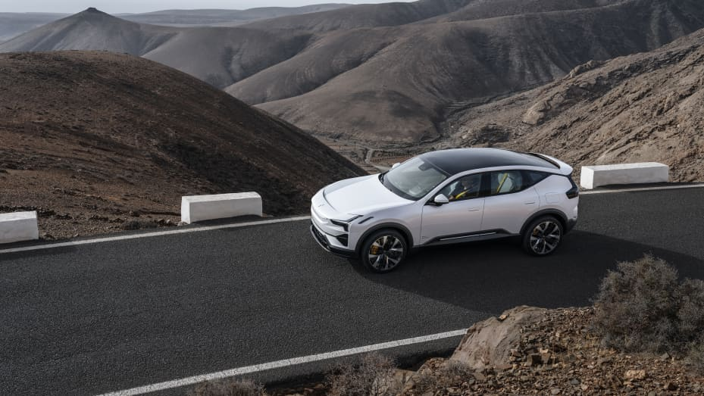

**Polestar 3**

*Courtesy: Polestar*

Swedish electric-vehicle maker [Polestar](https://www.cnbc.com/quotes/PSNY/) said Friday that its third-quarter operating loss narrowed from a year ago as revenue more than doubled, and it confirmed that it still expects to deliver 50,000 vehicles in 2022.

But the company warned that higher costs and supply-chain issues will continue to squeeze its margins into 2023.

Here are the key numbers from Polestar’s [third-quarter earnings report](https://investors.polestar.com/static-files/cf80a4e2-be03-45b0-a65c-e519b0bdc1ba), its first as a public company following its [merger with a special-purpose acquisition company](https://www.cnbc.com/2022/06/24/polestar-psny-nasdaq-debut-growth-plans-2025.html) in June.

* **Revenue:** $435.4 million, versus $212.9 million in the third quarter of 2021
* **Operating loss:** $196.4 million, down from $292.9 million a year ago

Despite the operating loss, Polestar was able to report a net profit of $299.4 million, or 14 cents per share, thanks to an accounting credit related to the revaluation of future share payouts. (Because Polestar’s share price has fallen since it went public, it will have to pay out less than it had previously expected, hence the credit.)

Shares rose sharply after the report and ended Friday’s session up over 20%.

“I would like to reiterate: Polestar is a real car company,” CEO Thomas Ingenlath said during the earnings call. “We are putting cars on the road today and we are delivering on our ambitious growth plan.”

CFO Johan Malmqvist said that Polestar’s lower operating loss was helped by its efforts to reduce costs, specifically short-term reductions in advertising and marketing spending. On the other hand, foreign exchange headwinds exacerbated the loss, and those are expected to continue into next year.

“As our cars are produced in China, the majority of our costs are in renminbi, which has strengthened against European currencies, leading to a higher cost of sale,” Malmqvist said during the earnings call.

Malmqvist said that Polestar still expects to deliver 50,000 vehicles in 2022, generating about $2.4 billion in revenue for the full year, both in line with its prior guidance. Those numbers imply deliveries of about 19,600 vehicles in the fourth quarter, producing about $924 million in revenue – and those vehicles are already built and in transit to customers now, he said.

Polestar ended the third quarter with about $988 million in cash, and it has since secured a $1.6 billion credit line from its two main owners, [Volvo Cars](https://www.cnbc.com/quotes/8JO0-FF/) and Chinese automaker [Geely](https://www.cnbc.com/quotes/175-HK/). That’s enough to fund the company through 2023, Malmqvist said.

**Cramer’s lightning round: Booz Allen is a buy**

**PUBLISHED FRI, NOV 11 20227:07 PM EST**

[**Krystal Hur**](https://www.cnbc.com/krystal-hur/)[**@KRYSHUR**](https://twitter.com/@kryshur)

**SHARE**Share Article via FacebookShare Article via TwitterShare Article via LinkedInShare Article via Email

**KEY POINTS**

* It’s that time again! “Mad Money” host Jim Cramer rings the lightning round bell, which means he’s giving his answers to callers’ stock questions at rapid speed.

**Booz Allen Hamilton Holding Corp (BAH)**

Share price year to date

WATCHLIST**+**

Chart

Line chart with 251 data points.

The chart has 1 X axis displaying Time. Range: 2022-01-03 00:00:00 to 2022-11-11 00:00:00.

The chart has 1 Y axis displaying values. Range: 60 to 120.

Mar ’22May ’22Jul ’22Sep ’22Nov ’2260708090100110120cnbc.com

End of interactive chart.

[Booz Allen Hamilton Holding Corp](https://www.cnbc.com/quotes/BAH/): “It was down big today, and I would be a buyer.”

**Piedmont Lithium Inc (PLL)**

Share price year to date

WATCHLIST**+**

Chart

Line chart with 250 data points.

The chart has 1 X axis displaying Time. Range: 2022-01-03 00:00:00 to 2022-11-11 00:00:00.

The chart has 1 Y axis displaying values. Range: 30 to 90.

Feb ’22Mar ’22Apr ’22May ’22Jun ’22Jul ’22Aug ’22Sep ’22Oct ’22Nov ’2230405060708090cnbc.com

End of interactive chart.

[Piedmont Lithium Inc](https://www.cnbc.com/quotes/PLL/): “I want you in something much more substantive than that.”

**Lumen Technologies Inc (LUMN)**

Share price year to date

WATCHLIST**+**

Chart

Line chart with 251 data points.

The chart has 1 X axis displaying Time. Range: 2022-01-03 00:00:00 to 2022-11-11 00:00:00.

The chart has 1 Y axis displaying values. Range: 4 to 16.

Mar ’22May ’22Jul ’22Sep ’22Nov ’2246810121416cnbc.com

End of interactive chart.

[Lumen Technologies Inc](https://www.cnbc.com/quotes/LUMN/): “They’re behind the eight ball, frankly. I just am afraid that it’s just too risky.”



**WATCH NOW**

**VIDEO03:06**

**Cramer’s lightning round: Booz Allen is a buy**

**Jim Cramer’s Guide to Investing**

[Click here to download](https://www.cnbc.com/cramerguide/) **Jim Cramer’s Guide to Investing**at no cost to help you build long-term wealth and invest smarter.

[*Sign up now*](https://www.cnbc.com/jointheclub/)*for the CNBC Investing Club to follow Jim Cramer’s every move in the market.*

**Mortgage rates fall sharply to under 7% after inflation eases**

**PUBLISHED THU, NOV 10 20223:30 PM ESTUPDATED THU, NOV 10 20228:18 PM EST**

thumbnail

[**Diana Olick**](https://www.cnbc.com/diana-olick/)[**@IN/DIANAOLICK**](https://linkedin.com/in/dianaolick)[**@DIANAOLICKCNBC**](https://facebook.com/DianaOlickCNBC)[**@DIANAOLICK**](https://twitter.com/DianaOlick)

**SHARE**Share Article via FacebookShare Article via TwitterShare Article via LinkedInShare Article via Email

**KEY POINTS**

* Mortgage rates fell sharply Thursday after a government report showed that inflation had cooled in October.
* The average rate on the 30-year fixed plunged 60 basis points from 7.22% to 6.62%, according to Mortgage News Daily.
* The rate, however, is still more than double what it was at the start of this year.

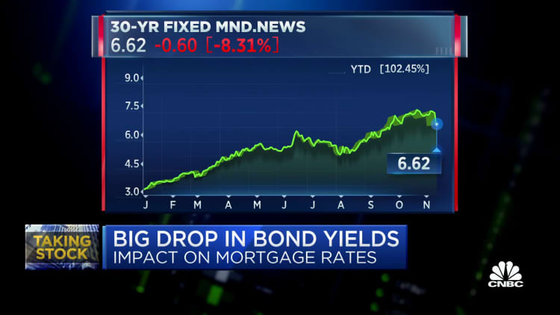

**WATCH NOW**

**VIDEO02:46**

**Big drop in bond yields impacts mortgage rates**

Mortgage rates fell sharply Thursday after a government report showed that [inflation had cooled in October](https://www.cnbc.com/2022/11/10/fed-officials-welcome-inflation-news-but-still-see-tighter-policy-ahead.html), prompting a decline in [bond yields](https://www.cnbc.com/quotes/US10Y/).

The average rate on the 30-year fixed plunged 60 basis points from 7.22% to 6.62%, according to Mortgage News Daily. That matches the record drop at the start of the Covid 19 pandemic. The rate, however, is still more than double what it was at the start of this year.

In turn, stocks of homebuilders such as Lennar, DR Horton and Pulte jumped, along with [broader market gains](https://www.cnbc.com/2022/11/09/stock-market-futures-open-to-close-news.html). Those stocks have been hammered by the sharp increase in rates over the past six months.

The Consumer Price Index rose in October at a slower pace than expected. As a result, bond yields dropped sharply, and mortgage rates followed, as they follow loosely the yield on the 10-year Treasury.

So what happens next?

“This is the best argument to date that rates are done rising, but confirmation requires next month’s CPI to tell the same story,” said Matthew Graham, chief operating officer of Mortgage News Daily. “This was always about needing two consecutive reports of this nature combined with acknowledgement from the Fed that the inflation narrative is shifting.”

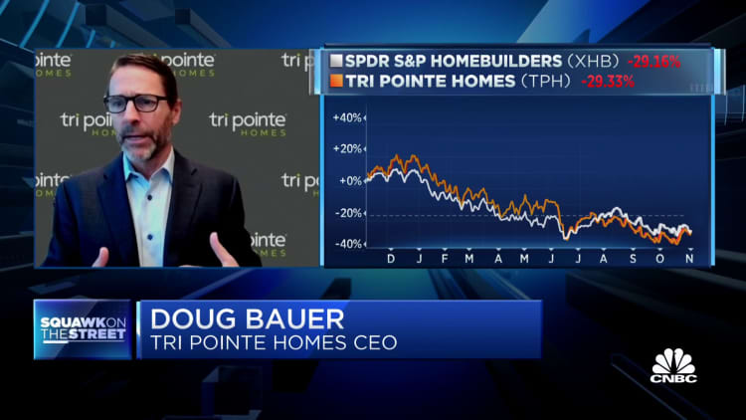

**WATCH NOW**

**VIDEO05:12**

**Housing is the canary in the coal mine, says Tri Pointe Homes CEO Doug Bauer**

But Graham said rates are not out of the woods yet. They are also unlikely to move dramatically lower, as there is still plenty of economic uncertainty both in U.S. and global financial markets.

**China eases Covid measures, trims quarantine time by two days**

**PUBLISHED FRI, NOV 11 202212:40 AM ESTUPDATED FRI, NOV 11 20222:52 AM EST**

thumbnail

[**Evelyn Cheng**](https://www.cnbc.com/evelyn-cheng/)[**@CHENGEVELYN**](https://twitter.com/chengevelyn)

**SHARE**Share Article via FacebookShare Article via TwitterShare Article via LinkedInShare Article via Email

**KEY POINTS**

* Instead of making travelers stay at a centralized quarantine facility for seven days upon arrival in the country, the new rules stipulate a five day quarantine, followed by three days of home observation, according to state media.
* The new timeframe also applied to close contacts of Covid infections within China, the report said.
* The number of Covid infections nationwide has surged in the last several days to the highest in about half a year.



**WATCH NOW**

**VIDEO02:38**

**China cuts quarantine time for international travelers by two days**

BEIJING — China reduced the quarantine time for international travelers by two days, state media said Friday.

Instead of making travelers stay at a centralized quarantine facility for seven days upon arrival in the country, the new rules stipulate a five day quarantine, according to state media. That’s followed by three days of home observation, unchanged from prior protocol.

The new timeframe also applied to close contacts of Covid infections within China, the report said.

In contact tracing, China said it will no longer track people beyond close contacts of Covid infections. Previously, people who were connected to those close contacts might face additional Covid restrictions.

The new measures reduced the number of regional risk designations to two from three — just low and high, the report said.

Overall, the new measures emphasized home quarantine instead of centralized quarantine.



**WATCH NOW**

**VIDEO01:31**

**China grapples with zero-Covid policy**

The measures also ended a policy that often resulted in the number of international flights, already operating at reduced levels, getting canceled.

The measures called for setting up a bubble for business people or sports teams entering China. People entering the bubble from China need to be vaccinated, and might need to quarantine once the event ends, the report said.

Shortly after the announcement, the [Hang Seng index](https://www.cnbc.com/quotes/.HSI/) soared and was up 7%, building on an earlier rally that followed U.S. data indicating relief from a recent surge in inflation.

Travel-related stocks saw a boost, with [China Eastern Airlines](https://www.cnbc.com/quotes/670-HK/) climbing 6% and [Cathay Pacific](https://www.cnbc.com/quotes/293-HK/) gaining almost 3% in the afternoon session.

Casino operators [MGM China](https://www.cnbc.com/quotes/2282-HK/), [Wynn Macau](https://www.cnbc.com/quotes/1128-HK/) and [Sands China](https://www.cnbc.com/quotes/1928-HK/) all saw shares gain around 8%.

China has stuck to its stringent zero-Covid policy, while the rest of the world has shifted to a “living with Covid” approach.

Beijing’s emphasis on what it calls “dynamic zero-Covid” has been implemented with significant variation at a local level, causing great uncertainty and dampening travel.

The number of Covid infections nationwide has [surged in the last several days](https://www.cnbc.com/2022/11/10/covid-outbreak-worsens-in-southern-chinese-city-of-guangzhou.html) to the highest in about half a year.

*— CNBC’s Jihye Lee contributed to this report.*

**Goldman Sachs CEO says he expects a ‘reopening’ in capital markets next year**

**PUBLISHED THU, NOV 10 20228:18 PM ESTUPDATED THU, NOV 10 20228:19 PM EST**

[**Krystal Hur**](https://www.cnbc.com/krystal-hur/)[**@KRYSHUR**](https://twitter.com/@kryshur)

**SHARE**Share Article via FacebookShare Article via TwitterShare Article via LinkedInShare Article via Email

**KEY POINTS**

* Goldman Sachs CEO David Solomon said Thursday that he expects capital markets to recover in the upcoming months.
* “I think what we’re going through at the moment is a reset of valuation expectations,” he said in an interview with CNBC’s Jim Cramer.

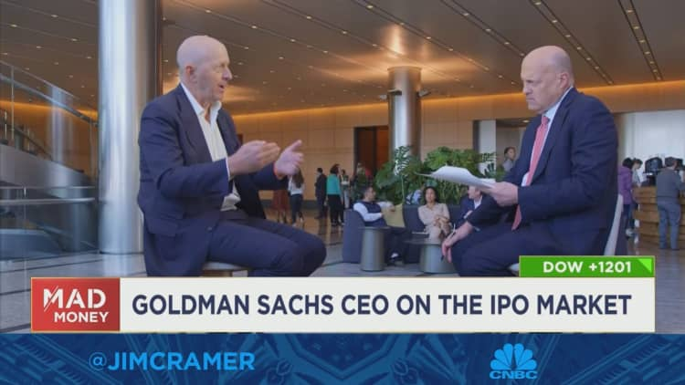

**WATCH NOW**

**VIDEO01:13**

**Goldman Sachs CEO says he expects a ‘reopening’ in capital markets next year**

[Goldman Sachs](https://www.cnbc.com/quotes/GS/) CEO David Solomon said Thursday that he expects capital markets to recover in the upcoming months.

“I think what we’re going through at the moment is a reset of valuation expectations,” he said in an interview with CNBC’s Jim Cramer. “In the coming months, we’ll see a little bit of a reopening in the capital markets when people get used to this valuation adjustment.”

While a low-interest rate environment allowed newly-minted companies to thrive and see their valuations swiftly balloon during the pandemic’s early stages, the initial public offerings market [nosedived this year](https://www.cnbc.com/2022/09/23/stock-market-ipos-went-from-boom-to-bust-in-2022.html). U.S.-listed companies raised $4.8 billion in proceeds during the first half of 2022 compared to $155 billion in 2021, [according to EY and Dealogic](https://assets.ey.com/content/dam/ey-sites/ey-com/en_gl/topics/ipo/ey-global-ipo-trends-q2-2022.pdf).

The main culprits include soaring inflation, the Federal Reserve’s interest-rate hikes, Russia’s invasion of Ukraine and Covid lockdowns that drove investors out of risky, high growth bets and into safer, defense stocks.

While those headwinds continue to persist, Solomon says the market is adjusting to its new reality.

“There’s always a backlog of companies that need to go public,” he said. “We’re three quarters into a more difficult capital markets environment. History would tell you, three, four, five, six quarters you get that readjustment.”

**Cramer’s lightning round: I no longer advocate that you should sell Activision Blizzard**

**PUBLISHED THU, NOV 10 20228:13 PM EST**

[**Krystal Hur**](https://www.cnbc.com/krystal-hur/)[**@KRYSHUR**](https://twitter.com/@kryshur)

**SHARE**Share Article via FacebookShare Article via TwitterShare Article via LinkedInShare Article via Email

**KEY POINTS**

* It’s that time again! “Mad Money” host Jim Cramer rings the lightning round bell, which means he’s giving his answers to callers’ stock questions at rapid speed.

**Advanced Micro Devices Inc (AMD)**

Share price year to date

WATCHLIST**+**

Chart

Line chart with 251 data points.

The chart has 1 X axis displaying Time. Range: 2022-01-03 00:00:00 to 2022-11-11 00:00:00.

The chart has 1 Y axis displaying values. Range: 50 to 175.

Mar ’22May ’22Jul ’22Sep ’22Nov ’225075100125150175cnbc.com

End of interactive chart.

[Advanced Micro Devices Inc](https://www.cnbc.com/quotes/AMD/): “We’ve cut the position back for my Charitable Trust. ... We’re happy and content to leave the rest and let it run up $8 today.”

**Medtronic PLC (MDT)**

Share price year to date

WATCHLIST**+**

Chart

Line chart with 251 data points.

The chart has 1 X axis displaying Time. Range: 2022-01-03 00:00:00 to 2022-11-11 00:00:00.

The chart has 1 Y axis displaying values. Range: 70 to 120.

Mar ’22May ’22Jul ’22Sep ’22Nov ’22708090100110120cnbc.com

End of interactive chart.

[Medtronic PLC](https://www.cnbc.com/quotes/MDT/): “I can’t recommend it. ... There are many better healthcare stocks out there.”

**Activision Blizzard Inc (ATVI)**

Share price year to date

WATCHLIST**+**

Chart

Line chart with 251 data points.

The chart has 1 X axis displaying Time. Range: 2022-01-03 00:00:00 to 2022-11-11 00:00:00.

The chart has 1 Y axis displaying values. Range: 60 to 85.

Mar ’22May ’22Jul ’22Sep ’22Nov ’22606570758085cnbc.com

End of interactive chart.

[Activision Blizzard Inc](https://www.cnbc.com/quotes/ATVI/): “I actually think that Activision Blizzard on its own right, at this point, could be worth what it’s selling for. And therefore, I no longer advocate that you should sell it.”

*Disclaimer: Cramer’s Charitable Trust owns shares of AMD.*

**Jim Cramer says a slowdown in the logistics industry suggests inflation could be coming down**

**PUBLISHED THU, NOV 10 20227:49 PM ESTUPDATED THU, NOV 10 20228:17 PM EST**

[**Krystal Hur**](https://www.cnbc.com/krystal-hur/)[**@KRYSHUR**](https://twitter.com/@kryshur)

**SHARE**Share Article via FacebookShare Article via TwitterShare Article via LinkedInShare Article via Email

**KEY POINTS**

* CNBC’s Jim Cramer on Thursday said that a cool-off in the logistics industry suggests that inflation could finally be cooling off.
* “We caught a real break today with a much lower-than-expected consumer price index number, and a huge part of that came down to how much it costs to get goods to the consumer,” he said.

**In this article**

* [**CHRWUNCH**](https://www.cnbc.com/quotes/CHRW)

Follow your favorite stocks**CREATE FREE ACCOUNT**

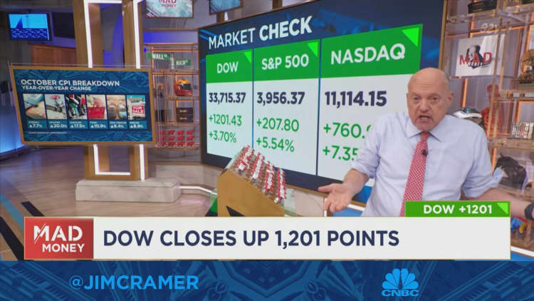

**WATCH NOW**

**VIDEO02:57**

**Jim Cramer on how the logistics industry drove inflation up**

CNBC’s Jim Cramer on Thursday said that inflation could finally be cooling off as the freight industry’s pandemic boom wanes.

“We caught a real break today with a much lower-than-expected consumer price index number, and a huge part of that came down to how much it costs to get goods to the consumer,” he said.

“Why would the Fed need to keep tightening ever harder if the root cause of inflation, moving stuff from place to place, is finally going in the right direction?” he added.

ADVERTISING

Stocks saw their biggest rally since 2020 on Thursday after October’s consumer price index data [came in lighter than expected](https://www.cnbc.com/2022/11/10/consumer-prices-rose-0point4percent-in-october-less-than-expected-as-inflation-eases.html), raising hopes that inflation could be peaking.

“When you look at all the positives that went … into today’s CPI reading, you keep coming back knowing it was just hard to move goods around,” which led to inflated prices for consumers,Cramer said.

[FreightWaves reported on Wednesday](https://www.freightwaves.com/news/ch-robinson-to-lay-off-up-to-1200-employees-sources-say) that logistics giant C.H. Robinson is laying off employees to cut costs and adjust for macroeconomic headwinds. This move comes after CEO Bob Biesterfeld said in the company’s post-earnings conference call on Nov. 2 that the company “got ahead of ourselves in terms of headcount.”

He added that the company is seeing a slowdown in demand for freight along with weakness in retail and housing, and expects freight markets to continue coming down from pandemic highs.

Cramer said that he expects inflation to continue to cool when supply costs for the freight industry such as labor and equipment decline more.

“They needed more trucks, more drivers, more fuel, so the cost of everything went up and they had to pass it on,” Cramer explained. “C.H. Robinson can’t charge as much when these costs go down. That’s where the big deflation gain really kicks in,” he added.

**Nio reports strong third-quarter revenue as it gears up for a big year-end production push**

**PUBLISHED THU, NOV 10 20226:40 AM ESTUPDATED THU, NOV 10 20224:18 PM EST**

thumbnail

[**John Rosevear**](https://www.cnbc.com/john-rosevear/)[**@JOHN__ROSEVEAR**](https://twitter.com/john__rosevear)

**SHARE**Share Article via FacebookShare Article via TwitterShare Article via LinkedInShare Article via Email

**KEY POINTS**

* Nio reported a third-quarter loss that was much greater than a year ago, but revenue surged.
* Nio’s gross margins have been squeezed by rising costs and lower sales of regulatory credits.
* Demand has been strong for its new ET5 sedan, and the company expects a record fourth quarter.

**In this article**

* [**9866-HK+14.35 (+20.40%)**](https://www.cnbc.com/quotes/9866-HK)

Follow your favorite stocks**CREATE FREE ACCOUNT**



**Employees stand next to a ET7 sedan at a NIO Inc. dealership in Shanghai, China, on Wednesday, June 8, 2022.**

*Qilai Shen | Bloomberg | Getty Images*

Chinese electric vehicle maker [Nio](https://www.cnbc.com/quotes/NIO/) on Thursday reported a loss of $577.9 million for the third quarter, significantly wider than a year ago, despite strong revenue following a 29% increase in vehicle sales.

Here are the key numbers from Nio’s [third-quarter earnings report](https://ir.nio.com/news-events/news-releases/news-release-details/nio-inc-reports-unaudited-third-quarter-2022).

* **Revenue:** $1.83 billion, up 32.6% from the third quarter of 2021.
* **Adjusted loss per share:** 30 cents, versus 6 cents per share in the year-ago period.
* **Cash at quarter end:** $7.2 billion, down from [$8.1 billion as of June 30](https://www.cnbc.com/2022/09/07/nio-reports-wider-second-quarter-loss-despite-increase-in-ev-shipments.html).

Shares of the company closed up over 11% on Thursday.

Nio said on Oct. 1 that it [delivered 31,607 vehicles](https://ir.nio.com/news-events/news-releases/news-release-details/nio-inc-provides-september-and-third-quarter-2022) in the third quarter, up 29% from the third quarter of 2021 and a record for the company.

Nio’s gross margin was 13.3%, slightly improved versus the 13% margin it reported in the second quarter, but down from 20.3% a year ago. Nio said the year-over-year margin decline was due to lower sales of regulatory credits, higher costs that have squeezed margins on its vehicles, and higher spending on its charging and service networks.

CEO William Bin Li said in a statement that the company has seen strong interest in its [new ET5 sedan](https://www.cnbc.com/2021/12/18/chinese-electric-car-start-up-nio-reveals-a-new-sedan-ar-vr-glasses.html), which he expects “will support a substantial acceleration of our overall revenue growth in the fourth quarter of 2022.” The ET5, the company’s second sedan, began shipping in September.

With the ET5 now available, Nio is working to increase production and shorten customer waiting times, Li said. Nio said that investors should expect it to deliver 43,000 and 48,000 vehicles in the fourth quarter, generating total revenue between RMB17,368 million ($2.4 billion) and RMB19,225 million ($2.7 billion).

**Judge rejects Walmart’s request for new trial after firing of employee with Down syndrome**

**PUBLISHED WED, NOV 9 20224:40 PM EST**

thumbnail

[**Melissa Repko**](https://www.cnbc.com/melissa-repko/)[**@MELISSA_REPKO**](https://twitter.com/melissa_repko)

**SHARE**Share Article via FacebookShare Article via TwitterShare Article via LinkedInShare Article via Email

**KEY POINTS**

* A federal judge dismissed Walmart’s request for a new trial in a disability discrimination lawsuit.
* A jury found last year that the retailer wrongfully fired Marlo Spaeth, a woman with Down syndrome who worked for nearly 16 years in a Walmart Supercenter.
* A Walmart spokesman said the company is “reviewing the opinion and considering our options.”



**Marlo Spaeth (left) was fired from Walmart in July 2015, after working there for nearly 16 years. Her sister, Amy Jo Stevenson, has been in a legal battle with the retail giant since then. She filed a discrimination complaint with the U.S. Equal Employment Opportunity Commission.**

*Amy Jo Stevenson*

A federal judge has rejected [Walmart’s](https://www.cnbc.com/quotes/WMT/) request for a new trial [after a jury found the retailer discriminated against a longtime employee](https://www.cnbc.com/2021/07/16/walmart-loses-eeoc-disability-discrimination-lawsuit.html) with Down syndrome by refusing to adjust her schedule and firing her.

In a court filing on Monday, the judge [stood by the July 2021](https://www.cnbc.com/2021/07/16/walmart-loses-eeoc-disability-discrimination-lawsuit.html) ruling. A jury found that Walmart violated the law by terminating Marlo Spaeth, an employee who [folded towels, tidied aisles and helped customers for nearly 16 years](https://www.cnbc.com/2021/07/23/walmart-worker-with-down-syndrome-fought-the-giant-retailer.html) in a Walmart Supercenter in Manitowoc, Wisconsin.

It ordered Walmart, the nation’s largest private employer, to pay more than $125 million in damages — one of the highest ever for a single victim won by the U.S. Equal Employment Opportunity Commission. The federal agency filed the disability discrimination suit on Spaeth’s behalf.

Damages were reduced by the judge to $300,000, the maximum allowed under the law.

The judge also ordered Walmart earlier this year [to give Spaeth more than $50,000 in back pay](https://www.cnbc.com/2022/03/09/judge-orders-walmart-to-reinstate-worker-with-down-syndrome.html) and immediately rehire her, if she is interested in the job.

The judge’s denial is the latest in [a seven-year battle between Spaeth’s family and Walmart.](https://www.cnbc.com/2021/07/23/walmart-worker-with-down-syndrome-fought-the-giant-retailer.html)

“The court has concluded that a reasonable jury could find that Walmart was aware that Spaeth needed an accommodation because of her disability,” Judge William Griesbach wrote in the Monday court filing. “The jury was well situated to answer that factual question, and this court will not disturb that conclusion.”

Spaeth’s sister, Amy Jo Stevenson told CNBC on Wednesday that the judge’s ruling is a relief. Yet she said she is still looking for closure.

Spaeth’s firing permanently shook up their lives and took away her sister’s sense of purpose, Stevenson said. Spaeth has also struggled with depression, and despite the historic jury award, “still hasn’t seen a penny,” Stevenson added.

The dispute began when the retailer adopted a computerized scheduling system and changed Spaeth’s longstanding work shift. Spaeth could not adjust to the schedule because of her disability, Stevenson told the jury. The change in hours kept Spaeth from taking the same bus and getting home in time for dinner. Instead of adjusting Spaeth’s shift to her old hours, Walmart fired her in July 2015.

Walmart contested the jury’s verdict and asked the judge to toss the damages. Among its arguments, Walmart said the federal agency did not prove the retailer knew Spaeth’s scheduling challenges were related to her Down syndrome.

Griesbach poked holes in that, saying the trial included plenty of evidence that “Spaeth’s limitations and need for an accommodation were obvious.” Some of that evidence came from Walmart’s own managers, who testified that Spaeth needed extra help when the company changed her work routine.

Walmart could appeal the case. Walmart spokesman Randy Hargrove said the company is “reviewing the opinion and considering our options.”

Stevenson said she is eager to receive the check, so she knows the years-long court battle is behind them. She plans to put it toward experiences that enrich her sister’s life — such as concert tickets, a new bowling ball or a trip to the Country Music Hall of Fame.

Since the firing, music has been one of Spaeth’s few joys, she said.

Stevenson said it is exhausting to see Walmart keep fighting the jury’s verdict.

“It blows my mind that they have yet to own up to anything,” she said. “I don’t expect them ever to at this point.”

**Stocks making the biggest moves premarket: Tapestry, WeWork, Rivian and others**

**PUBLISHED THU, NOV 10 20227:43 AM EST**

thumbnail

[**Peter Schacknow**](https://www.cnbc.com/peter-schacknow/)[**@PETERSCHACK**](https://twitter.com/peterschack)

**SHARE**Share Article via FacebookShare Article via TwitterShare Article via LinkedInShare Article via Email

**In this article**

* [**BROS-0.08 (-0.22%)**](https://www.cnbc.com/quotes/BROS)
* [**RIVN-0.15 (-0.43%)**](https://www.cnbc.com/quotes/RIVN)
* [**SIX+0.06 (+0.25%)**](https://www.cnbc.com/quotes/SIX)
* [**WE-0.11 (-3.63%)**](https://www.cnbc.com/quotes/WE)
* [**9866-HK+14.35 (+20.40%)**](https://www.cnbc.com/quotes/9866-HK)
* [**TPRUNCH**](https://www.cnbc.com/quotes/TPR)

Follow your favorite stocks**CREATE FREE ACCOUNT**

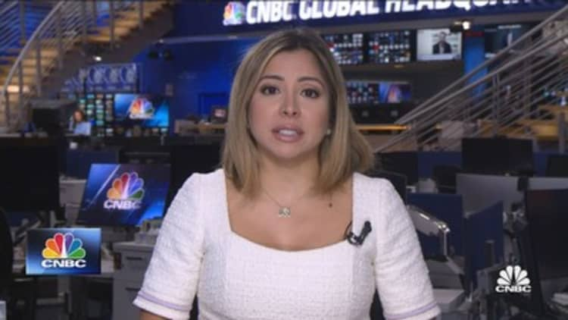

**WATCH NOW**

**VIDEO01:27**

**News Update – Pre-Markets**

*Check out the companies making headlines before the bell:*

[Tapestry](https://www.cnbc.com/quotes/TPR/) (TPR) – The company behind the Coach and Kate Spade brands beat top and bottom line estimates for its latest quarter, but cut its full-year forecast for the impact of the strong U.S. dollar and China’s Covid-19 restrictions. Tapestry slid 2% in premarket trading.

[Nio](https://www.cnbc.com/quotes/NIO/) (NIO) – The China-based electric car maker posted a wider-than-expected quarterly loss, but said it expected deliveries to nearly double in the current quarter from a year ago. Nio shares jumped 5.5% in premarket trading.

[WeWork](https://www.cnbc.com/quotes/WE/) (WE) – The office-sharing company’s stock fell 1.7% in the premarket after it reported a wider-than-expected quarterly loss. WeWork also plans to exit about 40 underperforming locations this month.

[Six Flags](https://www.cnbc.com/quotes/SIX/) (SIX) – The theme park operator’s stock initially dipped in premarket trading after it missed top and bottom line estimates for its latest quarter. However, it rebounded to a 2.9% gain after announcing an agreement with investment firm H Partners that raised the cap on H Partners’ stake in the company to 19.9% from 14.9%.

[Rivian](https://www.cnbc.com/quotes/RIVN/) (RIVN) – Rivian rallied 8.2% in off-hours trading after the electric vehicle maker reported a narrower-than-expected quarterly loss and kept its production schedule intact, even in the face of supply chain issues.

[Dutch Bros](https://www.cnbc.com/quotes/BROS/) (BROS) – Dutch Bros stock jumped 3.8% in the premarket after the operator of hand-crafted beverage shops reported better-than-expected profit and revenue for its latest quarter. The company also raised its full-year revenue outlook.

[AstraZeneca](https://www.cnbc.com/quotes/AZN/) (AZN) – AstraZeneca gained 4.8% in premarket trading after the drug maker reported upbeat quarterly results and raised its full-year profit forecast. AstraZeneca’s results got a boost from strong sales of its cancer drugs.

[Bumble](https://www.cnbc.com/quotes/BMBL/) (BMBL) – Bumble slumped 14% in premarket action after issuing a weak current-quarter revenue forecast. The dating service operator said its users are renewing subscriptions at a slower rate as consumers cut back on discretionary spending in the face of inflation.

[Fair Isaac](https://www.cnbc.com/quotes/FICO/) (FICO) – Fair Isaac staged a 10.4% rally in the premarket after its quarterly earnings beat analyst estimates and revenue grew in both its credit score and software units. The company, known for FICO credit scores, also gave an upbeat full-year forecast.

[ZipRecruiter](https://www.cnbc.com/quotes/ZIP/) (ZIP) – ZipRecruiter surged 12.6% in premarket trading after the online jobs site operator posted better-than-expected quarterly results and raised its full-year forecast. ZipRecruiter also announced a $200 million increase in its share repurchase program.

**5 things to know before the stock market opens Thursday**

**PUBLISHED THU, NOV 10 20227:12 AM ESTUPDATED THU, NOV 10 20228:37 AM EST**

thumbnail

[**Mike Calia**](https://www.cnbc.com/mike-calia/)[**@NEWSMC615**](https://twitter.com/NewsMC615)

**SHARE**Share Article via FacebookShare Article via TwitterShare Article via LinkedInShare Article via Email

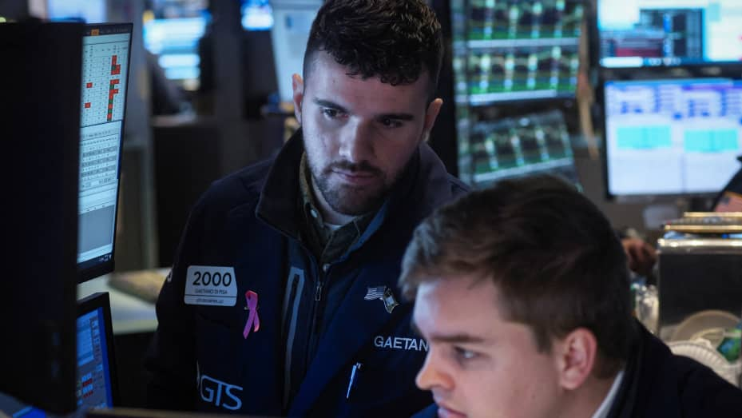

**Traders work on the floor of the New York Stock Exchange (NYSE) in New York City, U.S., November 9, 2022.**

*Brendan Mcdermid | Reuters*

*Here are the most important news items that investors need to start their trading day:*

**1. A lot to process**

Markets sold off Wednesday as investors sought something solid to hold onto during this uncertain time. The midterm elections might not have yielded a GOP “red wave,” but control of Congress is [still up in the air](https://www.cnbc.com/2022/11/09/live-updates-of-2022-midterm-election-day.html). Companies are still churning through earnings reports – big retailers are up next week – and there are some major economic data points to digest as the Federal Reserve pushes ahead with its battle against inflation. The consumer price index grew [less than expected in October](https://www.cnbc.com/2022/11/10/consumer-prices-rose-0point4percent-in-october-less-than-expected-as-inflation-eases.html), although it was still hot. “As everyone knows, markets really don’t like uncertainty,” said Chris Zaccarelli, chief investment officer at the Independent Advisor Alliance, according to CNBC’s [markets live blog](https://www.cnbc.com/2022/11/09/stock-market-futures-open-to-close-news.html).

**2. Bye-nance**



**Sam Bankman-Fried**

*Tom Williams | CQ-Roll Call, Inc. | Getty Images*

Sam Bankman-Fried’s crypto empire needed a savior. For a day, it looked like Changpeng Zhao, CEO of the world’s biggest crypto firm, Binance, would be his white knight. Binance said it would prop up Bankman-Fried’s liquidity-squeezed FTX. But then ... [nevermind](https://www.cnbc.com/2022/11/09/binance-backs-out-of-ftx-rescue-leaving-the-crypto-exchange-on-the-brink-of-collapse.html), said Binance. “In the beginning, our hope was to be able to support FTX’s customers to provide liquidity,” Binance said Wednesday. “But the issues are beyond our control or ability to help.” Now, FTX, which was valued at $32 billion earlier this year, is on the brink of a wipeout – a stunning fall from grace for Bankman-Fried and his company, which itself had become known as a savior to failing crypto firms.

**3. Bloodletting at the banks**

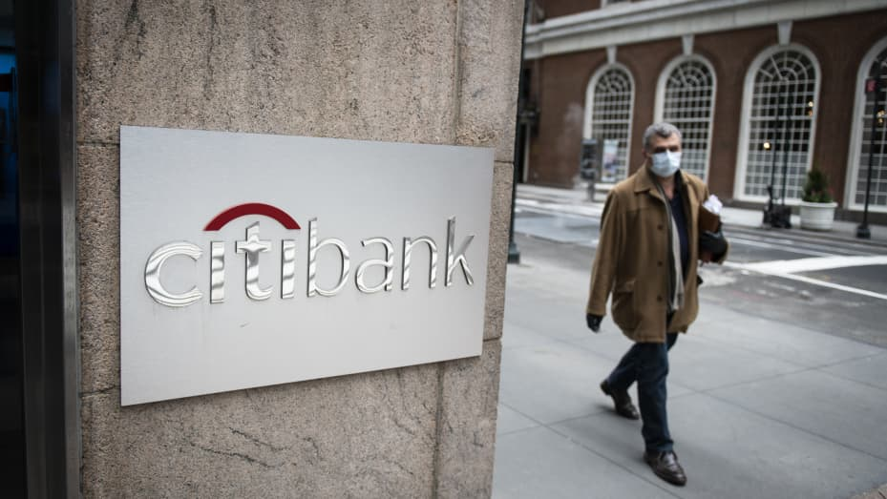

**A pedestrian wearing a protective mask walks past a Citibank branch in New York on Friday, April 10, 2020.**

*Bloomberg*

Job cuts at big banks are [picking up steam](https://www.cnbc.com/2022/11/09/wall-street-layoffs-pick-up-steam-as-citigroup-and-barclays-cut-hundreds-of-workers.html), as deal-making remains frozen in market conditions beset by uncertainty and rising interest rates, according to CNBC’s Hugh Son. [Citigroup](https://www.cnbc.com/quotes/C/) and Barclays rolled out dozens of layoffs this week, following hundreds of cuts at Goldman Sachs in September and ongoing terminations at struggling Credit Suisse. [JPMorgan Chase](https://www.cnbc.com/quotes/JPM/) is looking to potential job cuts at the end of the year as it seeks to shrink costs, and [Morgan Stanley](https://www.cnbc.com/quotes/MS/) is also examining possible layoffs. “Most of the banks are budgeting for declines in revenue next year,” a person involved with providing data and analytics to the banking industry told CNBC.

**4. A huge loss for Russia**



**Damaged parts of Velyka Oleksandrivka town, in the Kherson region, on Oct. 24, 2022.**

*Anadolu Agency | Anadolu Agency | Getty Images*

Russian forces are withdrawing from Kherson, in the southern part of Ukraine. It’s the latest embarrassing defeat for Vladimir Putin and his invasion of Russia’s former Soviet neighbor. Kherson was one of the areas Russia claimed in its illegal annexation of Ukrainian territory. Knowing the area’s importance to Russia, Ukraine President Volodomyr Zelenskyy greeted the news of the withdrawal with caution and wondered whether Putin’s armies were setting a trap. He also said, without offering further detail, that his forces are planning more operations to force Russian troops off Ukrainian soil. Read live war updates [here](https://www.cnbc.com/2022/11/10/russia-ukraine-war-updates.html).

**5. The crying of lot MSFT**



**Paul Cezanne’s “La Montagne Sainte-Victoire” is auctioned from Paul Allen’s collection at Christie’s in New York on Nov. 9, 2022.**

*Robert Frank | CNBC*

$1.5 billion? In this economy? Sure, why not. A large chunk of Microsoft co-founder Paul Allen’s art collection, which features pieces spanning 500 years, [was sold at auction Wednesday night](https://www.cnbc.com/2022/11/10/microsoft-co-founder-paul-allen-art-tops-1point5-billion-at-auction.html) to the tune of nearly $1.51 billion. That easily tops the $922 million paid for the Harry and Linda Macklowe collection, the previous record holder. Allen’s collection includes works by legendary artists Vincent van Gogh, Edward Steichen and Gustav Klimt. Georges Seurat’s “Les Poseuses, Ensemble” sold for $149.2 million, the biggest score of the night. All told, five works went for over $100 million. More items from Allen’s collection are due to hit the block Thursday. The proceeds will go to charity.

*– CNBC’s Alex Harring, MacKenzie Sigalos, Kate Rooney, Hugh Son, Holly Ellyatt and Robert Frank contributed to this report.*

**Rivian seeks to cut costs while boosting EV production to meet 2022 targets**

**PUBLISHED WED, NOV 9 20224:22 PM ESTUPDATED WED, NOV 9 20226:00 PM EST**

thumbnail

[**John Rosevear**](https://www.cnbc.com/john-rosevear/)[**@JOHN__ROSEVEAR**](https://twitter.com/john__rosevear)

**SHARE**Share Article via FacebookShare Article via TwitterShare Article via LinkedInShare Article via Email

**KEY POINTS**

* Electric vehicle maker Rivian Automotive on Wednesday reaffirmed its 25,000-vehicle production target for 2022.
* It said it plans to spend less to do it as the company reported third-quarter revenue that fell short of Wall Street’s estimate.
* Rivian said it now has “over 114,000” preorders for its R1-series trucks and SUVs.

**In this article**

* [**RIVN-0.15 (-0.43%)**](https://www.cnbc.com/quotes/RIVN)

Follow your favorite stocks**CREATE FREE ACCOUNT**

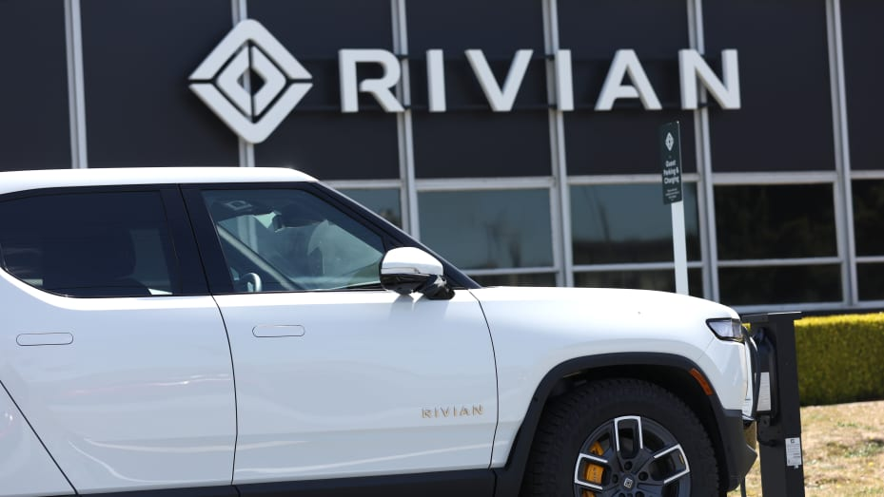

**Rivian electric pickup trucks sit in a parking lot at a Rivian service center on May 09, 2022 in South San Francisco, California.**

*Justin Sullivan | Getty Images*

Electric vehicle maker [Rivian Automotive](https://www.cnbc.com/quotes/RIVN/) on Wednesday reaffirmed its 25,000-vehicle production target for 2022, but said it plans to spend less to do it as the company reported third-quarter revenue that fell short of Wall Street’s expectations.

Rivian cut its guidance for 2022 capital expenditures: It now expects its full-year capital expenditures to total about $1.75 billion, down from the $2 billion it guided to after the second quarter, as it shifts some planned spending to next year.

The company still expects its full-year adjusted loss before income, taxes, depreciation and amortization to come in at $5.4 billion, in line with the guidance it gave in August.

Shares of the company rose 7% in after-hours trading.

Here are the key numbers from Rivian’s [third-quarter earnings report,](https://assets.rivian.com/2md5qhoeajym/6v7zO1FRJBVJvAvTe57y0A/2a3644c5b07a914feb637d348fb002b6/Rivian_Q3-2022_Shareholder-Letter.pdf) compared with average Wall Street analyst expectations as complied by Refinitiv:

* **Revenue:** $536 million, versus $551.6 million expected.
* **Adjusted loss per share:** $1.57, versus an expected loss of $1.82 per share.

Rivian’s net loss for the third quarter was about $1.72 billion, a wider loss than the $1.23 billion it reported a year earlier.

As of September 30, the company had about $13.8 billion in cash remaining, down from $15.5 billion as of June 30. Rivian said while inflation has been a factor in its supply chain, it’s taking steps to reduce costs and slow spending on future product. It reiterated that it’s “confident” its cash hoard will last through 2025.

As part of its moves to slow spending, the company now expects to launch its upcoming smaller product platform, called R2, in 2026 rather than in 2025 as it had previously said. The R2 will be built in a new factory in Georgia.

Rivian said it now has “over 114,000” preorders for its R1-series trucks and SUVs, up from [about 98,000 preorders](https://www.cnbc.com/2022/08/11/rivian-rivn-earnings-q2-2022.html) as of Aug. 11. Those totals don’t include the [100,000 electric delivery vans](https://www.cnbc.com/2020/10/08/amazon-new-electric-delivery-vans-created-with-rivian-unveiled.html) ordered by [Amazon](https://www.cnbc.com/quotes/AMZN/) in 2020.

Rivian said it’s added a second shift of workers at its Illinois factory, a key step toward boosting production volumes. It noted that the new workers are still coming online — but said that the second shift is already producing vehicles.

Rivian said on Oct. 3 that it [produced 7,363 vehicles in the third quarter](https://www.cnbc.com/2022/10/03/rivian-production-grows-67percent-in-3q-confirms-2022-goals.html) and delivered 6,584 vehicles to customers during the period. Year to date, through the third quarter, Rivian produced 14,317 vehicles.

The automaker also said Wednesday that with production volumes increasing, it has moved to shipping its vehicles by rail, rather than by truck. That change has reduced costs, but it also means that new vehicles may take more time to get to customers after being produced. Because of that lag, Rivian said, the gap between its quarterly production and delivery totals may increase going forward.

**Rocket Lab reports record quarterly revenue, with added contract wins**

**PUBLISHED WED, NOV 9 20225:24 PM ESTUPDATED WED, NOV 9 20226:36 PM EST**

thumbnail

[**Michael Sheetz**](https://www.cnbc.com/michael-sheetz/)[**@THESHEETZTWEETZ**](https://twitter.com/thesheetztweetz)

**SHARE**Share Article via FacebookShare Article via TwitterShare Article via LinkedInShare Article via Email

**KEY POINTS**

* Rocket Lab delivered quarterly results on Wednesday that boasted record revenue, with the space company tacking on additional contract wins across its business.
* The company reported third-quarter revenue of $63.1 million, up 14% from the second quarter.
* The spacecraft and components business won a number of contracts during the third quarter as well.

**In this article**

* [**RKLB+0.06 (+1.07%)**](https://www.cnbc.com/quotes/RKLB)

Follow your favorite stocks**CREATE FREE ACCOUNT**



**An Electron rocket launches from the company’s New Zealand facility on Nov. 4, 2022.**

*Rocket Lab*

[Rocket Lab](https://www.cnbc.com/quotes/RKLB/) delivered quarterly results on Wednesday that boasted record revenue, with the space company tacking on additional contract wins across its business.

“The quarter ended strongly for Rocket Lab,” CEO Peter Beck said on the company’s conference call with investors.

The company reported third-quarter revenue of $63.1 million, up 14% from the second quarter, with an adjusted EBITDA loss of $6.9 million – which was 62% lower than the third quarter a year ago. It had $333.3 million in cash on hand at the quarter’s end.

Rocket Lab stock is down 61% this year as of Wednesday’s close of $4.74 a share.

[*Sign up here to receive weekly editions of CNBC’s Investing in Space newsletter*](https://www.cnbc.com/spacenewsletter/)*.*

The space venture conducted three successful Electron rocket missions from its New Zealand facility during the quarter, bringing in $23 million in revenue. Rocket Lab has completed a company record of nine launches so far this year.

It expects to complete the first Electron launch from the U.S., a long-awaited mission from NASA’s Wallops facility in Virginia, in December after receiving a key certification from the space agency. That flight will launch satellites for HawkEye 360, the first of three launches contracted through Rocket Lab to deliver 15 satellites to orbit.

The company also expects to conduct a second Electron launch from Virginia within “weeks” of the first, for “an undisclosed satellite constellation operator.”

Rocket Lab’s broader Space Systems division brought in $40.1 million in revenue during the period. The spacecraft and components business won a number of contracts during the third quarter as well.

The company expanded on an existing contract with space company MDA, to support the [Globalstar](https://www.cnbc.com/quotes/GSAT/) constellation that is being heavily utilized by [Apple](https://www.cnbc.com/quotes/AAPL/) for iPhone satellite connectivity – with Rocket Lab building spacecraft, solar panels and radios. It will also operate a spacecraft control center as part of the agreement.

The company also won a pair of contracts worth $14 million to provide satellite separation systems for satellites being built by two companies for the Pentagon’s Space Development Agency, as well as a U.S. Space Force contract to supply solar power for three missile-warning satellites.

Additionally, Rocket Lab signed a research agreement with the Pentagon’s United States Transport Command to “explore cargo transport use” with its rockets.

Rocket Lab has begun production of the hardware for its forthcoming, larger Neutron rocket. Given needed research and development spending, Rocket Lab CFO Adam Spice said that “achieving and sustaining profitability can really only happen once we’ve gotten the majority” of work on Neutron completed. The rocket is expected to debut in 2024.

Beck emphasized on the call how [work to reuse its existing Electron rockets](https://www.cnbc.com/2022/11/04/rocket-lab-live-stream-company-attempts-electron-booster-catch-with-helicopter.html) will help make the next-generation vehicle successful.

“I wouldn’t be wanting to develop a reusable rocket without having all of this knowledge and experience of reentering launch vehicles,” Beck said.

The company forecast lower revenue for the fourth quarter, guiding to a range of $51 million to $54 million, citing an unspecified customer launch that was delayed to 2023.

Spice noted that Rocket Lab expects to conduct about 14 Electron launches next year.

**Disney plans targeted hiring freeze and job cuts, according to a memo from CEO Bob Chapek**

**PUBLISHED FRI, NOV 11 20224:51 PM ESTUPDATED FRI, NOV 11 20225:43 PM EST**

thumbnail

[**Alex Sherman**](https://www.cnbc.com/alex-sherman/)[**@SHERMAN4949**](https://twitter.com/sherman4949)

**SHARE**Share Article via FacebookShare Article via TwitterShare Article via LinkedInShare Article via Email

**KEY POINTS**

* Disney plans to freeze hiring and cut some jobs, according to an internal memo.
* The move comes after Disney reported disappointing quarterly results, sending the company’s stock down to a new 52-week low.
* Disney CEO Bob Chapek sent a memo to division leaders Friday afternoon.

**In this article**

* [**DIS+0.27 (+0.28%)**](https://www.cnbc.com/quotes/DIS)

Follow your favorite stocks**CREATE FREE ACCOUNT**



**In this photo illustration a close-up of a hand holding a TV remote control seen displayed in front of the Disney+ logo.**

*Thiago Prudencio | SOPA Images | LightRocket | Getty Images*

[Disney](https://www.cnbc.com/quotes/DIS/) plans to institute a targeted hiring freeze as well as some job cuts, according to an internal memo sent to executives.

“We are limiting headcount additions through a targeted hiring freeze,” CEO Bob Chapek said in a memo to division leads sent Friday and obtained by CNBC. “Hiring for the small subset of the most critical, business-driving positions will continue, but all other roles are on hold. Your segment leaders and HR teams have more specific details on how this will apply to your teams.”

**RELATED INVESTING NEWS**



[**Investors have been fleeing Big Tech for ‘old economy’ stocks. Here’s what it means for our holdings**](https://www.cnbc.com/2022/11/11/investors-fleeing-big-tech-for-old-economy-heres-what-it-means.html)

[**Paulina Likos**](https://www.cnbc.com/paulina-likos/)

**16 HOURS AGO**

He added: “As we work through this evaluation process, we will look at every avenue of operations and labor to find savings, and we do anticipate some staff reductions as part of this review.” Disney has approximately 190,000 employees.

ADVERTISING

Chapek also told executives business travel should be limited to essential trips only. Meetings should be conducted virtually as much as possible, he wrote in the memo.

Disney is also establishing “a cost structure taskforce” to be made up of Chief Financial Officer Christine McCarthy, General Counsel Horacio Gutierrez and Chapek.

“I am fully aware this will be a difficult process for many of you and your teams,” Chapek wrote. “We are going to have to make tough and uncomfortable decisions. But that is just what leadership requires, and I thank you in advance for stepping up during this important time.”

The moves come after Disney reported [disappointing quarterly results](https://www.cnbc.com/2022/11/08/disney-dis-earnings-q4-2022.html). Shares of the company fell sharply Wednesday, hitting a new 52-week low, before rebounding later in the week.

McCarthy said during Disney’s earnings call Tuesday that the company was looking for ways to trim costs.

“We are actively evaluating our cost base currently, and we’re looking for meaningful efficiencies,” she said. “Some of those are going to provide some near-term savings, and others are going to drive longer-term structural benefits.”

Disney’s streaming services [lost $1.47 billion last quarter](https://www.cnbc.com/2022/11/08/disney-gets-hit-by-media-worlds-shift-to-emphasize-profit-and-revenue-over-subscriber-growth-.html), more than double the unit’s loss from a year prior. McCarthy said losses will improve in 2023, and Chapek has promised streaming will become profitable by the end of 2024.

Other large media and entertainment companies, including [Warner Bros. Discovery](https://www.cnbc.com/quotes/WBD/) and [Netflix](https://www.cnbc.com/quotes/NFLX/), have cut jobs this year as valuations have slumped. Disney hasn’t announced any plans to eliminate jobs.

The full memo can be read here:

Disney Leaders-

As we begin fiscal 2023, I want to communicate with you directly about the cost management efforts Christine McCarthy and I referenced on this week’s earnings call. These efforts will help us to both achieve the important goal of reaching profitability for Disney+ in fiscal 2024 and make us a more efficient and nimble company overall. This work is occurring against a backdrop of economic uncertainty that all companies and our industry are contending with.

While certain macroeconomic factors are out of our control, meeting these goals requires all of us to continue doing our part to manage the things we can control—most notably, our costs. You all will have critical roles to play in this effort, and as senior leaders, I know you will get it done.

To be clear, I am confident in our ability to reach the targets we have set, and in this management team to get us there.

To help guide us on this journey, I have established a cost structure taskforce of executive officers: our CFO, Christine McCarthy and General Counsel, Horacio Gutierrez. Along with me, this team will make the critical big picture decisions necessary to achieve our objectives.

We are not starting this work from scratch and have already set several next steps—which I wanted you to hear about directly from me.

First, we have undertaken a rigorous review of the company’s content and marketing spending working with our content leaders and their teams. While we will not sacrifice quality or the strength of our unrivaled synergy machine, we must ensure our investments are both efficient and come with tangible benefits to both audiences and the company.

Second, we are limiting headcount additions through a targeted hiring freeze. Hiring for the small subset of the most critical, business-driving positions will continue, but all other roles are on hold. Your segment leaders and HR teams have more specific details on how this will apply to your teams.

Third, we are reviewing our SG&A costs and have determined that there is room for improved efficiency—as well as an opportunity to transform the organization to be more nimble. The taskforce will drive this work in partnership with segment teams to achieve both savings and organizational enhancements. As we work through this evaluation process, we will look at every avenue of operations and labor to find savings, and we do anticipate some staff reductions as part of this review. In the immediate term, business travel should now be limited to essential trips only. In-person work sessions or offsites requiring travel will need advance approval and review from a member of your executive team (i.e., direct report of the segment chairman or corporate executive officer). As much as possible, these meetings should be conducted virtually. Attendance at conferences and other external events will also be restricted and require approvals from a member of your executive team.

Our transformation is designed to ensure we thrive not just today, but well into the future—and you will hear more from our taskforce in the weeks and months ahead.

I am fully aware this will be a difficult process for many of you and your teams. We are going to have to make tough and uncomfortable decisions. But that is just what leadership requires, and I thank you in advance for stepping up during this important time. Our company has weathered many challenges during our 100-year history, and I have no doubt we will achieve our goals and create a more nimble company better suited to the environment of tomorrow.

Thank you again for your leadership.

-Bob

**Covid outbreak worsens in southern Chinese city of Guangzhou**

**PUBLISHED THU, NOV 10 20222:58 AM ESTUPDATED THU, NOV 10 20223:13 AM EST**

thumbnail

[**Evelyn Cheng**](https://www.cnbc.com/evelyn-cheng/)[**@CHENGEVELYN**](https://twitter.com/chengevelyn)

**SHARE**Share Article via FacebookShare Article via TwitterShare Article via LinkedInShare Article via Email

**KEY POINTS**

* Schools in eight of 11 districts in the city of Guangzhou moved classes online for most students as of Thursday.
* It was not immediately clear to what extent the latest business restrictions affected the ability of factories to operate.
* For businesses traveling to and from China’s capital city, getting a “pop-up window” on Beijing’s health code app is their greater source of worry.



**Guangzhou city in the southern province of Guangdong is the hardest hit in the latest Covid outbreak. Pictured here are closed stores in part of the city on Oct. 31, 2022.**

*Vcg | Visual China Group | Getty Images*

BEIJING — Covid infections are surging in the capital of China’s export-heavy Guangdong province, raising concerns of another drag on the national economy.

Schools in eight of 11 districts in the city of Guangzhou moved classes online for most students as of Thursday. In the last few days, more parts of the city have ordered people to stay home, and non-essential businesses to close.

“As things stand, it is hard to tell whether Guangzhou will repeat the experience of Shanghai in spring this year,” Nomura’s chief China economist Ting Lu and a team said in a note late Wednesday. “If Guangzhou repeats what Shanghai did in spring, it will lead to a new round of pessimism on China.”

Earlier this year, the metropolis of Shanghai locked down for about two months and broader Covid controls resulted in a second-quarter national GDP that grew by only 0.4%, according to official figures. [GDP bounced back in the third quarter with 3.9% growth](https://www.cnbc.com/2022/10/24/china-third-quarter-gdp.html), but then [exports unexpectedly dropped in October.](https://www.cnbc.com/2022/11/07/chinas-exports-shrink-in-october-badly-missing-expectations-for-growth.html)

It was not immediately clear to what extent Guangzhou’s latest business restrictions affected the ability of factories to operate. Many manufacturers are located outside the city but in the same province.

State-owned automaker GAC Group said its manufacturers in Guangzhou were operating normally as of Thursday morning. “The epidemic has not caused substantial impact,” the company said in a statement.



**WATCH NOW**

**VIDEO03:30**

**Investors should avoid ‘crowded’ Chinese stocks, says strategist**

In just a week, the number of Covid infections with symptoms in Guangdong has multiplied five times to 500 as of Wednesday. During that time, infections without symptoms surged seven times to about 2,500 cases.

The latest outbreak prompted the American Chamber of Commerce in China to postpone an event in Guangzhou, which was already delayed from September, Michael Hart, president of the chamber, said Thursday. He expects two more of the chamber’s events in the city this year will be postponed.

“These travel impacts are hurting the abilities of local governments to pitch for investments,” Hart said, noting such investments were not lost but delayed.

“I’ve canceled more travel than I’ve actually been able to do,” he said.

Late fall is a popular time for conferences and business travel in China.

Notably, Guangzhou has indefinitely delayed its auto show that was set to kick off next week. The country’s biggest auto show that Beijing was supposed to host earlier this year was never rescheduled.

**More travel restrictions**

“Probably a bigger concern [than getting sick] is what does [travel] do to your Beijing health code and can you get back?” Hart said, referring to a government smartphone app for tracking Covid exposure.

The city requires anyone entering a shopping mall, taxi or public space to use the app. The venue can deny entry if the app shows the individual does not have a negative Covid test result from within the last three days — or bears a “pop-up window” that’s supposed to indicate suspected contact with a Covid infection.

The pop-up window prevents people from entering Beijing.

Its appearance has become so frequent and somewhat unpredictable that a Chinese commentator said in a widely shared video that every business trip outside of Beijing was a choice between family and work. The video was removed from public view by Thursday morning.

**Read more about China from CNBC Pro**

[Goldman Sachs says buy these stocks ahead of a $2.6 trillion China reopening boom](https://www.cnbc.com/2022/11/11/goldman-stocks-to-buy-for-when-china-reopens-and-drops-no-covid.html)

[This Chinese electric carmaker’s stock could rally by more than 260%, Citi says](https://www.cnbc.com/2022/11/01/this-chinese-electric-carmakers-stock-could-rally-by-more-than-260percent-citi-says.html)

[China is an ‘attractive market’ with ‘inexpensive’ stocks, fund manager says giving 3 picks](https://www.cnbc.com/2022/10/25/chinese-stocks-are-inexpensive-after-big-drops-fund-manager-says-naming-3-stocks.html)

The Beijing health code app’s pop-up window also affects the mobility of people within the capital city, which has reported a growing number of infections over the last several days.

“In Beijing, you just assume a certain percentage of the workforce is going to have pop-up window issues,” Hart said, noting virus testing requirements for some office buildings has increased to once every 24 hours. “Instead of getting looser it’s getting tighter in some areas.”

**Here’s how five states voted on the legalization of recreational marijuana**

**PUBLISHED WED, NOV 9 202210:30 AM ESTUPDATED WED, NOV 9 20224:31 PM EST**

[**Stefan Sykes**](https://www.cnbc.com/stefan-sykes/)[**@THESTEFANSYKES**](https://twitter.com/thestefansykes)

**SHARE**Share Article via FacebookShare Article via TwitterShare Article via LinkedInShare Article via Email

**KEY POINTS**

* Five states had proposals to legalize recreational marijuana on the ballot in the midterm elections.
* Voters in Maryland and Missouri approved the legalization, while similar proposals were rejected in Arkansas, North Dakota and South Dakota.



**WATCH NOW**

**VIDEO01:38**

**Two out of five states vote to legalize recreational use of marijuana**

Voters in two states approved the legalization of recreational marijuana in Tuesday’s elections, joining the growing list of states where the cannabis market is regulated for adult use.

Maryland and Missouri join 19 other states and the District of Columbia in legalizing recreational marijuana, while legalization proposals did not pass in Arkansas, North Dakota and South Dakota.

Here’s a look at the five measures.

**Maryland**

Following the passage of Maryland’s [Question 4](https://elections.maryland.gov/elections/2022/Linda%20Lamone%20ltr.,%20ballot%20language,%208.3.2022.pdf), adults in the state will be allowed to possess up to 1.5 ounces, or two marijuana plants, beginning July 1, 2023.

The amendment also allows for the expungement of records for people arrested for marijuana possession, and for people serving time for simple possession to have their sentences reconsidered. It would also establish a cannabis business assistance fund for small businesses, as well as minority- and women-owned businesses, entering the cannabis industry.

Now, the state’s lawmakers will decide on licensing and taxation.

“Nothing has been set in stone regarding taxation or how those tax dollars will be distributed, which makes the upcoming legislative session extremely important,” said Kevin Ford, executive director of Uplift Action Fund, which advocates for equity in Maryland’s marijuana industry.

“Now, the real work begins to ensure that the rollout of Maryland’s adult-use market provides equal opportunity and equitable resources,” he said.

**Missouri**

[Missouri voters](https://www.nbcnews.com/politics/2022-elections/missouri-ballot-measures) approved the state’s [Amendment 3](https://www.sos.mo.gov/elections/petitions/2022BallotMeasures), which removes existing prohibitions on marijuana and allows adults to purchase and possess up to three ounces and grow up to six flowering plants at home.

A 6% sales tax will go toward facilitating automatic expungements for certain nonviolent marijuana offenses, veterans’ health care, substance misuse treatment and the state’s public defender system.

It also adds at least 144 new small business licensees to the existing businesses licensed for medical marijuana, according to Legal Missouri 2022, the advocacy group that sponsored the measure. New license holders will be selected by lottery.

“Missouri is poised to become a tent-pole for the industry in the Midwest,” said John Mueller, CEO of Greenlight, a cannabis company. He said his company expects Missouri to be an $800 million to $1 billion market.

**Arkansas**

Voters in Arkansas rejected [Issue 4](https://www.sos.arkansas.gov/uploads/elections/Issue_No._4_.pdf), which would have allowed for the purchase of up to an ounce of marijuana from licensed retailers.

The measure would have implemented a 10% sales tax, with the funds going toward law enforcement, operations at the University of Arkansas for Medical Sciences and drug court programs authorized by the Arkansas Drug Court Act, according to the [University of Arkansas Division of Agriculture](https://www.uaex.uada.edu/business-communities/voter-education/issue4.aspx).

The measure did not have provisions to expunge criminal records for marijuana convictions or for growing plants at home.

**North Dakota**

North Dakota’s [Measure 2](https://static1.squarespace.com/static/619565631edca1639f8cd043/t/62655b67fbf3e63b40feaf36/1650809703199/2022+Cannabis+Legalization+Petition+%28Final%29+-+initiative+only.pdf), which voters rejected, would have allowed for the possession of up to an ounce of marijuana.

It also would have granted permits to 18 retailers and seven cultivation facilities, imposed a 5% excise tax and allowed individuals three cannabis plants for at-home growing.

With 70% of votes counted as of Wednesday morning, [55% of North Dakotans voted against it.](https://www.nbcnews.com/politics/2022-elections/north-dakota-results?icid=election_nav)

Voters in the state also rejected marijuana legalization when it appeared on ballots in 2018, by a margin of 41% to 59%.

**South Dakota**

[Voters](https://www.nbcnews.com/politics/2022-elections/south-dakota-ballot-measures) in South Dakota rejected [Measure 27](https://sdsos.gov/elections-voting/assets/im27pr.pdf), which would have legalized possession of up to one ounce of marijuana.

Under the measure, individuals would have been able to own up to three plants at home, as long as they live in a jurisdiction where there is not a licensed marijuana retail store. The measure did not include the creation of a regulated market.

In 2020, voters approved a constitutional amendment to legalize cannabis, but the state Supreme Court nullified the results on technical grounds, a move championed by Republican Gov. Kristi Noem.

**Cramer’s lightning round: Northern Oil and Gas is not a buy**

**PUBLISHED WED, NOV 9 20227:28 PM EST**

[**Krystal Hur**](https://www.cnbc.com/krystal-hur/)[**@KRYSHUR**](https://twitter.com/@kryshur)

**SHARE**Share Article via FacebookShare Article via TwitterShare Article via LinkedInShare Article via Email

**KEY POINTS**

* It’s that time again! “Mad Money” host Jim Cramer rings the lightning round bell, which means he’s giving his answers to callers’ stock questions at rapid speed.

**Northern Oil and Gas Inc (NOG)**

Share price year to date

WATCHLIST**+**

Chart

Line chart with 251 data points.

The chart has 1 X axis displaying Time. Range: 2022-01-03 00:00:00 to 2022-11-11 00:00:00.

The chart has 1 Y axis displaying values. Range: 15 to 40.

Mar ’22May ’22Jul ’22Sep ’22Nov ’22152025303540cnbc.com

End of interactive chart.

[Northern Oil & Gas Inc](https://www.cnbc.com/quotes/NOG/): “I’d rather see you in something that right now, works.”

**Axon Enterprise Inc (AXON)**

Share price year to date

WATCHLIST**+**

Chart

Line chart with 251 data points.

The chart has 1 X axis displaying Time. Range: 2022-01-03 00:00:00 to 2022-11-11 00:00:00.

The chart has 1 Y axis displaying values. Range: 75 to 200.

Mar ’22May ’22Jul ’22Sep ’22Nov ’2275100125150175200cnbc.com

End of interactive chart.

[Axon Enterprise Inc](https://www.cnbc.com/quotes/AXON/): “Let it come down. It’s up 21 points. That’s way too high.”

**Energy Transfer LP (ET)**

Share price year to date

WATCHLIST**+**

Chart

Line chart with 251 data points.

The chart has 1 X axis displaying Time. Range: 2022-01-03 00:00:00 to 2022-11-11 00:00:00.

The chart has 1 Y axis displaying values. Range: 8 to 13.

Mar ’22May ’22Jul ’22Sep ’22Nov ’228910111213cnbc.com

End of interactive chart.

[Energy Transfer LP](https://www.cnbc.com/quotes/ET/): “It’s got a nice yield. I do like the pipeline companies very much. ET’s a win.”

**Tellurian Inc (TELL)**

Share price year to date

WATCHLIST**+**

Chart

Line chart with 251 data points.

The chart has 1 X axis displaying Time. Range: 2022-01-03 00:00:00 to 2022-11-11 00:00:00.

The chart has 1 Y axis displaying values. Range: 2 to 7.

Mar ’22May ’22Jul ’22Sep ’22Nov ’22234567cnbc.com

End of interactive chart.

[Tellurian Inc](https://www.cnbc.com/quotes/TELL/): “I believe that it is a call option on natural gas.”

<https://www.cnbc.com/2022/11/09/cramers-lightning-round-northern-oil-and-gas-is-not-a-buy.html>

**Volvo reveals new $80,000 electric SUV with Luminar lidar**

**PUBLISHED WED, NOV 9 20229:28 AM ESTUPDATED WED, NOV 9 202211:45 AM EST**

thumbnail

[**Michael Wayland**](https://www.cnbc.com/michael-wayland/)[**@MIKEWAYLAND**](https://twitter.com/@MikeWayland)

thumbnail

[**John Rosevear**](https://www.cnbc.com/john-rosevear/)[**@JOHN__ROSEVEAR**](https://twitter.com/john__rosevear)

**SHARE**Share Article via FacebookShare Article via TwitterShare Article via LinkedInShare Article via Email

**KEY POINTS**

* Volvo Cars’ plans to exclusively sell all-electric vehicles by 2030 kicked off Wednesday with the reveal of the EX90 – the first in a lineup of EVs for the Swedish automaker.
* The company said production of the car is expected to begin in the U.S. next year, with production in China to follow.
* The car marks the introduction of Luminar Technologies’ lidar system as standard equipment.

**In this article**

* [**LAZRUNCH**](https://www.cnbc.com/quotes/LAZR)

Follow your favorite stocks**CREATE FREE ACCOUNT**



**Volvo EX90**

*Volvo*

Volvo’s plans to exclusively sell all-electric vehicles by 2030 kicked off Wednesday with the reveal of its EX90 – the first in a new lineup of EVs for the Swedish automaker.

The carmaker is calling the seven-seat SUV its new flagship vehicle, starting at just under $80,000. The company said production of the car is expected to begin in the U.S. [next year in South Carolina](https://www.cnbc.com/2021/06/16/volvo-to-produce-new-polestar-3-electric-suv-in-south-carolina.html), with production in China to follow. U.S. customer deliveries are scheduled to begin in early 2024, Volvo said.

The EX90 resembles Volvo Cars’ current lineup of vehicles. On a full charge, the car is expected to achieve up to 300 miles of range, according to the company. The interior is modern, minimalistic – a trend made popular by [Tesla](https://www.cnbc.com/quotes/TSLA/) – with a large center control screen and small driver information cluster behind the steering wheel.

The car also marks the introduction of [Luminar Technologies’](https://www.cnbc.com/quotes/LAZR/) lidar system as standard equipment in a commercially built vehicle. Many in the automotive industry believe lidar is the next-generation of safety technology and a step closer to more highly-automated or autonomous vehicles.

Lidars, or light detection and ranging systems, can sense surroundings and help cars avoid obstacles. They use light to create high-resolution images that provide a more accurate view of surroundings than cameras or radar alone.

All EX90s will come standard with a lidar sensor and related software from Florida-based Luminar.

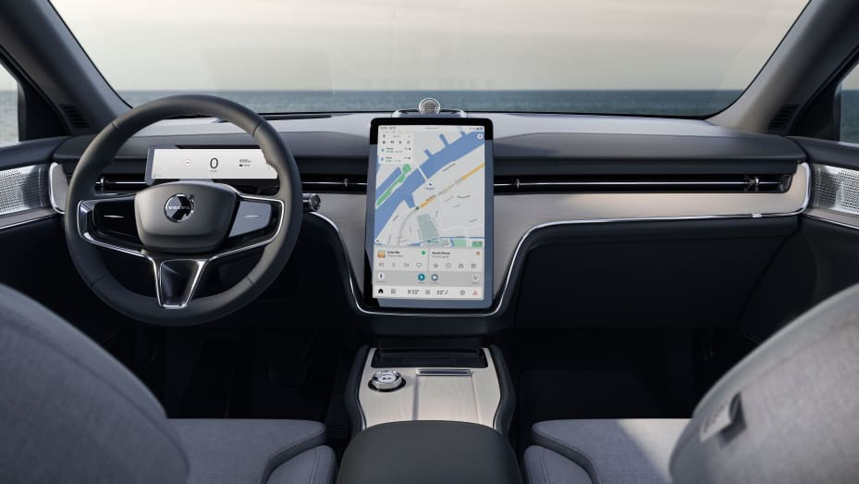

**Volvo EX90**

*Volvo*

Advanced driver-assist and autonomous-vehicle systems can also use lidar to help determine the vehicle’s precise location, by comparing the 3D images created by the sensor to detailed maps. Volvo’s decision to make a lidar system standard equipment in the EX90 will help support future upgrades to the vehicle’s driver-assist software and, eventually, self-driving software.

For Luminar, Volvo’s decision to make the company’s Iris lidar sensor standard on the EX90 is a major win that validates a key part of its longtime strategy – supporting driver-assist technologies that seek to assist a human driver, not replace the driver.

“From the start, Luminar’s strategy has been to get this life saving technology in the hands of as many people as possible – by first focusing on enabling advanced safety and unlocking autonomy for consumers with production vehicle programs,” said Luminar CEO Austin Russell. “A big part of what makes the Volvo EX90 so unique and bold is that it’s democratizing safety by including the lidar as standard on every vehicle.”

Starting with the EX90, Volvo, which is owned by China-based Geely Holding Group, plans to reveal one new fully electric car each year as it moves to exclusively offer EVs by 2030.

**Adidas warns of big earnings hit after ending Ye partnership**

**PUBLISHED WED, NOV 9 20222:56 AM ESTUPDATED WED, NOV 9 20227:12 AM EST**

[**Elliot Smith**](https://www.cnbc.com/elliot-smith/)[**@ELLIOTSMITHCNBC**](https://twitter.com/@ElliotSmithCNBC)

**SHARE**Share Article via FacebookShare Article via TwitterShare Article via LinkedInShare Article via Email

**KEY POINTS**

* The company ended its relationship with Ye, formerly known as Kanye West, on Oct. 25 after the musician launched a series of offensive and antisemitic tirades on social media and in interviews.
* Adidas now projects a net income from continuing operations of around 250 million euros ($251.56 million), down from a target of around 500 million euros laid out on Oct. 20.

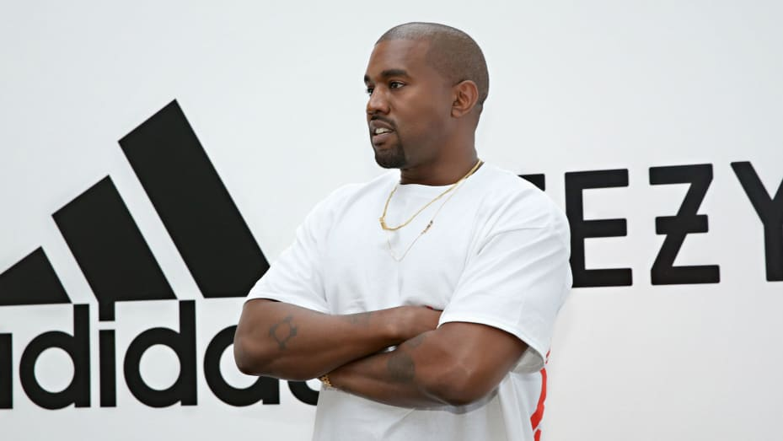

**Kanye West at an event announcing a partnership with Adidas on June 28, 2016 in Hollywood, California.**

*Getty Images*

[Adidas](https://www.cnbc.com/quotes/ADS1-FF/) on Wednesday cut its full-year guidance on the back of the German sportswear giant’s termination of its partnership with Kanye West’s Yeezy brand.

The company [ended its relationship with Ye](https://www.cnbc.com/2022/10/25/adidas-terminates-partnership-with-ye-following-rappers-antisemitic-remarks.html), formerly known as Kanye West, on Oct. 25 after the musician launched a series of offensive and antisemitic tirades on social media and in interviews.

**RELATED INVESTING NEWS**

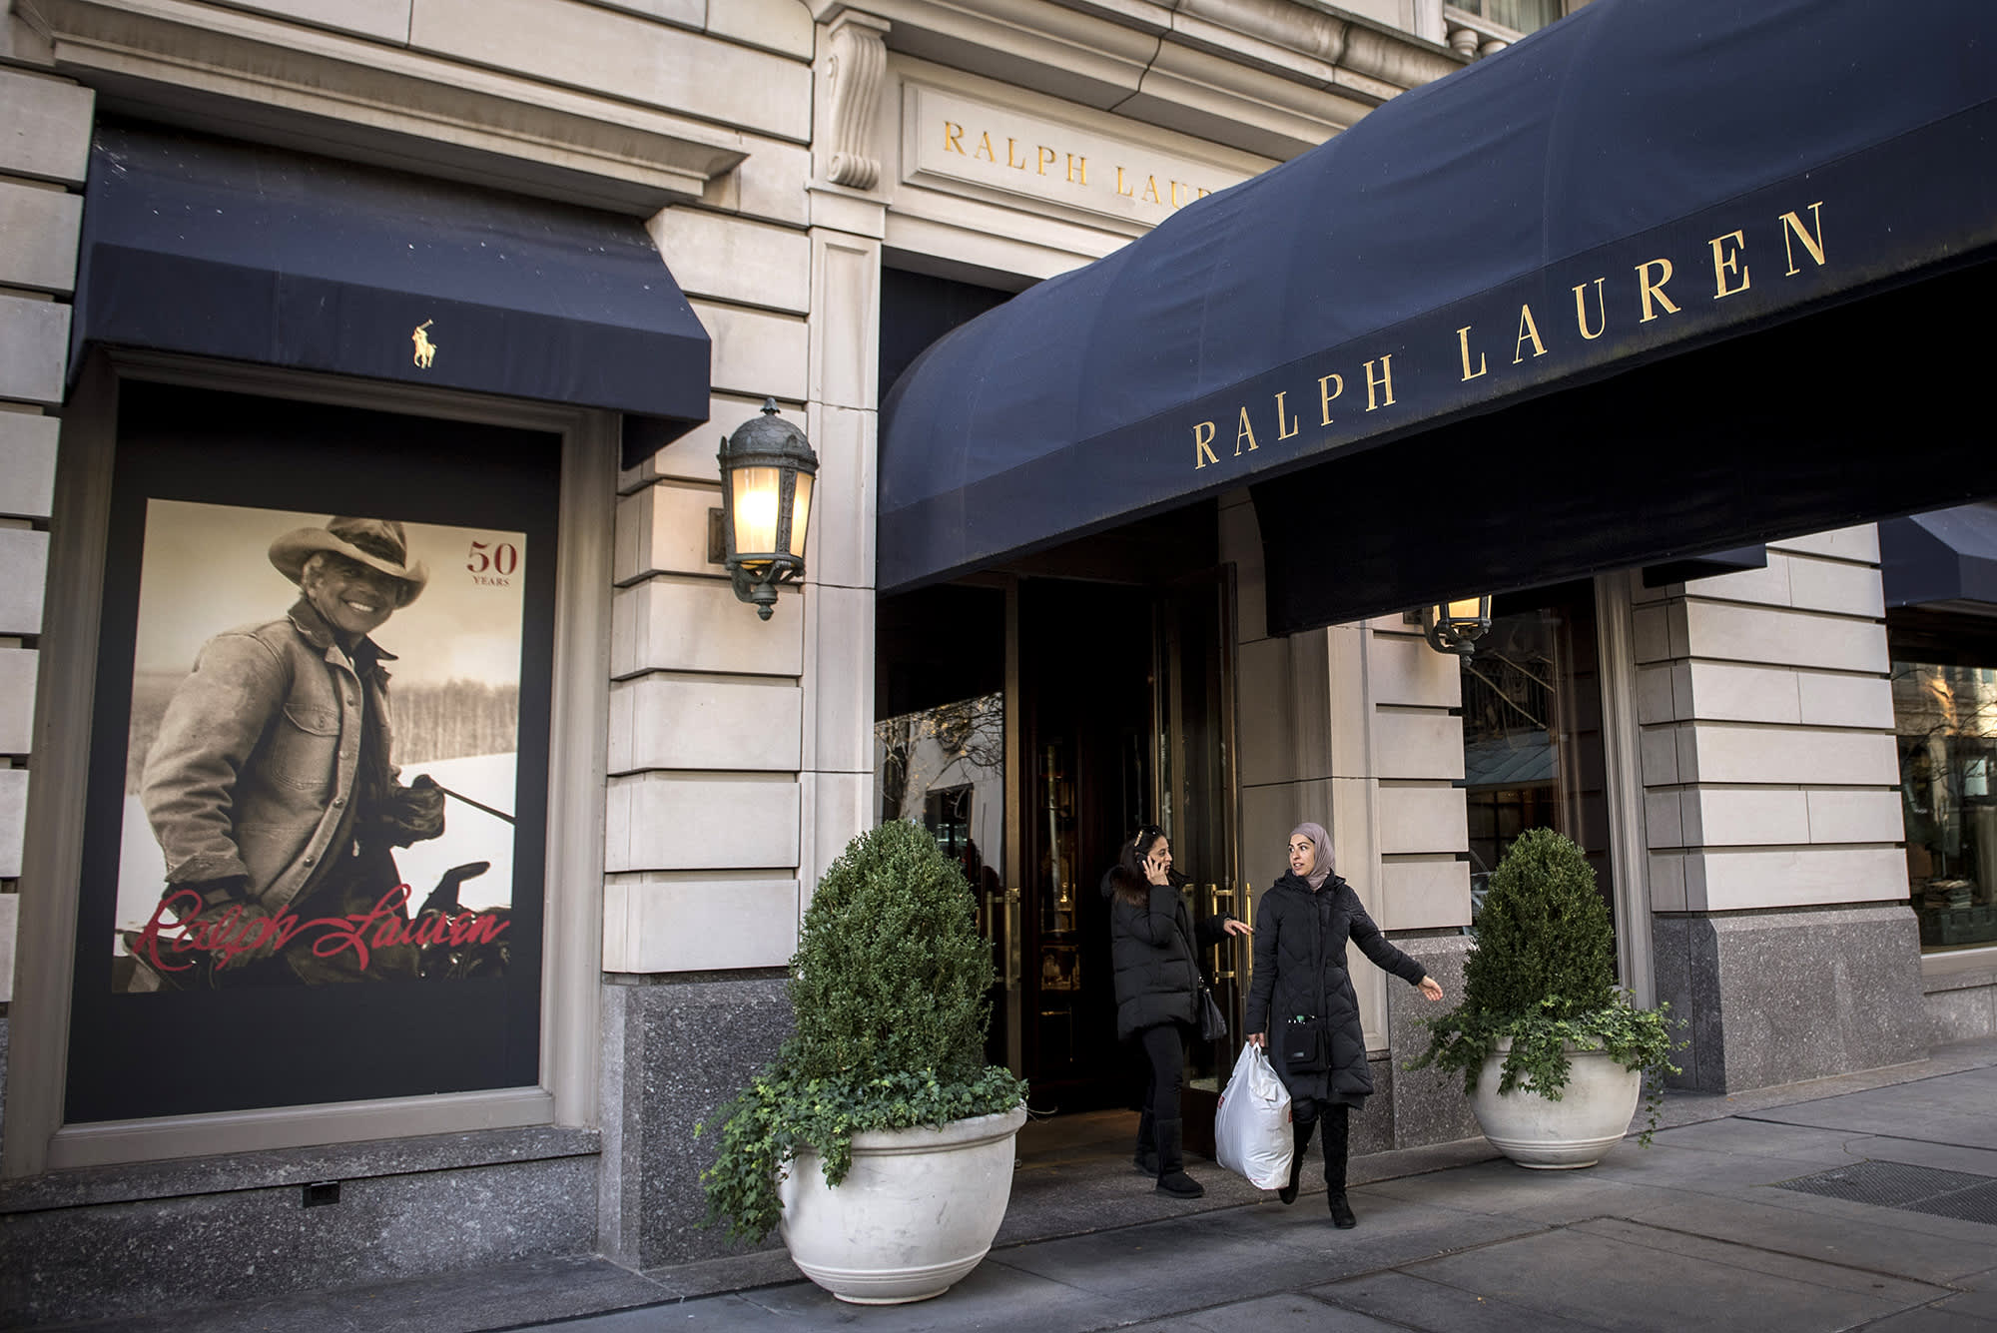

[**UBS calls Ralph Lauren a ‘turnaround stock,’ sees fashion brand rallying 36%**](https://www.cnbc.com/2022/11/11/ubs-calls-ralph-lauren-a-turnaround-stock-sees-fashion-brand-rallying-36percent.html)

[**Alex Harring**](https://www.cnbc.com/alex-harring/)

**19 HOURS AGO**

Adidas now projects a net income from continuing operations of around 250 million euros ($251.56 million), down from a target of around 500 million euros laid out on Oct. 20. The company now expects currency-neutral revenues for low single-digit growth in 2022, with gross margin now expected to come in at around 47% for the year.

Adidas reported a 4% year-on-year increase in currency-neutral sales in the third quarter, with double-digit growth in e-commerce in the EMEA, North America and Latin America. Gross margin fell by one percentage point to 49.1% on the back of “higher supply chain costs, higher discounting, and an unfavorable market mix,” the company said.

Operating profit came in at 564 million euros, while net income from continuing operations of 66 million euros, down from 479 million euros a year ago, was “negatively impacted by several one-off costs totalling almost 300 million as well as extraordinary tax effects in Q3,” Adidas said.

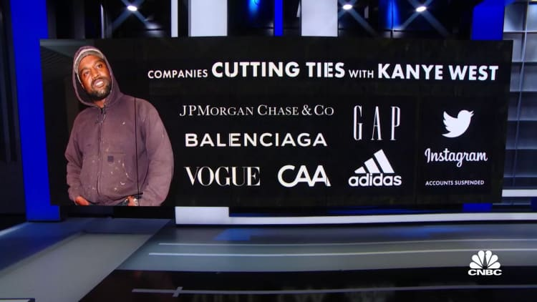

**WATCH NOW**

**VIDEO03:50**

**Adidas the latest company to drop Kanye West**

“This amount differs from the preliminary figure published on October 20, 2022, due to negative tax implications in the third quarter related to the company’s decision to terminate the adidas Yeezy partnership. This negative tax effect will be fully compensated by a positive tax effect of similar size in Q4,” Adidas said.

The company also revealed that it had already reduced its full-year guidance on Oct. 20 as a result of “further deterioration of traffic trends in Greater China, higher clearance activity to reduce elevated inventory levels as well as total one-off costs of around 500 million euros.”

“The market environment shifted at the beginning of September as consumer demand in Western markets slowed and traffic trends in Greater China further deteriorated,” Adidas CFO Harm Ohlmeyer said in a statement.

“As a result, we saw a significant inventory buildup across the industry, leading to higher promotional activity during the remainder of the year which will increasingly weigh on our earnings.”

Ohlmeyer said the company was “encouraged” by “noticeable” enthusiasm in the buildup to the FIFA World Cup in Qatar later this month.