

|  |
| --- |
| Note Program  2020 |
|  |
| June 1  Ho Chi Minh University of Education and Technology  Authored by: Group 9 |

# Basic design

|  |
| --- |
| Main view( Note) This design’s program was created by Winform.This program includes three main interfaces: Note, TrashNote, Carlendar |
| Note:Delete, Remind, Information, Add button, . |
| Trash Note:Delete forever, Restore.    Carlendar: Notify.  *Menu strip*  File: New Note, Open, Save, Save As, Exit. |

Edit: Undo, Redo, Cut, Copy, Paste, Delete, Select All, Date/Time.

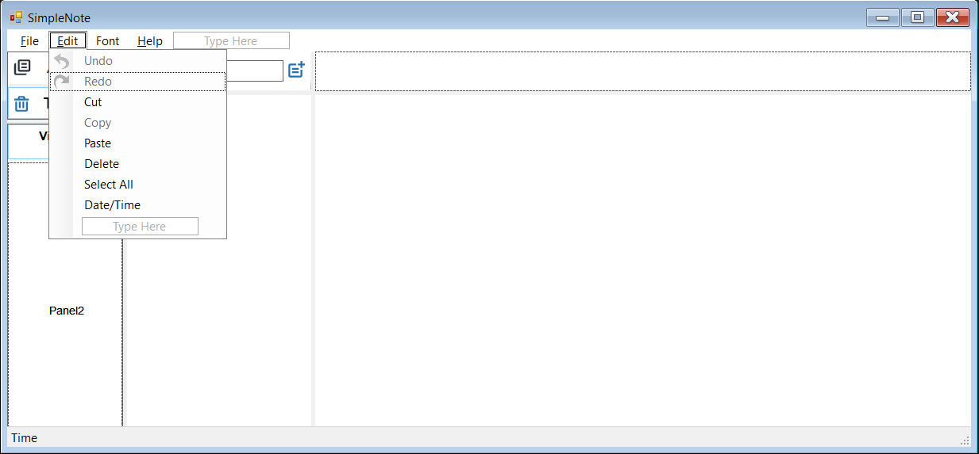

Font: Normal, Bold, Italic, Underline, Strike Throught, Text Color.

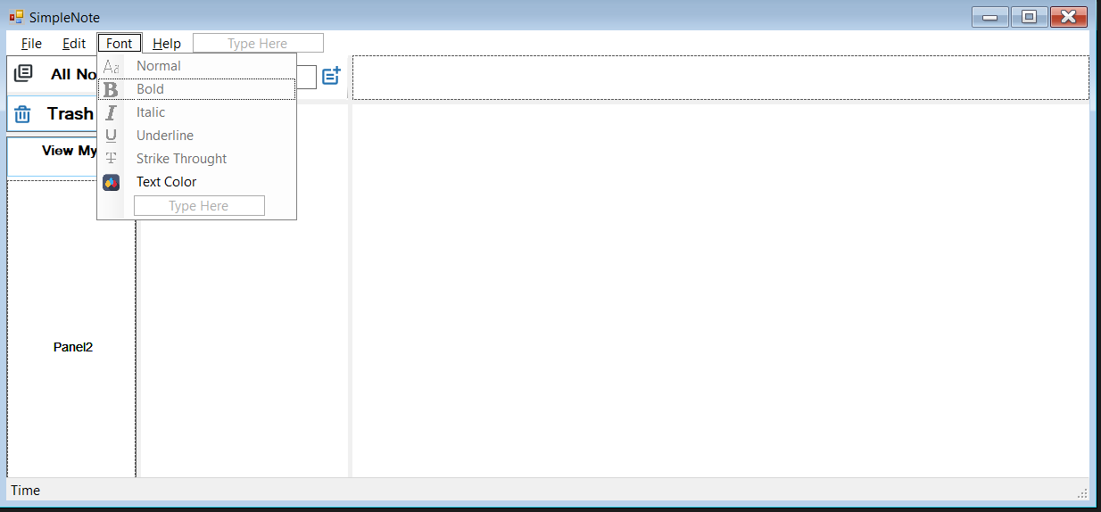

*Additional development features*

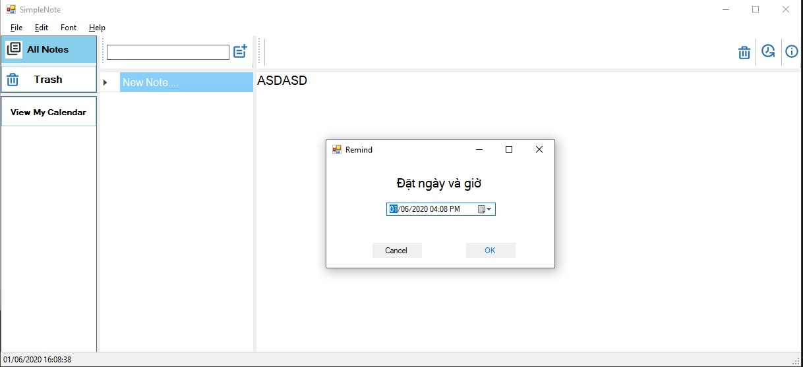

Set an alarm to remind inportant note or event.

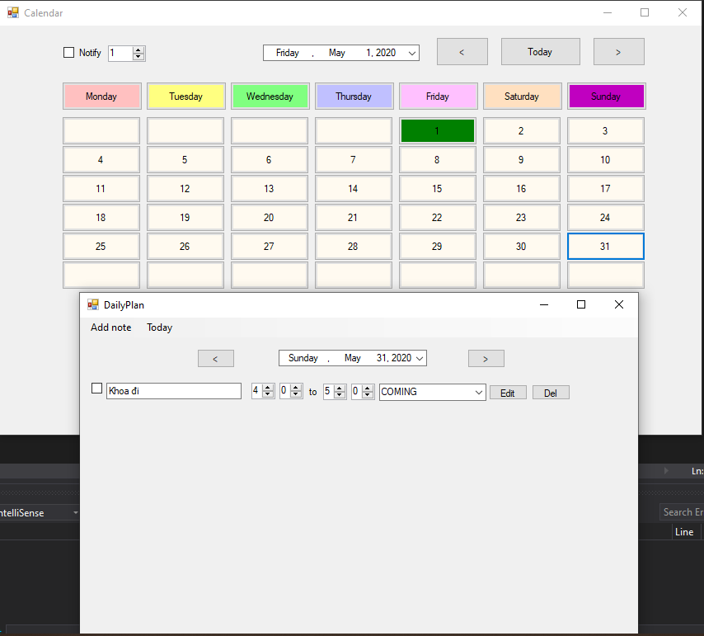

Carlendar Work to manage all event that was reminded by user in the next few days.