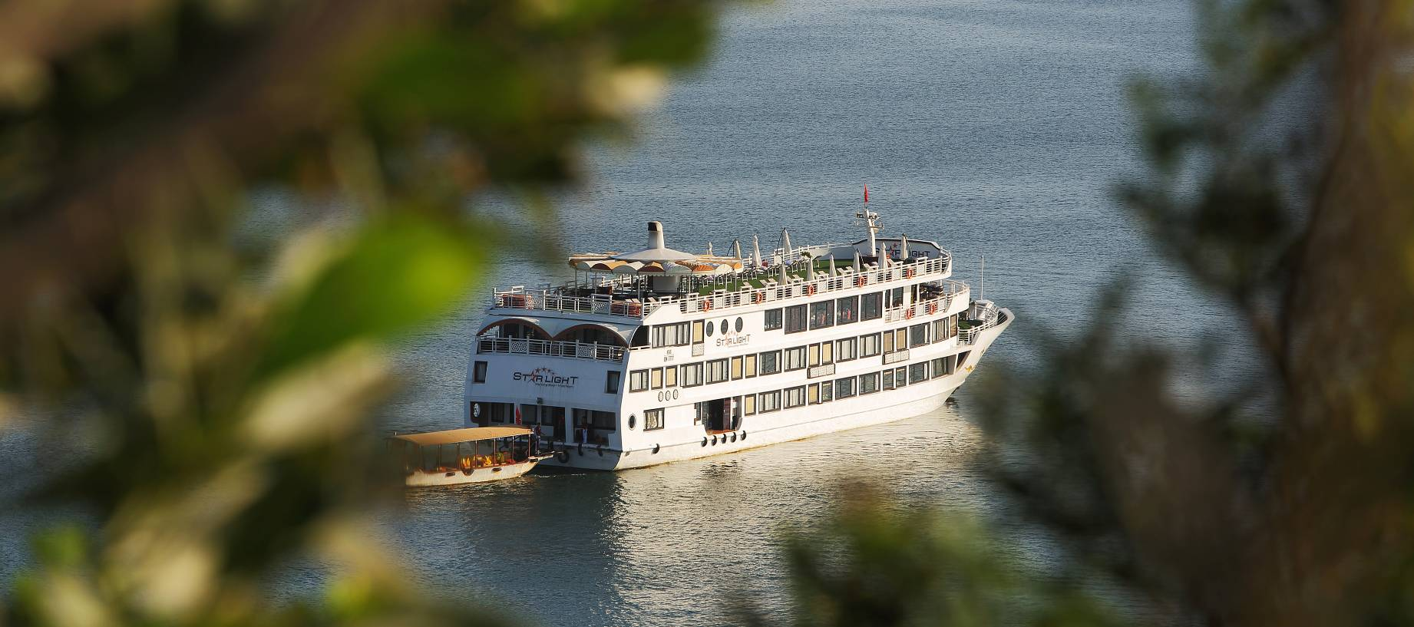

TO: VOUCHER HOLDER («ApplyFor»)
Service: «Trip»
Code: «Code»
Value: USD 550 (five hundred and fifty US Dollars)
Expiration: «ValidUntil»
*** Reserved for «Agency»
*** Not redeemable for cash
Managing Director:

Bùi Văn Chi

Head office: 10 Hang Manh Str., Hoan Kiem, Hanoi.
Tel: (84-4) 3926 4009
Fax: (84-4) 3926 4010
Email: sales@starlightcruises.com
Website: http://starlightcruises.vn/

