
AN INTERGRATED FINANCIAL MANAGEMENT SYSTEM FOR A SMALLSCALE SALON

SYSTEM DOCUMENTATION

SUBMITTED BY,
THIGA JOSEPH MUTURI
DIT-01-0085/2025

A SYSTEM DOCUMENTATION SUBMITTED IN PARTIAL FULFILMENT FOR THE AWARD OF DIPLOMA IN INFORMATION TECHNOLOGY BY ZETECH UNIVERSITY

APRIL 2026
DECLARATION
I hereby declare that this project is my original work and has been carried out by me in accordance with the requirements of my course. This project has not been submitted to any other institution for academic credit. I confirm that all sources of information used have been duly acknowledged.
I further declare that this system documentation has been prepared by me and reflects the work done during the development of the project.

Student Name: THIGA JOSEPH MUTURI Sign: _________________ Date: __________
Supervisor Name: SAMUEL KINUTHIA Sign: _________________ Date: __________

DEDICATION
I dedicate this project to my family for their constant support, encouragement, and understanding throughout my academic journey. Their belief in me has been my greatest motivation.
I also dedicate this work to my lecturers and mentor who guided me and provided valuable knowledge and support during the development of this project.

ABSTRACT
This project focuses on the design and development of an integrated financial management system for small-scale salons. Many salons face significant challenges in managing their finances due to reliance on manual methods such as notebooks and basic spreadsheets. These traditional approaches often lead to errors, data loss, poor record keeping, and difficulty in tracking business performance. As a result, salon owners struggle to monitor cash flow, evaluate profitability, and make informed decisions for business growth.
To address these challenges, the project introduces a web-based system that automates financial operations within a salon environment. The system enables efficient recording of customer payments and expenses, generates receipts, and maintains a detailed transaction history. It also provides automated daily, weekly, and monthly financial reports, allowing salon owners to easily monitor business performance. Additionally, secure user accounts ensure that only authorized staff can access and manage financial data, improving accountability and data security.
The system was developed using modern web technologies including HTML, CSS, JavaScript, PHP, and MySQL, with XAMPP serving as the local development environment. Throughout the development process, emphasis was placed on usability, performance, reliability, and security to ensure the system meets user needs effectively.
The final system successfully replaces manual bookkeeping with a more accurate, efficient, and user-friendly solution. It enhances financial management, reduces errors, and supports better decision-making, ultimately contributing to the growth and sustainability of small-scale salon businesses.

DEFINITION OF KEY TERMS
Cash Flow: The movement of money into and out of the salon business over a specific period.
Database: A structured collection of data that is stored and managed electronically for easy access and retrieval.
Expense: Money spent by the salon on operations such as purchasing products, paying bills, or other business costs.
Financial Management System: A digital system used to record, track, and manage financial transactions within a business.
Receipt: A document issued to a customer as proof of payment for services or products.
Transaction: Any financial activity involving the exchange of money, such as payments received or expenses incurred.
User Account: A profile created in the system that allows authorized individuals to access and use the system based on their roles.
Web Application: A software application that runs on a web browser and allows users to interact with the system online.

ABBREVIATIONS AND ACRONYMS
CSS – Cascading Style Sheets
HTML – HyperText Markup Language
IFMS – Integrated Financial Management System
JS – JavaScript
MDN – Mozilla Developer Network
PHP – Hypertext Preprocessor
SQL – Structured Query Language
VS Code – Visual Studio Code
W3C – World Wide Web Consortium

LIST OF FIGURES
Fig 2.2.1 Login Page Design (Hand-Sketched)
Fig 2.2.2 Sign-Up Form Design (Hand-Sketched)
Fig 2.2.3 Dashboard Interface Design (Hand-Sketched)
Fig 2.2.4 Products and Services Page Design (Hand-Sketched)
Fig 2.2.5 Receipt Page Design (Hand-Sketched)
Fig 2.3.1 Login Process Flowchart
Fig 2.3.2 Transaction Processing Flowchart
Fig 2.3.3 System Class Diagram
Fig 2.3.4 Financial Reporting Flowchart
Fig 3.1 Login Page Interface of SALONPRO IFMS
Fig 3.2 HTML and CSS Code for Login Page
Fig 3.3 Sign-Up Page Interface
Fig 3.4 Financial Dashboard Interface
Fig 3.5 Transaction Processing Page
Fig 3.6 Generated Customer Receipt
Fig 3.7 Financial Reports Interface
Fig 3.8 PHP Code for Login Validation
Fig 3.9 PHP Code for Transaction Processing
Fig 3.10 PHP Database Connection Code

LIST OF TABLES
Table 1.4 Functional Requirements Table
Table 1.5.1 Software Tools
Table 1.5.2 Hardware Resources
Table 1.5.3 Human Resources
Table 1.5.4 Other Resources
Table 1.6 Project Schedule Breakdown

TABLE OF CONTENTS
Table of Contents
CHAPTER ONE: PROJECT PLANNING AND ANALYSIS 1
Statement of Problem 1
Study Justification 1
System Objectives 1
General Objective 1
Specific Objectives 1
Functional Requirements 1
Breakdown of Tools & Resources to Be Used 2
1.5.1 Software Tools 2
1.5.2 Hardware Resources 2
1.5.3 Human Resources 3
1.5.4 Other Resources 3
Project Schedule Breakdown 1
CHAPTER TWO: DESIGN AND MODELING 2
2.1 Introduction to Modelling 2
2.2 User Interface Models 2
2.2.1 Login Page Design 2
2.2.2 Sign Up Form Design 3
2.2.3 Dashboard Design 4
2.2.4 Products/Services Page Design 5
2.2.5 Receipt Page Design 5
2.3 Logic Models 6
2.3.1 Login Process Flowchart 6
2.3.2 Transaction Processing Flowchart 7
2.3.3 System Class Diagram 8
2.3.4 Financial Reporting Process Flowchart 8
CHAPTER THREE: SYSTEM IMPLEMENTATION 10
3.1 Introduction 10
3.2 User Interface Development 10
3.2.1 Login Page Development 10
3.2.2 Sign-Up Page Development 11
3.2.3 Dashboard Interface Development 12
3.2.4 Transaction and Receipt Page 12
3.2.5 Reports Page 13
3.3 Logic Development 14
3.3.1 Login Validation Logic 14
3.3.2 Transaction Processing Logic 15
3.3.3 Database Storage Logic 16
3.4 Testing 18
3.5 Deployment 18
CHAPTER FOUR: CONCLUSION AND RECOMMENDATION 20
4.1 Conclusion 20
4.2 Recommendation 20
REFERENCES 21

CHAPTER ONE: PROJECT PLANNING AND ANALYSIS
(WORKPLAN)

Statement of Problem
Small-scale salons often struggle with managing their finances effectively. Most of them rely on manual methods such as notebooks or basic spreadsheets to record customer payments, expenses, and daily sales. These approaches are prone to errors, duplication, and even data loss. Without a reliable system, salon owners find it difficult to track profitability, monitor cash flow, or plan for growth. This lack of financial control can lead to poor decision-making, reduced customer trust, and limited sustainability of the business.

Study Justification
This project introduces an integrated financial management system designed specifically for small-scale salons. The system automates the recording of transactions, tracks expenses, and generates accurate financial reports. Features such as receipt generation, daily and monthly sales summaries, and secure staff accounts directly address the challenges of manual bookkeeping. By streamlining financial operations, the system enhances accountability, reduces errors, and empowers salon owners to make informed decisions that improve efficiency and business performance.

System Objectives

General Objective
- To develop an integrated financial management system for a small-scale salon that simplifies financial tracking and improves business efficiency.

Specific Objectives
- To implement automated recording of customer payments and salon expenses.
- To generate receipts and maintain transaction history for accountability.
- To provide daily, weekly, and monthly financial reports for better decision-making.
- To create secure user accounts for salon staff to access and manage financial records.

Functional Requirements
User | User Activities | Features
Salon  Owner | Records income and expenses | Dashboard for financial overview, expense entry, income tracking.
Salon  Owner | Reviews business performance | Automated daily/weekly/monthly financial reports.
Staff (Cashier) | Processes customer payments | Receipt generation, transaction logging, secure staff login.
Staff | Updates service charges or product sales | Editable service/product catalog linked to billing system
Customer | Receives proof of payment | Printed or digital receipts.
Table 1.4 Functional Requirements Table

Breakdown of Tools & Resources to Be Used

1.5.1 Software Tools
Software Tool | Purpose
HTML | Used to design the structure and layout of the web pages
CSS | Used to style the user interface and make the system visually appealing
JavaScript | Used to implement interactive features within the system
PHP | Used for server-side programming and handling system logic
MySQL | Used for storing and managing system data such as users, transactions, and expenses
XAMPP | Used as a local server environment to run Apache and MySQL during development
Visual Studio Code / Notepad++ | Used as the code editor for writing and editing system code
Google Chrome / Web Browser | Used for testing and running the web application

1.5.2 Hardware Resources
Hardware Resource | Purpose
Laptop / Desktop Computer | Used for system development, coding, testing, and documentation
Keyboard and Mouse | Used for input during system development
External Storage Device (Flash Disk) | Used for storing backups of the project files

1.5.3 Human Resources
Human Resource | Role
System Developer (Student) | Responsible for designing, coding, testing, and implementing the system
Project Supervisor | Provided guidance, evaluation, and feedback during project development
Salon Owner / Users | Provided information about salon operations and system requirements

1.5.4 Other Resources

Resource | Purpose
Internet Connection | Used for research, downloading development tools, and accessing learning resources
Online Tutorials (W3Schools, MDN, etc.) | Used to learn programming concepts and solve coding challenges
AI Assistance (ChatGPT) | Used for guidance in coding, debugging, and preparing documentation

1.6 Non-Functional Requirements
Non-functional requirements describe how the system should perform rather than what the system should do. They focus on the quality, performance, security, and usability of the SALONPRO IFMS system.
1.6.1 Security
The system must ensure that only authorized users can access financial information. Users must log in using valid credentials, and passwords should be securely stored in the database to prevent unauthorized access.
1.6.2 Performance
The system should respond quickly when users perform actions such as logging in, recording transactions, or generating reports. The system should process financial records efficiently without delays.
1.6.3 Usability
The system should have a simple and user-friendly interface that allows salon staff and owners to easily navigate and use the system without requiring advanced technical skills.
1.6.4 Reliability
The system should operate consistently and store financial records safely in the database. Data entered into the system should not be lost even if the system is restarted.
1.6.5 Scalability
The system should allow the addition of more users, services, products, and transactions as the salon business grows without affecting system performance.
1.6.6 Maintainability
The system should be easy to maintain and update. Developers should be able to modify or improve the system in the future without affecting existing features.

Project Schedule Breakdown

 | PROJECT MILESTONES
WEEKS | Project Planning & Analysis  (System Documentation: Coverpage & Chapter One) | Project Design & Modeling  (System Documentation Chapter Two) | Project Development & Testing  (System Documentation Chapter Three) | Project Deployment  (System Documentation Chapter Three) | Final Touches of System Documentation  (Preliminary Pages, Chapter Four & References) | Project Presentation
5-9 May
12-16 May
19-23 May
26-30 May
2-6 June
9-13 June
16-20 June
23-27 June
30-4 July
7-11 July
14-18 July
21-25 July
11 Aug
Table 1.6 Project Schedule Breakdown

CHAPTER TWO: DESIGN AND MODELING

2.1 Introduction to Modelling
This chapter presents the design and modelling of the Financial Management System for a small salon. The system was modelled to show clearly how it will function and how users will interact with it, while reducing possible errors before development begins. By creating user interface designs and system flow diagrams, the workflow and overall structure of the system were made easy to understand. The models provide guidance during implementation and ensure that the final system meets the operational needs of the salon.

2.2 User Interface Models
The user interface is the part of the system that the salon staff and owner use daily. It was designed to be simple and easy to navigate. By sketching the main pages and forms, I ensured that users can move through the system smoothly and complete tasks like logging in, recording sales, and viewing reports quickly and without confusion.

2.2.1 Login Page Design
The login page is the entry point to the SALONPRO IFMS system. It allows registered users such as the salon owner and staff members to securely access the system by entering their email and password. The login page also includes options for signing up for new accounts and recovering forgotten passwords.

LOGIN PAGE

Remember me

Don’t have an account? Register here
Enter Email
Enter Email

- Enter Email
Enter Password

LOGIN

Figure 2.2.1 : Login Page Design (Hand-Sketched)

2.2.2 Sign Up Form Design
The sign-up form allows new users to create an account in the system. The form collects details such as full name, email address, phone number, and password. This information is stored in the system database and used for authentication.
SIGN UP PAGE

Already have an account? Login Here

First Name

Email Address

Create Password

Confirm Password

ROLE (CASHIER)

Register

Figure 2.2.2: Sign-Up Form Design (Hand-Sketched)

2.2.3 Dashboard Design
The dashboard page provides an overview of the salon’s financial information. It displays summaries such as total income, expenses, recent transactions, and quick access to system features. This page helps the salon owner monitor the business performance easily.
DASHBOARD SalonOwner

DASHBOARD
TRANSACTONS

EXPENSES

SERVICE&PRODUCTS

REPORTS

STAFF MANAGEMENT

LOGOUT

Today’s Revenue

Today’s Expenses

Transactions

Print Report

Figure 2.2.3 Dashboard Page Design
Manage Staff

Figure 2.2.3: Dashboard Interface Design (Hand-Sketched)

2.2.4 Products/Services Page Design
This page allows staff members or the salon owner to manage salon services and products offered to customers. It displays a list of available services and products along with their prices.
PRODUCTS& SERVICES Salon Owner

DASHBOARD
TRANSACTONS

EXPENSES

REPORTS

STAFF MANAGEMENT

LOGOUT

+Add Item

SERVICE

Services& products

PRODUCT

Figure 2.2.3 Dashboard Page Design
CLOSE
PRINT

Figure 2.2.4: Products and Services Page Design (Hand-Sketched)

2.2.5 Receipt Page Design
The receipt page generates proof of payment for customers after a transaction has been completed. The receipt includes information such as the customer name, services purchased, total cost, and payment method.

RECIEPT
Salon Name: __________________________
Location: _____________________________
Phone: ________________________________
Receipt No: ___________________________
Date: _________________________________

Item / Service

(KES)

Quantity

Subtotal: __________________ KES
Tax (if any): _______________ KES
Total Amount: ______________ KES
Amount Paid: _______________ KES
Balance: ___________________ KES

Payment Method: Cash / M-Pesa / Card

Thank you for visiting our salon!
Figure 2.2.5: Receipt Page Design (Hand-Sketched)

2.3 Logic Models
Logic models represent how the system processes data and performs operations. These diagrams help illustrate how different system components interact and how processes flow within the system.

2.3.1 Login Process Flowchart
The login process flowchart illustrates the steps followed when a user attempts to access the system. The process begins when the user enters login credentials. The system then validates the information against the database. If the credentials are correct, access to the system dashboard is granted.

START
Enter Name, Email, Password
Validate input
Show error message
Save user to storage
Show Success Message
End

Fig 2.3.1 Login Process Flowchart

2.3.2 Transaction Processing Flowchart
This flowchart explains how the system processes customer transactions. When a customer pays for a service or product, the staff records the transaction, the system calculates the total amount, stores the data in the database, and generates a receipt.

Customer Payment

Print Recept
Store Transaction in Database
Calculate Total Amout
Record Transaction

r
Generate Reciept

Figure 2.3.2: Transaction Processing Flowchart

2.3.3 System Class Diagram
The class diagram represents the structure of the system by showing the different classes and their relationships. In the SALONPRO IFMS system, the main classes include User, Transaction, Expense, and Service. These classes store the data necessary for managing the salon’s financial operations.

User
-user ID
-surname
-password
-user Type
Transaction
-transaction ID
-date
-amount
-payment/ Method

User
-service ID
-service Name
-price

Expense
-expense ID
-date
-amount
-category

Figure 2.3.3: system class diagram

2.3.4 Financial Reporting Process Flowchart
This flowchart shows how the system generates financial reports. The process involves retrieving transaction and expense data from the database and summarizing it into daily, weekly, or monthly reports

Retrieve Transcation data
Retrieve expense data
Load data from database

Summarize data

Generate Monthly Report
Generate Daily Report
Generate
Weekly report

Figure 2.3.4: Financial Reporting Flowchart

CHAPTER THREE: SYSTEM IMPLEMENTATION
(DEVELOPMENT, TESTING AND DEPLOYMENT)

3.1 Introduction
This chapter explains the process followed in developing the SALONPRO IFMS (Salon Integrated Financial Management System). It describes the stages involved from setting up the development environment to designing the user interface, implementing system logic, testing the system, and deploying the final application.
The system was developed using HTML, CSS, JavaScript, PHP, and MySQL, while XAMPP was used as the local server environment. The development process involved designing user interfaces, implementing system functionality through backend logic, connecting the system to the database, and ensuring that all system features function correctly through testing.

3.2 User Interface Development
The user interface represents the part of the system that users interact with directly. The interfaces were developed using HTML for structure, CSS for styling, and JavaScript for interactive features.
The system provides interfaces for login, registration, dashboard viewing, transaction processing, receipt generation, and financial reporting.

3.2.1 Login Page Development
The login page allows registered users such as the salon owner and staff members to access the system securely. Users enter their email and password to authenticate their identity.
The login interface also includes options for sign up for new users and forgot password to recover lost login credentials.

Figure 3.1: Login Page Interface of SALONPRO IFMS
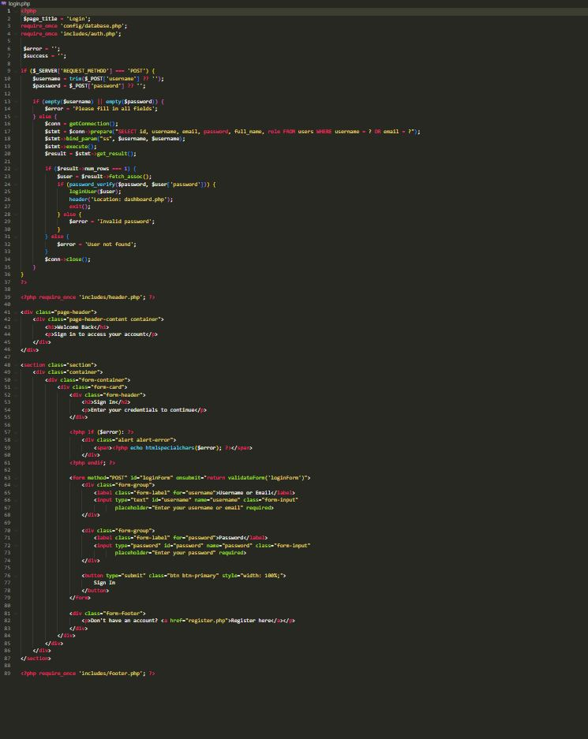
Figure 3.2: HTML and CSS Code for Login Page

3.2.2 Sign-Up Page Development
The sign-up page allows new users to create an account within the system. The user enters details such as full name, email address, password, and role (owner or staff).
The form ensures that user data is validated before being stored in the database.
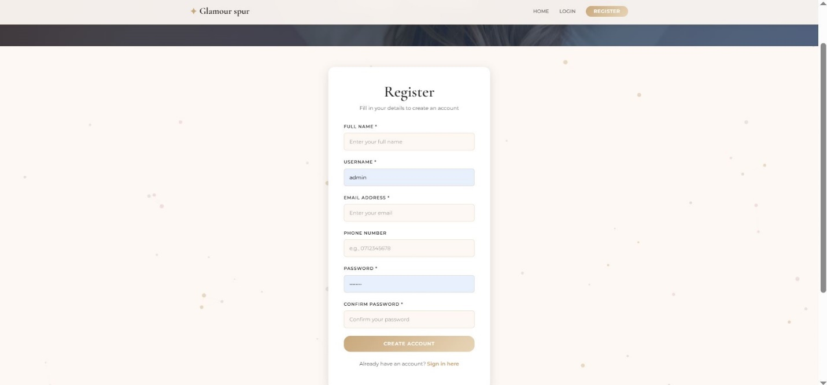
Figure 3.3: Sign-Up Page Interface

3.2.3 Dashboard Interface Development
The dashboard provides an overview of the salon’s financial activities. It displays information such as total income, expenses, recent transactions, and financial summaries.
The dashboard helps the salon owner monitor the financial performance of the business in real time.
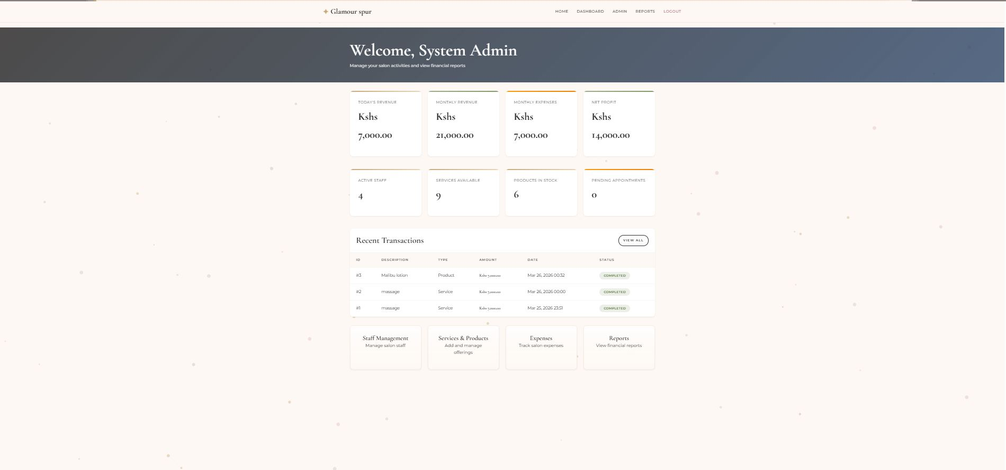
Caption: Figure 3.4: Financial Dashboard Interface

3.2.4 Transaction and Receipt Page
This interface allows staff members to record customer payments and generate receipts after services or products have been purchased.
The system automatically calculates the total cost and generates a receipt that can be printed or saved digitally.
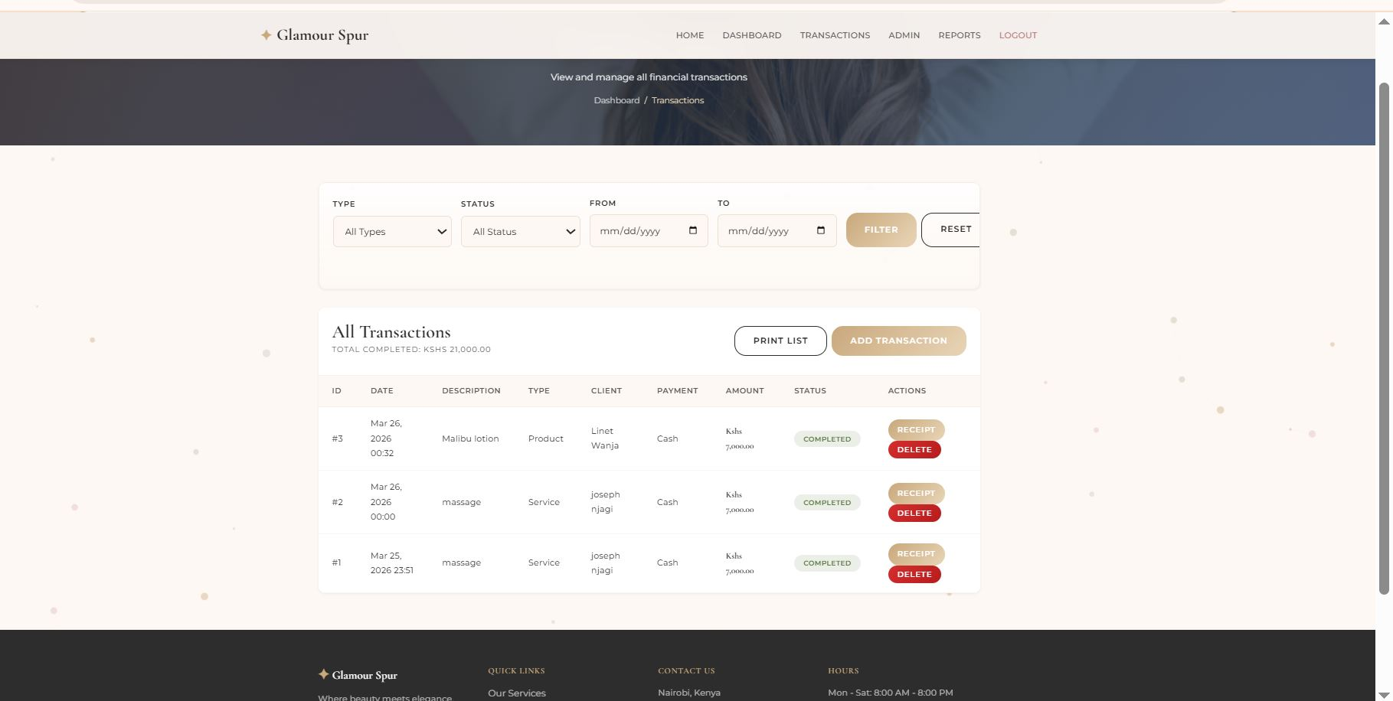
Caption: Figure 3.5: Transaction Processing Page
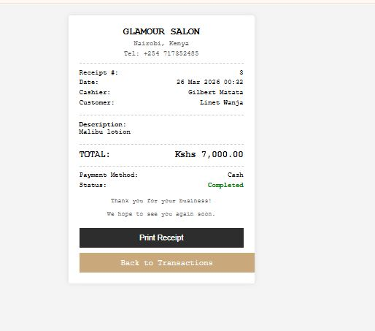
Caption: Figure 3.6: Generated Customer Receipt

3.2.5 Reports Page
The reports page allows the salon owner to view financial reports such as daily, weekly, and monthly income summaries.
These reports assist in evaluating business performance and making informed decisions.
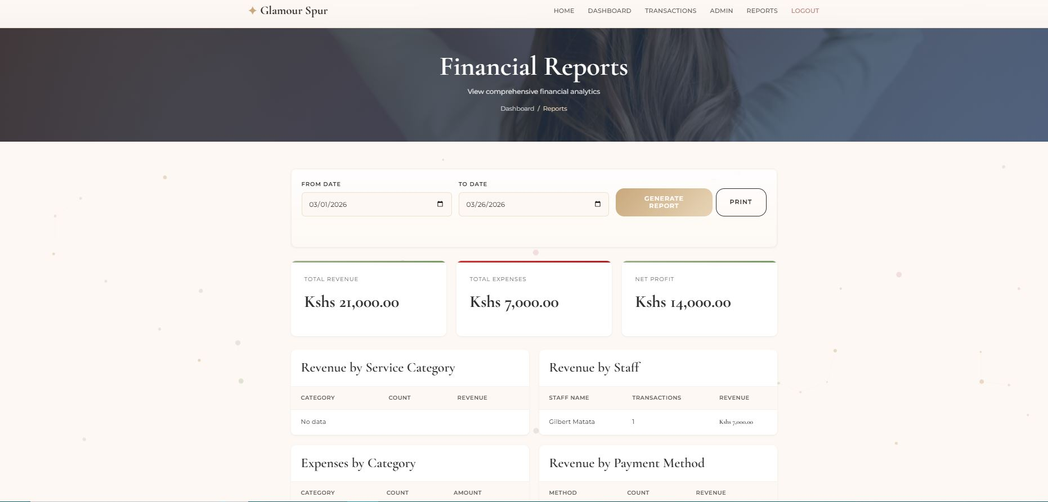
Caption: Figure 3.7: Financial Reports Interface

3.3 Logic Development
The logic side of the system controls how data is processed and how different operations are performed within the system.
PHP was used as the backend programming language to handle system logic such as user authentication, transaction processing, and database communication.

3.3.1 Login Validation Logic
The login validation process verifies whether the user's email and password match the records stored in the database.
When the user submits the login form, PHP checks the credentials against the database and grants access if they are valid.
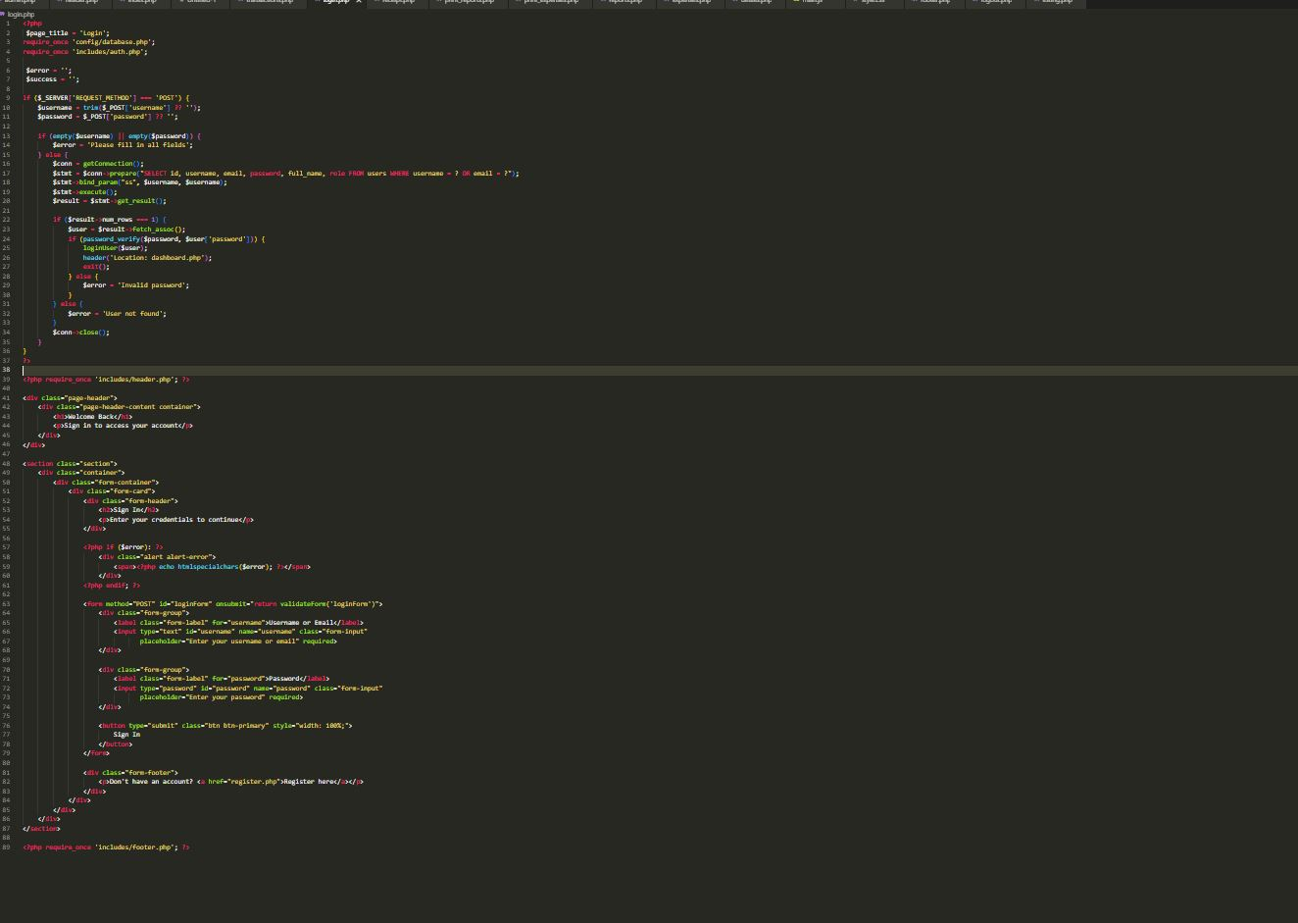
Figure 3.8: PHP Code for Login Validation

3.3.2 Transaction Processing Logic
The system processes transactions when a staff member records a customer payment. The transaction data is validated and stored in the database, and a receipt is generated automatically.
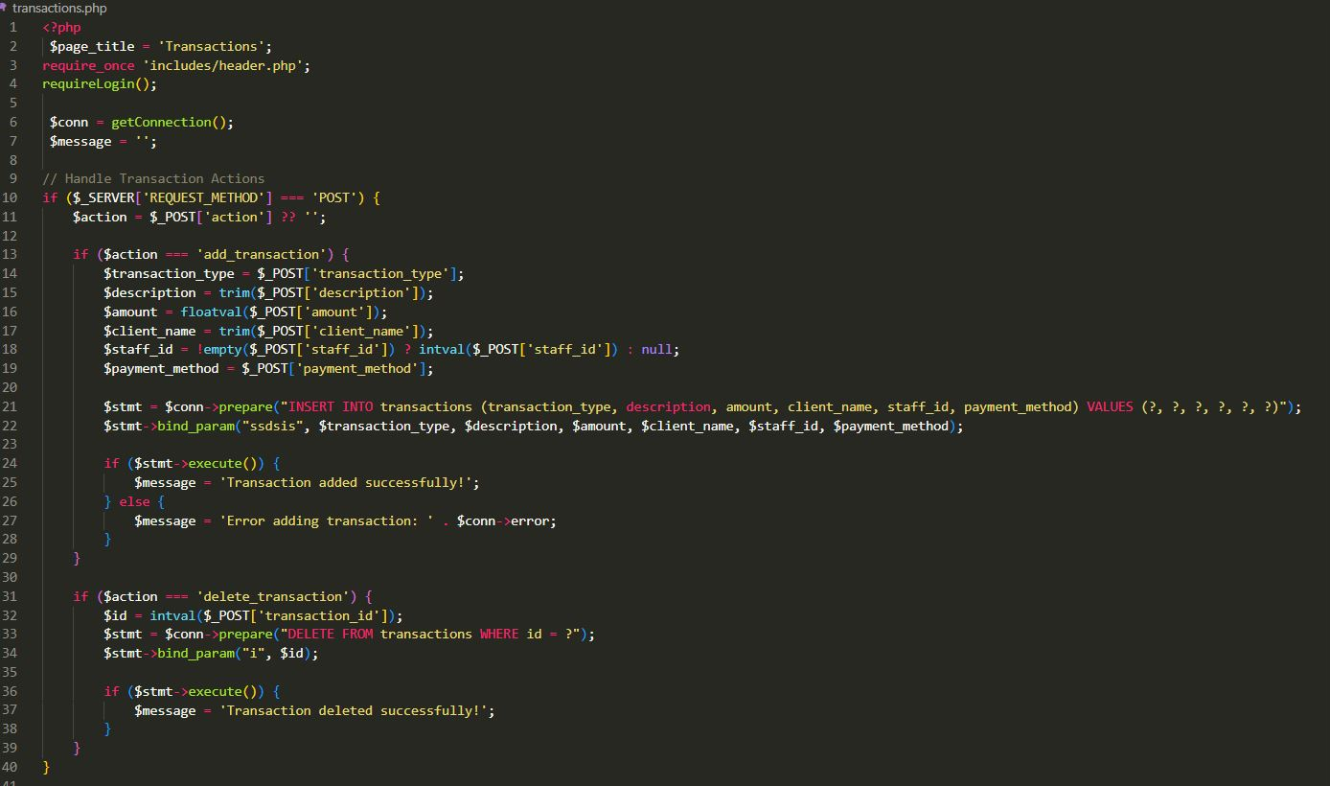
Caption: Figure 3.9: PHP Code for Transaction Processing

3.3.3 Database Storage Logic
The system uses MySQL to store user accounts, transactions, expenses, and service information.
PHP scripts connect to the database and perform operations such as inserting, retrieving, and updating records.

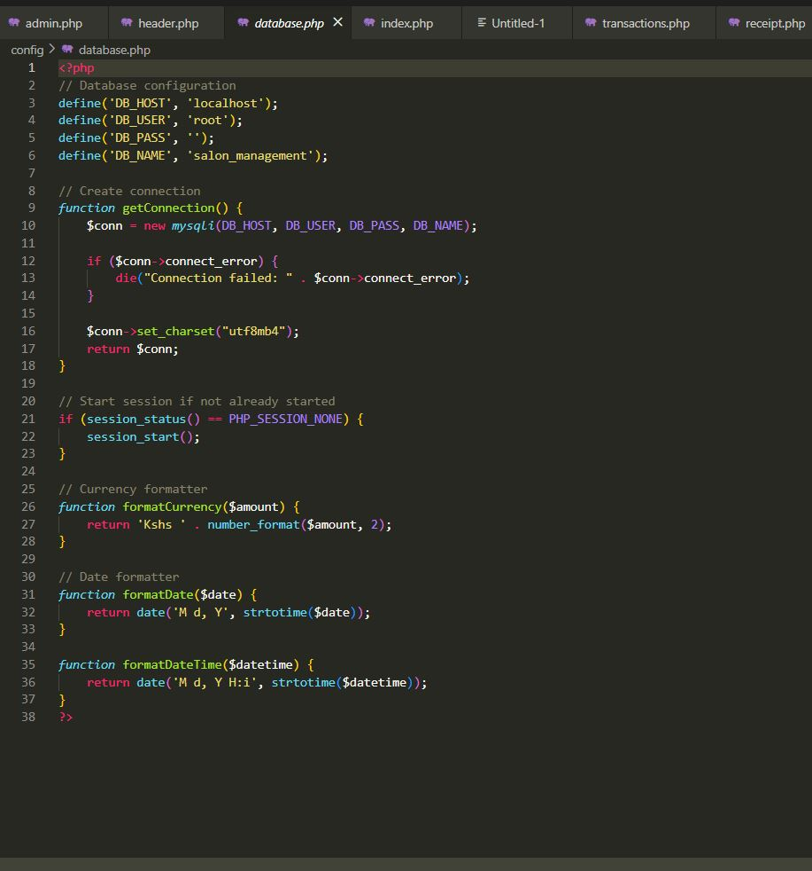
Caption: Figure 3.10: PHP Database Connection Code

3.4 Testing
Testing was carried out to ensure that all system features function correctly. Different parts of the system were tested individually and collectively.
The following tests were conducted:
Feature Tested | Test Action | Result
Login System | Enter valid and invalid login credentials | System correctly allowed valid users and rejected invalid ones
Sign-Up System | Created new user accounts | Accounts were successfully stored in the database
Transaction Processing | Recorded customer payment | Transaction saved and receipt generated
Expense Recording | Added expense entry | Expense correctly stored in database
Report Generation | Generated financial reports | Reports displayed correct financial summaries
Errors discovered during testing were corrected by adjusting the system code and improving input validation.

3.5 Deployment
The system was deployed using the XAMPP local server environment.
The deployment process involved the following steps:
- Installing XAMPP on the development computer.
- Creating a MySQL database using phpMyAdmin.
- Importing the system database tables into MySQL.
- Placing the project files inside the htdocs directory.
- Running the system using the browser through the address:
http://localhost/salonpro
This allows users to access the system through a web browser.
The system can also be deployed online using web hosting services such as Hostinger, InfinityFree, or 000WebHost.

CHAPTER FOUR: CONCLUSION AND RECOMMENDATION

4.1 Conclusion
The purpose of this project was to develop SALONPRO IFMS, a web-based financial management system designed to help small-scale salon businesses manage their financial activities effectively.
Chapter One introduced the background of the system, the problem statement, objectives, and system requirements. Chapter Two reviewed related systems and technologies used in financial management systems. Chapter Three explained the development process, user interface design, logic implementation, testing procedures, and deployment of the system.
The developed system successfully allows salon owners and staff to record customer payments, track expenses, generate receipts, and produce financial reports. This improves financial record keeping and supports better decision making within the salon business.
During the development of this project, new skills were learned in web development, database management, system testing, and system deployment. Some challenges encountered included debugging coding errors and ensuring proper database connectivity. However, these challenges were overcome through testing and research.

4.2 Recommendation
Although the SALONPRO IFMS system functions effectively, several improvements can be made in the future.
Future developers can consider integrating mobile payment systems such as M-PESA or bank card payments to allow customers to make electronic payments directly through the system.
The system can also be improved by integrating a receipt printer to allow automatic printing of physical receipts for customers.
Additionally, implementing cloud-based hosting would allow the system to be accessed remotely by salon owners from different locations.
Another possible improvement is the use of biometric authentication or smart card login systems to enhance security and user authentication.
These improvements would enhance the functionality and usability of the SALONPRO IFMS system.

REFERENCES
ChatGPT. (2026). Assistance in software development and documentation for SALONPRO IFMS project. https://chat.openai.com/
Duckett, J. (2014). PHP and MySQL: Server-side web development. Wiley.
Mozilla Developer Network. (2024). HTML basics. https://developer.mozilla.org/en-US/docs/Web/HTML
W3Schools. (2024). PHP tutorial. https://www.w3schools.com/php/
W3Schools. (2024). CSS tutorial. https://www.w3schools.com/css/
XAMPP. (2024). Apache distribution containing MySQL, PHP, and Perl. https://www.apachefriends.org/

