2.Text Mining Tutorial
- Import Data
# load relevant packages
library(tidyverse)
## Warning: package 'tidyverse' was built under R version 4.0.2
## ── Attaching packages ──────────────────────────────────────────────────────────────────────────────── tidyverse 1.3.0 ──
## ✓ ggplot2 3.3.1 ✓ purrr 0.3.4
## ✓ tibble 3.0.1 ✓ dplyr 0.8.5
## ✓ tidyr 1.1.0 ✓ stringr 1.4.0
## ✓ readr 1.3.1 ✓ forcats 0.5.0
## ── Conflicts ─────────────────────────────────────────────────────────────────────────────────── tidyverse_conflicts() ──
## x dplyr::filter() masks stats::filter()
## x dplyr::lag() masks stats::lag()
library(tidytext)
## Warning: package 'tidytext' was built under R version 4.0.2
The data set we use in this tutorial contains the lyrics of top 100 songs each year in billboards from 1964-2015
# import a csv file from an url
songs <- read_csv("https://raw.githubusercontent.com/thiha95/R_Tutorials/main/billboard_lyrics_1964-2015.csv")
## Parsed with column specification:
## cols(
## Rank = col_double(),
## Song = col_character(),
## Artist = col_character(),
## Year = col_double(),
## Lyrics = col_character(),
## Source = col_double()
## )
head(songs)
## # A tibble: 6 x 6
## Rank Song Artist Year Lyrics Source
## <dbl> <chr> <chr> <dbl> <chr> <dbl>
## 1 1 wooly bully sam the sham and… 1965 sam the sham miscellaneous wooly bully wooly bully sam the… 3
## 2 2 i cant help myself su… four tops 1965 sugar pie honey bunch you know that i love you i cant help… 1
## 3 3 i cant get no satisfa… the rolling ston… 1965 <NA> 1
## 4 4 you were on my mind we five 1965 when i woke up this morning you were on my mind and you we… 1
## 5 5 youve lost that lovin… the righteous br… 1965 you never close your eyes anymore when i kiss your lips an… 1
## 6 6 downtown petula clark 1965 when youre alone and life is making you lonely you can alw… 1
- Data manipulation with dplyr
dplyr is a tidyverse package for manipulation of data frame
More on dplyr: https://dplyr.tidyverse.org/
%>% (pipe operator) is widly used in tidyverse More on pipe operator: https://r4ds.had.co.nz/pipes.html
# data manipulation practice one
# to see which artists appear in billboard most often
top_artists <- songs %>%
group_by(Artist) %>% # allows you to perform any operation “by group”
summarise(n=n()) %>% # count the distinct values
top_n(10) # top 10 by n (count)
## Selecting by n
print(top_artists)
## # A tibble: 12 x 2
## Artist n
## <chr> <int>
## 1 elton john 26
## 2 janet jackson 22
## 3 kelly clarkson 17
## 4 madonna 35
## 5 mariah carey 25
## 6 michael jackson 22
## 7 pink 17
## 8 rihanna 19
## 9 stevie wonder 22
## 10 taylor swift 19
## 11 the beatles 17
## 12 whitney houston 19
# data manipulation practice two:
# to display songs of elton john that are published before 1975
elton_before_1975 <- songs %>%
filter(Artist =='elton john') %>%
filter(Year <= 1975)
print(elton_before_1975)
## # A tibble: 9 x 6
## Rank Song Artist Year Lyrics Source
## <dbl> <chr> <chr> <dbl> <chr> <dbl>
## 1 40 rocket man elton j… 1972 she packed my bags last night pre flight zero hour nine am and im gon… 1
## 2 7 crocodile rock elton j… 1973 i remember when rock was young me and suzie had so much fun holding h… 1
## 3 48 daniel elton j… 1973 daniel is traveling tonight on a plane i can see the red tail lights … 1
## 4 9 bennie and the jets elton j… 1974 hey kids shake it loose together the spotlights hitting something tha… 1
## 5 72 goodbye yellow bric… elton j… 1974 when are you gonna come down when are you going to land i should have… 1
## 6 78 dont let the sun go… elton j… 1974 i cant light no more of your darkness all my pictures seem to fade to… 1
## 7 3 philadelphia freedom elton j… 1975 i used to be a rolling stone you know if a cause was right id leave t… 1
## 8 34 lucy in the sky wit… elton j… 1975 picture yourself in a boat on a river with tangerine trees and marmal… 1
## 9 91 someone saved my li… elton j… 1975 when i think of those east end lights muggy nights the curtains drawn… 1
# data manipulation practice three
# count missing values in 'Lyrics' column
songs %>%
summarise(na_count = sum(is.na(Lyrics)))
## # A tibble: 1 x 1
## na_count
## <int>
## 1 250
songs_lyrics <- songs %>%
filter(is.na(Lyrics) == FALSE)
print(paste('Number of rows in origianl data frame:', nrow(songs)))
## [1] "Number of rows in origianl data frame: 5100"
print(paste('Number of rows in the data frame with no missing values:', nrow(songs_lyrics)))
## [1] "Number of rows in the data frame with no missing values: 4850"
- Text Tokenization with tidytext
The goal is to transform the data frame into a one-token-per-row format using the unnest_token() function.
More on tidytext, unnest_token() function: https://www.tidytextmining.com/tidytext.html
# unnest_tokens() function takes two argument:
# 1. output column name (word, in this example): the column that will be created as the text is unnested into it
# 2. input column name (Lyrics, in this case): the column that the text comes from
songs_words <- songs_lyrics %>%
select('Song', 'Year', 'Lyrics') %>% # only keep these three columns
unnest_tokens(word, Lyrics) # Lyrics -> word
print(songs_words)
## # A tibble: 1,602,898 x 3
## Song Year word
## <chr> <dbl> <chr>
## 1 wooly bully 1965 sam
## 2 wooly bully 1965 the
## 3 wooly bully 1965 sham
## 4 wooly bully 1965 miscellaneous
## 5 wooly bully 1965 wooly
## 6 wooly bully 1965 bully
## 7 wooly bully 1965 wooly
## 8 wooly bully 1965 bully
## 9 wooly bully 1965 sam
## 10 wooly bully 1965 the
## # … with 1,602,888 more rows
To filter the stop words
Stop word: a commonly used word (such as “the”, “a”, “an”, “in”).
# tidytext package has a built-in data set called stop_words
# let's take a look
stop_words
## # A tibble: 1,149 x 2
## word lexicon
## <chr> <chr>
## 1 a SMART
## 2 a's SMART
## 3 able SMART
## 4 about SMART
## 5 above SMART
## 6 according SMART
## 7 accordingly SMART
## 8 across SMART
## 9 actually SMART
## 10 after SMART
## # … with 1,139 more rows
# since song_words and stop_words have the same column name 'word'
# we can use the anti_join function to filter the stop words
# to find the 20 most popular words in lyrics
top_20_words <- songs_words %>%
anti_join(stop_words) %>%
count(word, sort = TRUE) %>%
top_n(20)
## Joining, by = "word"
## Selecting by n
print(top_20_words)
## # A tibble: 20 x 2
## word n
## <chr> <int>
## 1 love 15283
## 2 im 14279
## 3 dont 11587
## 4 baby 9098
## 5 youre 6592
## 6 yeah 6259
## 7 time 5176
## 8 girl 4803
## 9 wanna 4767
## 10 gonna 4550
## 11 ill 4216
## 12 feel 3697
## 13 night 3598
## 14 aint 3592
## 15 life 2900
## 16 heart 2871
## 17 ive 2652
## 18 ya 2449
## 19 wont 2313
## 20 hey 2214
To visualize the result using ggplot2 package.
More on ggplot2: https://r4ds.had.co.nz/data-visualisation.html
# bar chart of the top 20 most popular words in lyrics
top_20_words %>%
mutate(word = reorder(word, n)) %>% # reorder the word by their frequency
ggplot(aes(word, n)) +
geom_col() + # bar chart
xlab(NULL) +
coord_flip() # flip the x-y coordinates
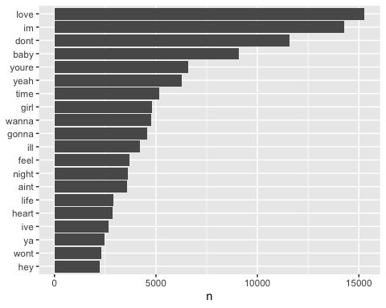
- Tokenization: bigrams
bigram: a two-word token
# bigram tokenization using unnest_tokens() with the argument 'token' and 'n'
songs_bigram <- songs_lyrics %>%
select('Song', 'Year', 'Lyrics') %>% # only keep these three columns
unnest_tokens(bigram, Lyrics, token = "ngrams", n=2) # Lyrics -> bigram
print(songs_bigram)
## # A tibble: 1,598,075 x 3
## Song Year bigram
## <chr> <dbl> <chr>
## 1 0 to 100 the catch up 2014 part i
## 2 0 to 100 the catch up 2014 i 0
## 3 0 to 100 the catch up 2014 0 to
## 4 0 to 100 the catch up 2014 to 100
## 5 0 to 100 the catch up 2014 100 verse
## 6 0 to 100 the catch up 2014 verse 1
## 7 0 to 100 the catch up 2014 1 fuck
## 8 0 to 100 the catch up 2014 fuck bein
## 9 0 to 100 the catch up 2014 bein on
## 10 0 to 100 the catch up 2014 on some
## # … with 1,598,065 more rows
filtering stop words in bigram take three steops 1. break the bigram column into two columns: word1 and word2 2. filter stopwords in word1 and word2 3. combine the two columns back to bigram
# separate the bigram into two columns
songs_bigram %>%
separate(bigram, c("word1", "word2"), sep = " ")
## # A tibble: 1,598,075 x 4
## Song Year word1 word2
## <chr> <dbl> <chr> <chr>
## 1 0 to 100 the catch up 2014 part i
## 2 0 to 100 the catch up 2014 i 0
## 3 0 to 100 the catch up 2014 0 to
## 4 0 to 100 the catch up 2014 to 100
## 5 0 to 100 the catch up 2014 100 verse
## 6 0 to 100 the catch up 2014 verse 1
## 7 0 to 100 the catch up 2014 1 fuck
## 8 0 to 100 the catch up 2014 fuck bein
## 9 0 to 100 the catch up 2014 bein on
## 10 0 to 100 the catch up 2014 on some
## # … with 1,598,065 more rows
# filter the stop words
songs_bigram %>%
separate(bigram, c("word1", "word2"), sep = " ") %>%
filter(!word1 %in% stop_words$word) %>%
filter(!word2 %in% stop_words$word)
## # A tibble: 203,156 x 4
## Song Year word1 word2
## <chr> <dbl> <chr> <chr>
## 1 0 to 100 the catch up 2014 100 verse
## 2 0 to 100 the catch up 2014 verse 1
## 3 0 to 100 the catch up 2014 1 fuck
## 4 0 to 100 the catch up 2014 fuck bein
## 5 0 to 100 the catch up 2014 chill shit
## 6 0 to 100 the catch up 2014 100 nigga
## 7 0 to 100 the catch up 2014 nigga real
## 8 0 to 100 the catch up 2014 real quick
## 9 0 to 100 the catch up 2014 raptopaythebill shit
## 10 0 to 100 the catch up 2014 dont feel
## # … with 203,146 more rows
bigram_filtered <- songs_bigram %>%
separate(bigram, c("word1", "word2"), sep = " ") %>%
filter(!word1 %in% stop_words$word) %>%
filter(!word2 %in% stop_words$word) %>%
unite(bigram, word1, word2, sep = " ") # unite the word1, word2 column into bigram column
print(bigram_filtered)
## # A tibble: 203,156 x 3
## Song Year bigram
## <chr> <dbl> <chr>
## 1 0 to 100 the catch up 2014 100 verse
## 2 0 to 100 the catch up 2014 verse 1
## 3 0 to 100 the catch up 2014 1 fuck
## 4 0 to 100 the catch up 2014 fuck bein
## 5 0 to 100 the catch up 2014 chill shit
## 6 0 to 100 the catch up 2014 100 nigga
## 7 0 to 100 the catch up 2014 nigga real
## 8 0 to 100 the catch up 2014 real quick
## 9 0 to 100 the catch up 2014 raptopaythebill shit
## 10 0 to 100 the catch up 2014 dont feel
## # … with 203,146 more rows
To visualize the result using ggplot2 package.
# bar chart: most popular two-word phrase in lyrics
bigram_filtered %>%
count(bigram, sort = TRUE) %>%
top_n(20) %>%
mutate(bigram = reorder(bigram, n)) %>%
ggplot(aes(bigram, n)) +
geom_col() +
xlab(NULL) +
coord_flip()
## Selecting by n
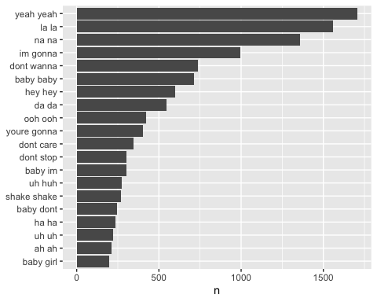
- Sentiment Analysis
The method in this tutorial is a simple word-based sentiment analysis. It requires no machine learning.
# tidytext has a data frame that labels certain
# to retrieve the sentiment labeled word table
senti_words <- get_sentiments("bing")
print(senti_words)
## # A tibble: 6,786 x 2
## word sentiment
## <chr> <chr>
## 1 2-faces negative
## 2 abnormal negative
## 3 abolish negative
## 4 abominable negative
## 5 abominably negative
## 6 abominate negative
## 7 abomination negative
## 8 abort negative
## 9 aborted negative
## 10 aborts negative
## # … with 6,776 more rows
# to count the most frequent negative and positive words
songs_words %>%
inner_join(senti_words) %>%
count(word, sentiment, sort = TRUE) %>%
group_by(sentiment) %>%
top_n(10) %>%
ungroup() %>%
mutate(word = reorder(word, n))
## Joining, by = "word"
## Selecting by n
## # A tibble: 20 x 3
## word sentiment n
## <fct> <chr> <int>
## 1 love positive 15283
## 2 like positive 10949
## 3 right positive 3946
## 4 good positive 2885
## 5 well positive 2420
## 6 better positive 1655
## 7 bad negative 1258
## 8 hard negative 1241
## 9 shake negative 1207
## 10 sweet positive 1136
## 11 break negative 977
## 12 hot positive 949
## 13 wrong negative 946
## 14 fall negative 925
## 15 best positive 908
## 16 cry negative 899
## 17 shit negative 896
## 18 crazy negative 861
## 19 work positive 844
## 20 lonely negative 748
# facet bar chart
songs_words %>%
inner_join(senti_words) %>%
count(word, sentiment, sort = TRUE) %>%
group_by(sentiment) %>%
top_n(10) %>%
ungroup() %>%
mutate(word = reorder(word, n)) %>%
ggplot(aes(word, n, fill = sentiment)) +
geom_col(show.legend = FALSE) +
facet_wrap(~sentiment, scales = "free_y") +
labs(y = "Top 10 Postive and Negative Words",
x = NULL) +
coord_flip()
## Joining, by = "word"
## Selecting by n
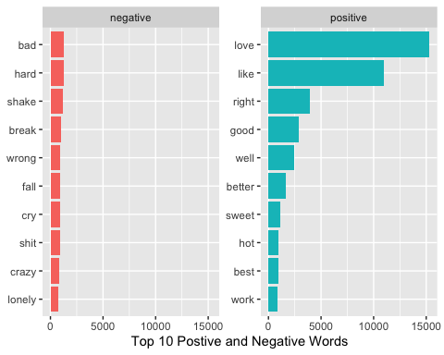 Song-level sentiment analysis
Steps: 1. create a table with songs and their word_count 2. count the negative words of each song 3. calculate the negative ratio (negative_word_count / word_count) of each song 4. most negative songs: songs with the highest negative ratio
# calculate the word counts table by songs
wordcounts <- songs_words %>%
group_by(Year, Song) %>%
summarize(word_count = n())
wordcounts
## # A tibble: 4,842 x 3
## # Groups: Year [51]
## Year Song word_count
## <dbl> <chr> <int>
## 1 1965 a walk in the black forest 161
## 2 1965 all day and all of the night 193
## 3 1965 all i really want to do 202
## 4 1965 baby dont go 159
## 5 1965 baby im yours 144
## 6 1965 baby the rain must fall 92
## 7 1965 back in my arms again 235
## 8 1965 california girls 180
## 9 1965 cant you hear my heart beat 215
## 10 1965 cara mia 148
## # … with 4,832 more rows
# count the negative words in each song
negative_words <- get_sentiments("bing") %>%
filter(sentiment == "negative")
negative_by_song <- songs_words %>%
inner_join(negative_words) %>%
group_by(Year, Song)%>%
summarise(negative_words_count = n())
## Joining, by = "word"
negative_by_song
## # A tibble: 4,521 x 3
## # Groups: Year [51]
## Year Song negative_words_count
## <dbl> <chr> <int>
## 1 1965 a walk in the black forest 1
## 2 1965 all i really want to do 10
## 3 1965 baby im yours 3
## 4 1965 baby the rain must fall 4
## 5 1965 back in my arms again 4
## 6 1965 california girls 1
## 7 1965 cara mia 3
## 8 1965 catch us if you can 1
## 9 1965 count me in 4
## 10 1965 crying in the chapel 1
## # … with 4,511 more rows
# create a data frame
negative_rate_by_song <- wordcounts %>%
inner_join(negative_by_song, by = c("Year", "Song"))%>%
mutate(negative_rate = negative_words_count / word_count) %>%
arrange(desc(negative_rate)) %>%
distinct(Song, .keep_all = TRUE) %>%
unite(Year_Song,Year, Song, sep = ", ") %>%
top_n(20)
## Selecting by negative_rate
print(negative_rate_by_song)
## # A tibble: 20 x 4
## Year_Song word_count negative_words_count negative_rate
## <chr> <int> <int> <dbl>
## 1 1976, shake shake shake shake your booty 206 94 0.456
## 2 2013, harlem shake 46 13 0.283
## 3 2014, shake it off 520 123 0.237
## 4 2015, shake it off 520 123 0.237
## 5 1986, bad boy 237 51 0.215
## 6 1985, the wild boys 245 51 0.208
## 7 2008, shake it 359 67 0.187
## 8 2008, disturbia 478 89 0.186
## 9 2009, disturbia 478 89 0.186
## 10 1984, cum on feel the noize 244 41 0.168
## 11 1965, wooly bully 125 21 0.168
## 12 1999, wild wild west 751 125 0.166
## 13 1979, knock on wood 228 36 0.158
## 14 2010, break your heart 420 66 0.157
## 15 1978, disco inferno 391 61 0.156
## 16 1998, cruel summer 300 46 0.153
## 17 2013, i knew you were trouble 372 56 0.151
## 18 1970, hey there lonely girl 162 24 0.148
## 19 1988, shake your love 395 58 0.147
## 20 2014, burn 469 68 0.145
negative_rate_by_song %>%
ggplot(aes(reorder(Year_Song, negative_rate), negative_rate)) +
geom_col(show.legend = FALSE) +
labs(y = "Twenty Most Negavie Songs 1965 - 2014",
x = NULL) +
coord_flip()
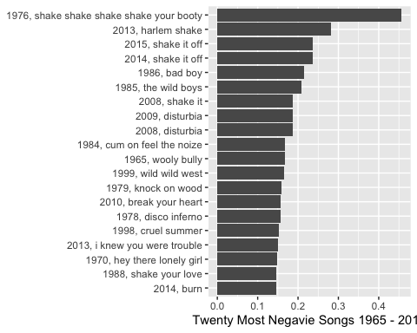 As we can see, the result is problematic. ‘shake’ is labeled as a negative words in the dictionary, but it does not always has a negative connotation in song lyrics. One way of modifying the result is to remove ‘shake’ from the senti_word table.
# filter the 'shake'
negative_words_new <- get_sentiments("bing") %>%
filter(sentiment == "negative") %>%
filter(word != 'shake')
negative_by_song_new <- songs_words %>%
inner_join(negative_words_new) %>%
group_by(Year, Song)%>%
summarise(negative_words_count = n())
## Joining, by = "word"
wordcounts %>%
inner_join(negative_by_song_new, by = c("Year", "Song"))%>%
mutate(negative_rate = negative_words_count / word_count) %>%
arrange(desc(negative_rate)) %>%
distinct(Song, .keep_all = TRUE) %>%
unite(Year_Song,Year, Song, sep = ", ") %>%
top_n(20) %>%
ggplot(aes(reorder(Year_Song, negative_rate), negative_rate)) +
geom_col(show.legend = FALSE) +
labs(y = "Twenty Most Negavie Songs 1965 - 2014",
x = NULL) +
coord_flip()
## Selecting by negative_rate
