A Hybrid Biomedical Image-Analysis Pipeline for Fluorescence-Microscopy Nuclei
Assignment 3 — AI in Biomedical Imaging | [Student Name] — [Student ID] | 17 August 2026
Note: the assignment requires a PDF submission of at most 4 pages. report.pdf (2-column, verified at exactly 4 pages) is the file to submit. This .docx has the same content in a single-column layout for easy editing — update the name/ID above, then either re-export this file to PDF and check the page count, or make the same edit directly in report.html and re-render (see README).
1 Overview of methods
Modality & data. The assigned modality is synthetic fluorescence microscopy (DAPI-like nuclear staining), 112 RGB 256×256 images with paired binary/instance masks, split 80/20/12 (train/val/test), plus 4 corrupted test variants for the robustness extension. All images were converted to 8-bit grayscale (PIL) and confirmed at 256×256 (bilinear resize kept in the code path for portability to other sizes).
Pipeline, as implemented. Task 1 pairs an EDA (sample grid, pooled intensity histogram) with a direct image description from a local vision-language model (llama3.2-vision via Ollama), comparing a naive prompt against a schema-constrained, descriptive-not-diagnostic prompt, repeated 3× to expose run-to-run variability. Task 2 segments the same image classically — Otsu threshold → morphological opening/closing & small-object removal → connected-component labelling → regionprops_table — turns the table into a short deterministic numeric summary, and sends only that text (never the pixels) to a smaller local text LLM (llama3.2) for a paragraph + JSON. Task 3 trains a compact U-Net (4 encoder/decoder stages, base width 16, ≈1.94M parameters, skip connections, combined BCE+Dice loss) for 40 epochs (Adam, lr=1e-3, batch 4, CPU) and evaluates Dice/IoU on the held-out val split. Task 4 chains the trained U-Net → regionprops → code-computed JSON fields → LLM narrative across all 12 unseen test images, aggregated to a CSV. Throughout, numeric JSON fields a user would act on are computed in code, never by LLM arithmetic — the design rationale behind this is discussed under Q4.
2 Task 1 — data preparation & VLM description
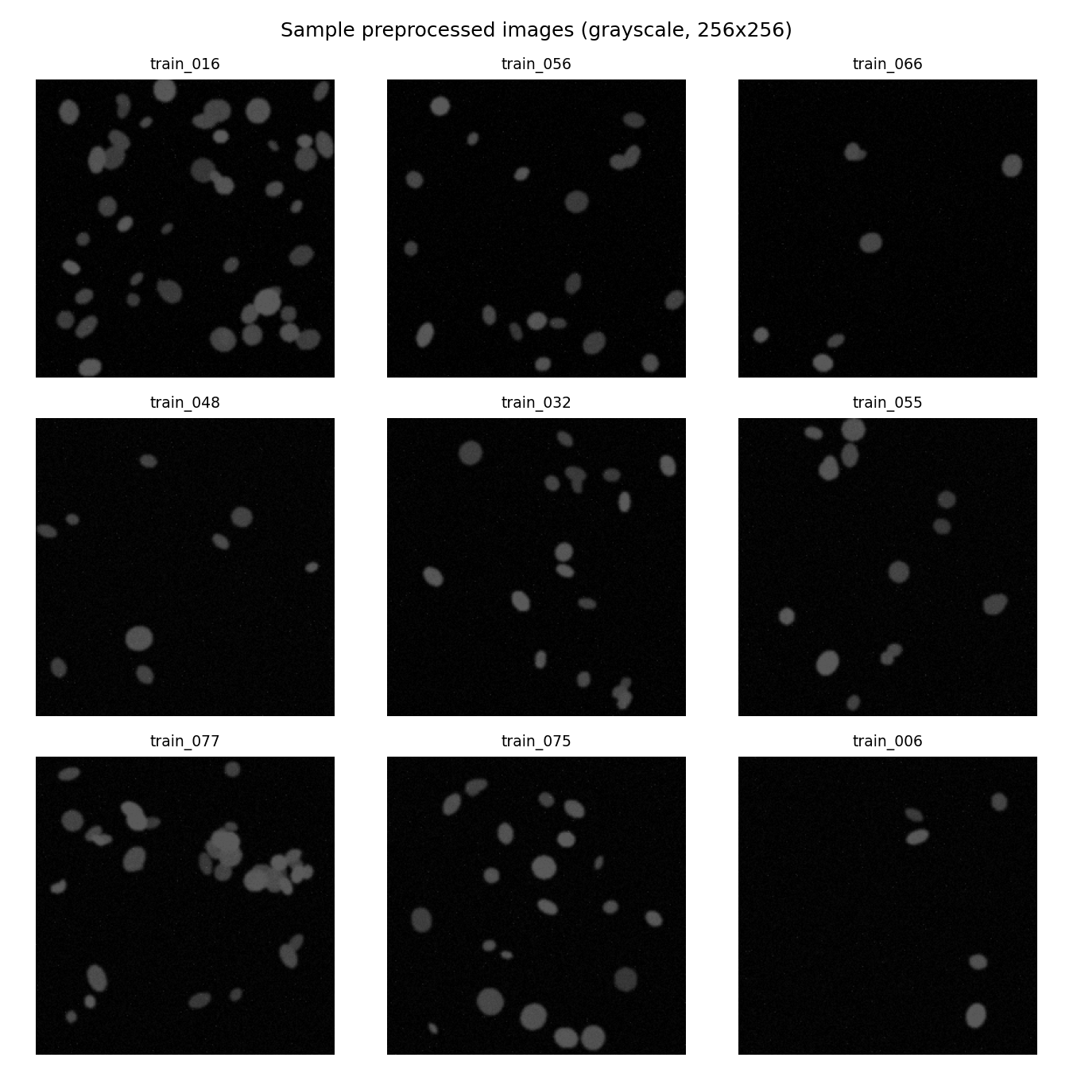
Fig. 1. Nine random preprocessed (grayscale, 256×256) training images.
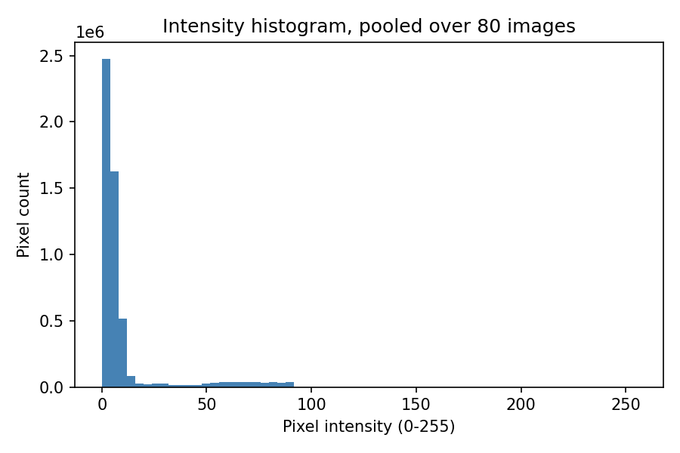
Fig. 2. Pixel-intensity histogram pooled over all 80 training images: strongly right-skewed, dark background dominates, with a long low-count tail from nucleus signal — typical of fluorescence images on a black field.
Naive prompt (“What is this image showing? ... is there anything wrong with the tissue?”) returned free prose that volunteered an unprompted, confident clinical-sounding judgement: “cells appear to be healthy and normal, with no visible signs of damage or abnormalities.” Nothing in the prompt asked for a health assessment — the model defaulted to one, which is exactly the failure mode Task 1 is designed to catch.
Optimised prompt (used for all reported VLM outputs)
You are an assistant that provides objective, descriptive observations about a biomedical research image, for educational purposes only. You are NOT a diagnostic tool: you must not name a disease, give a diagnosis, or suggest treatment. Describe only what is visually observable.
Report: modality, tissue_type, notable_features (1-2 sentences, purely descriptive), image_quality (focus/contrast/noise). If not confident about any field, write "uncertain" instead of guessing.
Respond with ONLY a single JSON object:
{"modality": "...", "tissue_type": "...", "notable_features": "...", "image_quality": "..."}
(Full prompt text, incl. exact schema line, in src/vlm_description.py / outputs/json_records/task1_vlm_description.json; shown condensed here for space.)
{"modality": "fluorescence microscopy",
"tissue_type": "uncertain",
"notable_features": "Bright blue spots are scattered across the image,
possibly representing cellular structures or other biological features.",
"image_quality": "uncertain"}
Run-to-run variability. Three repeats of the identical optimised prompt on the same image gave different answers for tissue_type (“uncertain”, “cell culture”, “uncertain”) and image_quality (“uncertain” twice, but once a full descriptive sentence). Wording of notable_features also changed each time. This is expected LLM sampling variance, not a bug — it is exactly why a single free-text VLM call should never be the sole record of an image (see Q1/Q4).
3 Task 2 — classical features & numbers-first interpretation
On train_004, Otsu + morphology detected 37 objects. A sample of the region table:
label | area | ecc. | solidity | mean int.
1 | 267 | 0.761 | 0.950 | 66.8
3 | 478 | 0.821 | 0.746 | 64.8
4 | 2036 | 0.826 | 0.565 | 73.5
7 | 102 | 0.650 | 0.953 | 52.0

Numbers-first interpretation prompt
You are an assistant that interprets a table of image-analysis measurements... You are NOT given the image itself, only these numeric measurements, and must not invent visual details... You are NOT a diagnostic tool.
Measurements summary: {n_objects, area/eccentricity/solidity/mean_intensity/extent stats}
1. Write ONE short paragraph (3-4 sentences) on count, density, size spread, shape regularity.
2. Output JSON: {"n_objects": int, "density_class": "sparse|normal|dense",
"shape_regularity": "regular|irregular", "quality_flag": "ok|uncertain"}
If ambiguous, use "uncertain" rather than guessing.
LLM json: {"n_objects": 37, "density_class": "sparse",
"shape_regularity": "irregular", "quality_flag": "uncertain"}
Code json: {"n_objects": 37, "density_class": "normal",
"shape_regularity": "irregular", "quality_flag": "ok",
"mean_area": 360.9}
Note the disagreement: the code rule (<15 sparse, 15–40 normal, >40 dense) puts 37 objects at normal density; the LLM, given that same count in the prompt text, wrote sparse — a numeric-reasoning slip even in a numbers-only, image-free setting. This is direct evidence that the code-derived JSON, not the LLM's JSON, must be treated as ground truth (Task 4 architecture; Q4).
4 Task 3 — U-Net segmentation
The U-Net (Section 1 architecture) was trained for 40 epochs on the 80-image train split and evaluated on the 20-image val split; Fig. 3 shows the resulting training and validation curves.
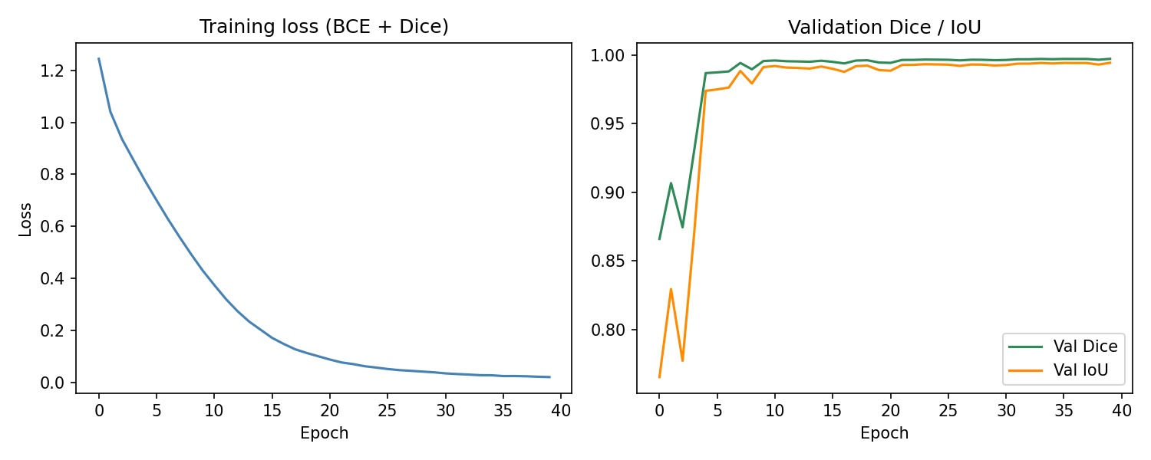
Fig. 3. Training loss (BCE+Dice) and validation Dice/IoU over 40 epochs. Both curves plateau by ~epoch 15-20; the visible dip in early-epoch Dice/IoU (epochs 1-3) reflects the randomly-initialised decoder before it learns to close small holes.
Split | Method | Mean Dice | Mean IoU
val (n=20) | Otsu (classical) | 0.976 | 0.953
val (n=20) | U-Net (BCE+Dice, 40 ep.) | 0.997 | 0.994

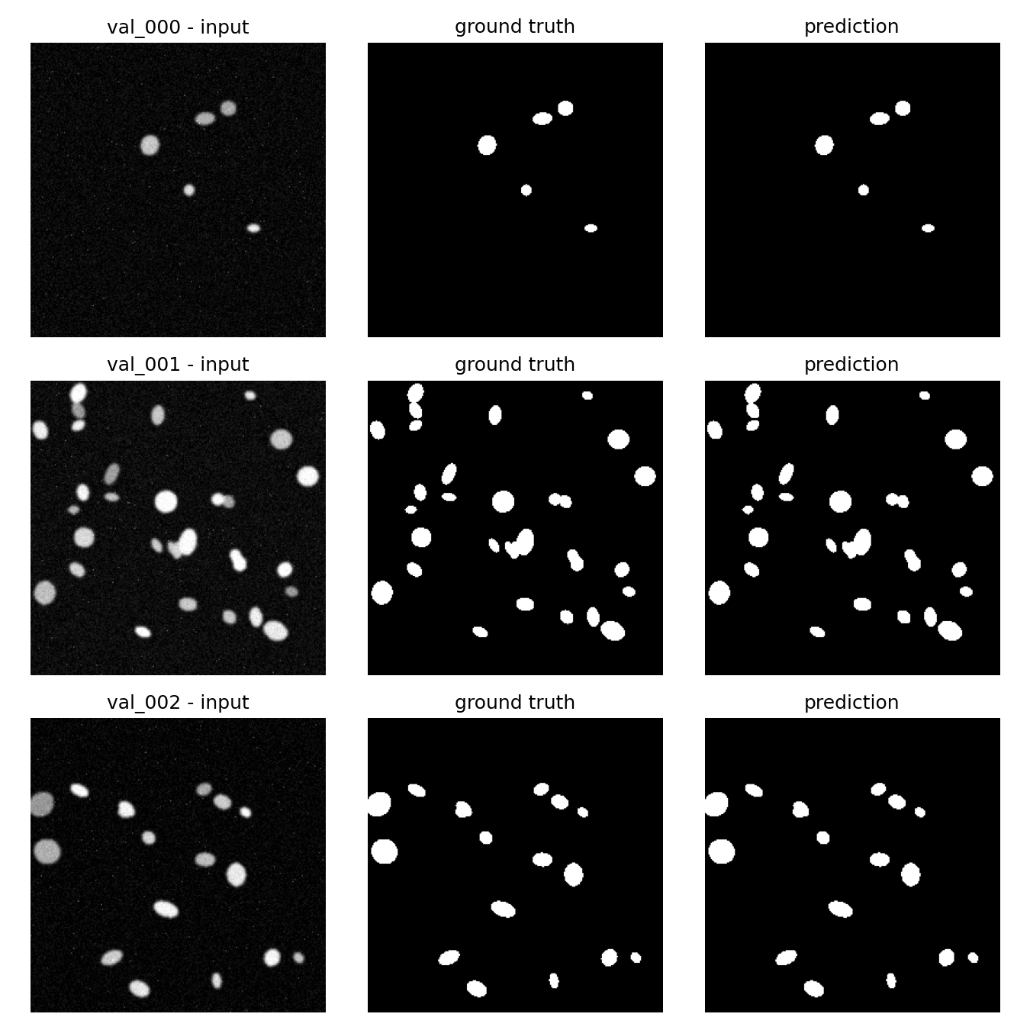
Fig. 4. Input / ground-truth / U-Net prediction for 3 validation images (val_000–val_002) — predicted masks are visually close to pixel-identical to ground truth.
5 U-Net vs Otsu, and the hybrid pipeline (Task 4)
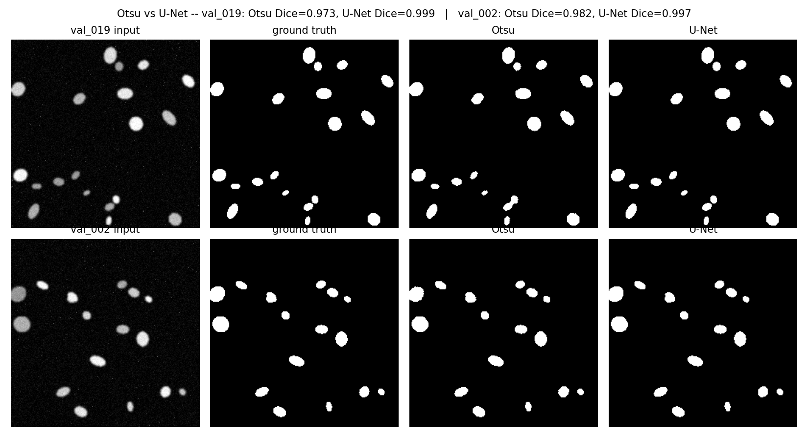
Fig. 5. Qualitative comparison on the two extreme cases from val: U-Net's largest margin (val_019, touching/medium-contrast nuclei — Otsu leaves ragged, notched edges) and its smallest margin (val_002, large well-separated bright nuclei — a global threshold is already nearly correct).
The U-Net matched or beat Otsu on every validation image; there was no case where Otsu was actually better, only cases where its disadvantage was small. That the gap is largest on medium-contrast/touching objects and smallest on large, bright, well-isolated ones (Fig. 5) is consistent with Otsu's single global threshold being a good approximation only when foreground/background separation is already easy.
Task 4 example record (test_000, unseen)
{"image_id": "test_000", "n_objects": 8, "mean_area": 191.0,
"density_class": "sparse", "quality_flag": "ok",
"narrative": "The test_000 image contains 8 objects with varying sizes,
as indicated by a standard deviation of 111 pixels in their areas.
These objects appear to have a range of shapes ... suggesting some
elongation or irregularity. However, the mean solidity and extent
values suggest that most ... are roughly convex and well-defined ..."}
All 12 test images were processed this way (U-Net mask → regionprops → code JSON fields → LLM narrative) and aggregated into outputs/task4_hybrid_records.csv (one row per image; n_objects ranged 8–43, density_class sparse/normal/dense throughout). The narrative prompt keeps Task 2's numbers-only, non-diagnostic framing but asks for prose only (the JSON fields are already fixed by code, so the LLM is not asked to repeat them):
You are an assistant that writes a short, objective narrative for a biomedical research image, for educational purposes only. You are NOT a diagnostic tool. You are given only numeric measurements below, not the image itself -- do not invent visual details beyond what the numbers imply.
Image id: {image_id}
Measurements from automatic segmentation: {summary_text}
Write ONE short paragraph (3-4 sentences) ... If the numbers are ambiguous, say so rather than guessing. Plain text only, no JSON.
Robustness extension (bonus)
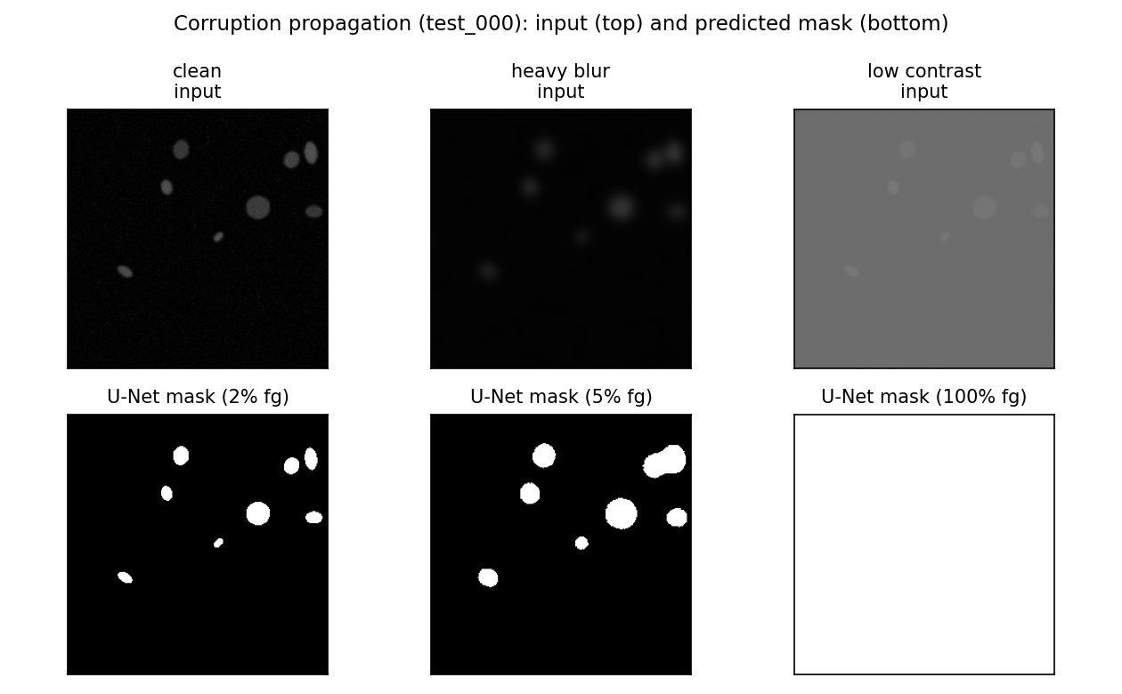
Fig. 6. Corruption propagation on test_000. Blur softens object boundaries but the mask still finds discrete objects. Low contrast is catastrophic: the U-Net mask becomes 100% foreground (the whole frame), silently breaking every downstream stage.
Two corrupted variants (heavy Gaussian blur; low-contrast rescale) of 2 test images were traced through all four stages. Blur: pixel std drops ~40–44% (stage 1), mask Dice-vs-GT collapses from ~0.997 to ~0.65 (stage 2, Fig. 6 middle column), object count drops modestly. Low-contrast: pixel mean shifts by hundreds of percent (stage 1), the mask completely fails to 100% foreground (Dice≈0.05–0.36, Fig. 6 right column), and the region table collapses to a single “object” with area=65535 — exactly 256×256. Critically, the LLM narrative for this case still reads fluently (“a single, elongated oval-shaped object…”) with no hint of failure — only the structured field area=65535 exposes it. The earliest stage at which the corruption is detectable at all is stage 1 (raw pixel statistics, before segmentation even runs); the earliest stage at which it becomes unambiguous without instrumenting raw pixels is the stage-3 feature table, not the narrative.
6 Discussion & answers to the set questions
Q1 — VLM vs numbers-first: which is more useful, which is more trustworthy? The direct VLM description (Task 1) is more useful for a fast, human-readable first impression — it reads naturally and needs no downstream code to consume. It is less trustworthy: it is non-deterministic (Section 2), it is not grounded in any measurement that can be independently re-checked, and the naive-prompt run showed it will volunteer confident-sounding judgements it was never asked for. The numbers-first pipeline (Task 2) is more trustworthy because every quantity is reproducible — re-running Otsu+regionprops on the same image always gives the same table — and the LLM's role is reduced to phrasing rather than measuring. It is not perfectly trustworthy either (Section 3 showed a density-class misclassification), which is exactly why the code-derived JSON, not either LLM's JSON, is treated as ground truth throughout.
Q2 — Did the U-Net improve on Otsu? Examples. Yes, on every validation image (mean Dice 0.997 vs 0.976; mean IoU 0.994 vs 0.953). U-Net's advantage is largest on val_019 (Otsu 0.973 vs U-Net 0.999) where nuclei are medium-contrast and partly touching — Otsu's fixed global threshold leaves ragged edges and small spurious fragments (Fig. 5, top row). Otsu is closest to U-Net (though still behind) on val_002 (0.982 vs 0.997), where nuclei are large, bright, and well-isolated against a clean dark background — conditions under which a single threshold is nearly sufficient by construction.
Q3 — Dice/IoU meaning and failure modes. Dice = 2|P∩G| / (|P|+|G|) and IoU = |P∩G| / |P∪G| both measure pixel-set overlap between predicted (P) and ground-truth (G) foreground; IoU penalises boundary/size mismatches more harshly than Dice for the same error. Mean val Dice 0.997 / IoU 0.994 mean predicted masks are almost pixel-identical to ground truth on this dataset. The (narrow, 0.995–0.999) per-image range is lowest on images with more, smaller, or more closely packed nuclei (e.g. val_004, val_005, val_012) — consistent with the qualitative panels, where residual error concentrates at object boundaries and at touching instances. Because the model outputs one binary foreground mask rather than per-instance labels, it structurally cannot separate two touching nuclei into two objects even when the pixel-level Dice looks excellent — a real limitation Dice/IoU do not expose.
Q4 — Where can the LLM hallucinate, and what mitigates it? Three concrete points were observed: (i) Task 1's free-text tissue_type/image_quality fields changing answer across identical re-runs; (ii) Task 2's LLM assigning density_class="sparse" to 37 objects when the code rule (and its own stated count) implies “normal”; (iii) the robustness test's narrative describing a physically broken, whole-frame mask as “a single, elongated oval-shaped object” without flagging anything wrong. Mitigations used in the code: a constrained JSON schema that explicitly permits “uncertain” (removing the pressure to fabricate a confident answer); an explicit “not a diagnostic tool” role instruction; isolating the interpretation LLM from pixels entirely in Tasks 2/4 so it cannot invent visual detail beyond the numbers it is given; a regex-based JSON-extraction-with-retry helper (llm_utils.chat_json) that rejects and retries malformed output; and, most importantly, computing every numeric field a downstream user would act on (n_objects, mean_area, density_class, quality_flag) directly from the regionprops table in code, never from the LLM's own arithmetic. Keeping this code-derived JSON as the source of truth matters because it is deterministic and diffable (identical input → identical output, unlike the LLM text), can be automatically range-checked (e.g. flag area ≥ image area, exactly what would have caught the corrupted-image failure), and lets an auditor trace any number back to the exact pixels and function that produced it — the fluent narrative alone cannot offer any of that.
Q5 — Clinical trust and the highest-impact change. No part of this system should be trusted in a real clinical setting yet. The near-perfect Dice (0.997) reflects a fully synthetic dataset of clean, well-separated, uniformly-stained blobs on a flat dark background — the model has never seen real staining variability, overlapping nuclei at density, or acquisition artefacts, so the number says more about the dataset's ease than about the model's real-world skill. The VLM step is demonstrably non-deterministic and can produce confident-sounding but unverified claims. And evaluation is at the pixel/mask level only — there is no instance-level check, so the pipeline could report a plausible object count for the wrong reason. Considering accuracy, auditability, and dataset limits together, the single highest-impact change would be replacing the synthetic dataset with a real, expert-annotated microscopy/histology set (with a held-out clinical-site split) and wiring the automatic range/plausibility checks the robustness test motivates (e.g. reject or flag any code-derived record whose area is implausible, before any narrative reaches a user) — together these close both the generalisation gap and the “plausible but wrong” narrative failure mode this report demonstrates.
References
Ronneberger, O., Fischer, P., Brox, T. (2015). U-Net: Convolutional Networks for Biomedical Image Segmentation. MICCAI.
Otsu, N. (1979). A Threshold Selection Method from Gray-Level Histograms. IEEE Trans. Systems, Man, and Cybernetics, 9(1), 62–66.
van der Walt, S. et al. (2014). scikit-image: image processing in Python. PeerJ, 2:e453.
Sørensen, T. (1948). A method of establishing groups of equal amplitude... Biol. Skr., 5, 1–34. (Dice/Sørensen coefficient.)
Meta AI (2024). Llama 3.2 Model Card (incl. vision variants). Served locally via Ollama (ollama.com).
Caicedo, J. C. et al. (2019). Nucleus segmentation across imaging experiments: the 2018 Data Science Bowl. Nature Methods, 16, 1247–1253.

