1.Write a JavaScript program to display the current day and time in the following format.

Sample Output :

Today is : Friday.

Current time is : 4 PM : 50 : 22

2.Write a JavaScript program to print the contents of the current window.

3.Write a JavaScript program to get the current date.

Expected Output:mm-dd-yyyy, mm/dd/yyyy or dd-mm-yyyy, dd/mm/yyyy

4.Write a JavaScript program where the program takes a random integer between 1 to 10, the user is then prompted to input a guess number. If the user input matches with guess number, the program will display a

message "Good Work" otherwise display a message "Not matched".

5.Write a JavaScript program to calculate multiplication and division of

two numbers (input from user).

Sample form:

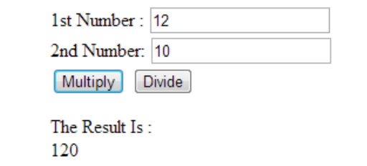

6.Write a JavaScript program to get the website URL (loading page) & print on console.

7.Write a JavaScript program to capitalize the first letter of each word of a given string.

8.Write a JavaScript program to check if a given string contains equal number of p's and s's present.

Sample output :

Input string :

paatpss

Output : true

Input string : paatps

Output : false

9.Write a JavaScript program to create a new string of 4 copies of the last 3 characters of a given original string. The length of the given string must be 3 and above.

Sample

input 1: "Python 3.0"

Output 1: 3.03.03.03.0

Input 2: "JS"

OUTPUT2 :false

Input3 : JavaScript

Output3: iptiptiptipt

10.Write a JavaScript program to swap the first and last elements of a given array of integers. The array length should be at least 1.

11.Write a JavaScript function that reverse a number.Using built in functions.

Example x = 32243;

Expected Output :

34223

12.Write a JavaScript function that returns a passed string with letters in alphabetical order. Using built in functions.

Example string :

'webmaster'

Expected Output :

'abeemrstw'

Assume punctuation and numbers symbols are not included in the

passed string.

13.Write a JavaScript function that accepts a string as a parameter and find the longest word within the string.

Using builtin functions.

Example string

: 'Web Development Tutorial'

Expected Output :

'Development'

Write a JavaScript function to extract unique characters from a string.

Example string

: "thequickbrownfoxjumpsoverthelazydog"

Expected Output

: "thequickbrownfxjmpsvlazydg"

Write a JavaScript function to get the number of occurrences of each letter in specified string.

Sample input :

The quick brown fox jumps over the lazy dog

Sample Output:

"T":1,"h":2,"e":3,"q":1,"u":2,"i":1,"c":1,"k":1,"b":1,"r":2,"o":4,"w

":1,"n":1,"f":1,"x":1,"j":1,"m":1,"p":1,"s":1,"v":1,"t":1,"

l":1,"a":

1,"z":1,"y":1,"d":1,"g":1

14.Write a JavaScript function that generates a string id (specified length) of random characters.

Sample character list:

"ABCDEFGHIJKLMNOPQRSTUVWXYZabcdefghijklmnopqrstuvwxyz0123456

789"

Length : 8

Output :

XppJs2BC

15.Write a JavaScript function to find longest substring in a given a string without repeating characters.

Sample Input :

google.com

Sample Output:

gle.com

Sample input :

example.com

Sample output:

xample.co

1.

How to detect a textbox's content has changed using jQuery?

2

.Change button text using jQuery.

3

. Add 3 new options to a drop

-

down list using jQuery.

4

. Set background

-

image using jQuery CSS property.

Appointment request created successfully with order ID 25962549. You will receive a confirmation letter to the registered email Id, on confirmation from the medical centre.