1.Write a program to create database in mongodb using node.js.

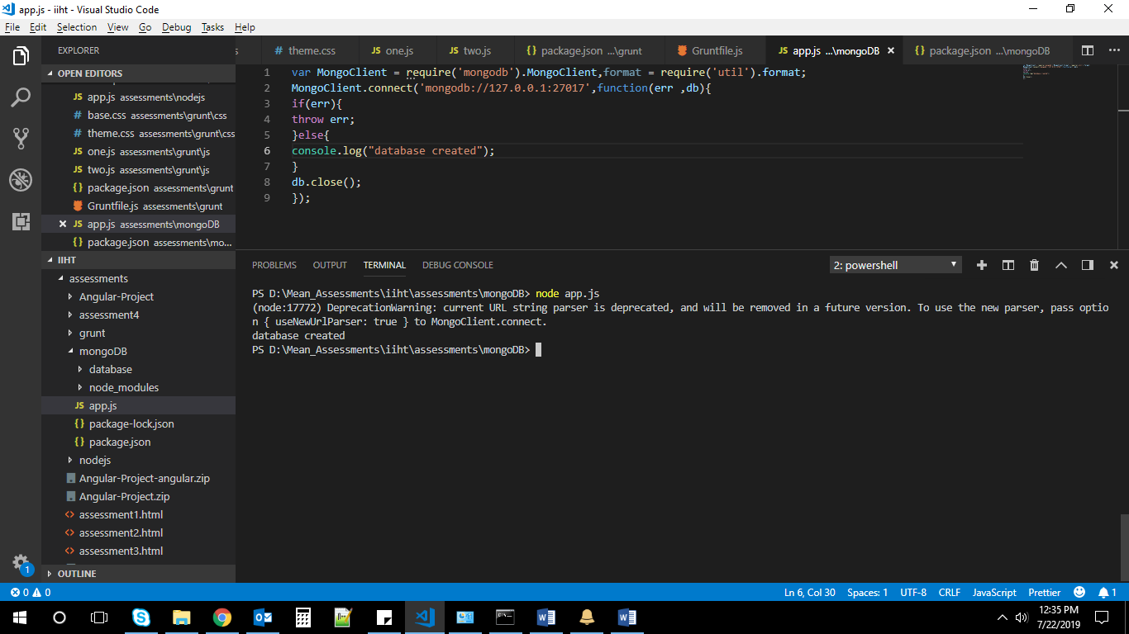

2.Write a program to insert data into mongodb using node.js.

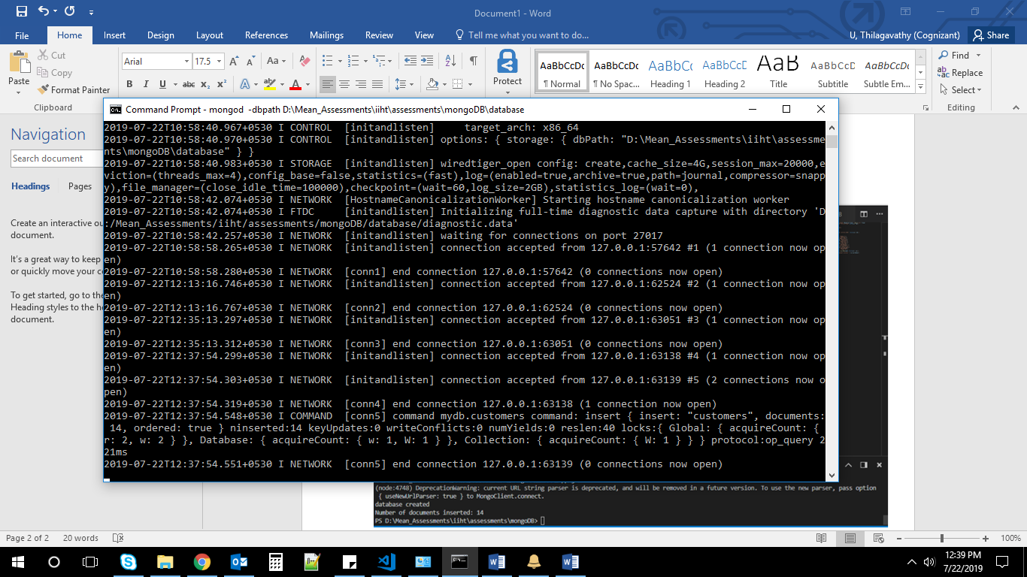

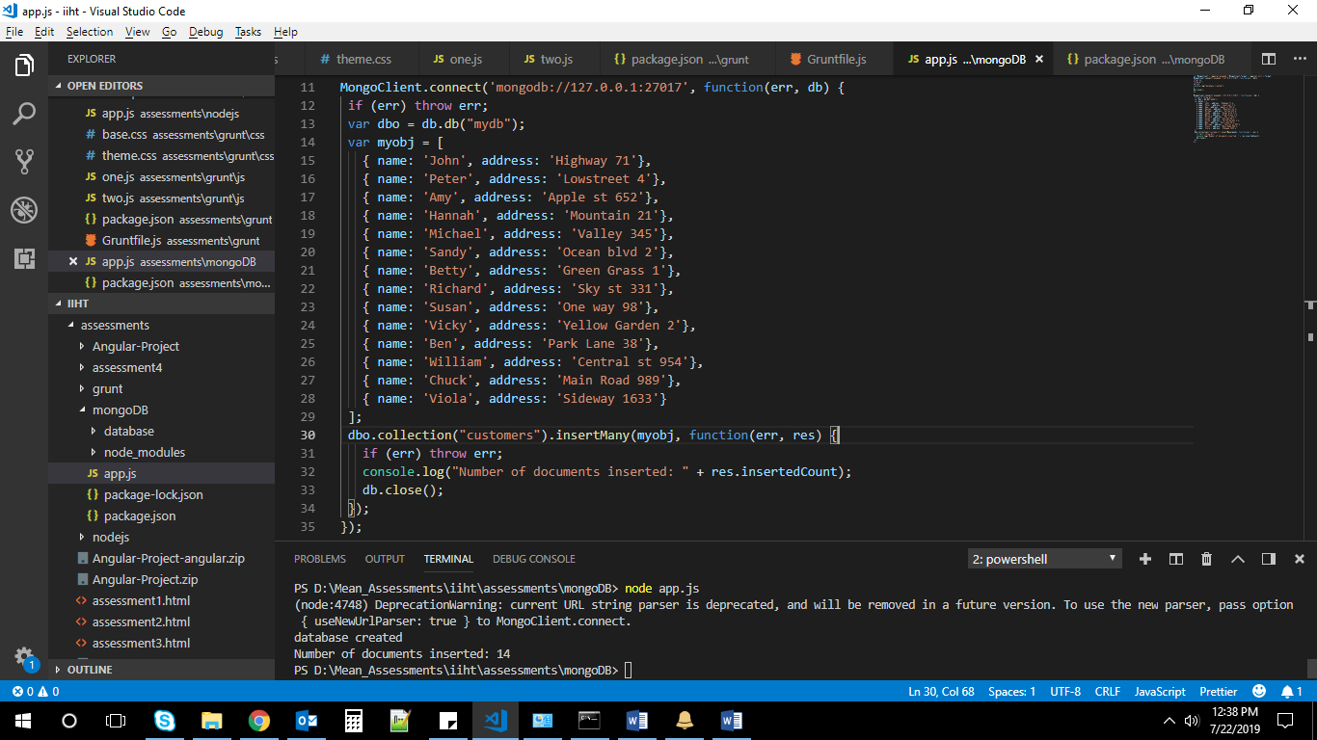

3.Write a program to select data from mongodb using node.js.

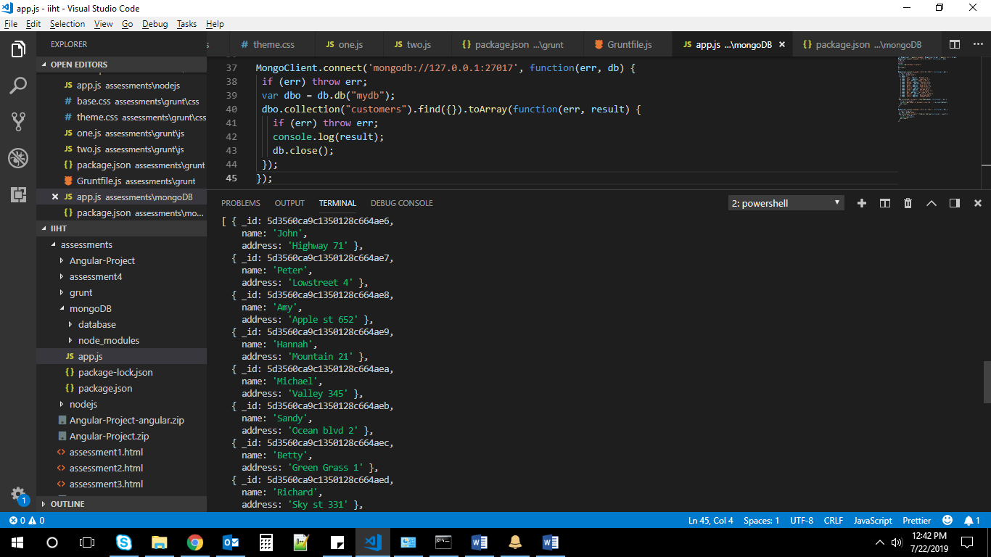

4.Write a program to create database in MySql using node.js.

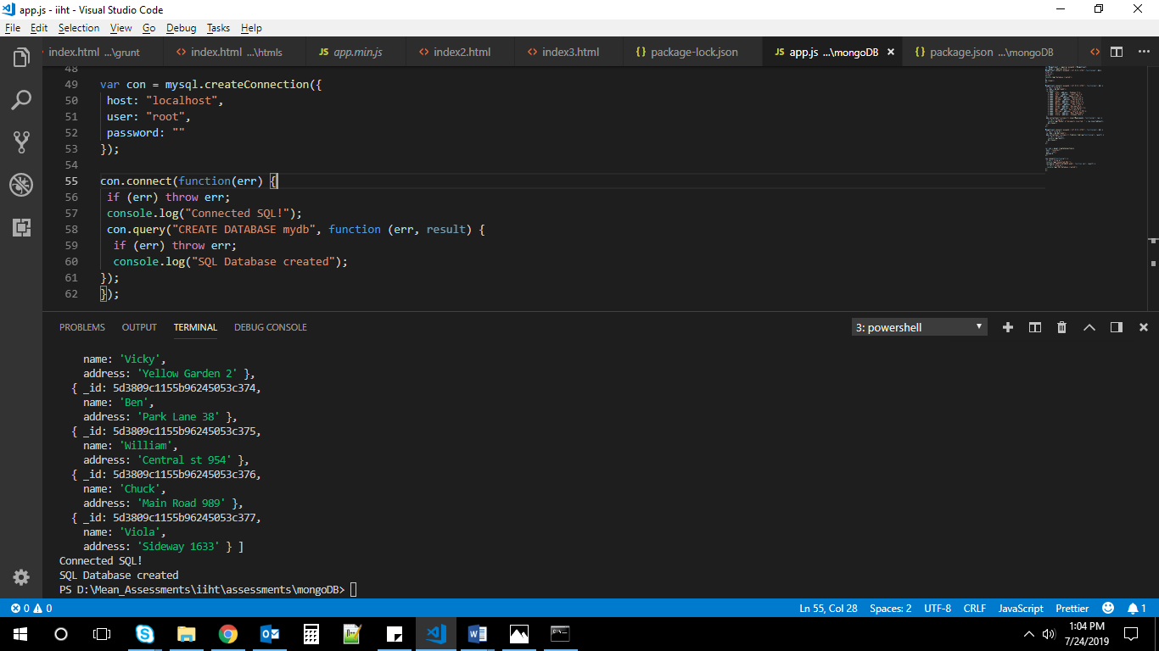

5)Write a program to insert data into Mysql using node.js.

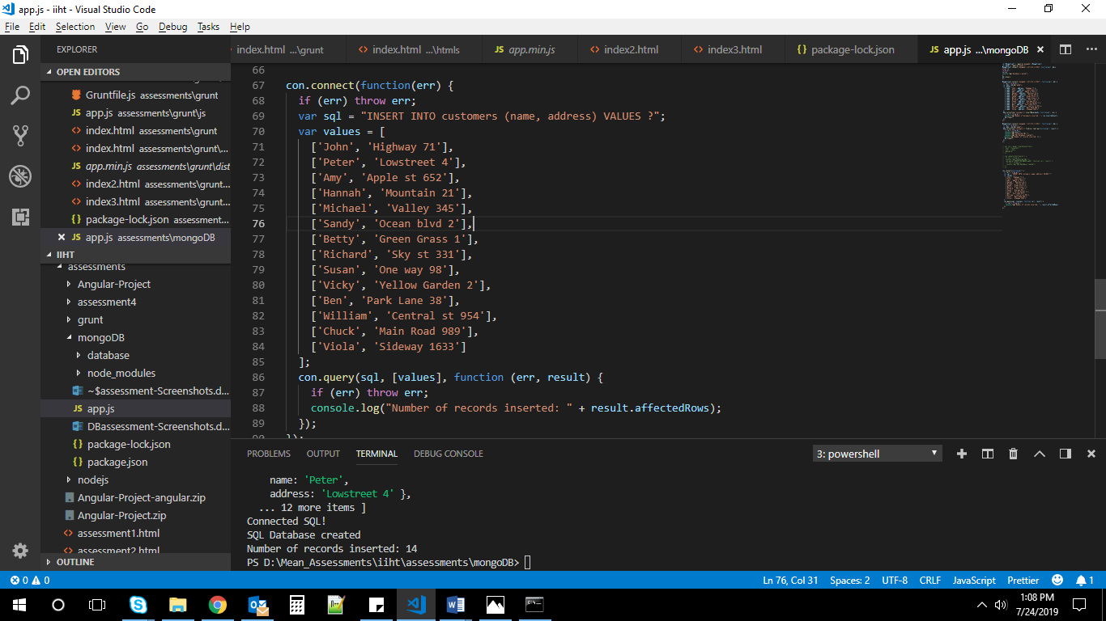

6)Write a program to select data from Mysql using node.js.

