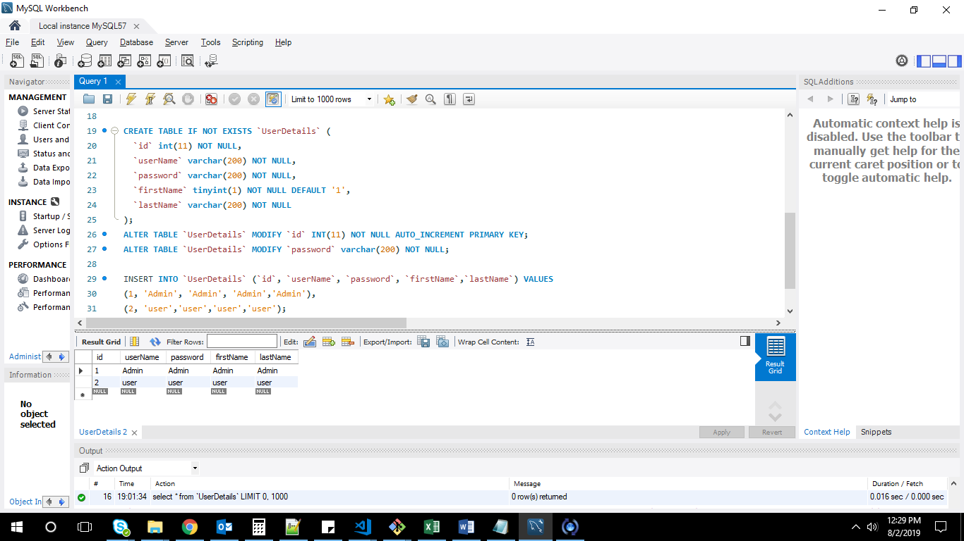

UserDetails table -creation:

CREATE TABLE IF NOT EXISTS `UserDetails` (

`id` int(11) NOT NULL,

`userName` varchar(200) NOT NULL,

`password` varchar(200) NOT NULL,

`firstName` tinyint(1) NOT NULL DEFAULT '1',

`lastName` varchar(200) NOT NULL

);

ALTER TABLE `UserDetails` MODIFY `id` INT(11) NOT NULL AUTO_INCREMENT PRIMARY KEY;

ALTER TABLE `UserDetails` MODIFY `password` varchar(200) NOT NULL;

INSERT INTO `UserDetails` (`id`, `userName`, `password`, `firstName`,`lastName`) VALUES

(1, 'Admin', 'Admin', 'Admin','Admin'),

(2, 'user','user','user','user');

select * from `UserDetails`;

login screen :

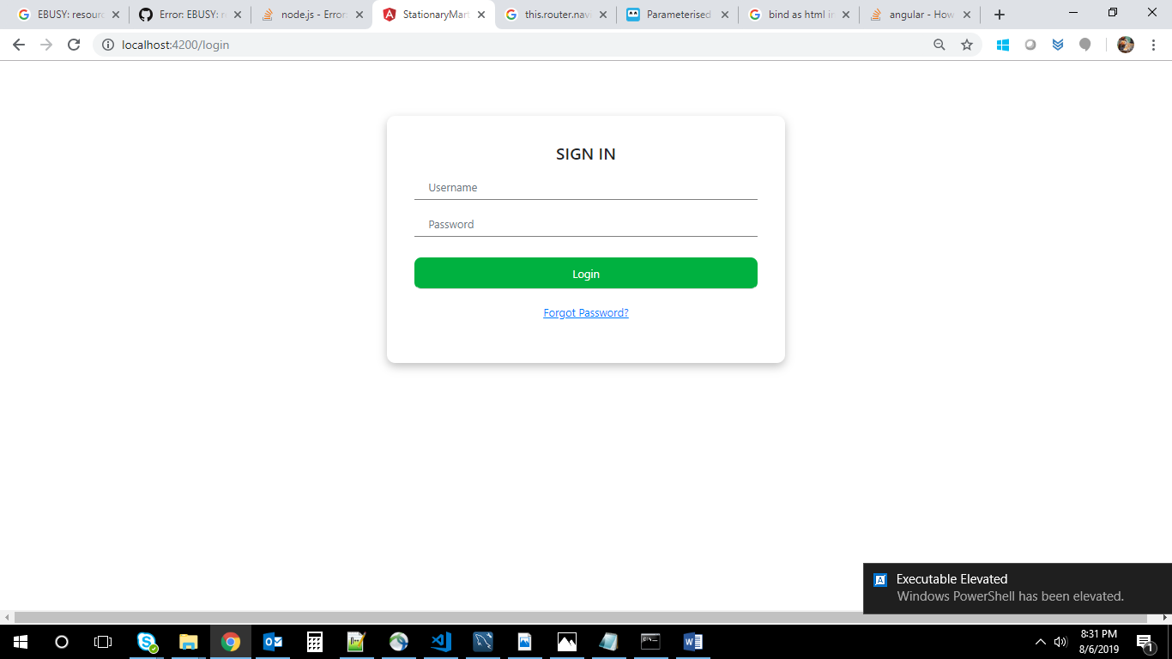

**Username: user**

**Password: user**

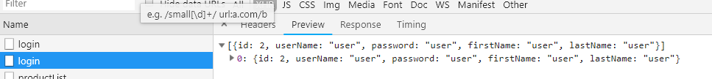

Local storage user data :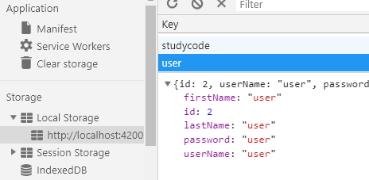

MYSQL PRODUCT LIST TABLE :

CREATE TABLE IF NOT EXISTS `Products` (

`productid` int(11) NOT NULL,

`productName` varchar(200) NOT NULL,

`imageUrl` varchar(500) NOT NULL,

`desc` varchar(11000) NOT NULL,

`price` varchar(200) NOT NULL

);

ALTER TABLE `Products` MODIFY `productid` INT(11) NOT NULL AUTO_INCREMENT PRIMARY KEY;

INSERT INTO `Products` (`productid`, `productName`, `imageUrl`, `desc`,`price`) VALUES

(1, '75 piece wooden set', '\\stationary image\\75piecewoodenset.jpg', '75 piece wooden set contains pens and color pencils .</br> open type wooden box.</br> 2 Layers wooden box.</br> FABIR CASTEL SET.</br>

','1800'),

(2, 'Color Pencils', '\\stationary image\\colorPencils.jpg', '12 piece color pencil set .</br> solid color.</br> clean finish.</br> FABIR CASTEL SET.</br>

','200'),

(3,'Color Sketch pens','\\stationary image\\colorSketchPens.jpg','12 piece color pencil set .</br> solid color.</br> clean finish.</br> FABIR CASTEL SET.</br>','200'),

(4,'Crayons','\\stationary image\\cryons.jpg','12 piece color pencil set .</br> solid color.</br> clean finish.</br> FABIR CASTEL SET.</br>','100'),

(5,'Eraser','\\stationary image\\eraser.jpg','Pencil Eraser</br> clean Eraser, dust free</br> NATRAJ ERASERS','4'),

(6,'ExamPads','\\stationary image\\examPads.jpg','Nice crip, hold more than 50 papers.</br>NATRAJ EXAM PADS','50'),

(7,'Files','\\stationary image\\files.jpg','Office files , Thread type.</br> hold 2000 papers.</br>Easy to hold .<br> NATRAJ FILES','100'),

(8,'Highlighter Pen Set','\\stationary image\\highlighterPenSet.jpg','2 piece highlighter Pen Set .</br> solid color.</br> clean finish.</br> FABIR CASTEL SET.</br>','60'),

(9,'Note Books','\\stationary image\\noteBooks.jpg',' 200 sheets note books.</br> unruled </br> pure White </br> ITC CLASS MATE NOTE BOOKS','50'),

(10,'pens','\\stationary image\\pens.jpg','5 set ball point pen </br> unique color blue ball point pens </br> RENOLD PENS','25'),

(11,'Scales for kids','\\stationary image\\scalesforkids.jpg','30 cm SCALES for kids.</br> plastic product , various colors .</br> transparent.</br>NATRAJ SCALES','10'),

(12,'SHARPNERS','\\stationary image\\sharpeners.jpg','2 piece pencil sharpeners.</br> share edge pencils ,easy using.</br>NATRAJ SHARPNERS','5'),

(13,'smiley Pouch','\\stationary image\\smilePouch.jpg','7 piece smiley pouch.</br>various colors.</br> ','100'),

(14,'smiley Pouch','\\stationary image\\smileyPouch2.jpg','8 piece smiley pouch.</br>various colors.','100');

Display products:

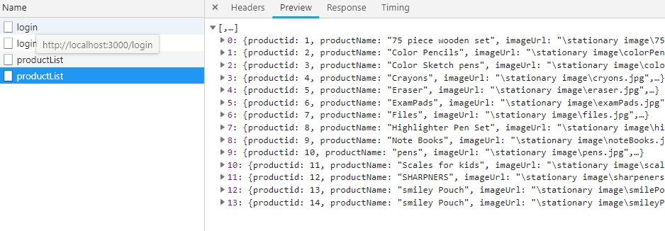

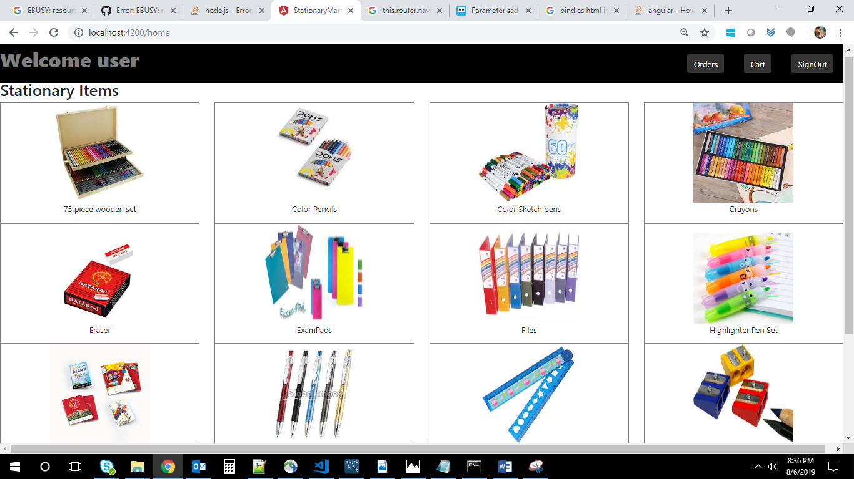

Display each product:

