**HOW TO CALCULATE TIME IN QUOTE VALIDATION PAGE – Mission tech Dev. / 2nd part**

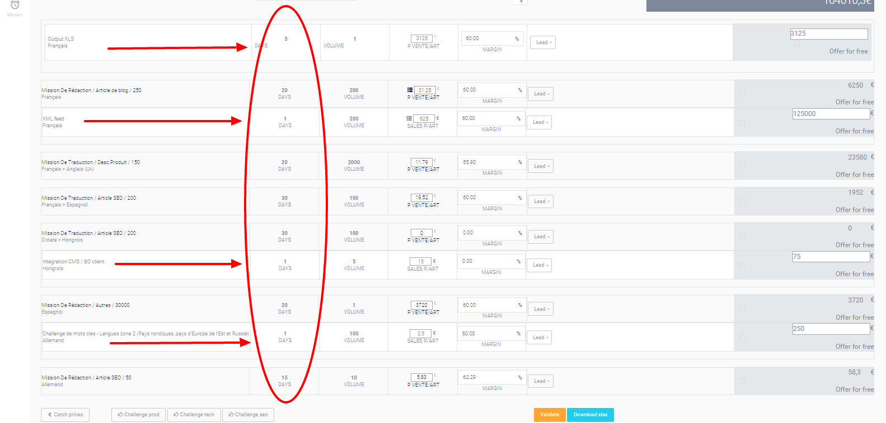

**To calculate the cost :**

**Sales or other users will give the volume.**

**We know the cost for 1 volume because of configuration table** [**http://admin-ep.edit-place.com/quote/tech-mission-type**](http://admin-ep.edit-place.com/quote/tech-mission-type)

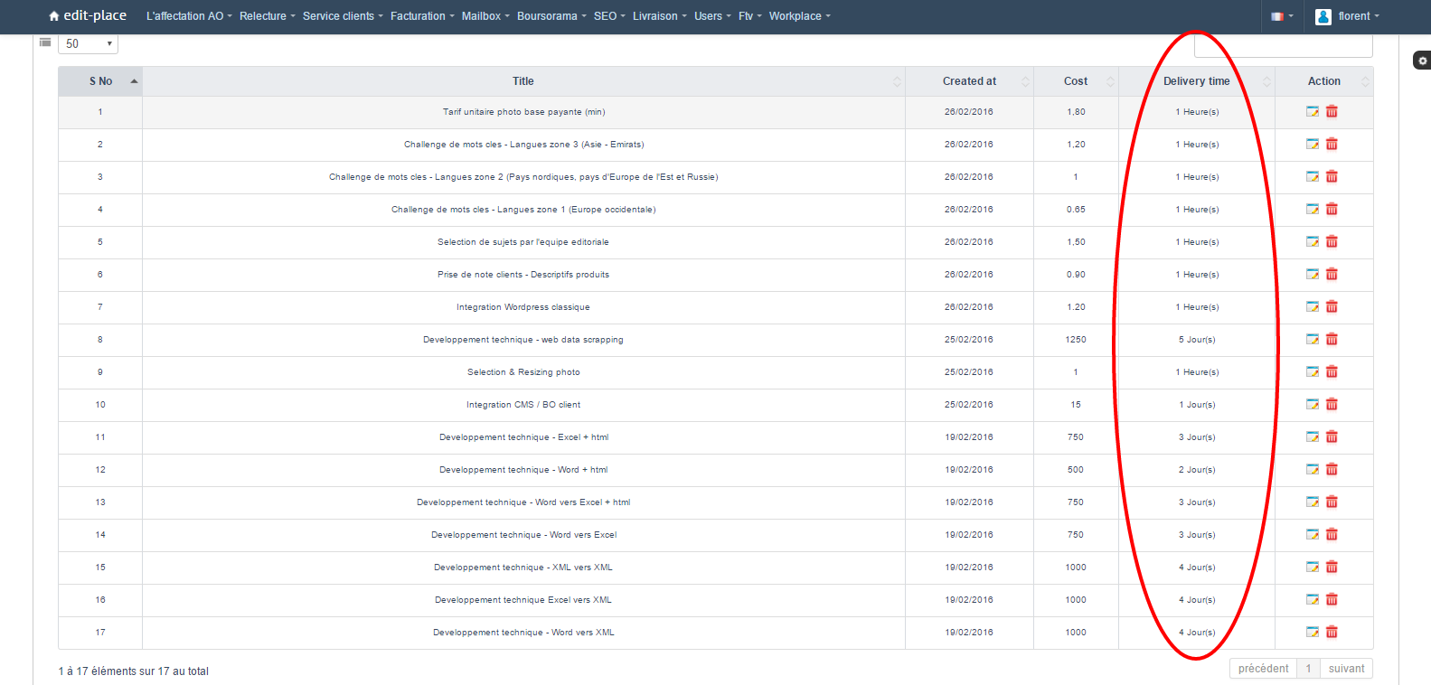

**To know the total time we will spend on the mission, we multiply the Volume * Time for 1.**

**For example : Developpement technique - web data scrapping : Delivery times : 5 days**

**If 1 dev tech. – web data scrapping : 5 days**

**If 2 : 10 days**

**For example : Selection de sujets par l'equipe editorial : Delivery times : 1 heure(s) means 1 hour(s)**

**If 1 selection de sujets par l’equipe editorial : 1 hour**

**If 2 selection de sujets par l’équipe editorial : 2 hours**

**If 5 : 5 hours**

|  |
| --- |
| **Problem : there is 8 working hours in one day** |

**So,**

**If 10 selection de sujets par l’equipe editorial : 10 hours meaning 1 days and 2 hours**

**Meaning 1 day and ¼ day = 1,25 days**

**Problem : there is some dev. we can count in minutes.**

**We have 60 minutes in 1 hour**

**We have 8*60 minutes in 1 day = 480 minutes**

**Add a “minute(s)” in selection on Delivery Time in Tech Mission Configuration :** [**http://admin-ep.edit-place.com/quote/tech-mission-type**](http://admin-ep.edit-place.com/quote/tech-mission-type)

**In fact**

**Tarif unitaire photo base payante (min) = 1,8 euros par photo = 1 min**

**Means,**

**If I have 1 volume of Tarif unitaire photo base payante,   
it takes 1 minute(s)**

**1/480 day**

**If I have 250 volume of Tarif unitaire photo base payante**

**250 minute(s)**

**4,16 heure(s)**

**0,52 day(s) but 0,5 day(s) will be enough**

**If I have a 480 volume of Tarif unitaire photo base payante**

**480 minute(s)**

**8 heure(s)**

**1 day(s)**

**WE ALREADY COUNT ON WORKING DAYS IN QUOTE VALIDATION.**

**LET KEEP IT THIS WAY**

**WE WILL SEE 0,5 DAYS FOR EXAMPLE.**

**ONLY ONE NUMBER BEHIND COMMA WILL BE ENOUGH**