TECH Mission SPEC / Integration Mission SPEC

**Tech Mission / ONESHOT**

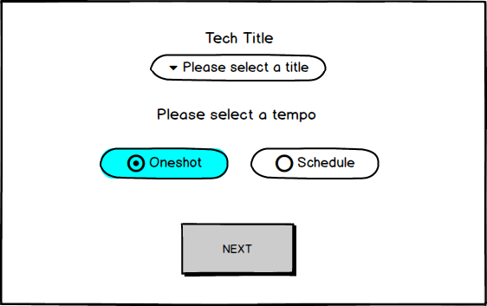

This is the new modal Tech Title / Oneshot during Tech Mission Creation :  
<http://admin-ep.edit-place.com/quote-new/create-quote-mission-view>

Meaning : Select a tech title, and it’s One shot so depending of the title, what we define here on Tech Configuration Table <http://admin-ep.edit-place.com/quote/tech-mission-type>, we will know cost.

If I select Output XLS and Oneshot, it’s

**DUReE LA MISSION = 1  
Volume TOTAL = 1**

**COST = 250**

**Mission summary doesn’t change, except it’s always going to be :  
“Durée de la mission = 1 day”  
“Volume total =1”**

Meaning, one technical dev. is required for this mission  
It’s gonna take one day and it’s gonna cost 250€.

**Tech Mission / SCHEDULED**

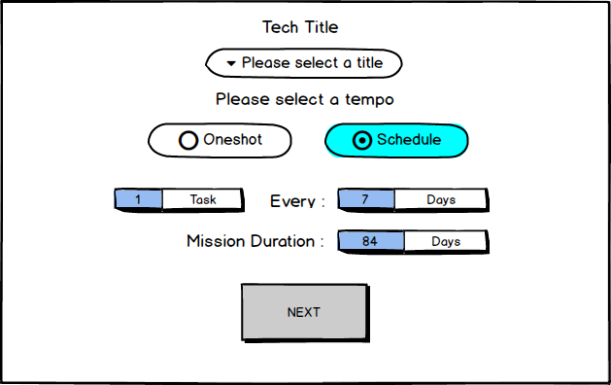

This is the new modal Tech Title / scheduled during Tech Mission Creation :

<http://admin-ep.edit-place.com/quote-new/create-quote-mission-view>

Meaning : Select a tech title, and it’s scheduled so we need the cost for 1 task based on Tech Configuration Table <http://admin-ep.edit-place.com/quote/tech-mission-type>

Calcul is the one :

(Total Mission duration / Frequency) * Task number per frequency * Technical dev cost

If TN = Task number / F = frequency / MD = Mission duration and TDC = Technical dev cost  
(MD/F)*TN*TDC = cost in euros for the mission

For example with numbers we’ve in the picture above Tech Mission / SCHEDULED :

1 task = T

7 days = F

84 days = D

(84/7) * 1 * 250 = 12 * 250 = 3 000 €  
This mission requires 1 technical dev. every 7 days during 84 days, meaning 12 technical dev.

Each technical dev., for example OUTPUT XLS costs 250 € for one working day.

The Tech cost for this mission is : 3 000€ + Margin.

**INTEGRATION / ONESHOT**

This is a new kind of tech mission, not based on standard prices. It’s always different. It’s part of Tech mission but known as Integration.

We’ll create a new type of mission :

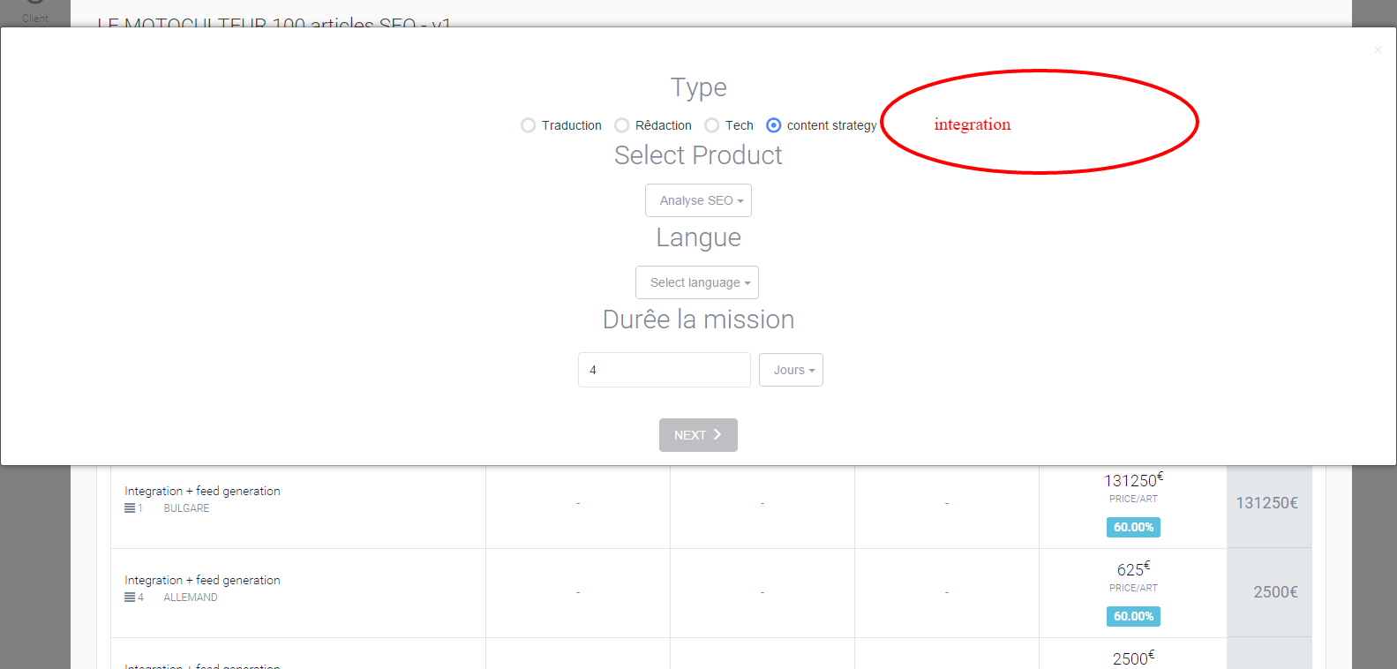

Which will be linked to the configuration table here :

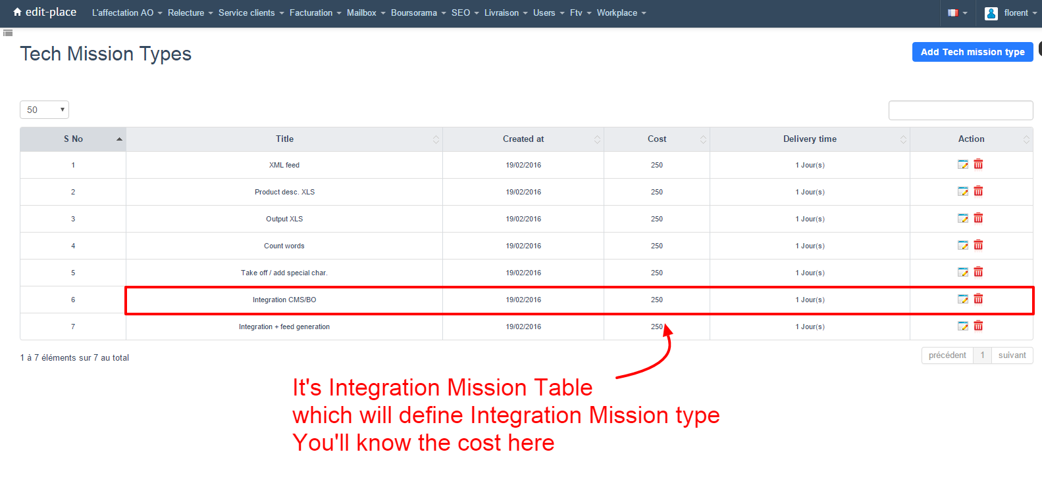

You will recognize the Type : **Integration CMS/BO**

First page : It’s for choosing a Language as on Tech Mission Creation : “Langue” -- SAME  
Second page : it’s for linking the Integration mission to prod mission or not -- SAME  
 Same as Tech Mission : “Link to Prod mission page”

Third page : It’s Integration Title page

**Integration Mission / ONESHOT**

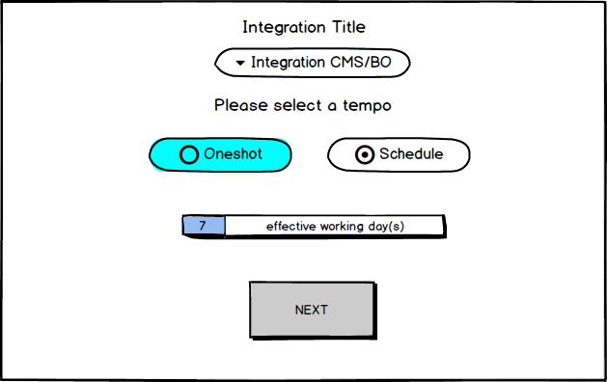

If I select OneShot, then, I select number of effective working days.

This action will permit to multiply the cost given on Configuration Table to know The MISSION COST

Example here : 7*250 = 1750 € + Margin

Fourth page : Mission Summary

We’ll have a resume of informations we have registered in Creation Integration Mission pages :

MISSION TYPE: Integration

MISSION PRODUCT: Integration CMS/BO  
LINKED TO : Yes or No  
Perform to  
TEMPO : One shot

MISSION LANGUAGE: Language X choosen

EFFECTIVE WORKING DAYS : X number of days

**INTEGRATION / SCHEDULED**

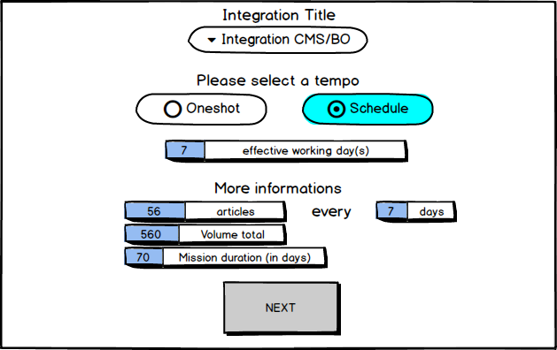

If the mission is scheduled,

It’s ALMOST the same as if it’s not.

Selection of effective working days is NECESSARY, same as INTEGRATION/ONESHOT  
The mission can’t be validated without knowing it.

This action will permit to multiply the cost given on Configuration Table.

Example here : 7*250 = 1750 € + Margin

To know the Mission cost

We’ve some more informations : it’s important BUT not linked to any calculation.

We just want to permit to sales and Techmanager to give more details about the mission.

If the Integration Mission is linked to prod mission :

You get the information thanks to prod. Mission

You’ll know the Volume.  
You’ll know the Mission duration (if you don’t because they have ticked “Je ne sais pas”, it doesn’t matter)  
You’ll know the tempo  
  
If you don’t know the informations, sales or Techmanager can completed it  
If it’s not completed, it doesn’t matter, we can create the mission

If the Integration Mission is not linked to prod mission

Sales or Techmanager will completed “More informations” themselves and if they don’t know, they don’t complete informations and it doesn’t matter.

All informations given on the Integration Title page (on 3rd page) are in Mission Summary on 4th page

MISSION TYPE: Integration

MISSION PRODUCT: Integration CMS/BO

LINKED TO : Yes or No

Perform to

TEMPO : Scheduled

MISSION LANGUAGE: Language X choosen

EFFECTIVE WORKING DAYS : X number of days

More informations

TEMPO DETAILS :  
TOTAL VOLUME :   
MISSION DURATION :

Integration Wordpress : X volume (= nombre d’articles)  
Integration CMS/BO : X volume (= effective working days)