**Modify profile BO**

1. Date is not saving properly when edited and saved (when you pick in calender)(**working fine**)

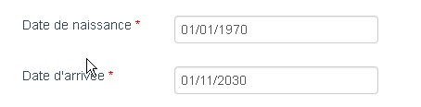

1. RIB: once you add new one and select it as default, it is not saved properly as default. Once you come back it shows previous selection(**Done**)
2. RIB: If you delete any RIB and save, then it wont show any default selected value(**Done**)
3. Photo: Once you upload a photo and click on Annuler, it shows uploaded message below browse button



1. Validation is missing for Skype Id (same as yahoo id) to check existing
2. Password recovery mail: “Longin” should be login, to be translated to French and web mail password is empty

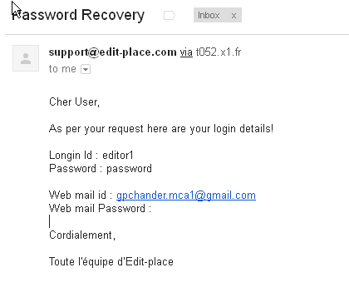

1. If possible add integer validation for postal code and telephone numbers
2. Showing status inactive for an active user

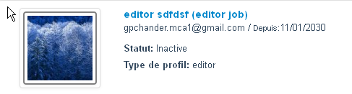

I have tested FTV issues in test site and below are my comments in red.

-          Issue :

o   **Selection of « Emission à modifier » should be like the bo test in chaine with « en copie de votre demande » = search by completion based on list** Not fixed

Emission à modifier field should be like the selection box shown in the screenshot below

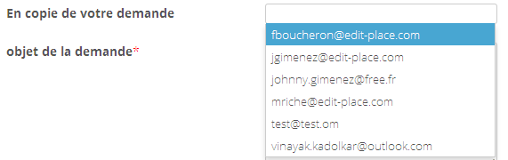

o   **Special Character in french to fix**. FO: Fine in ‘Créer une nouvelle demande’. Not fixed in ‘Duplication de la demande’

o   **Change the name « Galerie Photo » by « visuel » it was already done but due to last back up i guess the updates had been canceled** FO: Fine in ‘Créer une nouvelle demande’. Not fixed in ‘Duplication de la demande’

-          Updates :

o   **Sort A -> Z for « emission à modifier »** Sorting is working one way in both FO and FO

o   **Create a buton « nouvelle émission » (new broadcast) if we have to add a new emission to the list. Also mention it in the historic .** Not done. Rakesh will check and let you know on this later