SIMATS ENGINEERING (SAVEETHA SCHOOL OF ENGINEERING)
Department of Computer Science and Engineering

ASSESSMENT TOOL 3 – DEBUGGING & OPTIMISATION TASK
Course Code: | CSA06 | Course Title: | Design and Analysis of Algorithms
CO Assessed: | CO2 – Manipulation (BL1, BL2, BL3) | Assessment: | Assessment Tool 3 – Debugging &  Optimisation Task
Weightage: | 10% of CIA | Total Marks: | 100
CO2 Statement: | Apply Brute Force technique to solve sorting, searching, Closest-Pair and Convex-Hull problems  (BL1, BL2, BL3)
Student Name: | Shree Thilak Muthukrishna | Reg. No.: | 192572046
Section / Batch: | CSE AI | Date: | 01-08-2026

Instructions to Students
- Answer the following question. Total Marks: 100.
- Carefully analyze the given program/code segment before identifying errors.
- Clearly identify logical, syntactical, and performance-related issues in the code.
- Apply systematic debugging techniques to correct the errors effectively.
- Optimize the given solution by improving efficiency, reducing unnecessary computations, or enhancing time complexity wherever possible.
- Provide proper justification for all corrections and optimization decisions.
- Write clean, structured, and well-documented code with appropriate comments.
- Maintain clarity, logical reasoning, and technical accuracy throughout the solution.

Question Type | Focus Area | Questions
Debugging &  Optimisation Task | Identify errors, debug programs, and optimize algorithm efficiency using appropriate techniques | Q1

SECTION A – DEBUGGING & OPTIMISATION TASK
Debugging Closest Pair Code (Wrong Initialization and Comparison in C)
The following brute force Closest Pair implementation in C initializes the minimum distance
incorrectly and uses the wrong comparison direction, leading to incorrect results even for simple
point sets. Carefully analyze why the algorithm never preserves the actual smallest distance among
all pairs. Apply systematic debugging to correctly initialize the minimum distance and update it
only when a smaller valid distance is found. Optimize the implementation by avoiding redundant
distance calculations where possible. Analyze the time complexity of the corrected solution and
rewrite the final C code with proper comments.

Code of Conduct
I __________________________ (Name / Reg No) certify that this submission is my original work and that I have adhered to the guidelines specified for this assessment. I understand that any violation of academic integrity rules will result in disciplinary action.
Signature of the Student: _________________________

RUBRICS FOR CALCULATION

Criteria | Wt. | Level 4 – Exemplary | Level 3 –  Proficient | Level 2 –  Developing | Level 1 –  Beginning
Problem  Identification | 20% | Accurately identifies all errors and root causes with clear understanding | Identifies most errors with minor gaps | Identifies some errors but misses key issues | Unable to identify errors correctly
Debugging | 25% | Applies systematic debugging techniques effectively to resolve issues | Uses appropriate debugging methods with minor errors | Limited debugging approach; requires guidance | Unable to debug or resolve issues
Optimization | 20% | Optimizes code by significantly improving time complexity using efficient algorithms | Improves time complexity with minor gaps in efficiency | Limited improvement in time complexity | No improvement;  inefficient approach retained
Analysis | 20% | Demonstrates strong logical reasoning and clear justification of solutions | Shows reasonable  analysis with some justification | Limited analysis; weak reasoning | No analytical reasoning demonstrated
Code Quality | 15% | Produces clean, wellstructured code with proper comments and documentation | Code is mostly clear with minor documentation gaps | Code lacks structure and proper documentation | Poorly written code with no documentation

Marks Evaluation:
Criteria |  | Wt. | Level 4 –  Exemplary | Level 3 –  Proficient | Level 2 –  Developing | Level 1 –  Beginning
Problem Identification |  | 20%
Debugging |  | 25%
Optimization |  | 20%
Analysis |  | 20%
Code Quality |  | 15%
Total Marks (100):

Faculty In-charge | Course Coordinator | Head of Department
Name: | Name: | Name:
Signature: _______________ | Signature: _______________ | Signature: _______________
Date: ___________________ | Date: ___________________ | Date: ___________________

Question 1
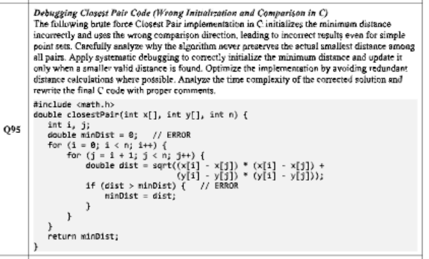

#include <stdio.h>
#include <math.h>
#include <float.h>

double closestPair(int x[], int y[], int n) {
if (n < 2) return 0.0;

int i, j;
double minDist = DBL_MAX;

for (i = 0; i < n; i++) {
for (j = i + 1; j < n; j++) {
double dist = sqrt((x[i] - x[j]) * (x[i] - x[j]) +
(y[i] - y[j]) * (y[i] - y[j]));
if (dist < minDist) {
minDist = dist;
}
}
}
return minDist;
}

int main() {
printf("Shree Thilak Muthukrishna \n192572046\n");
int x[] = {0, 1, 4, 2};
int y[] = {0, 1, 5, 3};
int n = sizeof(x) / sizeof(x[0]);

double result = closestPair(x, y, n);
printf("Minimum distance: %f\n", result);

return 0;
}

