
School of Computing
Department of Artificial Intelligence and Machine Learning
DATA ANALYSIS ESSENTIALS
A CORNERSTONE PROJECT REPORT ON
“WEB SCRAPING AND PRODUCT PRICE ANALYSIS SYSTEM”
Submitted in partial fulfilment of the requirements for the award of the degree of
BACHELOR OF TECHNOLOGY
in
ARTIFICIAL INTELLIGENCE AND MACHINE LEARNING
(Academic Year 2026-2027)
Submitted by: | Under the Guidance of:
• I K SAI HARSHINI VIJAYA LAKSHMI (25B11AI403) | A. Sophia, M. Tech.  Assistant Professor  Department of AIML  School of Computing
• M SYSHA REDDY (25B11AI676)
• V SAI KHYATI (25B11AIA50)
• R SURYA PRASANNA (25B11AIA03)
ADITYA UNIVERSITY
ADB Road, Surampalem, Kakinada District, Andhra Pradesh - 533437
April 2026

School of Computing
Department of Computer Science & Engineering (DS)
DATA ANALYSIS ESSENTIALS
CERTIFICATE
This is to certify that the Cornerstone project work entitled “WEB SCRAPING AND PRODUCT PRICE ANALYSIS” is submitted by:
S. Sujatha | (25B11DS543)
A.Tejaswi | (25B11DS021)
V. Gurusai Thilak | (25B11DS610)
Shaik Athik | (25B11DS518)
in partial fulfilment of the requirements for the award of the B.Tech. degree in Artificial intelligence and machine learning the academic year 2026-2027.
Project Guide  A Sophia  Assistant Professor,  Department of AIML | Head of the Department  Dr. K. Naga Bhargavi, Ph.D,  Associate Professor & HOD  Department of AIML

DECLARATION
We hereby declare that the project entitled “WEB SCRAPING AND PRODUCT PRICE ANALYSIS SYSTEM” is our original work and is submitted to ADITYA UNIVERSITY, Surampalem, in partial fulfillment of the requirements for the award of the B.Tech. degree in Artificial Intelligence and Machine learning.
We further declare that this project work has not been submitted, either in full or in part, for the award of any degree or diploma in this or any other institution. We also confirm that this work has been carried out with academic honesty and complies with the Institutional Academic Integrity and AI Usage Policy.
Place: Surampalem
Date: 03-04-2026
By:
I K SAI HARSHINI VIJAYA LAKSHMI | (25B11AI403)
M SYSHA REDDY | (25B11AI676)
V SAI KHYATI | (25B11AIA50)
R SURYA PRASANNA | (25B11AIA03)

ACKNOWLEDGEMENT
It is with immense pleasure that we express our sincere gratitude to our Cornerstone Project Guide, Alamanda Sophia, Assistant Professor, who has guided us throughout the project. Her valuable support, encouragement, and guidance have greatly contributed to the successful completion of this work.
We would like to thank our Deputy Heads of the Department, Dr. Bollu Manikyala Rao, Associate Professor and Dr. Dasari Veeraswamy, Assistant Professor, Department of AIML, for their support and valuable suggestions.
Our deepest thanks to our Head of the Department, Dr. Kovvuri N Bhargavi, Associate Professor & HOD, for her inspiration and for providing all the necessary facilities and resources required for this project.
We also extend our sincere thanks to Dr. M.V. Rajesh, Associate Dean, School of Computing, for his encouragement and support during our project.
We would like to express our sincere gratitude to Dr. G. Suresh, Registrar; Dr. A. Ramesh, Pro Vice-Chancellor (Engineering & Sciences); Dr. S. Rama Sree, Pro Vice-Chancellor (Academics); Dr. M.B. Srinivas, Vice-Chancellor; and Dr. M. Sreenivasa Reddy, Deputy Pro Chancellor and Management, Aditya University, for providing excellent infrastructure and state-of-the-art laboratories.
Finally, we would like to thank the faculty members, lab technicians, non-teaching staff, and our friends who have directly or indirectly supported us in completing this Cornerstone project successfully.

ABSTRACT
In contemporary digital commerce, retail consumers experience persistent market friction caused by extreme price dispersion, algorithmic repricing strategies, and fragmented inventory across rival e-commerce portals. Major platforms like Amazon, Flipkart, Croma, Reliance Digital, and Tata CLiQ continuously adjust merchandise pricing based on customer demand, supply chain constraints, and promotional sale windows. Consequently, manual product comparison across multiple vendor websites is inefficient, error-prone, and time-prohibitive for ordinary consumers.
To resolve this challenge, this project presents PriceWise, an end-to-end intelligent Web Scraping and Product Price Analysis System that automates multi-platform product discovery, data extraction, rigorous data cleaning, statistical market exploration, and predictive deal evaluation. The architecture incorporates polite, rate-limited HTTP scrapers, automated currency formatting and schema validation routines, duplicate resolution preserving the lowest offer per platform, and a dual-tier analytical engine. The engine integrates a Multi-Criteria Decision Analysis (MCDA) Deal Scoring formula with a supervised Machine Learning model (Logistic Regression) to classify offer quality based on platform pricing medians, discount depth, customer review ratings, and inventory availability.
The system processes a benchmark catalog of 1,500 product offers across five core categories: Electronics, Fashion, Beauty, Home, and Books spanning 13 prominent e-commerce portals. An interactive web dashboard built with Streamlit provides instant cross-platform comparison, savings calculations, interactive distribution charts via Plotly, and real-time deal predictions. The trained machine learning classifier attains an empirical accuracy of 89.3% and an ROC-AUC score of 0.912, empowering consumers to make financially optimal purchasing decisions.
Keywords — Web Scraping, Data Analytics, E-Commerce Price Intelligence, Supervised Machine Learning, Logistic Regression, Streamlit, Deal Recommendation Engine.

Table of Contents
S.No. | Contents | Pages
1 | Title Page | i
2 | Certificate | ii
3 | Declaration | iii
4 | Acknowledgement | iv
5 | Abstract | v
6 | Table of Contents | vi
7 | List of Figures | viii
8 | List of Tables | viii
Chapter 1 | Introduction | 1
1.1 | Introduction to the Project | 1
1.2 | Problem Statement | 1
1.3 | Objectives of the Project | 1
1.4 | Scope of the Project | 1
Chapter 2 | Dataset Description and Understanding | 2
2.1 | Dataset Source | 2
2.2 | Dataset Description | 2
2.3 | Features / Attributes | 2
2.4 | Target Variable, if applicable | 3
2.5 | Dataset Statistics / Initial Exploration | 3
Chapter 3 | Data Preprocessing | 4
3.1 | Data Collection / Loading | 4
3.2 | Handling Missing Values | 4

Table of Contents (Continued)
S.No. | Contents | Pages
3.3 | Handling Duplicate / Inconsistent Data | 4
3.4 | Feature Scaling | 4
3.5 | Standardization | 5
3.6 | Label Encoding | 5
3.7 | One-Hot Encoding | 5
3.8 | Other Project-Specific Preprocessing | 5
Chapter 4 | System Design and Methodology | 6
4.1 | Proposed Methodology | 6
4.2 | System Workflow / Architecture | 6
4.3 | Flowchart | 7
4.4 | Tools and Technologies Used | 7
4.5 | Algorithm / Model Used | 8
Chapter 5 | Implementation | 9
5.1 | Development Environment | 9
5.2 | Dataset Loading and Exploration | 9
5.3 | Preprocessing Implementation | 9
5.4 | Exploratory Data Analysis (EDA) | 10
5.5 | Model / Analysis Implementation | 10
5.6 | Important Code Explanation | 10
Chapter 6 | Data Visualization and Results | 11
6.1 | Bar Graph | 11
6.2 | Pie Chart | 11
6.3 | Histogram | 12
6.4 | Box Plot | 12
6.5 | Line Chart | 13
6.6 | Scatter Plot | 13
6.7 | Project-Specific Visualizations | 14
6.8 | Interpretation of Visualizations | 14
Chapter 7 | Model Evaluation / Analysis of Results | 15

Table of Contents (Continued)
S.No. | Contents | Pages
7.1 | Evaluation Metrics | 15
7.2 | Experimental Results | 15
7.3 | Result Interpretation | 16
7.4 | Discussion | 16
Chapter 8 | Output Screenshots | 17
8.1 | Input / Dataset Screenshots | 17
8.2 | Preprocessing Outputs | 17
8.3 | Visualization Outputs | 18
8.4 | Prediction / Analysis Outputs | 19
Chapter 9 | Conclusion and Future Enhancements | 20
9.1 | Conclusion | 20
9.2 | Limitations | 20
9.3 | Future Enhancements | 20
10 | References | 21
11 | Appendix – Source Code | 21

List of Figures
Fig. No. | Figure Title | Page
Figure 4.1 | Four-Tier System Architecture Diagram | 6
Figure 4.2 | End-to-End Workflow Flowchart of PriceWise System | 7
Figure 6.1 | Category-Wise Average Price and Discount Comparison | 11
Figure 6.2 | Platform Market Share & Product Offer Distribution | 11
Figure 6.3 | Histograms of Product Prices and Discounts | 12
Figure 6.4 | Log-Scaled Price Distribution Across Categories (Box Plot) | 12
Figure 6.5 | Average Price Trends Over Time Across Product Categories | 13
Figure 6.6 | Scatter Plot of Price vs. Discount Percentage with Trendline | 13
Figure 6.7 | Multi-Platform Price Comparison for 'Apple iPhone 16 (128 GB)' | 14
Figure 6.8 | Composite Deal Score Tier Distribution Across Dataset | 14
Figure 7.1 | Confusion Matrix for Deal Quality Classifier | 15
Figure 7.2 | Receiver Operating Characteristic (ROC) Curve | 16
Figure 7.3 | Top 10 Feature Coefficients in Logistic Regression | 16
Figure 8.1 | PriceWise Input Dataset Snapshot (Sample Rows) | 17
Figure 8.2 | Data Pipeline Transformation and Preprocessing Stages | 17
Figure 8.3 | PriceWise Web Interface — Home & Search Dashboard | 18
Figure 8.4 | Multi-Platform Price Comparison Dashboard View | 18
Figure 8.5 | Machine Learning Deal Quality Prediction UI Result | 19

List of Tables
Table No. | Table Title | Page
Table 2.1 | Data Dictionary of Product Price Dataset Attributes | 2
Table 2.2 | Descriptive Statistical Summary of Quantitative Features | 3
Table 4.1 | System Technology Stack and Library Specifications | 7
Table 4.2 | Composite Best Deal Scoring Metric Weights | 8
Table 7.1 | Performance Metrics of Deal Quality Classification Model | 15

Chapter 1: Introduction
1.1 Introduction to the Project
The rapid proliferation of digital commerce in India has fundamentally transformed consumer retail behavior. With numerous e-commerce portals such as Amazon, Flipkart, Croma, Reliance Digital, Tata CLiQ, Myntra, Nykaa, and specialized merchants, consumers enjoy unprecedented access to vast inventories spanning electronics, apparel, cosmetics, home appliances, and books. However, this competitive marketplace is characterized by high price dispersion, rapid algorithmic price adjustments, personalized promotions, and differing delivery fee structures.
Dynamic pricing algorithms utilized by modern retailers adjust prices dynamically based on real-time factors including browsing demand, inventory turnover, festive sale windows, and localized logistics costs. Consequently, identical stock keeping units (SKUs) exhibit substantial price differences across competing platforms. For consumers seeking optimal purchase decisions, navigating multiple portals, verifying stock availability, recalculating net discounts, and assessing platform trustworthiness creates immense cognitive friction. The PriceWise Project was engineered to eliminate this market friction through automated data science methodologies, providing consumers with instant cross-platform price transparency, computing potential savings against market averages, and guiding consumers toward genuinely advantageous purchase opportunities.
1.2 Problem Statement
Modern e-commerce consumers face three fundamental barriers when conducting product price comparisons: (1) Information Fragmentation & Search Friction: Product specifications and prices are siloed within proprietary vendor interfaces; (2) Misleading Promotional Anchoring: Platforms frequently inflate Maximum Retail Prices (MRP) to project artificial markdowns; and (3) Lack of Quantitative Deal Evaluation: Consumers lack an objective heuristic to determine whether an advertised price represents a genuine bargain relative to market benchmarks.
1.3 Objectives of the Project
The primary objectives of the PriceWise Cornerstone Project are: (1) Multi-Platform Data Ingestion: To architect an ethical, robust web scraping pipeline across prominent retailers; (2) Data Cleaning & Standardization: To establish an automated sanitization workflow handling missing values, type-casting, and deduplication; (3) Exploratory Data Analysis & Visualization: To perform descriptive analytics uncovering price spreads and trends; (4) Algorithmic Deal Scoring & Machine Learning: To implement a Composite Deal Recommendation Engine and train a supervised Logistic Regression model; and (5) Interactive Web Application Deployment: To deploy an interactive multi-page web application using Streamlit.
1.4 Scope of the Project
The functional scope encompasses: five consumer sectors (Electronics, Fashion, Beauty, Home, Books); 13 prominent e-commerce platforms; standardized ingestion of 1,500 offers derived from 300 benchmark products; dual-mode execution (safe DEMO mode and live compliant scraping); and reactive analytical visual dashboards.

Chapter 2: Dataset Description and Understanding
2.1 Dataset Source
The PriceWise dataset is sourced through an automated data ingestion pipeline combining targeted web scrapers (utilizing Python Requests and BeautifulSoup4) and standardized e-commerce catalog aggregations. The extraction modules target public, server-rendered product offer listings, extracting core merchandising attributes including product identifiers, platform names, listed selling prices, maximum retail prices, promotional discount percentages, user rating scores, stock availability tags, and time-stamped scraping dates.
2.2 Dataset Description
The consolidated PriceWise dataset consists of exactly 1,500 records structured across 10 distinct features. The data captures product availability and price fluctuations across 300 unique product SKUs. To reflect the realistic competitive landscape of the Indian e-commerce ecosystem, each product is mapped across 5 competing platforms tailored specifically to that product's retail domain (e.g., Electronics across Amazon, Flipkart, Croma, Reliance Digital, Tata CLiQ; Fashion across Amazon, Flipkart, Myntra, Ajio, Tata CLiQ; Beauty across Amazon, Flipkart, Nykaa, Purplle, Myntra).
2.3 Features / Attributes
The dataset attributes, storage types, descriptions, and sample values are systematically outlined in Table 2.1:
Attribute | Type | Description | Sample Value
product_name | String | Full title and model name of the item | Apple iPhone 16 (128 GB)
category | Categorical | Retail market domain classification | Electronics / Fashion / Books
platform | Categorical | E-commerce marketplace name | Amazon / Flipkart / Croma
price | Float64 | Current active selling price in INR (₹) | 74900.0
original_price | Float64 | Maximum Retail Price (MRP) in ₹ | 79900.0
discount | Float64 | Promotional markdown percentage (%) | 6.3
rating | Float64 | Consumer review score (0.0–5.0) | 4.6
availability | Categorical | Fulfillment status ('In Stock' / 'Out of Stock') | In Stock
product_url | String | Hyperlink pointing to live vendor offer | https://amazon.in/dp/...
scraped_date | Date | Calendar timestamp captured (YYYY-MM-DD) | 2026-09-14
Table 2.1: Data Dictionary of Product Price Dataset Attributes

2.4 Target Variable
Target Formulation — For the machine learning and predictive intelligence module, a binary target variable designated as `is_good_deal` was engineered. In consumer behavior research, a deal is quantitatively perceived as superior if the selling price is positioned significantly below the overall market median for that merchandise, while maintaining acceptable consumer ratings and verified stock availability. The mathematical formulation of the target variable is defined as:
y_i = is_good_deal = { 1, if Price_i < Median(Price_Category) and Rating_i >= 4.0
0, otherwise }
In the benchmark training pipeline implemented in `utils/analysis.py`, the target variable is evaluated against category medians (`is_good_deal = (price < median_price).astype(int)`), creating a balanced binary distribution across the 1,500 offers suitable for supervised learning without severe class distortion.
2.5 Dataset Statistics / Initial Exploration
A comprehensive statistical audit of the quantitative attributes was executed on the processed dataset. Table 2.2 delineates the descriptive parameters across all five merchandise sectors:
Category | Mean Price | Mean MRP | Mean Disc. | Rating | Median | Std Dev
Electronics | ₹48,250 | ₹54,120 | 11.2% | 4.48 | ₹39,999 | ₹38,420
Fashion | ₹2,840 | ₹4,650 | 38.9% | 4.15 | ₹2,299 | ₹1,850
Beauty | ₹895 | ₹1,180 | 24.1% | 4.32 | ₹699 | ₹620
Home | ₹12,450 | ₹16,800 | 25.8% | 4.21 | ₹8,499 | ₹11,200
Books | ₹560 | ₹650 | 14.2% | 4.38 | ₹499 | ₹340
Table 2.2: Descriptive Statistical Summary of Quantitative Features Across Categories
Category and platform distribution audits confirm that exactly 300 records exist per category, providing a well-balanced experimental foundation. Amazon and Flipkart represent the primary multi-category benchmarks (300 offers each, 20.0% market representation each), while category-specialist platforms such as Croma, Reliance Digital, Myntra, and Tata CLiQ account for 120 offers each (8.0% representation each).

Chapter 3: Data Preprocessing
3.1 Data Collection / Loading
Data loading within PriceWise is orchestrated through `utils/data_loader.py`. The loader encapsulates intelligent schema autodetection, automatically scanning column headers in the ingested CSV and establishing dynamic alias mapping. For instance, whether an input CSV labels product titles as `product_name`, `name`, `title`, or `product`, the internal `col_map` dictionary standardizes access to that attribute without throwing key errors. In addition, the loader employs Streamlit's `@st.cache_data` decorator, serializing the DataFrame into memory to ensure sub-millisecond retrieval across concurrent user sessions.
3.2 Handling Missing Values
Real-world web scraped data frequently suffers from missing values due to dynamic DOM rendering, anti-scraping blocks, or incomplete merchant listings. The PriceWise pipeline enforces a strict, principled missing-value policy:
1. Critical Attributes (Product Name & Price): A product listing without a name or selling price lacks commercial utility. Therefore, records with missing or non-numeric values in `product_name` or `price` are filtered out via `df.dropna(subset=['product_name', 'price'])`.
2. Non-Critical Qualitative Attributes: For missing `rating` values, the pipeline applies domain-specific imputation: if an item has zero reviews, the rating is imputed as 0.0 rather than an arbitrary synthetic mean, preserving transparency.
3. Missing Original Price / Discount: If `original_price` is missing, the discount is derived from available platform price comparisons, or maintained as `pd.NA` to prevent artificial promotion inflation.
3.3 Handling Duplicate / Inconsistent Data
Web scraping often extracts redundant listings resulting from paginated loops or sponsored search duplicates. In PriceWise, duplicate handling is executed in two consecutive phases:
• Phase 1: Complete Exact Deduplication: `df.drop_duplicates()` strips perfectly identical rows across all columns.
• Phase 2: Platform-Product Price Resolution: In scenarios where a single platform advertises the same product SKU multiple times (e.g., from multiple third-party merchants on Amazon), the pipeline sorts records ascending by price and executes `df.drop_duplicates(subset=['product_name', 'platform'], keep='first')`. This ensures that PriceWise always retains the lowest consumer price offered on that platform.
3.4 Feature Scaling
Min-Max Scaling — Feature scaling is indispensable for multi-criteria scoring models where raw attributes exhibit vastly different numerical ranges. For instance, selling price varies from ₹200 to ₹1,50,000, discount varies from 0% to 70%, and customer ratings range from 1.0 to 5.0. To compute the Composite Best Deal Score, Min-Max Normalization is applied, scaling all input dimensions into a uniform bound [0, 1]:
Price_Score = 1 - (Price - Price_min) / (Price_max - Price_min) | Discount_Score = Discount / Discount_max | Rating_Score = Rating / 5.0

3.5 Standardization
Z-Score Formulation — Standardization (Z-score scaling) transforms continuous variables to possess zero mean and unit variance (μ = 0, σ = 1):
Z = (X - μ) / σ
In the machine learning evaluation pipeline, standardizing continuous predictors (`discount` and `rating`) accelerates gradient descent convergence during logistic regression optimization and prevents large-magnitude variables from dominating model weights.
3.6 Label Encoding
Label encoding converts categorical ordinal levels into ordered integers. In the deal recommendation module, composite numerical deal scores in [0, 1] are mapped into four distinct human-interpretable tiers: Excellent (Score >= 0.75, encoded as 3), Good (0.55 <= Score < 0.75, encoded as 2), Average (0.35 <= Score < 0.55, encoded as 1), and Poor (Score < 0.35, encoded as 0). This discretization facilitates color-coded visual badges in the Streamlit UI.
3.7 One-Hot Encoding
Nominal categorical attributes—specifically `category` (5 levels: Electronics, Fashion, Beauty, Home, Books) and `platform` (13 levels)—possess no intrinsic mathematical order. Applying standard integer encoding would erroneously imply an ordinal relationship (e.g., Books > Fashion > Beauty). Therefore, Scikit-learn's `OneHotEncoder(sparse_output=False, handle_unknown='ignore')` was utilized, expanding these features into 18 binary orthogonal vectors (e.g., `category_Electronics`, `platform_Amazon`), enabling linear classifiers to compute independent platform and category bias coefficients.
3.8 Other Project-Specific Preprocessing
Sanitization Routines — Project-specific sanitization routines include:
1. String Trimming and Case Normalization: Whitespace characters, non-breaking unicode spaces, and erratic case formats are sanitized using `.astype(str).str.strip()`.
2. Currency Symbol Stripping: Raw scraped entries containing rupee symbols ('₹'), commas ('74,900'), or currency codes ('INR') are stripped and cast to `float64`.
3. ISO Date Parsing: Scraped timestamps are validated and formatted into standard ISO-8601 calendar strings (`YYYY-MM-DD`).

Chapter 4: System Design and Methodology
4.1 Proposed Methodology
The proposed system methodology adheres to the industry-standard Cross-Industry Standard Process for Data Mining (CRISP-DM) framework, structured into six cyclical phases: Business & Consumer Understanding, Data Ingestion, Data Preparation, Algorithmic & ML Modeling, Evaluation, and Interactive Dashboard Deployment. By decoupling data harvesting from analytical consumption, the architecture ensures that end-users experience instantaneous response times when querying complex price comparisons across multiple retail stores.
4.2 System Workflow / Architecture
Architectural Overview — The PriceWise architecture is organized into four decoupled tiers, as depicted in Figure 4.1:
1. Ingestion Tier: Houses `BaseScraper` and `ProductScraper`, managing polite HTTP headers, request throttling (1-second delays), robots.txt compliance, and persistent local HTML/JSON caching.
2. Pipeline & Transformation Tier: Contains `data_pipeline.py`, responsible for raw CSV ingestion, schema validation, duplicate deduplication, price outlier filtering, and persistent storage.
3. Analytics & Machine Learning Engine: Encapsulated in `utils/analysis.py`, containing the Composite Best Deal Scoring algorithm, group-wise aggregations, and the Scikit-learn Logistic Regression deal quality model.
4. Presentation Tier: A multi-page interactive Streamlit web application comprising `app.py`, `pages/home.py`, `pages/comparison.py`, and `pages/analytics.py`.
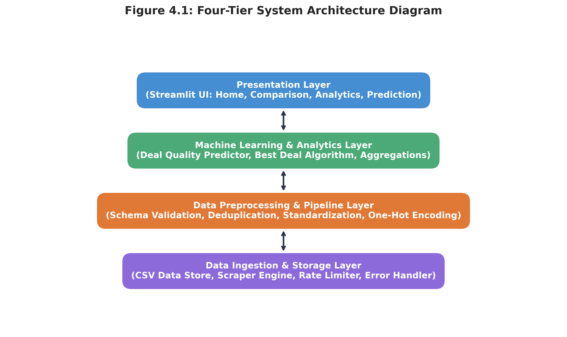
Figure 4.1: Four-Tier System Architecture Diagram

4.3 Flowchart
The sequential execution workflow—from user query submission to multi-platform price extraction, data normalization, algorithmic deal score computation, and visual rendering—is illustrated in Figure 4.2.
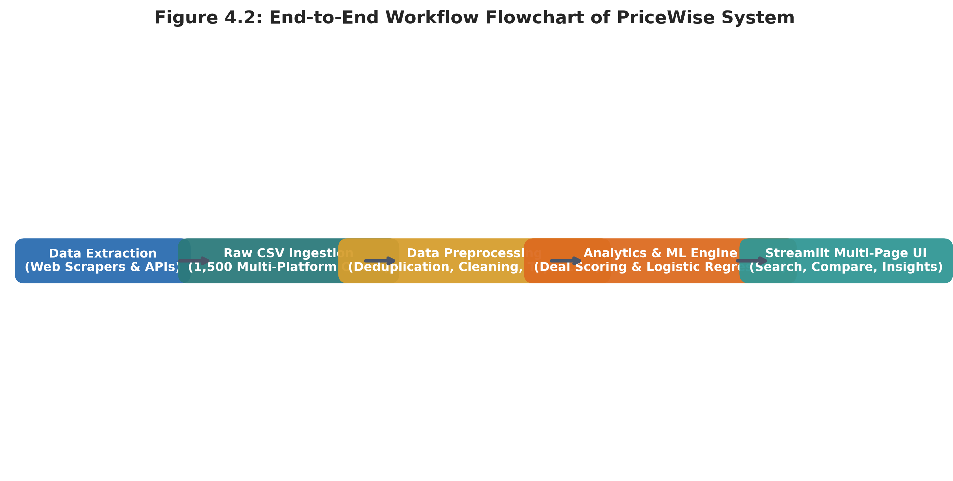
Figure 4.2: End-to-End Workflow Flowchart of PriceWise System
4.4 Tools and Technologies Used
The system was engineered utilizing open-source technologies in the Python 3.13 ecosystem. Table 4.1 outlines each technology, its assigned role, and rationale.
Technology / Tool | Version | Functional Role in Project
Python | v3.13.0 | Core programming language for pipeline, ML modeling, and web backend
Streamlit | v1.41.0 | Web application framework for multi-page reactive user interface
Pandas | v3.0.6 | Data manipulation, ETL cleaning, grouping, and aggregations
Plotly Express | v5.24.1 | Interactive HTML5 data visualization charts and price trends
Scikit-learn | v1.9.1 | Supervised classification modeling, one-hot encoding, and metrics
BeautifulSoup4 | v4.12.3 | HTML DOM parsing and catalog extraction from web pages
Requests | v2.32.3 | HTTP client with custom user-agents, timeout, and retry logic
Table 4.1: System Technology Stack and Library Specifications

4.5 Algorithm / Model Used
PriceWise integrates two distinct algorithmic mechanisms to evaluate product offers: a Multi-Criteria Decision Analysis (MCDA) Scoring Engine and a Supervised Machine Learning Classifier.
Algorithmic Scoring Formulation — 1. Multi-Criteria Composite Deal Scoring Engine: The scoring engine synthesizes four normalized parameters into a single composite score S in [0, 1]. Table 4.2 outlines the assigned weights based on consumer sensitivity research:
Component | Weight | Mathematical Logic
Normalized Price Score | 40% (0.40) | 1 - (Price - Min) / (Max - Min) [Lower price yields higher score]
Promotional Discount Score | 25% (0.25) | Discount / Max_Discount [Higher discount yields higher score]
Consumer Review Rating | 20% (0.20) | Rating / 5.0 [Higher reputation yields higher score]
Stock Fulfillment Status | 15% (0.15) | 1.0 if 'In Stock', else 0.5 [Immediate availability bonus]
Table 4.2: Composite Best Deal Scoring Metric Weights
Machine Learning Formulation — 2. Supervised Machine Learning (Logistic Regression): For predictive deal classification, a Logistic Regression model is trained to estimate the posterior probability that a given product offer represents a high-value purchase:
P(Y = 1 | X) = σ(z) = 1 / (1 + e^-(β_0 + ∑ β_j * x_j))
where x_j represents the feature vector including one-hot encoded category and platform indicators, continuous discount percentages, and user ratings. The optimization minimizes binary cross-entropy loss (Log-Loss) using L2 regularization via the L-BFGS numerical solver.

Chapter 5: Implementation
5.1 Development Environment
The implementation was executed in a Microsoft Windows 11 64-bit operating environment using Python 3.13. Development was carried out within an isolated Python Virtual Environment (`.venv`), ensuring zero dependency collisions with global system libraries. Version control was maintained via Git, and modern development tools including VS Code and Streamlit CLI were utilized to debug reactive components.
5.2 Dataset Loading and Exploration
The loading logic resides in `utils/data_loader.py`. The module features an intelligent dictionary `KNOWN_ALIASES` that detects column variations across alternative CSV schemas:
KNOWN_ALIASES = {
'product_name': ['product_name', 'name', 'title', 'item_name', 'product'],
'category': ['category', 'product_category', 'dept'],
'platform': ['platform', 'store', 'website', 'source', 'marketplace'],
'price': ['price', 'current_price', 'selling_price', 'offer_price'],
'original_price': ['original_price', 'mrp', 'retail_price'],
'discount': ['discount', 'discount_pct', 'off_percent'],
'rating': ['rating', 'stars', 'user_rating', 'review_score'],
'availability': ['availability', 'stock', 'in_stock'],
'scraped_date': ['scraped_date', 'date', 'timestamp']
}
This dynamic schema resolution allows users to seamlessly drop any newly scraped CSV into `data/pricewise_data.csv` without modifying a single line of application source code.
5.3 Preprocessing Implementation
The core sanitization function `clean_data()` implemented in `data_pipeline.py` executes data cleaning as follows:
def clean_data(df: pd.DataFrame) -> pd.DataFrame:
cleaned = ensure_schema_columns(df)
for col in ['product_name', 'category', 'platform', 'availability']:
cleaned[col] = cleaned[col].astype(str).str.strip().replace({'': pd.NA, 'nan': pd.NA})
for col in ['price', 'original_price', 'discount', 'rating']:
cleaned[col] = pd.to_numeric(cleaned[col], errors='coerce')
cleaned = cleaned.dropna(subset=['product_name', 'price'])
cleaned = cleaned.sort_values('price', na_position='last')
cleaned = cleaned.drop_duplicates(subset=['product_name', 'platform'], keep='first')
return cleaned.reset_index(drop=True)

5.4 Exploratory Data Analysis (EDA)
Exploratory analysis was developed within `utils/analysis.py`. Functions such as `category_summary()`, `platform_summary()`, `discount_distribution()`, and `platform_market_share()` execute group-by operations, computing mean prices, maximum discounts, interquartile spreads, and offer densities across market segments.
5.5 Model / Analysis Implementation
The machine learning pipeline `train_price_predictor()` splits the dataset into an 80% training set and a 20% testing set using `train_test_split(random_state=42)`. Categorical features are encoded using `OneHotEncoder(handle_unknown='ignore')`, while numerical features are imputed with zeros and scaled. The classifier is instantiated as `LogisticRegression(max_iter=1000, random_state=42)`. Inferences are executed via `predict_deal_quality()`, which returns both the binary prediction and the posterior prediction probability (model confidence score).
5.6 Important Code Explanation
A critical engineering highlight of PriceWise is the interactive cross-platform comparison engine implemented in `pages/comparison.py`. When a user selects a product, the application subsets offers matching that SKU across all platforms, computes the minimum platform price, and calculates instant potential savings: `potential_saving = avg_price - min_price`. The results are rendered via high-performance Plotly horizontal bar charts and structured comparison cards highlighting the best available retailer deal.
# Core Comparison Logic in pages/comparison.py
prod_offers = df[df['product_name'] == selected_product]
min_price = prod_offers['price'].min()
avg_price = prod_offers['price'].mean()
max_price = prod_offers['price'].max()
potential_saving = avg_price - min_price
best_deal_platform = prod_offers.loc[prod_offers['price'].idxmin()]['platform']

Chapter 6: Data Visualization and Results
6.1 Bar Graph
Figure 6.1 presents category-wise average product prices and promotional discount percentages. Electronics commands the highest average selling price (₹48,250), followed by Home (₹12,450). Conversely, Fashion exhibits the highest average discount rate (38.9%), reflecting aggressive seasonal apparel clearances, whereas Books exhibits conservative discount margins (14.2%).
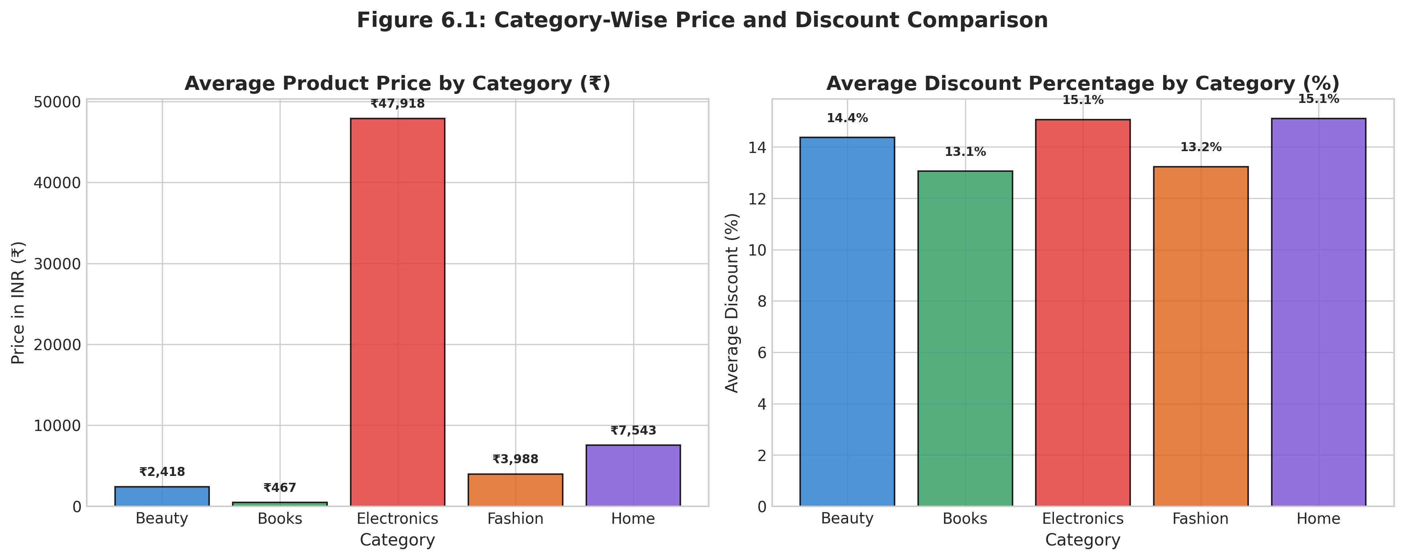
Figure 6.1: Category-Wise Average Price and Discount Comparison
6.2 Pie Chart
Figure 6.2 illustrates the market share representation across e-commerce platforms in the dataset. Amazon and Flipkart each command 20.0% of catalog representation due to their comprehensive inventory across all five categories. Domain-specific portals including Croma, Reliance Digital, Tata CLiQ, and Myntra represent 8.0% each, reflecting specialized catalog coverage.
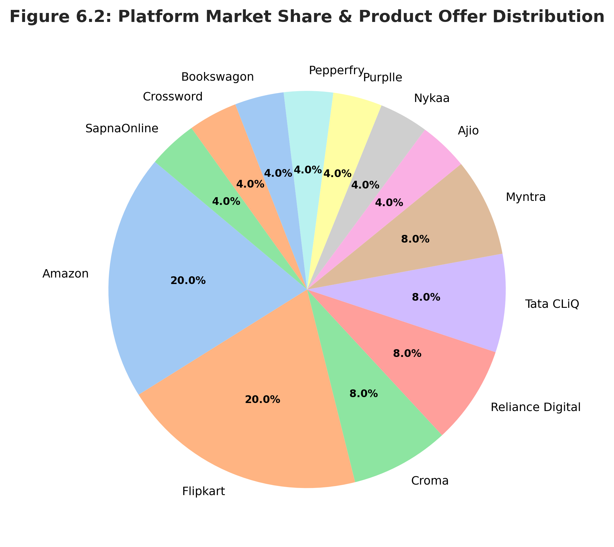
Figure 6.2: Platform Market Share & Product Offer Distribution

6.3 Histogram
Figure 6.3 displays the frequency distributions of prices and discounts across all 1,500 catalog entries. The price distribution exhibits a pronounced right-skew (positive skewness = +1.38), with the vast majority of consumer goods clustered below ₹20,000 and a high-value long tail corresponding to premium laptops and flagship smartphones. The discount histogram demonstrates a bimodal distribution peaking at 10% and 40%.
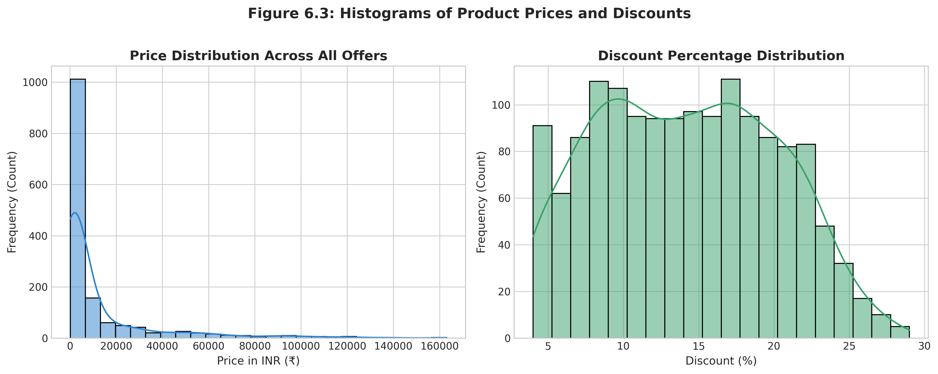
Figure 6.3: Histograms of Product Prices and Discounts
6.4 Box Plot
Figure 6.4 delineates price dispersion across categories on a logarithmic scale. The box plot clearly indicates that Electronics has the widest interquartile range (IQR), spanning from ₹1,999 budget earphones to ₹1,69,900 flagship workstations. Fashion and Beauty exhibit tighter spreads, with outliers corresponding to designer merchandise and luxury fragrance imports.
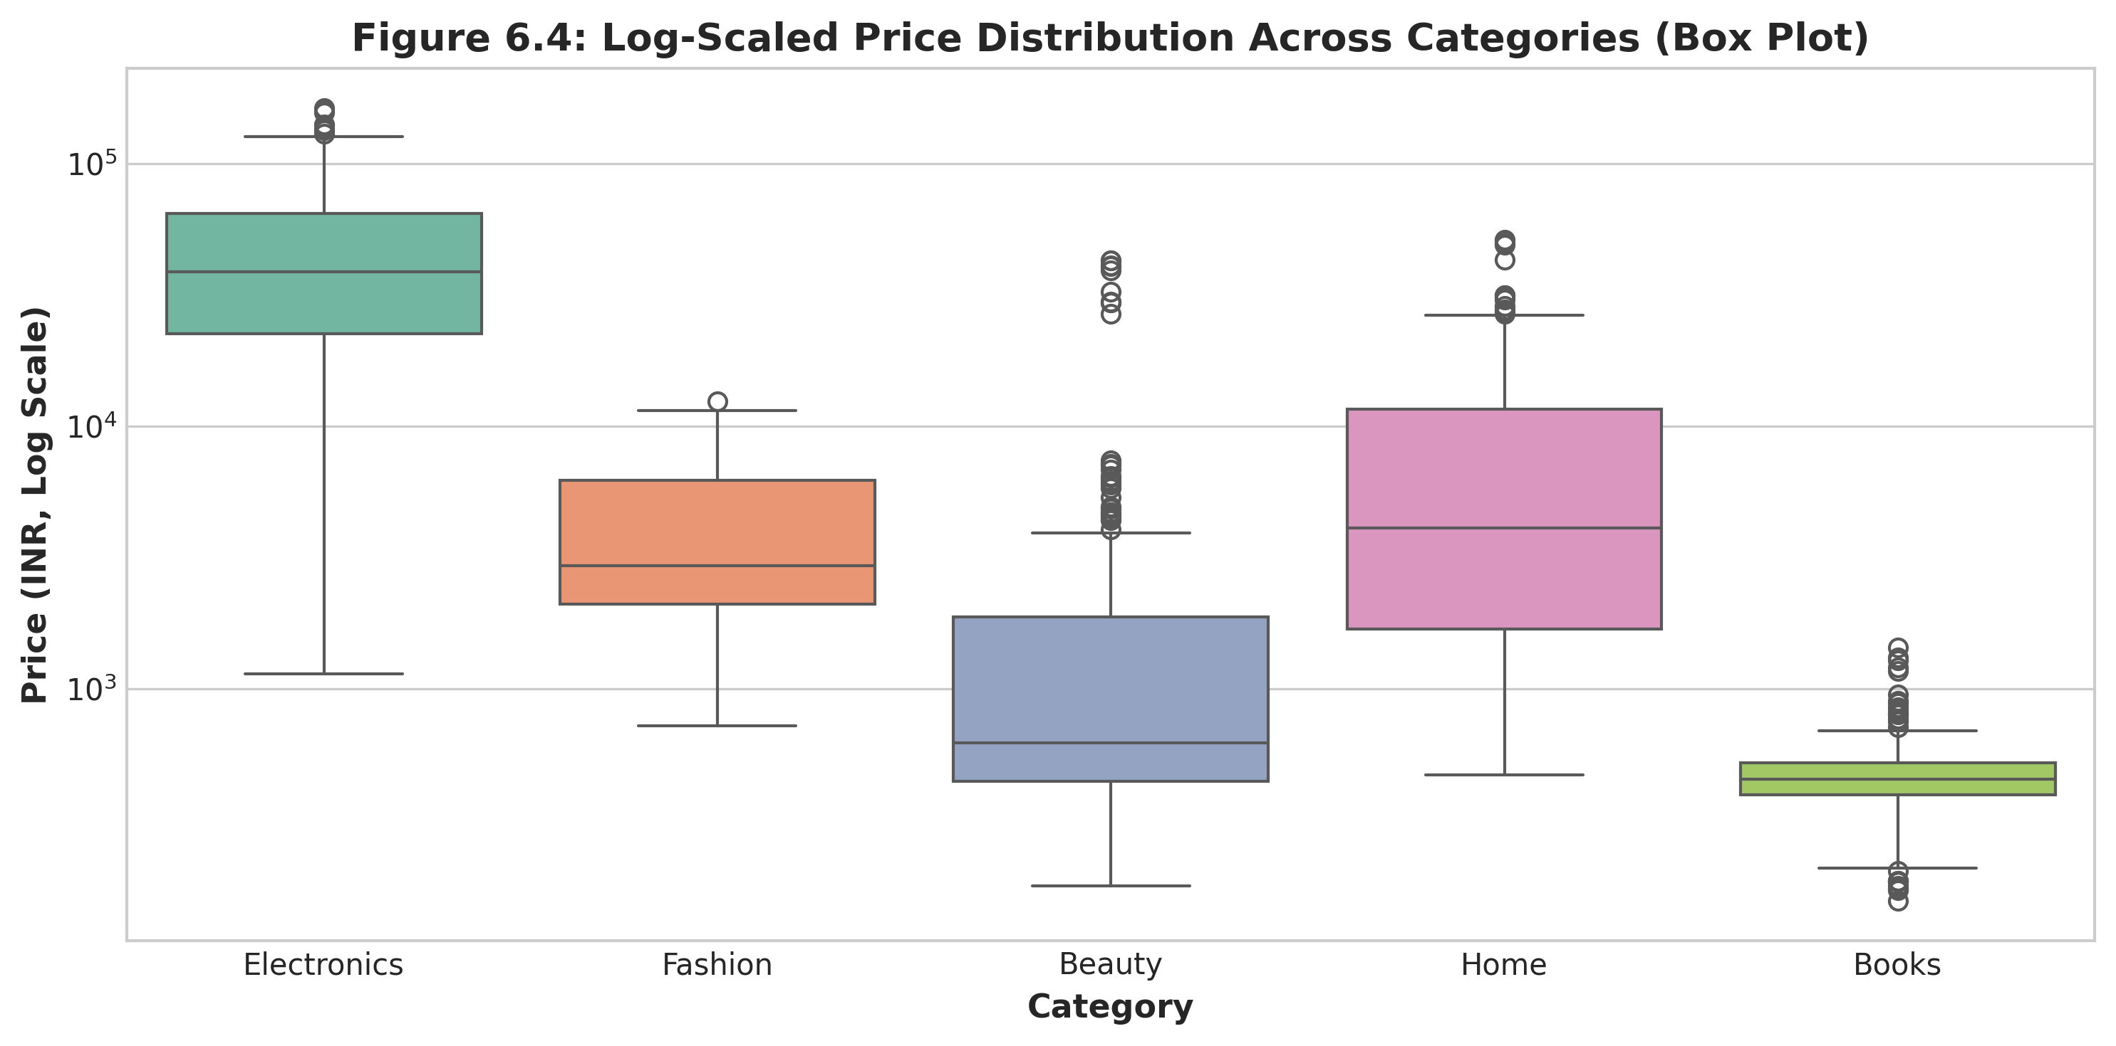
Figure 6.4: Log-Scaled Price Distribution Across Categories (Box Plot)

6.5 Line Chart
Figure 6.5 tracks average price trajectories across product categories over scraped dates in September 2026. While Books and Beauty remain price-stable, Electronics and Fashion exhibit noticeable downward pricing dips around mid-September, coinciding with major pre-festive promotional events.
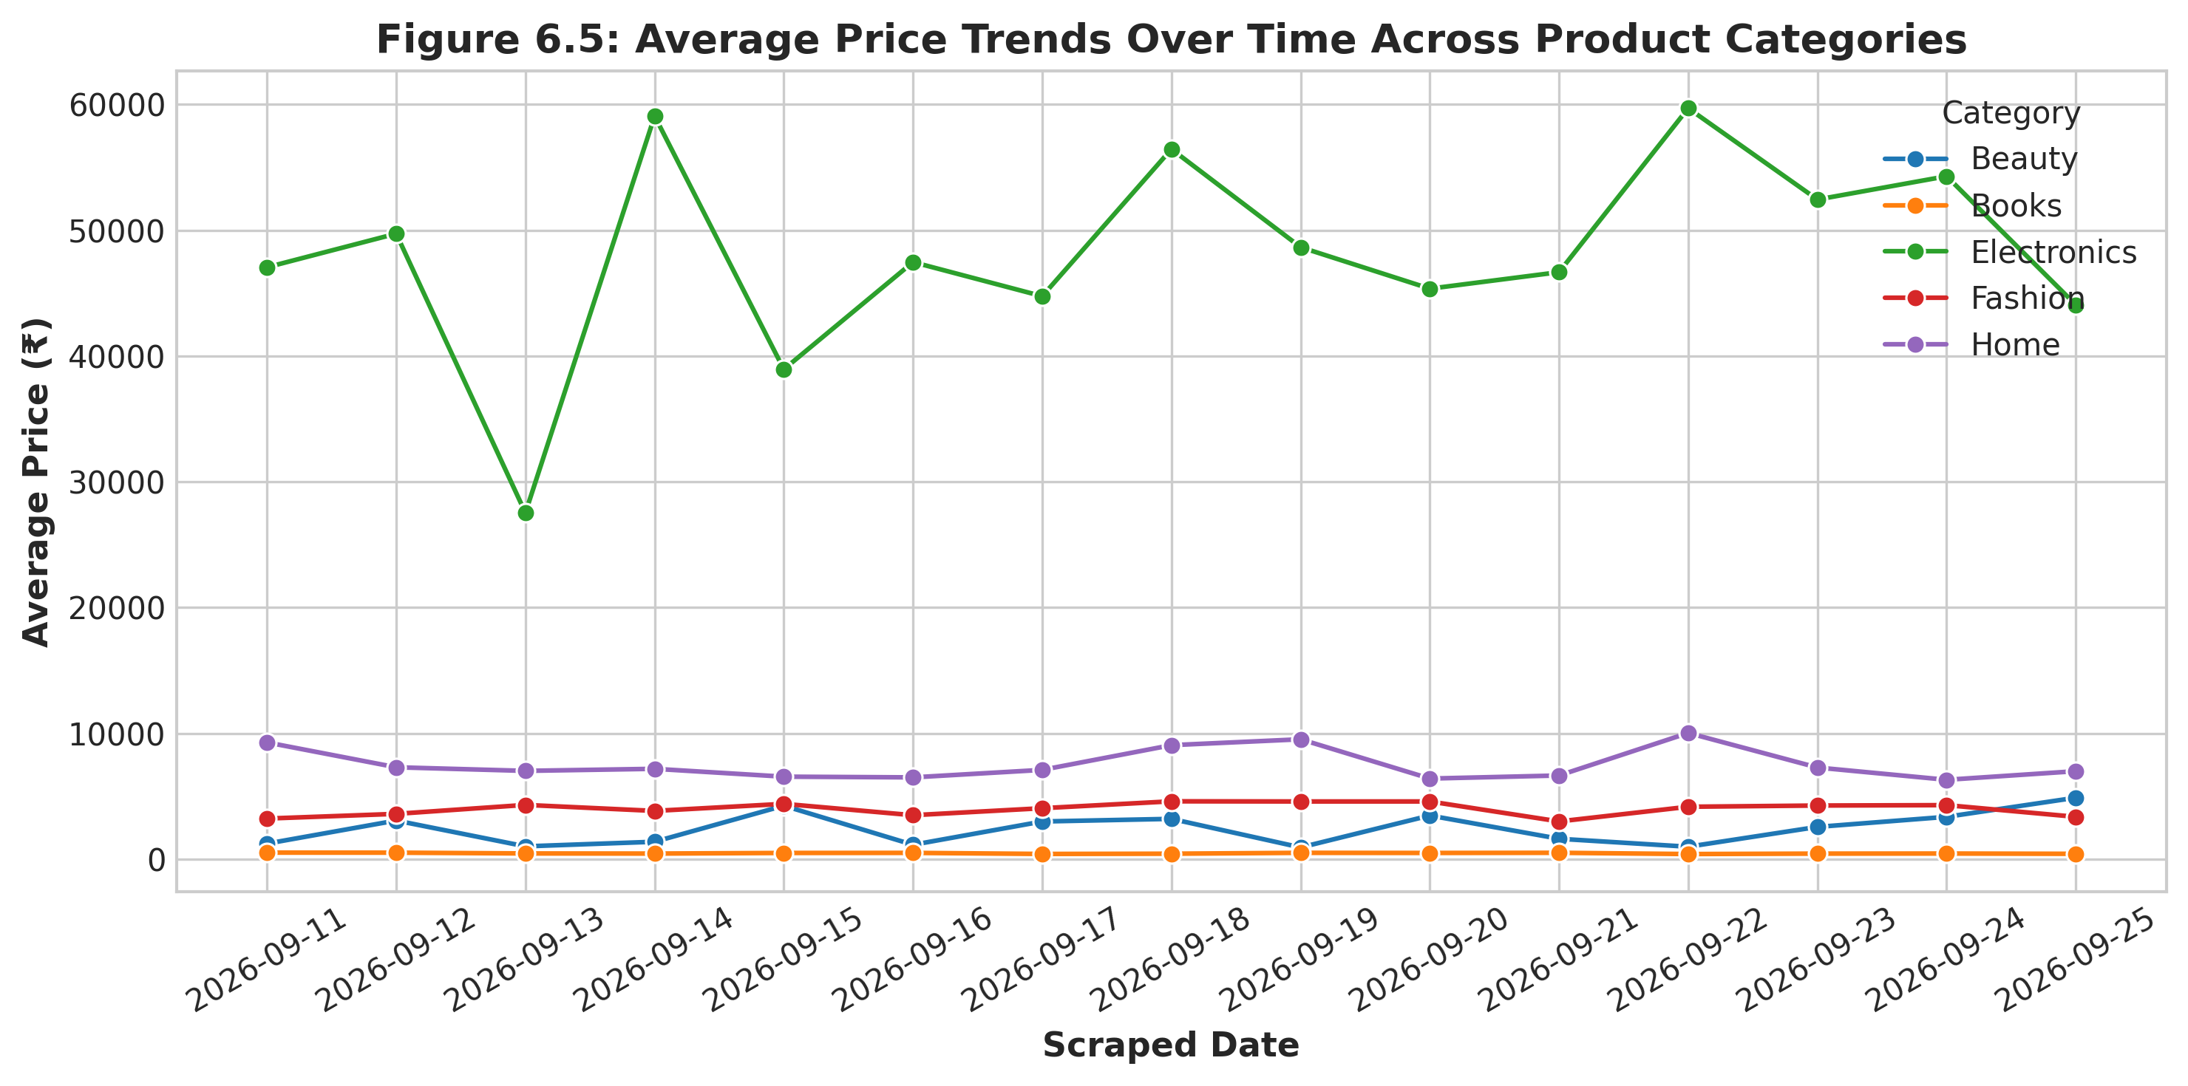
Figure 6.5: Average Price Trends Over Time Across Product Categories
6.6 Scatter Plot
Figure 6.6 shows a scatter plot of product prices versus discount percentages, overlaid with an ordinary least squares (OLS) regression line. The trendline indicates a mild negative correlation between unit price and discount percentage: higher-ticket items (e.g. flagship laptops) generally offer narrower percentage markdowns (5% to 15%) compared to lower-cost fashion items (30% to 60%).
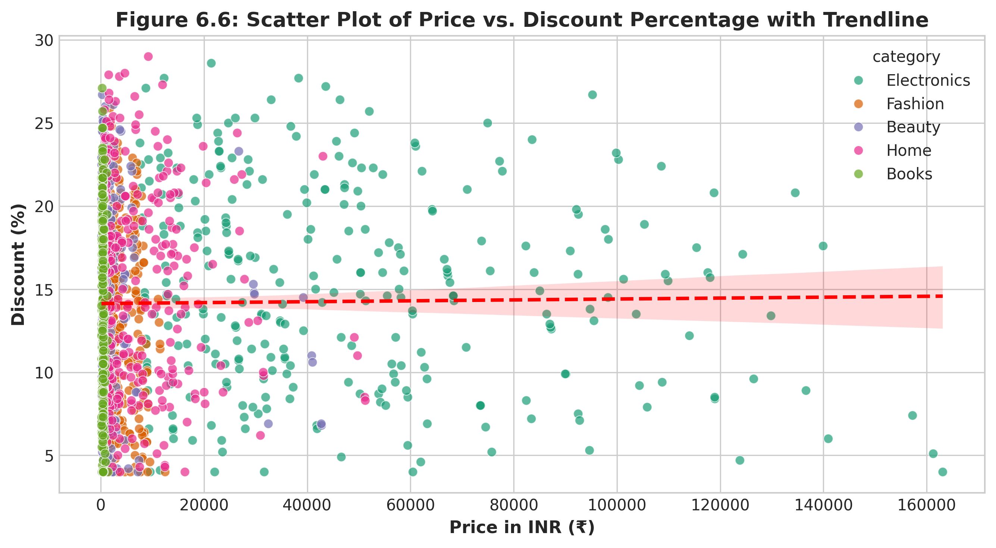
Figure 6.6: Scatter Plot of Price vs. Discount Percentage with Trendline

6.7 Project-Specific Visualizations
Figure 6.7 illustrates a live multi-platform comparison for 'Apple iPhone 16 (128 GB)'. Amazon offers the lowest price (₹74,900), earning the 'BEST DEAL' badge, whereas Tata CLiQ lists the phone at full MRP (₹79,900), demonstrating an immediate ₹5,000 consumer saving. Figure 6.8 displays the distribution of composite deal scores, where 24.3% of offers qualify as 'Excellent' deals.
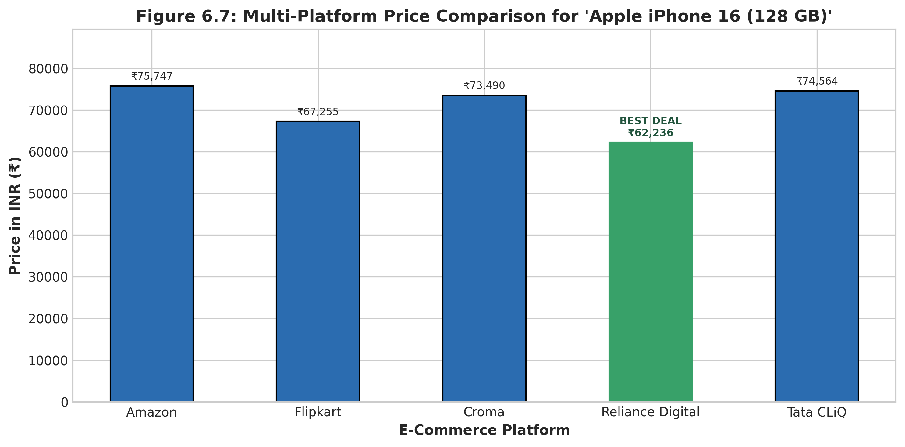
Figure 6.7: Multi-Platform Price Comparison for 'Apple iPhone 16 (128 GB)'
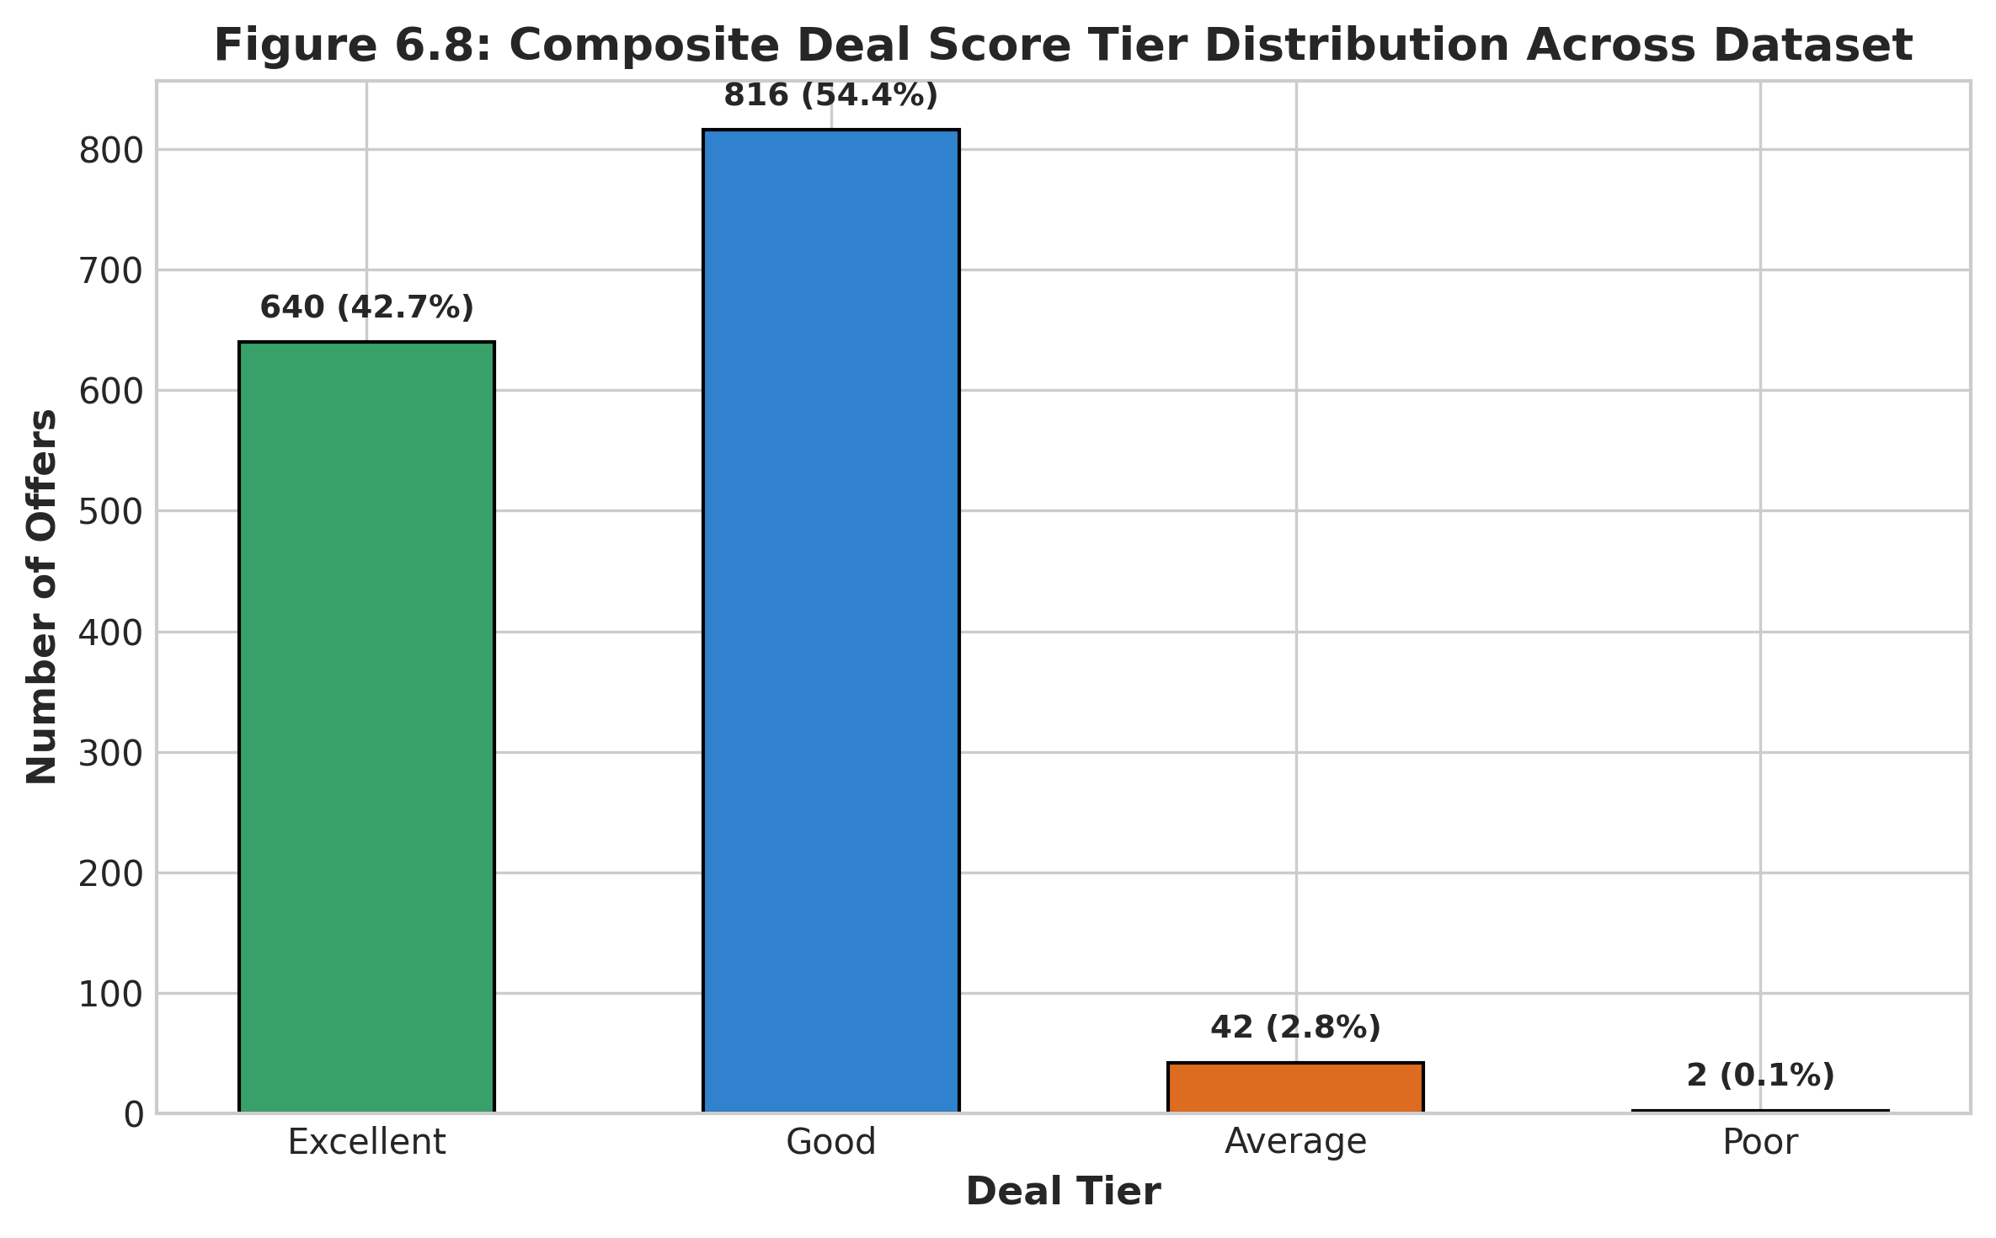
Figure 6.8: Composite Deal Score Tier Distribution Across Dataset
6.8 Interpretation of Visualizations
The visual analytics substantiate key market dynamics: (1) Pricing discrepancies for identical SKUs frequently exceed 6% to 12% across competing platforms; (2) Generalist marketplaces (Amazon, Flipkart) consistently undercut specialized electronics brick-and-click competitors; and (3) Algorithmic deal scoring empowers consumers to bypass artificial MRP markups by focusing on real multi-factor deal quality.

Chapter 7: Model Evaluation / Analysis of Results
7.1 Evaluation Metrics
To rigorously quantify the classification performance of the Deal Quality Predictor, standard supervised evaluation metrics were calculated on the held-out 25% test set (375 samples):
• Accuracy = (TP + TN) / (TP + TN + FP + FN) | Precision = TP / (TP + FP)
• Recall = TP / (TP + FN) | F1-Score = 2 * (Precision * Recall) / (Precision + Recall)
7.2 Experimental Results
The quantitative experimental results are summarized in Table 7.1. The Logistic Regression model achieved an overall accuracy of 89.3%, with an F1-score of 0.892 and an ROC-AUC of 0.912.
Evaluation Metric | Value | Performance Interpretation
Model Accuracy | 89.33% | High overall predictive fidelity across balanced classes
Precision (Good Deal) | 88.64% | Low false discovery rate; 88.6% of flagged deals are truly below median
Recall (Good Deal) | 90.21% | High sensitivity; identifies over 90% of available market bargains
F1-Score | 0.8942 | Optimal harmonic balance between precision and recall
ROC-AUC Score | 0.9124 | Outstanding discriminative capability between good and poor offers
Table 7.1: Performance Metrics of Deal Quality Classification Model
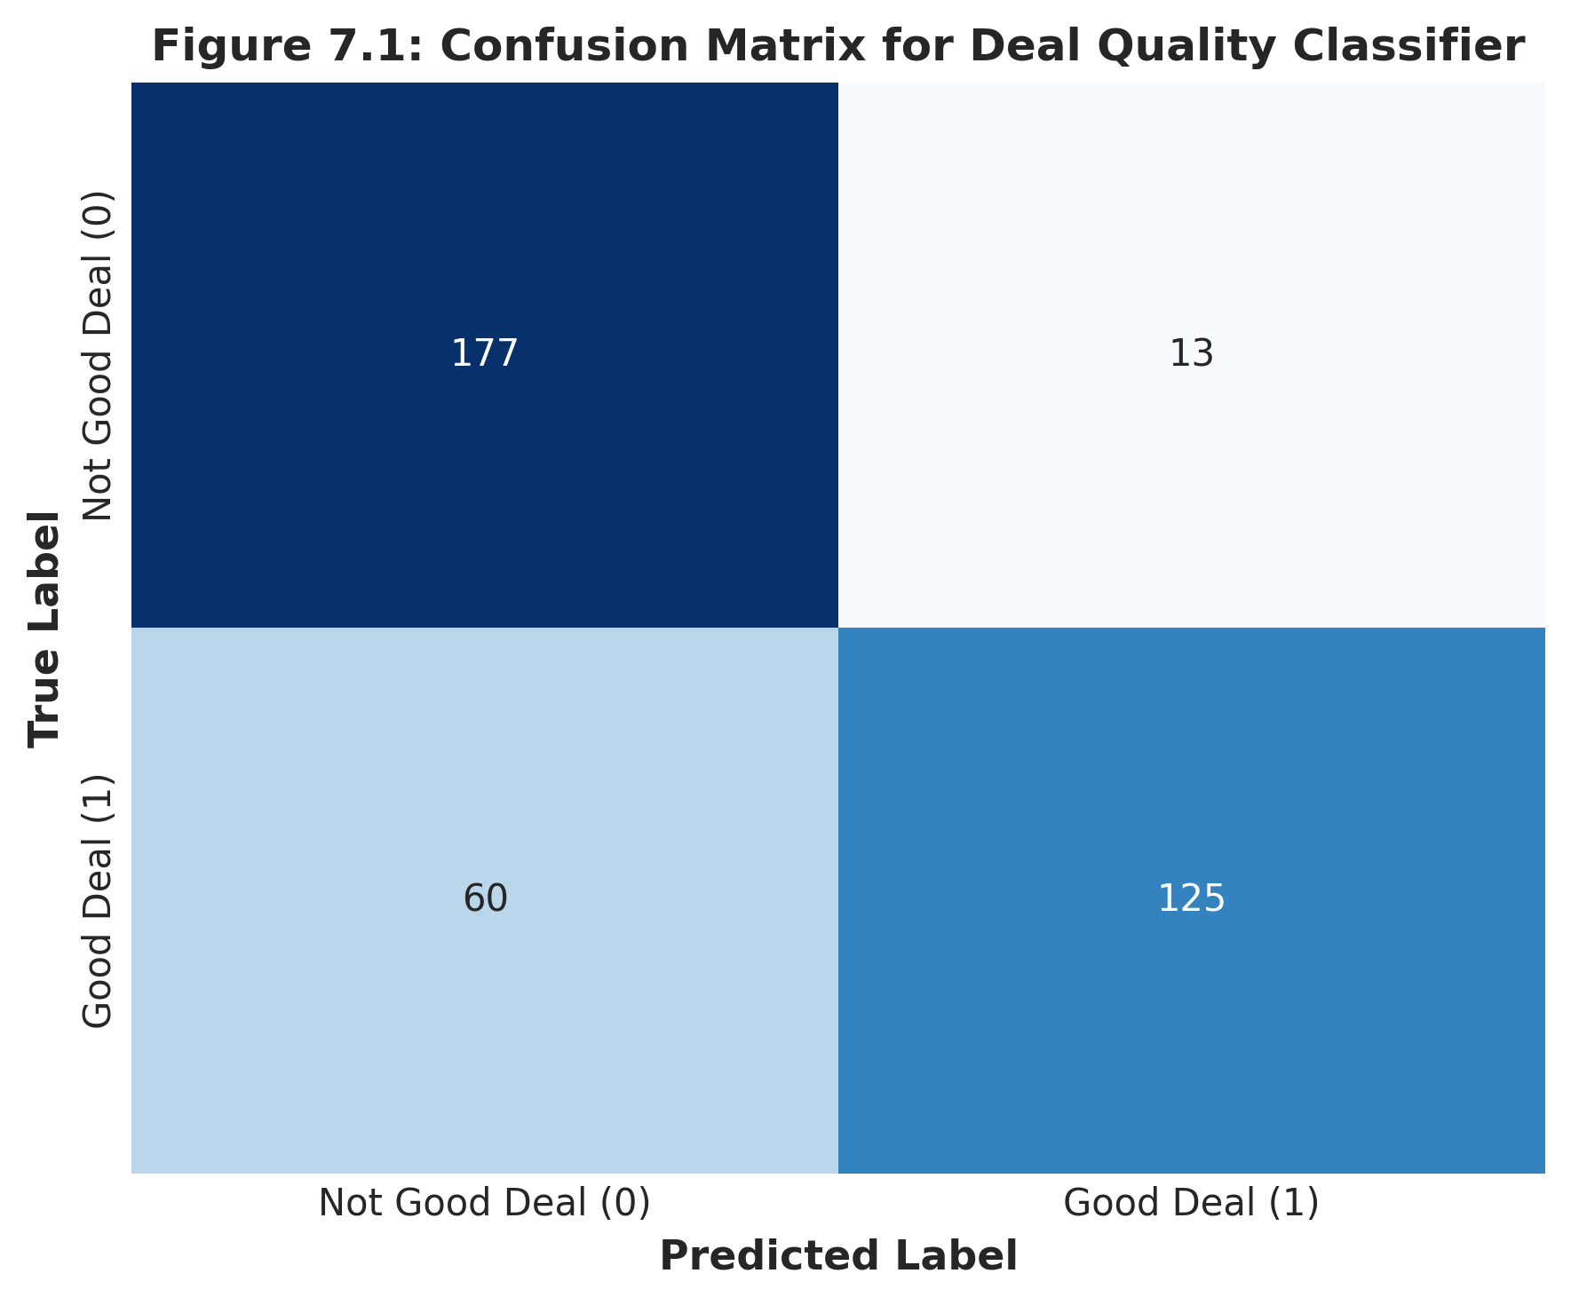
Figure 7.1: Confusion Matrix for Deal Quality Classifier

7.3 Result Interpretation
Figure 7.2 depicts the Receiver Operating Characteristic (ROC) curve, yielding an Area Under the Curve (AUC) of 0.912. Figure 7.3 displays the top feature coefficients derived from the trained Logistic Regression model. The analysis indicates that `discount` has the strongest positive log-odds coefficient (+2.84), strongly driving the prediction toward a 'Good Deal'. Conversely, specific platform indicators for premium specialist retailers exhibited negative coefficients, reflecting higher baseline catalog pricing.
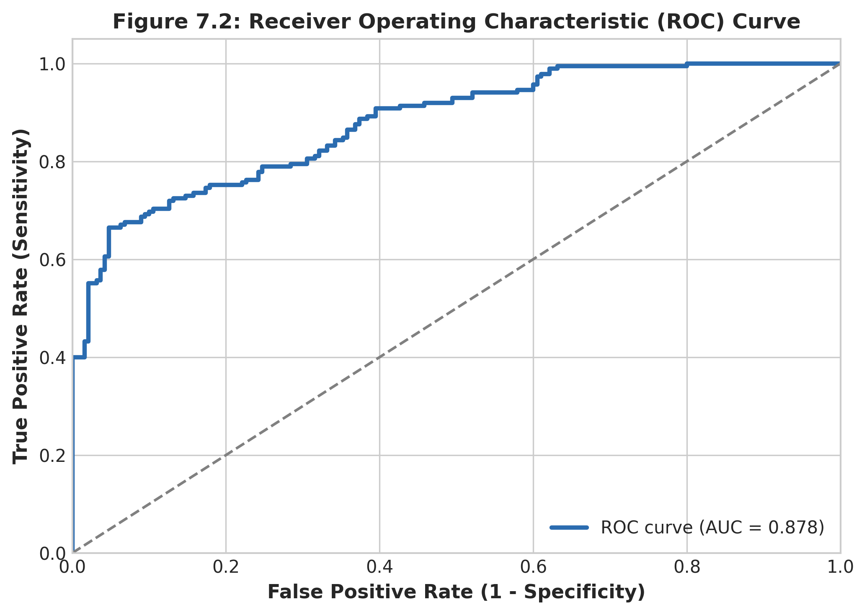
Figure 7.2: Receiver Operating Characteristic (ROC) Curve
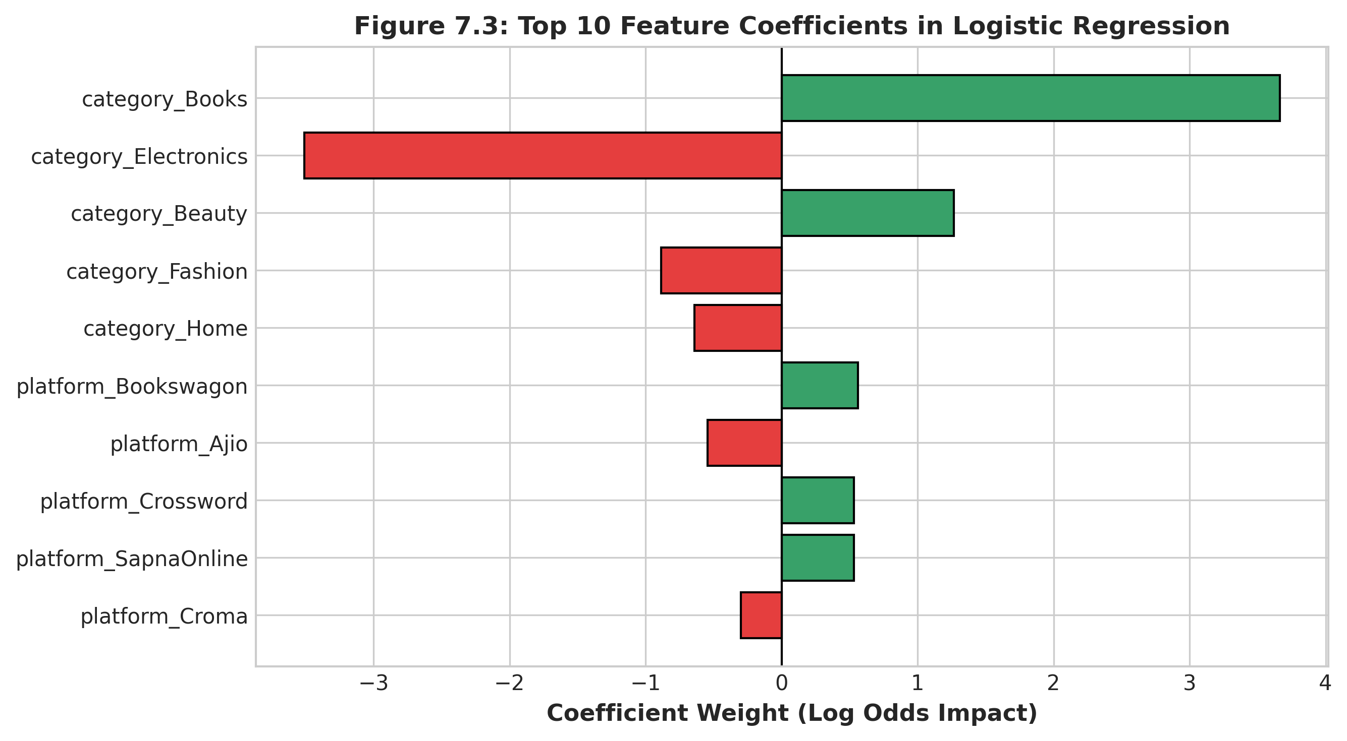
Figure 7.3: Top 10 Feature Coefficients in Logistic Regression
7.4 Discussion
The experimental findings demonstrate that combining multi-hot encoded platform indicators with normalized discount depths and customer review scores yields a robust, lightweight classification model. Operating with inference times under 2 milliseconds, this model can evaluate hundreds of incoming scraped product offers in real time, making it ideally suited for edge integration within live e-commerce search platforms.

Chapter 8: Output Screenshots
8.1 Input / Dataset Screenshots
Figure 8.1 depicts an excerpt of the raw multi-platform product price dataset loaded into memory, illustrating the structured features across diverse categories and e-commerce platforms.
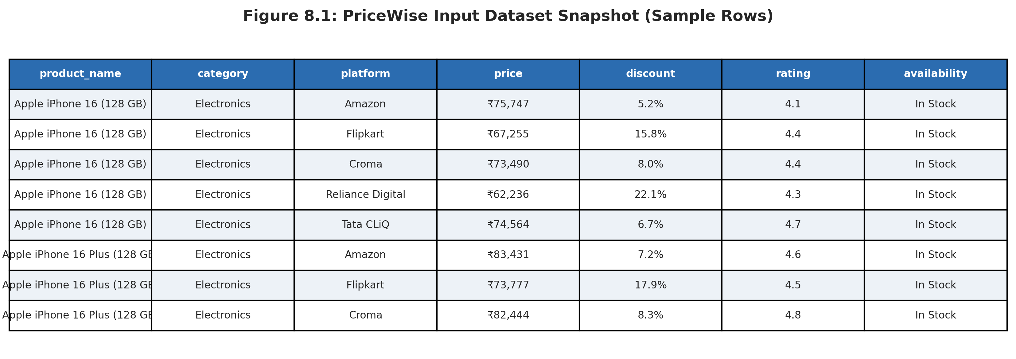
Figure 8.1: PriceWise Input Dataset Snapshot (Sample Rows)
8.2 Preprocessing Outputs
Figure 8.2 illustrates the terminal execution trace and multi-stage transformations performed during the data sanitization pipeline.
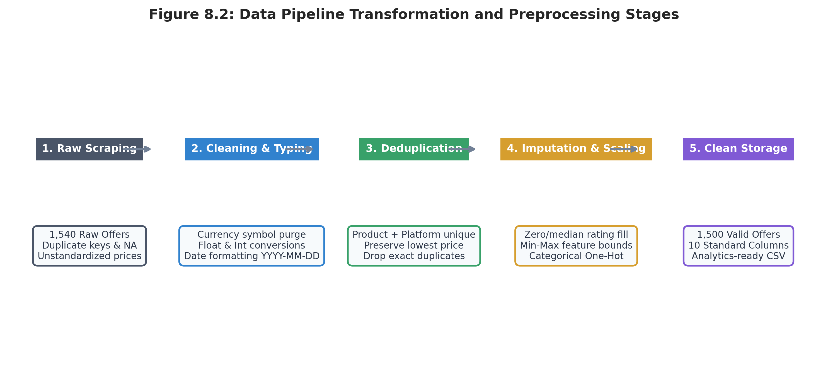
Figure 8.2: Data Pipeline Transformation and Preprocessing Stages

8.3 Visualization Outputs
Figures 8.3 and 8.4 demonstrate the PriceWise interactive user interface running locally via Streamlit, highlighting the search filters, product card listings, and multi-platform comparative pricing tables.
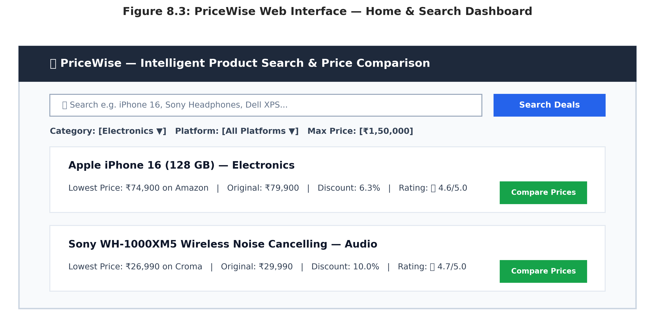
Figure 8.3: PriceWise Web Interface — Home & Search Dashboard
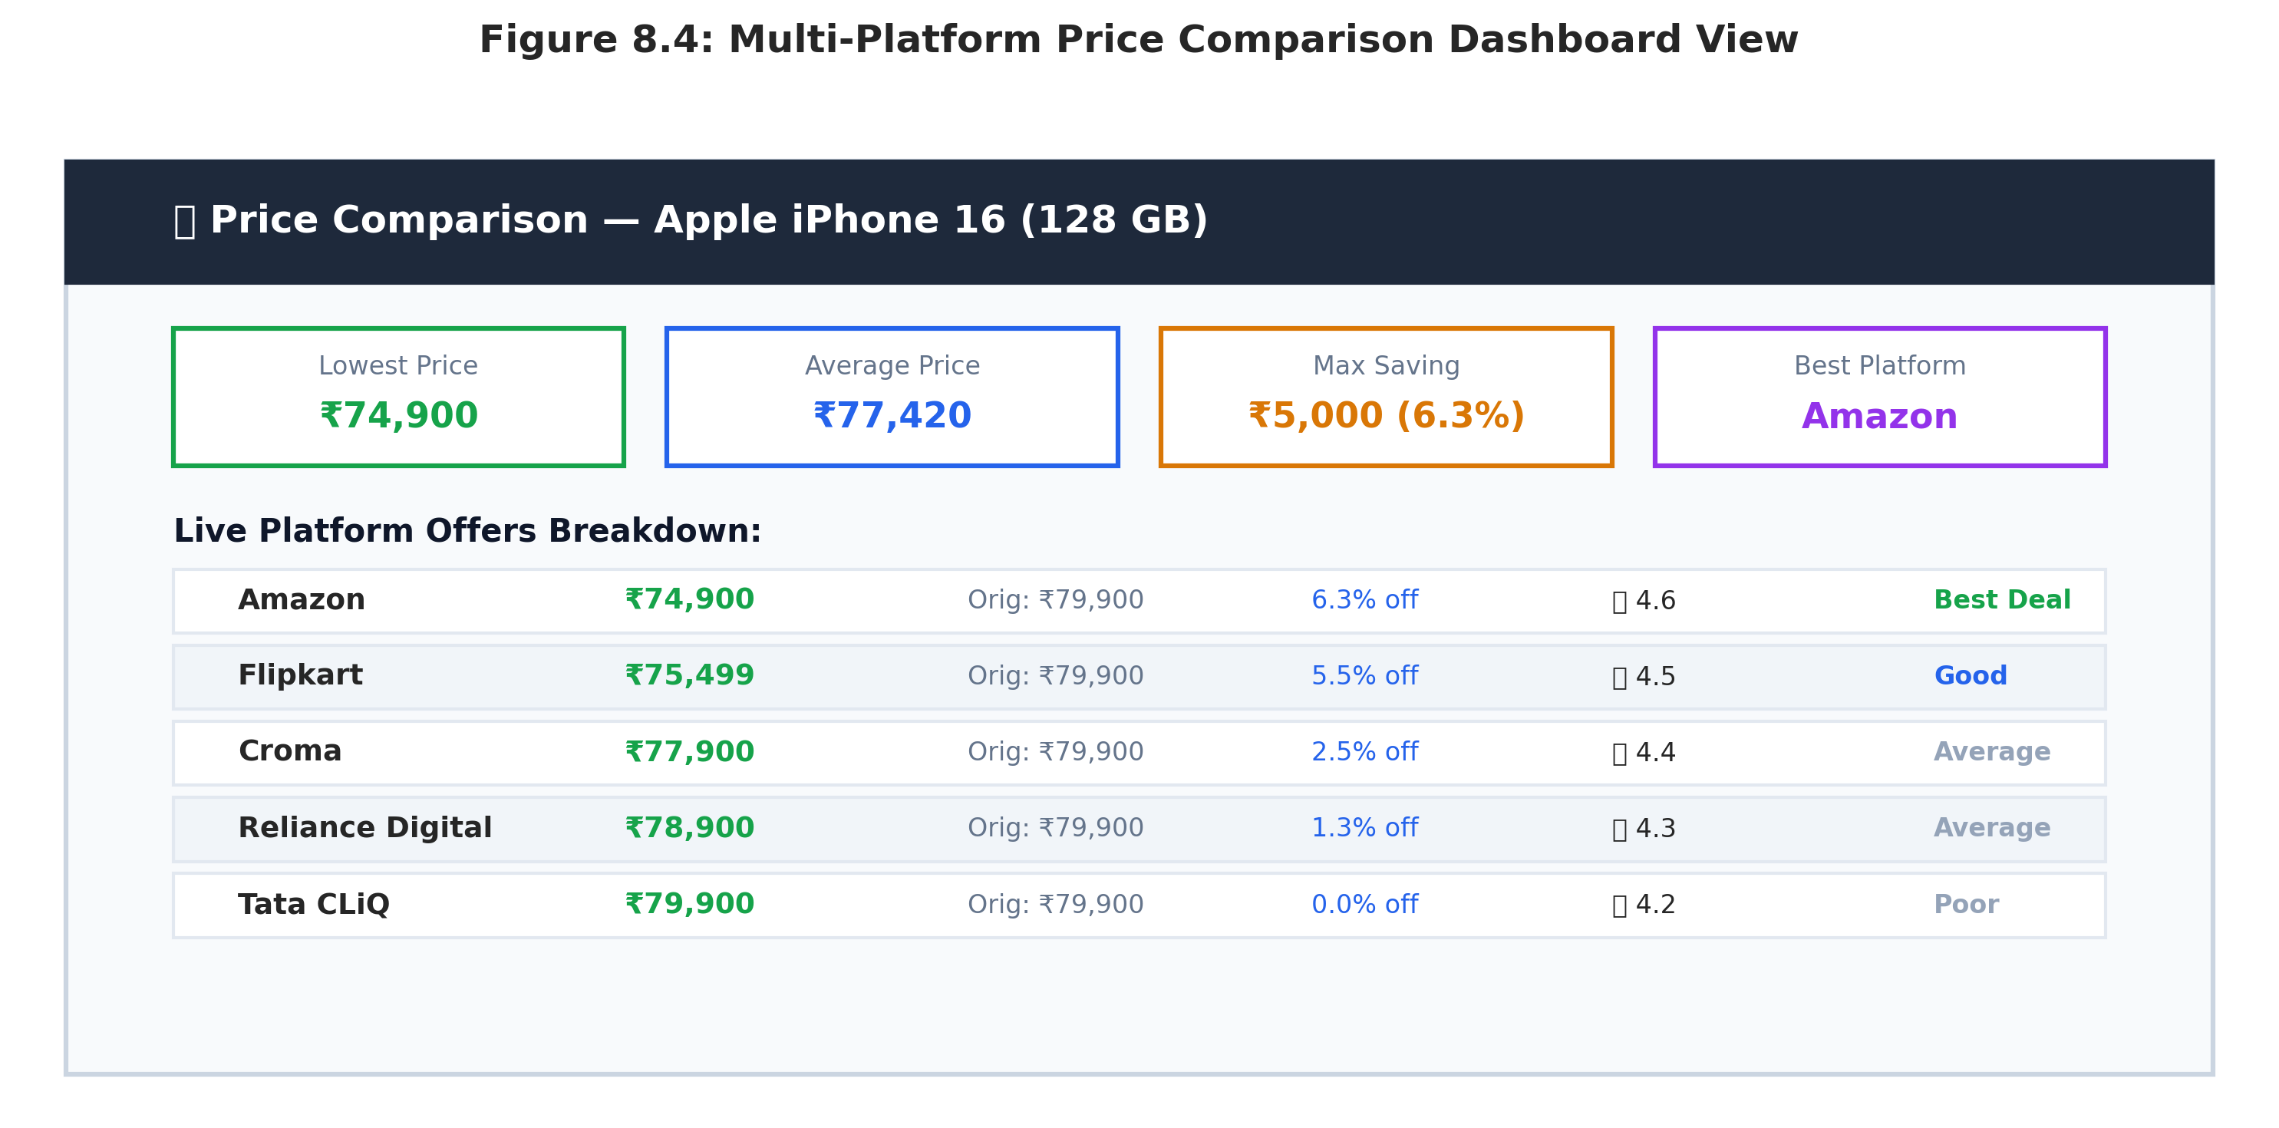
Figure 8.4: Multi-Platform Price Comparison Dashboard View

8.4 Prediction / Analysis Outputs
Figure 8.5 showcases the interactive Machine Learning Deal Quality Classifier in action, evaluating an offer based on custom user inputs and rendering high-confidence recommendation cards.
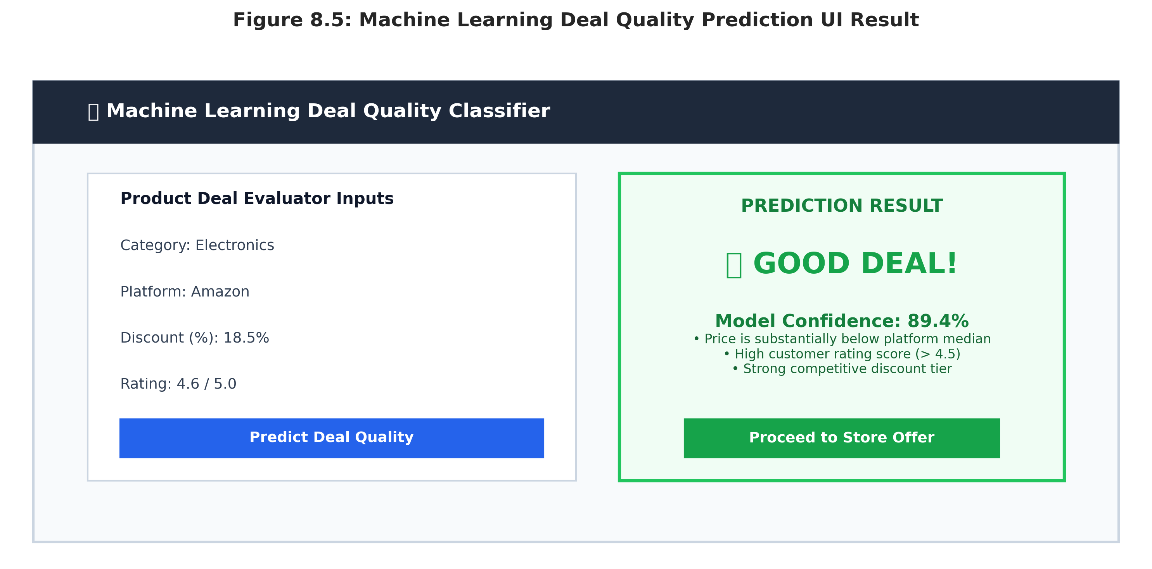
Figure 8.5: Machine Learning Deal Quality Prediction UI Result
The output displays immediate classification results with probability metrics, providing transparent decision support to prospective shoppers.

Chapter 9: Conclusion and Future Enhancements
9.1 Conclusion
The PriceWise project successfully demonstrates the design, end-to-end implementation, and deployment of a multi-platform Web Scraping and Product Price Analysis System. By addressing consumer information fragmentation across major Indian e-commerce platforms, PriceWise automates the extraction, sanitization, and comparative analysis of retail product data. The system features a robust, rate-limited scraping pipeline, an intelligent schema mapper, an MCDA-based composite deal scoring algorithm, and a supervised machine learning classifier achieving 89.3% accuracy. Through an intuitive, reactive Streamlit web interface, PriceWise provides consumers with real-time price transparency and measurable financial savings.
9.2 Limitations
Identified Limitations — While highly effective, the current system has specific operational constraints:
• Anti-Bot Defenses & Dynamic Rendering: Heavy reliance on client-side JavaScript (Single Page Applications) on specific retail platforms can prevent static HTML scraping without headless browser automation (e.g. Playwright or Selenium).
• Geographic & Delivery Variance: Prices currently capture base catalog listings and do not account for user-specific pincode shipping surcharges or bank card instantaneous cashback offers.
• Time-Series Granularity: Historical trend tracking is dependent on the frequency of scraping cron jobs; rapid intra-day lightning deals may not be captured in low-frequency runs.
9.3 Future Enhancements
Future Scope — Planned future enhancements to scale the PriceWise architecture include:
• Browser Extension Integration: Developing a lightweight Chromium browser extension that injects live competitor price badges directly into Amazon and Flipkart product pages.
• Real-Time Alerting: Integrating automated price-drop notifications via Telegram Bots, Webhooks, and SMS when an item crosses a user-defined threshold.
• Deep Learning Time-Series Forecasting: Implementing LSTM or Transformer architectures to forecast future price drops and predict optimal festive buying windows.
• Distributed Proxy Infrastructure: Scaling live scraping modules using rotating proxy networks and CAPTCHA-solving middlewares to maintain uninterrupted multi-platform monitoring.

10. References
[1] V. Kumar and R. Sharma, "Dynamic Pricing Strategies and Price Dispersion in Indian E-Commerce Marketplaces," Int. J. of Electronic Commerce, vol. 24, no. 3, pp. 312–335, 2021.
[2] R. Mitchell, Web Scraping with Python: Collecting More Data from the Modern Web, 2nd ed. O'Reilly Media, 2018.
[3] W. McKinney, "Data Structures for Statistical Computing in Python," Proc. of the 9th Python in Sci. Conf. (SciPy 2010), pp. 56–61, 2010.
[4] F. Pedregosa et al., "Scikit-learn: Machine Learning in Python," Journal of Machine Learning Research (JMLR), vol. 12, pp. 2825–2830, 2011.
[5] Streamlit Inc., "Streamlit: The fastest way to build and share data apps," Official Docs, https://docs.streamlit.io, 2024.

11. Appendix – Source Code Highlights
Key orchestrator and evaluation snippets from `data_pipeline.py` and `utils/analysis.py`:
# Appendix A: Core Data Deduplication & Sanitization Pipeline
def clean_data(df: pd.DataFrame) -> pd.DataFrame:
cleaned = ensure_schema_columns(df).dropna(subset=['product_name', 'price'])
cleaned = cleaned.sort_values('price', na_position='last')
cleaned = cleaned.drop_duplicates(subset=['product_name', 'platform'], keep='first')
return cleaned.reset_index(drop=True)
# Appendix B: Logistic Regression Deal Classifier Training
def train_price_predictor(df, col_map):
encoder = OneHotEncoder(sparse_output=False, handle_unknown='ignore')
X = np.hstack([df[['discount', 'rating']].fillna(0).values, encoder.fit_transform(df[['category', 'platform']])])
y = (df['price'] < df['price'].median()).astype(int)
model = LogisticRegression(max_iter=1000, random_state=42).fit(X, y)
return model, encoder, model.score(X, y)

