7/12/2020

Thilak Rethinekumar

Indian Cuisine Recommendation System - For Massachusetts, USA

Capstone Project - The Battle of Neighbourhoods

**Introduction:**

Massachusetts with its diverse culture comes with diverse cuisines like Indian, Chinese, Mediterranean, Mexican etc.

We wanted to do some detailed exploratory data analysis of all the neighbourhoods in Massachusetts and find answers to below questions.

**Problem statement:**

Find answers to following questions:

1. What are best location in Massachusetts for Indian Cuisine?

2. Which areas have most Indian Restaurants?

3. Which all areas lack Indian Restaurants but potential to improve?

4. Which is the biggest chain of Indian restaurants in Massachusetts?

**Data Sourcing:**

For this project we need the following data:

1. Massachusetts data with list of Neighborhoods along with their latitude and longitude.
2. Data source : https://public.opendatasoft.com/explore/dataset/us-zip-code-latitude-and-longitude/export/?refine.state=MA
3. Description: This data set contains all the Neighborhoods of Massachusetts with their latitude and longitude.

* Indian restaurants in each neighbourhood of Massachusetts.
* Data source : Foursquare API
* Description: By using this API we will get all the venues in each neighbourhood. We can filter these venues to get only Indian restaurants.

**Methodology:**

1. We begin by collecting the Massachusetts data from the following link <https://public.opendatasoft.com/explore/dataset/us-zip-code-latitude-and-longitude/export/?refine.state=MA>

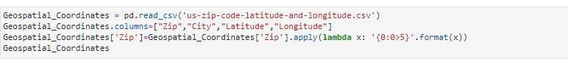

1. Get Four square API credentials
2. Define a function to get venues using Four square API
3. For each and every Neighborhood, need to call the above defined function to get the venues and then filter only Indian Restaurants and assign them all to a Pandas data frame

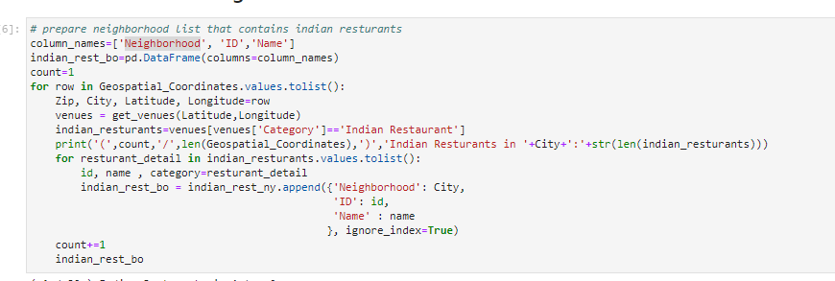

1. Create a Bar diagram to show which Neighborhood has got most number of Indian Restaurants in Massachusetts

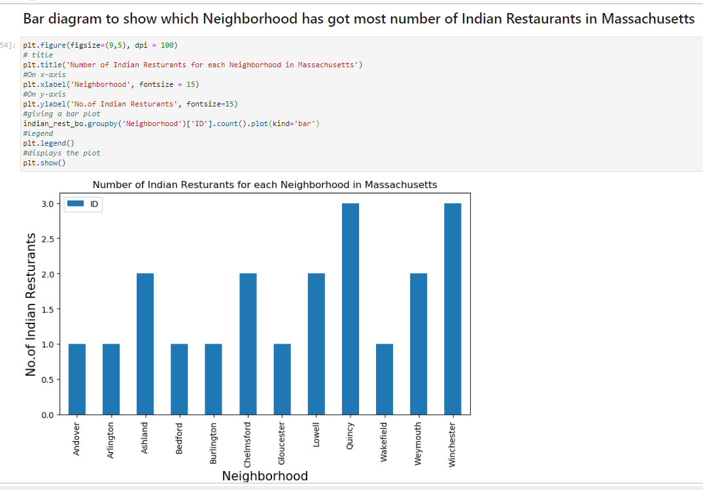

1. Create a Pie chart to show the biggest chain of Indian Restaurants for each Neighborhood in Massachusetts

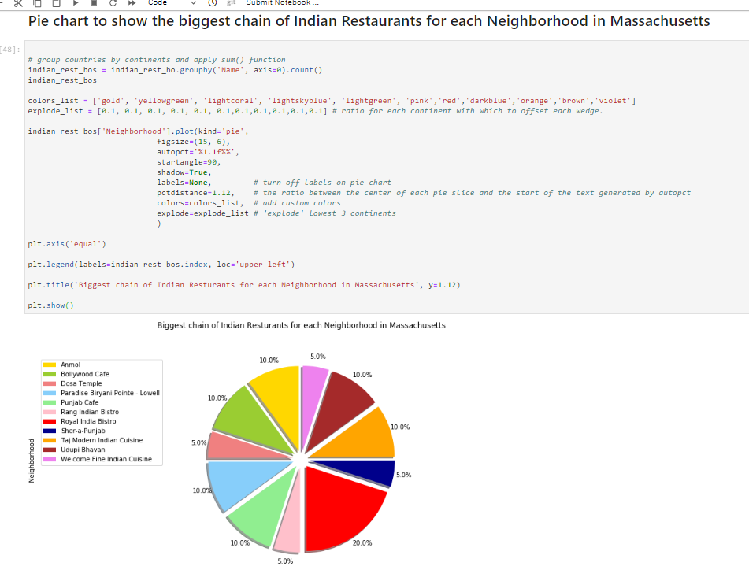

1. Create a function to get more details like Ratings, Likes and Tips for each and every restaurant using Foursquare API
2. Create a pandas data frame with Likes, Ratings and Tips for each and every Indian Restaurant in Massachusetts

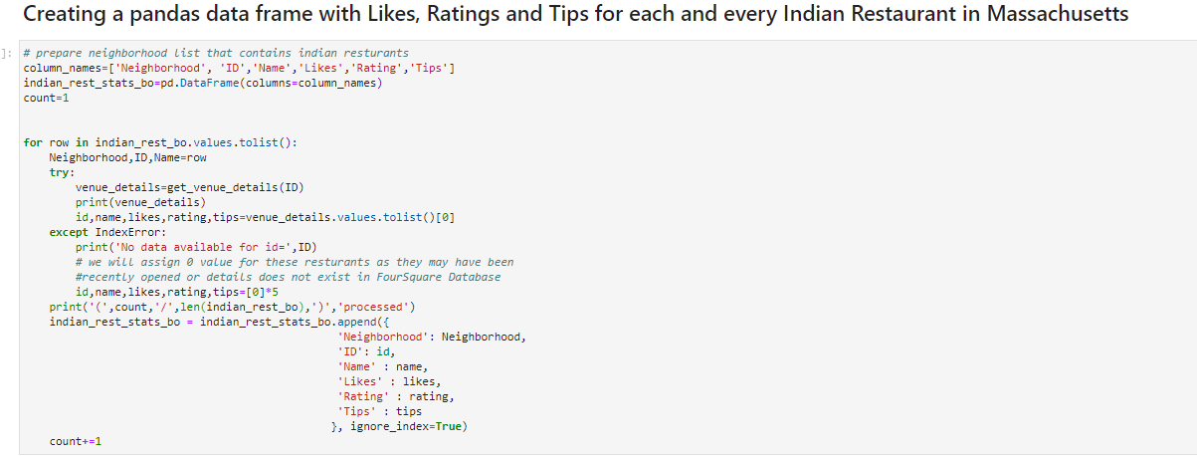

1. Find Most liked restaurant in Massachusetts

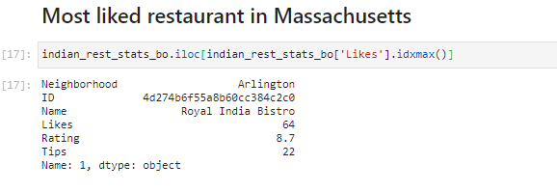

1. Find Highly rated restaurant in Massachusetts

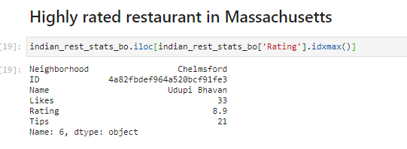

1. Find top locations in Massachusetts for Indian Restaurants

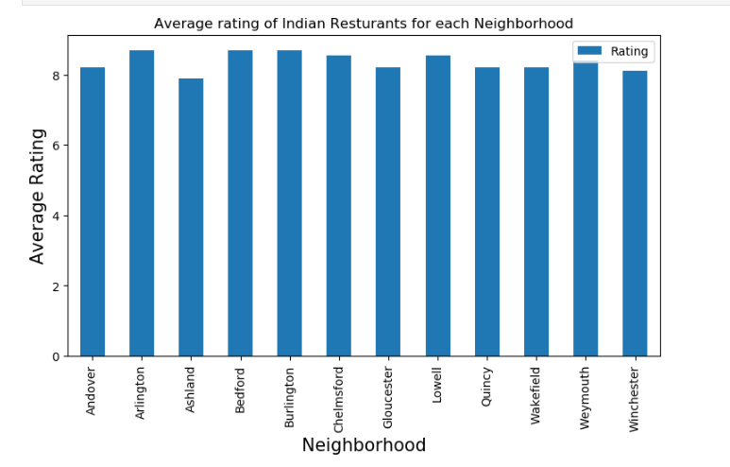

1. Map showing top 5 areas in Massachusetts for good Indian Restaurants

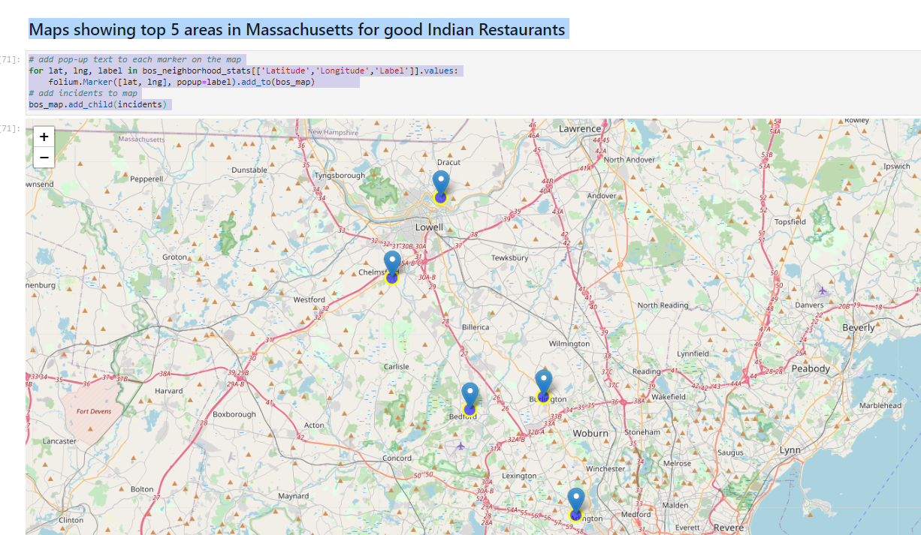

**Discussion & Conclusion:**

## 1) What are best location in Massachusetts for Indian Cuisine?

### Arlington, Bedford, Burlington, Chelmsford, Lowell. Refer above map as well as the bar diagram.

## 2) Which areas have most Indian Restaurants ?

### Quincy and Winchester has most Indian Restaurants. Refer the bar diagram.

## 3) Which all areas lack Indian Restaurants but potential to improve?

### Andover, Arlington, Bedford, Burlington, Gloucestar, Wakefield are the places which lack Indian restaurants.

### However, Arlington, Bedford, Burlington already has some best Indian Restaurants.

### So, Andover, Gloucestar and Wakefield has got the potential to improve. If one want to start an Indian Restaurant, then it would be the best place.

## 4) Which is the biggest chain of Indian restaurants in Massachusetts?

### Royal Indian Bistro is the biggest chain of Indian restaurants in Massachusetts. Refer the pie chart as well.

Note:

There is always room for improvement and hence the above solution provided can also be improved for best results depending upon the data we have.

We can also develop prediction model which can accept a town as input parameter and it can recommend best Indian Restaurant in that town.