IK437A

Information Security Management- Application Areas
Examination Task 1: Project Plan

Project Name:TMC
Authors:
Team Member A
Team Member B
Team Member C
[Author Name]

Date: 2025-04-25

1.Introduction/Summary 2
2.Project organization 2
3.Problems and objectives/goals 3
4.Problem 3
5.Objectives 4
6.Deliverables 5
7.Implementation & timetable 6
8.Resource analysis 7
9.Quality criteria 7
10. Risk analysis 8
11. Reference list 9
12. Attachments 10

Table.1 Document revision information
Version | Date | Changes
1.0 | 2025-04-25 | First draft
1.1 | 2025-05-02 | Revised - minor changes
2.0 | 2025-05-16 | Final - Change of scope, objectives and goal.

1.Introduction/Summary
Note: This is an anonymized, conceptual version of a university GRC/ISO 27001 group project. The company name, client contacts, and teammates have been replaced with fictional placeholders; private contact details and tool links have been removed. It is shared here to illustrate methodology and planning approach, not to represent any real organization or individuals.
This project aims to support TMC, a Swedish-based company providing a secure video communication platform, in expanding its digital services to municipalities by aiding them in meeting the municipality's procurement-related information security requirements for operating in the Swedish public sector.

TMC was first created as a private, secure video communication network, especially to help elderly individuals and their families stay in touch. It provides a straightforward, secure, and easy-to-use communication method for those with low levels of digital literacy.

The core issue faced by TMC is that some municipalities are hesitant to adopt the platform due to GDPR-related concerns, specifically the storage of data on Google Cloud, a service operated by a U.S.-based company. Although TMC uses non-EU cloud storage, this remains a barrier in certain public procurements.

In this project, we will assess TMC’s current business model, focusing on whether its information security complies with municipal procurement requirements. We will also provide clear documentation and recommendations to strengthen TMC’s position in the public sector. The project will be carried out in close collaboration with TMC representatives and will include internal and external business analyses, a risk analysis, and a gap analysis.

2.Project organization
Contacts: ceo@example.com & sales@example.com
The project owners are the CEO and the Sales & Marketing Partner from the company TMC. The CEO's responsibilities mainly involve providing background information and outlining the needs of the project, as well as ensuring that the project aligns with the company's vision and direction. Nina will focus more on offering practical insights and ensuring that the proposed solutions fit within their current systems and processes.
Our main duty as information security consultants is to thoroughly examine TMC's current information security procedures and determine whether they comply with the requirements established by Swedish municipalities. This involves identifying the gap between TMC's existing security posture and the expectations of public sector clients in relation to procurement.
The work will be conducted remotely using Discord and partially on the university's premises. In the future, meetings may be held at TMC or via digital platforms such as Zoom or Teams, depending on the availability of the project owners and the project's needs.

Name | Role | Responsibilities
the CEO | CEO and Partner | Assist by providing TMC’s background and needs through a case description. Ensures that work aligns with their company’s vision and direction.
the Sales & Marketing Partner | Sales & Marketing Partner | Assist with operational questions by providing practical insights into the existing workflows at TMC. Ensuring that the proposed solution fits their current system and processes.
Team Member A | Project manager | Responsible for planning and organizing the project, coordinating team activities, and ensuring deadlines are met.
Team Member B | Project Communicator | Responsible for communicating with municipalities and scheduling meetings with TMC.
Team Member C | Risk Manager | Oversees the identification, analysis, and mitigation of potential risks to the project.
[Author Name] | Project Coordinator | Team communication, project documentation and progress monitoring.

3.Problems and objectives/goals
TMC is facing a critical challenge in scaling its video communication platform to public sector clients, specifically municipalities due to concerns regarding compliance with the General Data Protection Regulation (GDPR). Although the platform does not provide municipalities with access to any personal data or login credentials, some municipalities remain reluctant to adopt the service because user data is stored on Google Cloud, which is owned by a U.S.-based company. So Swedish municipalities hesitate to use this application due to regulatory concerns since the government organization completely relies on the rules and regulations.
The objectives we have for this project is to clarify information security roles and responsibilities for the different stakeholders connected to TMC, analyze the information security requirements set by municipalities, identify risk factors, conduct a gap analysis and deliver actionable recommendations to TMC.
The goal of this project is to support TMC in meeting the municipality's procurement-related information security requirements for operating in the Swedish public sector.

4.Problem
Actual Problem to Be Solved
TMC is having trouble expanding its services to Swedish municipalities as many municipalities require that all customer data is stored within the EU and are very careful about information security when choosing digital communication tools like “TMC”.
TMC currently uses Google Cloud, which raises concern for municipalities about how data is protected and where it is stored. Even though TMC believes they follow privacy and security rules, and they do not give municipalities access to users' data, they are not sure how to clearly show or explain this to municipalities.
For Whom Is This a Problem?
- TMC: TMC cannot expand its market in the public sector due to concerns about its data storage and security practices, which prevents municipalities from using the platform. As a result, this limits their growth and leads to the loss of important contracts.
- Municipalities: Municipalities are also affected since the elderly population is continuously increasing. According to the World Health Organization (2022) one in six people in the world will be aged 60 or over by 2030. This means more people will have to live at home due to limited space in retirement homes. Municipalities may be required to allocate additional staff and resources to conduct in-person visits for elderly care services efforts that could otherwise be supported or partially replaced through secure, remote communication solutions such as the one provided by TMC.
- End Users (care recipients & families): When municipalities choose not to use the TMC platform due to security concerns, elderly users and their families may miss out on the benefits of the app as a simple way to communicate with care workers.
Problem Definition
Currently, TMC is facing problems getting accepted by municipalities because they use Google Cloud services to store data, which municipalities do not prefer. Municipalities want all customer data to be stored within the EU.
Even though TMC believes they are in compliance with GDPR they lack clear documentation explaining how their system meets the municipality's information security requirements. They are also not aware of all the requirements that the municipalities have concerning information security and would like a better understanding of that.
Explicit Problem Scope
- In Scope:
  - Identifying key information security requirements that municipalities prioritize during procurement.
  - Analyzing TMC’s current information security practices to see what is missing compared to municipal requirements.
  - Evaluate risk factors that may affect TMC’s compliance with information security requirements.
  - Providing clear actionable recommendations to aid TMC to meet municipal requirements.
- Out of Scope:
  - The functionality of the app or technical infrastructure, such as hosting data on EU-based servers.
  - Implementing technical solutions or enforcing compliance,the project focuses on assessment and recommendations, not development.
  - Providing a legal certificate and full GDPR audit. Role is to simply review current information security practices of TMC and suggest improvement where needed by analyzing municipal procurement requirements.
  - Not responsible for providing any end-user training guidelines or tools for TMC or the municipalities.

5.Objectives
This project has five main objectives and one overarching goal: to support TMC in meeting the municipality's procurement-related information security requirements for operating in the Swedish public sector. Throughout the project, these objectives and the goal will be prioritized, with the hope that all of them will be achieved. Each objective will be clearly defined and linked to a specific deliverable, making it possible to verify its completion by the end of the project. The goal, however, will be more difficult to measure in terms of achievement, as it serves more as a guiding beacon throughout the project's duration. Down below is a more detailed description of our objectives.
Clarify information security roles and responsibilities – Define the roles and responsibilities of all relevant stakeholders in relation to information security. This will be achieved by conducting both internal and external stakeholder analyses.
Analyze the information security requirements set by municipalities - Analyze different procurement agreements made by municipalities to create a list of information security requirements. With a focus on data protection, GDPR requirements, and organizational impact.
Identify risk factors – Determine and evaluate any risk variables that may affect TMC’s information security compliance. Examples of internal and external risks include security misconfigurations, GDPR compliance issues, organizational limitations, data breaches and human factors.
Conduct a gap analysis – Investigate TMC’s current information security level and compare it to the level required by municipalities in their procurement agreements. By establishing TMC’s current information security level, we aim to help them identify areas where they are lacking, as well as areas where they are currently sufficient.
Deliver actionable recommendations to TMC - Deliver a set of clear, actionable recommendations to TMC, grounded in the findings and analyses conducted throughout the project. These recommendations will be directly tied to specific deliverables such as our risk analysis and communication guidelines.

6.Deliverables
Deliverables | Activity | Responsible | Estimated Delivery Date
Project Plan | Understand functional and non-functional requirements & project scope | Project consultants and TMC Company | 22 April 2025
 | Online meeting with group members to clarify the scope.  Draft email to get the scope from TMC | Project consultants | 23 April 2025
 | Online meeting with group members to draft project plans. | Project consultants | 24 April 2025
 | Submit a project plan proposal |  | 25 April 2025
Revised project plan | Submit the revised project plan | Project consultants | 02 May 2025
Internal Analysis document and Information assets document | Prepare Internal analysis document | Project consultants | 13 May 2025
 | Send Internal Stakeholders analysis document and Information assets document for TMC CEO and CTO | Project consultants | 13 May 2025
Final Project plan | Submit the revised project plan | Project consultants | 16 May 2025
Information Security requirement list | Analyze different procurement agreements sent by municipalities and create an IS requirements list with the findings. | Project consultants | 20 May 2025
External Analysis document | Prepare external Stakeholders Analysis document | Project consultants | 21 May 2025
Risk Analysis document | Identify security requirements with MSB framework, and conduct risk assessment, draft risk assessment report and risk mitigation strategy. | Project consultants | 23 May 2025
Gap Analysis document | Conducting gap analysis based on the e TMC’s current information security level and comparing it to the level required by municipalities in their procurement agreements. | Project consultants | 28 May 2025
Actionable recommendations document | Draft project reports with proposed solutions and information security requirements | Project consultants | 30 May 2025

7.Implementation & timetable
Phase plan
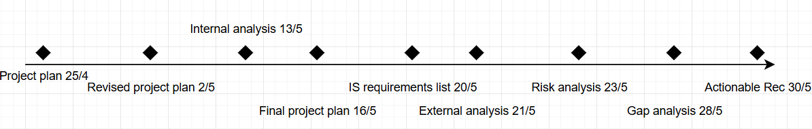

Gantt Chart
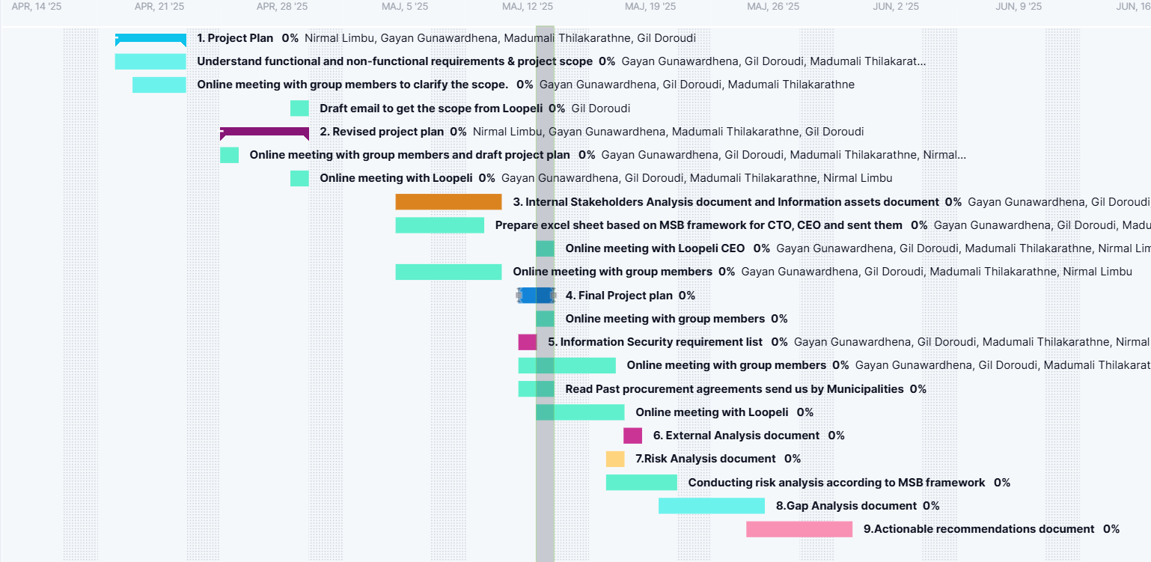

8.Resource analysis
Number of hours - Each person is estimated to work 280 hours during the project, based on a 7-week timeline with an estimated 40 hours of work per week. This estimation allows us to effectively plan resources, manage workloads, and ensure that key deliverables are completed within the expected timeframe.
Equipment and Tools - Our personal computers. Softwares such as Google Docs, Word, PowerPoint and Draw.io. MSB Methodological support tool for information security work.
Premises - While the majority of the project work will be conducted remotely, we will also make use of physical spaces to facilitate collaboration and meetings when necessary. These include group rooms and classrooms at the university, which are well-suited for focused discussions and joint work sessions. Furthermore, we hope to occasionally use meeting rooms and other facilities at TMC, however this is not something they have confirmed.
Literature - The project will use a broad selection of literature, including core course materials from both the current and previous semesters. In addition, we will use regulatory literature with a particular focus on GDPR and legal considerations relevant to municipalities.

9.Quality criteria
In our project, which consists of an information security analysis and proposed solutions (using MSB’s methodological tools), the FURPS model helps guide and evaluate the quality of our deliverables in the following ways:
Functionality
Our reports and recommendations will fulfill TMC’s security needs while ensuring compliance with GDPR and municipal information security requirements. Deliverables will also clarify the roles and responsibilities of stakeholders and address identified risks with practical, standards-based solutions.
Usability
All deliverables, including guidelines, reports, and visual diagrams, will be clearly structured and written to be accessible to all stakeholders, including the CEO, the Sales & Marketing Partner, and municipal partners. Our goal is to ensure comprehension and usability even for those without technical or legal backgrounds. This aligns with ISO/IEC 25010:2011 principles such as operability and user error protection.
Reliability
Our analyses and recommendations will be based on recognized, trusted methodologies to ensure consistency and accuracy. Risk assessments, gap analyses, and compliance checks will produce reproducible results when reassessed using the same tools and standards. We follow ISO/IEC 25010:2011 guidelines on availability, fault tolerance, and recoverability.
Performance
Performance in our context refers to how effectively the deliverables communicate insights and can be applied in practice. The risk analysis will clearly highlight GDPR-related risks and their mitigation. The gap analysis will accurately compare TMC’s current and required security postures. Our recommendations will be structured, actionable, and tailored to improve data protection processes without causing unnecessary delays or complexities.
Supportability
Documentation, diagrams, and tools provided will be clear, reusable, and easy to maintain. We aim to create deliverables that TMC can continue to use and adapt in the future, enabling long-term support for their information security strategy.

10. Risk analysis
Area | Probability  (1-5) | Effect  (1-5) | Perceived risk  (Prob effect) | Action
The external partner does not respond to communication. | 5 | 5 | 25 | Plan A: Try other forms of communication than email, like phone calls and contacting our Instructor for guidance.  Plan B: We will have to assume the problem on our own and try to make the best out of it.
A group member gets sick. | 3 | 3 | 9 | Plan A: We try to assign easier tasks to that member while the other makes up for the missing member.  Plan B: Allocate extra hours to other team members.
Poor time management. | 3 | 4 | 12 | Plan A: Create a detailed timeline with allocating plenty of time for each task.  Plan B: Reduce the scope of the project to make it fit the actual time.
Lack of previous legal documents availability. | 4 | 4 | 16 | Plan A: Communicate with external partner TMC that we need the documents from their previous legal assessment.  Plan B: Search literature for similar organizations legal documents concerning GDPR to be able to make educated estimates of the legal requirements TMC needs to adhere to.
Lack of knowledge on the municipality's procurement process. | 4 | 3 | 12 | Plan A: We allocate more hours towards researching municipal Procurement Portals like Visma Opic, Mercell TendSign Municipal procurement websites.  Plan B: Ask TMC about their previous experience and guidance about how to find the information.
Misunderstanding the major problem. | 4 | 4 | 16 | Plan A: Immediate clarification and realignment.  Plan B: Working agile and adapting to the mistakes we make throughout the project.
Bad risk assessment. | 3 | 4 | 12 | Plan A: Use the MSB framework to perform an accurate and useful risk assessment.  Plan B: Compare with the previous risk assessment reports provided by TMC.

11. Reference list
International Organization for Standardization & International Electrotechnical Commission. (2011). Systems and software engineering—Systems and software Quality Requirements and Evaluation (SQuaRE)—System and software quality models (ISO/IEC Standard No. 25010:2011). https://www.iso.org/standard/35733.html​

TMC. (n.d.). TMC – Enkel videosamtal för äldre och anhöriga. https://TMC.se/

ProjectManager.com. (2025). Project plan – TMC security implementation. ProjectManager. https://example.com/removed-for-privacy

Swedish Civil Contingencies Agency. (2025). Method support for systematic information security work. https://metodstod-informationssakerhet.msb.se/

World Health Organization. (2022, October 1). Ageing and health. https://www.who.int/news-room/fact-sheets/detail/ageing-and-health

12. Attachments

