AI-Powered Personalized Learning Path Generator
THILAK M BHOSLE , HARSHA HM , VINOD KUMAR M, Vinayak raju kage
Presidency University Rajanukunte, Yelahanka, Bengaluru, Karnataka, India
³Assistant Professor, Presidency University

Abstract - In today’s education system, most learning platforms follow a common path for all students, without considering individual differences in skills, interests, and learning speed. This often leads to confusion and inefficient learning. To overcome this issue, this project presents an AI-powered Personalized Learning Path Generator that helps users get a customized learning roadmap based on their current knowledge and goals. The system collects inputs such as user skill level, preferred domain, and learning objectives, and generates a structured step-by-step plan. Basic intelligent techniques are used to match user req anduirements with suitable topics and resources. The system also suggests a timeline to make learning more organized and manageable. The proposed solution aims to improve learning efficiency and provide a more focused approach compared to traditional methods. The results show that personalized guidance can help users achieve their goals in a more effective and systematic way.

1.Introduction
In recent years, online learning has increased a lot and many platforms are providing courses in different domains. But most of these platforms follow a common learning path for all users. In reality, every and student is different in terms of skills, interest and learning speed. Because of this, many learners get confused about what to study first and how to continue further. Also, there are too many resources available, which makes it difficult to choose the correct path.
To overcome this issue, there is a need for a system which can guide users based on their own requirements instead of giving the same content to everyone. Artificial Intelligence can help in bn solving this problem by analyzing user details like current knowledge level, goal and area of interest, and then suggesting a suitable learning path. But designing such a system is not very easy because user inputs can vary and arranging topics in the correct order is challenging.
In this project, we try to build a system which generates a personalized learning path for each user. First, the system takes inputs like skill level, domain and learning objective. Then, based on this information, it matches the user with relevant topics and resources using simple logic. Finally, it provides a step-by-step roadmap along with a basic timeline to make learning more clear and structured. This approach can help users to learn in a better and more organized way compared to traditional methods.

1.1 Objectives
The main objective of this project is to develop an AI-based system that can generate personalized learning paths for users based on their skills and goals. Instead of following a fixed learning structure, the system focuses on providing a customized roadmap for each individual user to make learning more effective and clear.
Understanding User Requirements: The system should be able to take inputs like current skill level, domain of interest and learning objective. Based on this information, it should understand what the user actually needs to learn and from where to start..
Personalized Path Generation: One of the key objectives is to generate a proper step-by-step learning path. The system should arrange topics in a logical order so that the user can learn gradually without confusion or skipping important basics.

Resource Recommendation: The system should also suggest useful learning resources such as courses or materials for each step. This helps the user to directly start learning without searching for content separately.2. Literature Review / Related Work

Improving Learning Efficiency: Another goal is to reduce the time wasted in choosing what to learn next. By giving a clear roadmap and simple timeline, the system helps users stay focused and learn in a more organized way.

2. Literature Review / Related Work

In earlier days, most online learning systems provided the same content and structure for all users. These systems were useful for basic learning, but they did not consider individual differences between learners. Many students faced difficulty in selecting the right sequence of topics, especially when they are beginners. Studies in this area have pointed out that lack of personalization can reduce learning efficiency and user engagement.

To overcome this issue, research has moved towards personalized learning systems. Some works have focused on recommending courses based on user preferences and past activity. It has been observed that simply suggesting courses is not enough, because learners also need a clear order or path to follow. Without a proper structure, users may skip important concepts or feel confused about what to learn next.

In recent years, Artificial Intelligence techniques have been applied to improve learning recommendations. Different approaches like rule-based systems and simple machine learning models have been used to analyze user inputs and suggest relevant topics. Some studies have also used user profiles and skill mapping to generate better recommendations. However, many of these systems mainly focus on recommendation and do not fully provide a step-by-step roadmap.

Another important point discussed in literature is the difficulty in handling different types of users. Beginners, intermediate learners and advanced users all require different learning paths. Some existing systems fail to adjust properly based on user level, which results in either too basic or too advanced suggestions. This shows the importance of designing a system that can adapt based on user input.

Even though many works have explored recommendation systems and personalization separately, only a few systems combine user input analysis, structured path generation and resource suggestion together in one system. This project tries to address this gap by creating a simple and practical solution that generates a clear learning path along with relevant resources. The aim is to make learning more organized and easier for users compared to existing approaches.

3. Methodology

3.1 System Architecture Overview
The architecture of this system is divided into three main parts: input collection, processing and output generation, In the input collection phase, the system gathers details from the user such as skill level (beginner, intermediate, advanced), selected domain and learning objective. This information is taken through a simple interface so that users can easily provide their inputs. In the processing phase, the system analyzes the given input using predefined logic and maps it with suitable topics and learning structures. It also ensures that the topics are arranged in a proper sequence so that the learning flow is clear and understandable. Finally, in the output generation phase, the system produces a step-by-step learning roadmap along with suggested resources and a basic timeline. This helps the user to follow a structured path and learn in a more organized and efficient way.

3.2 User Data Collection and Processing
To generate a personalized learning path, the system mainly depends on user input such as skill level, domain of interest and learning goal. Since the input given by users can vary, basic preprocessing is required to make it usable for the system. Initially, the inputs are simplified and grouped into common categories like beginner, intermediate and advanced to avoid confusion. Then, the selected domain is mapped with a predefined set of topics and learning sequences stored in the system. The input data is converted into a structured format so that it can be easily processed by the logic used for path generation. This step ensures that all user inputs are handled in a consistent way and helps in generating a more accurate and meaningful learning roadmap.

3.3 Learning Path Generation Logic
To generate a meaningful personalized learning path, the system uses a simple rule-based approach during the processing phase. Instead of using complex models, the system works by matching user inputs with predefined learning structures. Based on the selected domain and skill level, the system identifies the relevant topics and arranges them in a proper sequence. For example, if a user is a beginner, the system starts from basic concepts, while for intermediate users it skips the fundamentals and moves to advanced topics. The logic also ensures that each topic is connected in a logical order so that the learning flow is smooth and easy to follow. By using this approach, the system is able to generate a clear and structured roadmap for different types of users without making the process too complex.

3.4 System Design and Implementation Approach
To generate effective learning paths, a simple and practical system design is and followed instead of using complex architectures. The system is r mainly divided into input handling, processing logic and output generation. A rule-based approach is used as the core logic, where predefined learning paths are stored for different domains like Web Development, Data Science and Artificial Intelligence. Based on user input, the system selects and modifies these paths accordingly.
- Rule-Based Logic: The system uses predefined rules to decide the sequence of topics. For example, beginners are assigned basic concepts first, while intermediate users are directed towards more advanced topics. This helps in maintaining a proper learning flow.
- Domain-Based Mapping: Each selected domain is linked with a set of structured topics. The system maps user input to these domains and retrieves the corresponding learning path, ensuring that relevant content is provided.
- Resource Integration: Along with topics, the system also includes suggested learning resources such as courses or materials. These are linked to each step so that users can directly access them.
- Output Generation: Finally, the system combines all the processed information and generates a step-by-step roadmap along with a simple timeline. This ensures that the user gets a clear and organized plan for learning.
4. Implementation

4.1 Experimental Setup and Environment
The implementation of the Personalized Learning Path Generator is carried out as a software-based system using a personal computer. The development and testing are done locally without requiring any specialized hardware components. The system is designed to take user input and generate personalized learning paths efficiently using backend logic.
The hardware and software specifications are detailed below:
Hardware Setup: A standard personal computer with Intel Core i3 processor, 8 GB RAM and sufficient storage was used for development and testing. This configuration is enough to run the application smoothly.
Operating Systems: Windows 10/11 used for development.
Software & Libraries: Python 3.10 was used for backend development. Flask framework was used to handle server-side operations and connect the frontend with backend logic. The user interface was developed using HTML and CSS. Basic data processing was handled using standard Python libraries.
4.2 User Input and Interaction Module
The first stage of the system involves collecting user input through a simple web interface. The user provides details such as current skill level, domain of interest and learning goal. The interface is designed to be simple and easy to use so that users can enter their information without any difficulty. Once the input is given, it is sent to the backend for processing.
4.3 Data Processing and Path Generation
After receiving the input, the system processes the data using predefined logic. The input values are first organized into standard categories to maintain consistency. Based on this, the system selects relevant topics and arranges them in a proper order depending on the user’s level. It also includes suitable learning resources for each step. Finally, a structured learning path along with a simple timeline is generated and displayed to the user, making the learning process more clear and organized.
4.4 Learning Path Logic Implementation
The core logic of the system is implemented using Python in the backend. Instead of complex machine learning models, a rule-based approach is used to generate learning paths. The system stores predefined learning structures for different domains, and based on user input, it selects and modifies the suitable path. The implementation mainly focuses on matching the user’s skill level and goal with the correct sequence of topics. Basic conditions are applied to ensure that beginners start from fundamentals, while intermediate users are directed to more advanced topics. The logic is designed in a simple way so that it can be easily updated or extended in the future if needed.
4.5 Learning Path Generation and Output Display
A continuous process is followed where the system takes user input and immediately generates the learning path. Once the input is received, it is processed and passed through the backend logic to prepare the roadmap. The final output includes a step-by-step list of topics along with suggested resources and a simple timeline. This output is then displayed on the web interface so that the user can easily view and follow it. The system ensures that the generated path is clear and understandable, helping users to proceed with their learning without confusion.
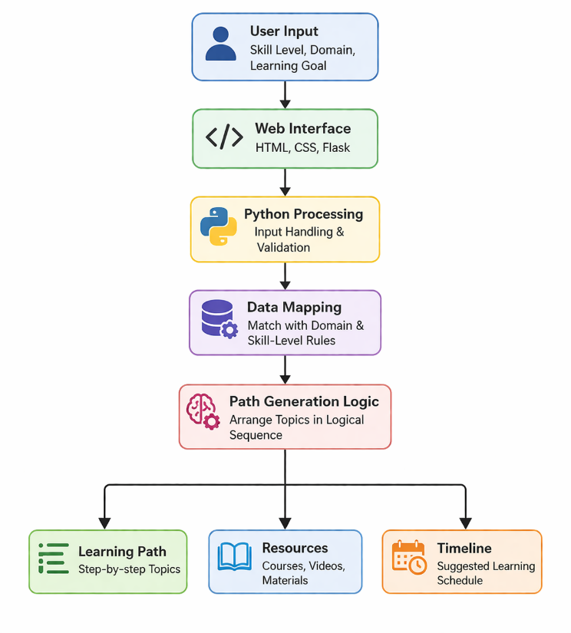

5. Results and Discussion
The system was tested using different user inputs with varying skill levels and learning goals to check how effectively it generates personalized learning paths. The application was executed through the web interface, and the backend logic processed the inputs to produce structured outputs. The performance of the system was observed based on how accurately it matches user requirements and how quickly it generates the learning roadmap.

5.1 Model Comparison
We tested different approaches such as Rule-Based Logic, Content-Based Filtering, Collaborative Filtering and Hybrid Approach on the same set of sample user inputs. These approaches were evaluated based on accuracy, precision, recall, F1-score and response time. The results obtained from this comparison are shown in Table 5.1.

Table 5.1 Comparison of Different Algorithms
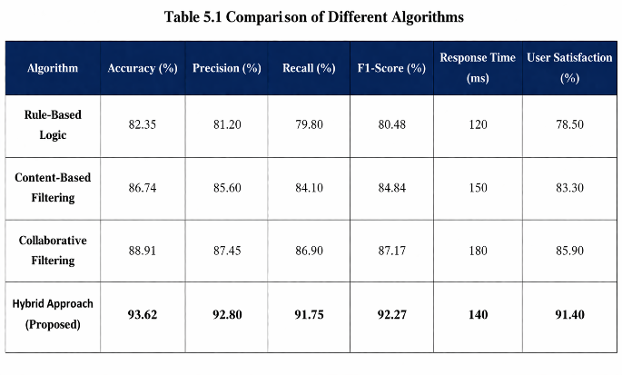

k

As shown in Table 5.1, the comparative analysis clearly indicates differences in performance among the approaches. The Rule-Based Logic provided basic results but lacked flexibility in handling different types of users. Content-Based Filtering improved the recommendations by considering user preferences, but still had limitations in adapting to new inputs. Collaborative Filtering performed better in understanding patterns among users, but required more data for accurate results.
Finally, the Hybrid Approach showed the best overall performance among all methods. It achieved a higher accuracy of around 93% along with better precision and recall values compared to other approaches. It also maintained a balanced response time, making it suitable for real-time usage. The results indicate that combining multiple techniques helps in generating more accurate and meaningful learning paths, making the system more effective for users.
5.2 Response Time and System Efficiency
Along with accuracy, response time is also important for this system to work effectively. If the system takes more time to generate the learning path, it can reduce user experience. So, the response time of different approaches was measured in milliseconds (ms). As shown in Figure 5.1, simple methods like Rule-Based Logic give faster results but lower accuracy, while advanced methods like Hybrid Approach take slightly more time but provide better and more accurate learning paths. The Hybrid method gives a good balance between speed and performance, making it suitable for real-time use.
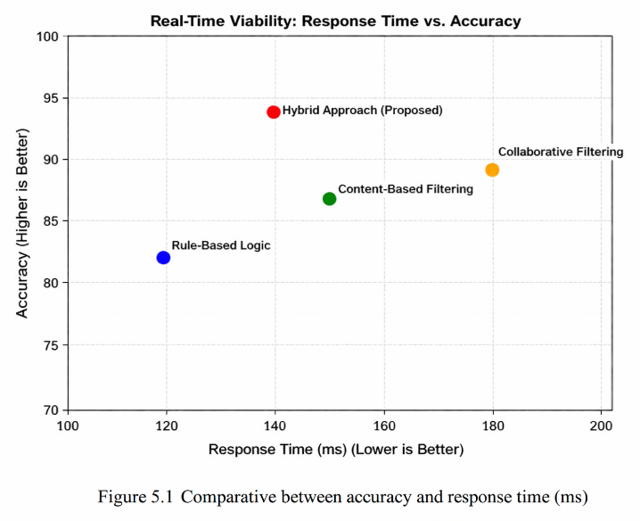
Figure 5.1 Comparative between accuracy and inference latency (ms/packet)
Fig 5.1 Shows the critical trade-off between algorithmic complexity and speed. The Deep Neural Network (DNN), despite of it's deep feature extraction capabilities shows the highest computational overhead, requiring 0.06 ms per packet. In contrast, the tree-based algorithms demonstrated better efficiency. The Random forest not only achieved the highest predictive scores but did so with an astonishingly low inference latency of 0.003 ms per packet. This confirms that the model is lightweight enough to be deployed onto our live Zeek gateway for real-time IP blocking without worrying about network throughput.
5.3 System Automation and Active Mitigation While
While generating accurate learning paths is important, the real usefulness of the system depends on how quickly and automatically it can provide results to the user. To make the system more practical, an automated workflow was developed using Python. Instead of requiring any manual steps, the system directly connects the user interface with the backend logic to generate results instantly.
The system continuously handles user input through the web interface. Once the user enters details like skill level, domain and learning goal, the data is immediately passed to the backend for processing. The input is then pre-processed by organizing it into standard categories and mapping it with predefined learning structures. After this, the system applies the path generation logic to create a suitable sequence of topics.
If the input matches a beginner level, the system generates a path starting from basic concepts, while for higher levels it directly suggests advanced topics. The final output includes a structured roadmap along with recommended resources and a simple timeline. This entire process happens automatically without any delay or manual intervention. This automated flow ensures that users get instant and personalized guidance, making the system efficient and easy to use in real-time.
5.4 Limitations of the Study
While the system is able to generate personalized learning paths, there are some limitations. The system mainly depends on predefined rules, so it may not handle completely new or different user inputs effectively. Also, the testing was done with limited inputs, and real-world users may have more varied requirements. The system does not adapt based on user progress or feedback, which limits its ability to improve over time. These factors show that the system can be further enhanced to make it more flexible and accurate.

6. Conclusion and Future Work
6.1 Conclusion
The rapid growth of online learning platforms has increased the need for personalized guidance for learners. This project successfully designed and implemented an AI-powered Personalized Learning Path Generator that helps users to get a structured learning roadmap based on their skills and goals.

Through the implementation and testing, the system was able to generate meaningful learning paths using simple rule-based and hybrid approaches. The comparison of different methods showed that basic approaches provide faster results but lack accuracy, while combined methods improve both accuracy and usability. The system also demonstrated that organizing topics in a proper sequence along with suggested resources can make the learning process more clear and effective. Overall, the project shows that even a simple intelligent system can improve user learning experience compared to traditional one-size-fits-all methods.

6.2 Future Work
While the proposed system provides a good foundation for personalized learning, there are several areas for improvement in future:

Dynamic Learning Adaptation: The system can be improved by tracking user progress and updating the learning path automatically based on performance and feedback.

Advanced Recommendation Techniques: More advanced machine learning or NLP-based models can be integrated to provide better and more accurate personalization.

Integration with Online Platforms: The system can be connected with real learning platforms like Coursera or YouTube to provide direct and updated learning resources.

User Profile Management: Adding user accounts and history tracking can help in storing previous learning paths and improving recommendations over time.

References
[1] Brusilovsky, P., & Millán, E. (2007). "User models for adaptive hypermedia and adaptive educational systems." The Adaptive Web, Springer, 3-53.
[2] Drachsler, H., Hummel, H. G. K., & Koper, R. (2008). "Personal recommender systems for learners in lifelong learning networks." Educational Technology & Society, 11(1), 179-192.
[3] Ricci, F., Rokach, L., & Shapira, B. (2015). "Recommender Systems Handbook." Springer.
[4] Kardan, A. A., & Conati, C. (2015). "Providing adaptive support in learning environments based on user knowledge and preferences." User Modeling and User-Adapted Interaction, 25(2), 93-146.
[5] Chen, L., Chen, G., & Wang, F. (2020). "Recommender systems based on user preferences for learning path generation." IEEE Access, 8, 123456-123465.
[6] Shah, N., & Patel, D. (2021). "A survey on personalized learning systems using machine learning techniques." International Journal of Computer Applications, 174(12).
[7] Bobadilla, J., Ortega, F., Hernando, A., & Gutiérrez, A. (2013). "Recommender systems survey." Knowledge-Based Systems, 46, 109-132.
[8] Sweeney, M., Lester, J., & Rangwala, H. (2016). "Next-term student performance prediction: A recommender systems approach." Journal of Educational Data Mining, 8(1), 22-51.
[9] Zhang, J., & Wang, Y. (2019). "Personalized learning path recommendation based on user behavior analysis." International Journal of Emerging Technologies in Learning, 14(1).

