
DAYANANDA SAGAR UNIVERSITY SCHOOL OF ENGINEERING
Devarakaggalahalli, Harohalli, Kanakapura Road, Dt. Bangalore South, Karnataka -562112

DEPARTMENT OF COMPUTER SCIENCE & ENGINEERING
(DATA SCIENCE)
CAPSTONE PROJECT REPORT

Driver Drowsiness And Health Monitoring
2025-2026
BACHELOR OF TECHNOLOGY
IN

COMPUTER SCIENCE & ENGINEERING
(DATA SCIENCE)

SUBMITTED BY
RITHESH KUMAR S - ENG24DS0145 S KISHORE KUMAR - ENG24DS0146
THILAK M - ENG24DS0168
NANDHA GOKUL R - ENG24DS0184

UNDER THE SUPERVISION OF
Prof. Manjula M, Assistant Professor
Prof. Mriganka Das, Assistant Professor Computer Science & Engineering (Data Science)
Dayananda Sagar University, Bengaluru Academic Year: 2025–2026

DAYANANDA SAGAR UNIVERSITY SCHOOL OF ENGINEERING
Devarakaggalahalli, Harohalli, Kanakapura Road, Dt. Bangalore South, Karnataka -562112

CERTIFICATE

This is to certify that the Capstone Project titled “Driver Drowsiness And Health Monitoring” has been carried out by Rithesh Kumar S- ENG24DS0145, S Kishore Kumar- ENG24DS0146, Thilak
M- ENG24DS0168, Nandha Gokul R- ENG24DS0184, Bonafide students of Bachelor of Technology in Computer Science and Engineering (Data Science) at the School of Engineering, Dayananda Sagar University, Bangalore, in partial fulfilment of the requirements for the award of the degree of Bachelor of Technology in Computer Science and Engineering (Data Science) during the academic year 2025–2026. It is further certified that all corrections and suggestions indicated during the internal assessment have been incorporated in the final report submitted to the departmental library. The project report has been approved as it satisfies the academic requirements in respect of the project work for the said degree.

Prof. Mriganka Das | Dr.Shaila S | Dr. Udaya Kumar Reddy K. R.
Assistant Professor  Dept. Of CSE (Data Science)  School of Engineering Dayananda Sagar University  Date: | Professor  Dept. Of CSE (Data Science) School of Engineering  Dayananda Sagar University Date: | Dean  School of Engineering  Dayananda Sagar University  Date:

Name of the Examiner Signature of Examiner
1.
2.

DECLARATION

We, Rithesh Kumar S- ENG24DS0145, S Kishore Kumar- ENG24DS0146, Thilak M- ENG24DS0168, Nandha Gokul R- ENG24DS0184 ,are students of Eighth semester B.Tech in Computer Science and Engineering (Data Science), at School of Engineering, Dayananda Sagar University, hereby declare that the Major Project titled “Driver Drowsiness And Health Monitoring “ has been carried out by us and submitted in partial fulfilment for the award of degree in Bachelor of Technology in Computer Science and Engineering (Data Science) during the academic year 2025- 2026

\

Name 1: Rithesh Kumar S
USN : ENG24DS0145

Name 2: S Kishore Kumar
USN : ENG24DS0146

Name 3: Thilak M
USN : ENG24DS0168

Name 4: Nandha Gokul R
USN : ENG24DS0184

Place : Bengaluru Date:

ACKNOWLEDGEMENT
It is a great pleasure for us to acknowledge the assistance and support of many individuals who have been responsible for the successful completion of this project work. First, we take this opportunity to express our sincere gratitude to School of Engineering & Technology. Dayananda Sagar University for providing us with a great opportunity to pursue our Bachelor's degree in this institution.

We would like to thank Dr. Udaya Kumar Reddy K. R. Dean, School of Engineering & Technology, Dayananda Sagar University for his constant encouragement and expert advice.

It is a matter of immense pleasure to express our sincere thanks to Dr. Shaila S G. Department Chairperson, Computer Science and Engineering (Data Science), Dayananda Sagar University, for providing right academic guidance that made our task possible.

We would like to thank our guide Prof. Mriganka Das Dept. of Computer Science and Engineering (Data Science), Dayananda Sagar University for sparing her valuable time to extend help in every step of our project work, which paved the way for smooth progress and the fruitful culmination of the project.

We would like to thank our Project Coordinator Professor Manjula M and as well as all the staff members of Computer Science and Engineering (Data Science) for their support. We are also grateful to our family and friends who provided us with every requirement throughout the course.

We would like to thank one and all who directly or indirectly helped us in the Project work.

SIGNATURE:

Rithesh Kumar S - ENG24DS0145
S Kishore Kumar - ENG24DS0146
Thilak M - ENG24DS0168
Nandha Gokul R - ENG24DS0184

TABLE OF CONTENTS
CHAPTER 1 INTRODUCTION 01
CHAPTER 2 PROBLEM DEFINITION 03
CHAPTER 3 LITERATURE SURVEY 05
CHAPTER 4 PROJECT DESCRIPTION 08
  - FLOWCHART 09
  - ASSUMPTIONS AND DEPENDENCIES 12
CHAPTER 5 REQUIREMENTS 13
  - HARDWARE AND FUNCTIONAL REQUIREMENTS 14
CHAPTER 6 METHODOLOGY 16
  - PREPROCESSING 17
CHAPTER 7 IMPLEMENTATION 19
CHAPTER 8 EXPERIMENTATION 25
  - BACKEND 26
  - IMPLEMENTATION [FRONTEND] 28
CHAPTER 9 RESULTS AND DISCUSSION 29
CHAPTER 10 CONCLUSION AND FUTURE WORK 31
REFERENCES 34

ABSTRACT

Road accidents caused by driver fatigue and sudden health issues are a major concern worldwide,
leading to significant loss of life and property. This project proposes an intelligent Driver
Drowsiness and Health Monitoring System designed to enhance road safety by continuously
tracking the driver’s alertness and physiological condition in real time. The system utilizes
computer vision techniques to monitor facial features such as eye closure, blink rate, and head
position to detect signs of drowsiness. Simultaneously, health parameters including heart rate
and body temperature are measured using wearable or embedded sensors.

When signs of fatigue or abnormal health conditions are detected, the system triggers immediate
alerts through audio and visual warnings to wake the driver or prompt corrective action. In
critical situations, the system can also send notifications to emergency contacts or connected
systems. The integration of image processing, sensor data analysis, and machine learning
algorithms ensures accurate detection and minimal false alarms.

This approach provides a cost-effective and scalable solution for improving driver safety,
reducing accident risks, and supporting intelligent transportation systems. The proposed system
can be implemented in personal vehicles as well as commercial transportation to ensure safer
driving environments.

CHAPTER 1 INTRODUCTION

CHAPTER 1 INTRODUCTION

Road safety has become a critical global issue due to the increasing number of accidents caused by
driver fatigue and unexpected health emergencies. Long driving hours, lack of sleep, stress, and
medical conditions such as heart-related problems significantly reduce a driver’s alertness and
reaction time. These factors often lead to fatal accidents, especially on highways and during
night driving. Therefore, there is a growing need for intelligent systems that can monitor
both the driver’s attentiveness and health condition in real time.

Advancements in technologies such as computer vision, machine learning, and the Internet of Things (IoT) have made it possible to develop smart monitoring systems for vehicles. Driver drowsiness detection systems typically analyze visual cues such as eye closure, yawning frequency, and head movements using cameras and image processing techniques. At the same time, health monitoring systems use sensors to measure physiological parameters like heart rate, body temperature, and sometimes blood oxygen levels.

By integrating these two approaches, a comprehensive Driver Drowsiness and Health Monitoring
System can be developed to enhance driver safety. The system continuously evaluates the driver’s
state and provides timely alerts in case of fatigue or abnormal health conditions. This not only
helps prevent accidents but also ensures quick response during medical emergencies.

The increasing adoption of such intelligent safety systems in modern vehicles highlights their importance in reducing road fatalities and improving transportation safety. This project aims to design an efficient, reliable, and cost-effective solution that can be easily implemented in real-world driving scenarios.

CHAPTER 2
PROBLEM DEFINITION

CHAPTER 2 PROBLEM DEFINITION
Road accidents due to driver drowsiness and sudden health failures remain a significant
challenge in modern transportation systems. Drivers often experience fatigue because of
long working hours, insufficient rest, or monotonous driving conditions, which leads to
reduced attention, slower reaction times, and impaired decision-making. In many cases,
drivers are unaware of their drowsy state, making it difficult to take preventive action in time.

In addition to fatigue, unexpected medical conditions such as cardiac issues, stress, or abnormal
vital signs can occur while driving, posing serious risks not only to the driver but also to
passengers and other road users. Traditional vehicle safety systems primarily focus on external
factors like collision avoidance and do not adequately address the internal condition of the driver.
Existing solutions for drowsiness detection or health monitoring are often limited in scope,
working independently rather than as an integrated system. Some rely solely on visual cues,
which may be affected by lighting conditions, while others depend only on wearable sensors
that may not always be convenient or accurate. Furthermore, many systems lack real-time
alert mechanisms or emergency response features.

Therefore, the problem is to design and develop an efficient, real-time system that can
simultaneously monitor driver drowsiness and vital health parameters with high accuracy
and reliability. The system should be capable of providing timely warnings, minimizing
false detections, and enabling quick emergency response, thereby reducing the risk of
accidents and improving overall road safety.

CHAPTER 3 LITERATURE SURVEY

CHAPTER 3 LITERATURE SURVEY

Driver drowsiness and health monitoring systems have gained significant attention
in recent years due to their potential to reduce road accidents caused by fatigue and
sudden health issues. Researchers have explored various techniques to detect driver
drowsiness, broadly categorized into behavioral, physiological, and vehicle-based
approaches. Behavioral methods primarily rely on visual features such as eye closure
rate (PERCLOS), blinking patterns, yawning, and head movements.With the
advancement of artificial intelligence, especially in the fields of computer vision and
deep learning, Convolutional Neural Networks (CNNs) have been widely used to
analyze facial expressions and detect signs of fatigue. These methods are non-intrusive
and suitable for real-time applications; however, they are highly sensitive to
environmental factors such as lighting conditions, camera angle, and occlusion caused
by accessories like glasses or masks.

Physiological-based approaches, on the other hand, focus on biological signals such as Electroencephalogram (EEG), Electrocardiogram (ECG), and heart rate variability. These signals provide a more accurate representation of the driver’s mental and physical state, making them highly reliable for fatigue detection. Studies conducted between 2018 and 2022 demonstrate that machine learning algorithms such as Support Vector Machines (SVM) and deep learning models can effectively classify drowsiness levels using EEG data. Despite their high accuracy, these methods are often considered impractical for real-world applications due to their intrusive nature, as they require sensors to be attached to the driver’s body..
Vehicle-based approaches analyze driving patterns such as steering wheel movement, lane deviation,
and speed fluctuations to detect abnormal behavior associated with drowsiness. These methods are
advantageous because they are non-intrusive and can be easily integrated into existing vehicle systems.
However, their reliability is limited since driving behavior can vary significantly depending on road
conditions, traffic, and individual driving styles. As a result, recent research has shifted towards hybrid
or multimodal systems that combine multiple data sources, including behavioral, physiological, and
vehicle-based inputs. These systems leverage sensor fusion techniques and advanced machine learning
models to improve detection accuracy and robustness, particularly in real-world scenarios.

In addition to drowsiness detection, there has been a growing interest in driver health monitoring
systems that track physiological parameters such as heart rate, oxygen saturation, and stress levels.
These systems aim to detect potential health risks, including cardiac abnormalities and sudden loss of
consciousness, thereby enhancing overall driving safety. The integration of Internet of Things (IoT)
technologies has further enabled real-time data transmission and analysis, allowing for timely alerts
andemergencyinterventions.

CHAPTER 4 PROJECT DESCRIPTION

CHAPTER 4 PROJECT DESCRIPTION

FLOW CHART

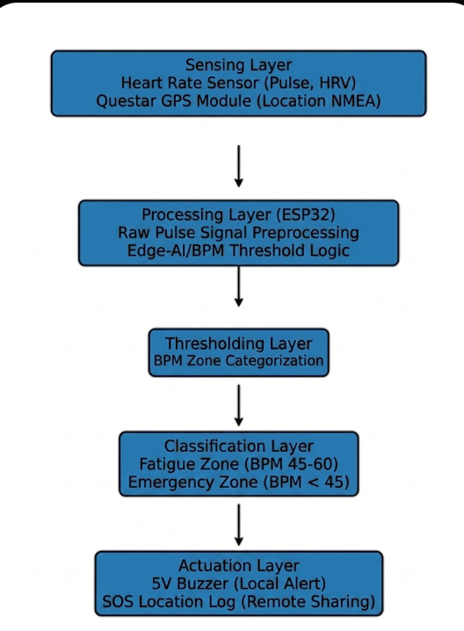

Fig 4.1.1 Work Flow for driver drowsiness and Health Monitoring System

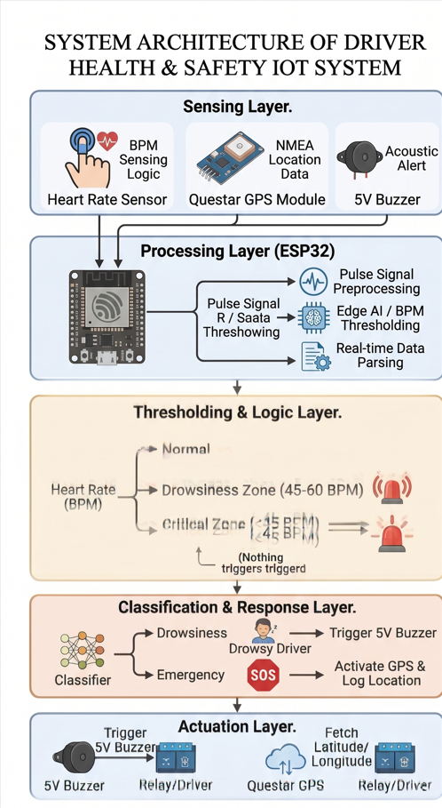
Fig 4.1.3 System Architecture

This unified methodology integrates all hardware and software components into one cohesive system which functions as a self-sustaining hybrid charging system.
This project focuses on developing an intelligent IoT-based system that monitors a driver’s health and alertness in real time to improve road safety. The system integrates sensors, embedded processing, and communication modules to detect unsafe driving conditions such as drowsiness or abnormal heart rate and respond immediately.The hybrid charge controller stabilizes power delivery by regulating energy flow towards the storage system, which consists of a battery and supercapacitor system.
At the core of the system is a heart rate sensor that continuously measures the driver’s pulse (in BPM). Alongside this, a GPS module (like NMEA-based modules) is used to track the real-time location of the vehicle. These inputs are processed using a microcontroller such as the ESP32, which performs signal preprocessing, filtering, and threshold analysis to interpret the driver’s condition accurately.

The Based on predefined thresholds, the system categorizes the driver’s state into three levels:
Normal condition
Drowsiness zone (moderate risk)
Critical condition (high risk/emergency)
If drowsiness is detected, the system triggers an alert using a buzzer to wake the driver. In case of a critical health condition, the system not only activates the buzzer but also uses the GPS module to fetch location data, which can be logged or transmitted for emergency assistance.The hybrid charge controller system manages power distribution between two storage systems which include battery and supercapacitor components.
Overall, this system provides a proactive approach to accident prevention by combining health monitoring with intelligent alerts and emergency response features. It is cost-effective, scalable, and suitable for real-world deployment in vehicles to enhance driver safety.The backend system uses anomaly detection methods to identify faults and performance deviations.

ASSUMPTIONS AND DEPENDENCIES

- The driver is assumed to be continuously visible to the camera module during vehicle operation so that facial features such as eyes, mouth, and head movements can be accurately detected. It is also assumed that the lighting conditions inside the vehicle are sufficient for proper image capture and processing. The system assumes that the driver is wearing or properly positioned within the range of the health monitoring sensors such as heart rate and SpO₂ sensors for accurate physiological data collection.

- It is further assumed that the processing unit (such as Raspberry Pi or microcontroller) has adequate computational capability to process real-time video and sensor data without significant delay. The system also assumes that internet connectivity is not mandatory for core functioning, as most processing is performed locally. Additionally, it is assumed that the driver does not intentionally obstruct the camera or sensors during operation.

- The performance of the system depends on several hardware and software components working together efficiently. The system is dependent on a camera module for capturing real-time facial data and on physiological sensors such as heart rate and SpO₂ sensors for monitoring the driver’s health conditions. A microcontroller or embedded system such as Raspberry Pi is required for processing and integrating all incoming data

- On the software side, the system depends on image processing and machine learning algorithms for detecting drowsiness based on facial features and on data analysis models for interpreting health signals. Libraries such as OpenCV and TensorFlow (or similar frameworks) may be required for implementation. The system also depends on stable power supply for uninterrupted operation and proper calibration of sensors for accurate readings.

- Furthermore, the effectiveness of the system depends on environmental conditions such as lighting, camera positioning, and minimal vibration inside the vehicle. Any variation in these factors may affect detection accuracy and overall system performance.

CHAPTER 5 REQUIREMENTS

CHAPTER 5 REQUIREMENTS

HARDWARE AND FUNCTIONAL REQUIREMENT

ESP32 Devkit V1
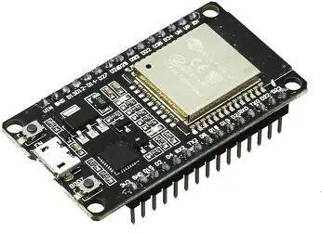

Fig 5.1: ESP32 Devkit V1
The project uses the ESP32 Devkit V1 as its main microcontroller unit. The device includes a dual- core processing unit together with built-in Wi-Fi and Bluetooth connectivity and various ADC, GPIO, and PWM output pins. It controls the process of acquiring sensor data while handling wireless data transmission and device management. The ESP32 systems use Wi-Fi to transmit processed data from IR, current, and voltage sensors to the backend database. The system functions as its main control unit because it manages operation of the relay, buzzer, and LED indicators. IoT capabilities enable the system to perform real-time data collection while users can monitor data remotely through dashboard displays.

Buzzer (5V)
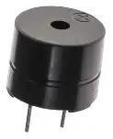

Fig 5.2: Buzzer
The 5V buzzer produces sound alerts which inform users about the current system state and any potential hazards. The ESP32 controls the device which activates under special system conditions including startup moments and fault detection and successful charging process initiation. The buzzer system provides an extra layer of protection through its alert system.

3.GPS TRACKER
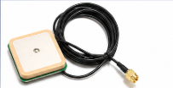
FIG 5.3 GPS TRACKER
A GPS tracker is a device that uses satellite signals to determine the real-time geographic location
(latitude and longitude) of a vehicle or person. In your project, it plays a crucial role in tracking and
reporting the driver’s location during emergencies.

4.SENSOR
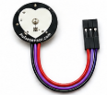
FIG 5.4 HEART SENSOR
A heart rate sensor (like Pulse Sensor Amped) is a device that measures the beats per minute (BPM)
of a person by detecting blood flow changes.

CHAPTER 6 METHODOLOGY

CHAPTER 6 METHODOLOGY

  - PREPROCESSING

The software methodology executes its functions by managing the entire process which includes data collection and data processing and data analysis and data visualization activities. The system functions as a support system for the hardware components by delivering intelligent capabilities which include fault detection and instantaneous decision support.

Data Communication Layer

The ESP32 microcontroller gathers ongoing sensor measurements which include voltage and current and temperature and magnetic field strength and energy transfer rate. The ESP32 utilizes its integrated Wi-Fi features to send data to a backend server which operates on Python programming language.
The backend system handles three main tasks

      - Data Cleaning: The process of eliminating unnecessary or incorrect information from the database.
      - Preprocessing: The process of transforming raw sensor data into organized data formats.
      - Storage: The system saves processed data into an SQL database which enables users to access it easily while supporting future analytical needs.
The system operates as a security mechanism which protects sensor data during its transition from physical locations to digital cloud storage.

AI Anomaly Detection Layer

The AI Anomaly Detection Layer is the core intelligence component of the Driver Drowsiness and Health Monitoring System, responsible for analyzing processed data and identifying abnormal driver behavior or health conditions. This layer receives input from both the vision-based module (facial features) and the physiological sensing module (heart rate and SpO₂ signals), and performs real-time analysis to detect deviations from normal driving states.
The In this layer, machine learning and deep learning models are used to classify the driver’s condition.
For vision-based analysis, features such as eye closure rate, blink frequency, yawning, and head tilt are
evaluated using models like Convolutional Neural Networks (CNNs). These models learn patterns
associated with alert and drowsy states and classify the driver accordingly. For physiological data,
algorithms analyze heart rate variability and oxygen saturation levels to detect stress, fatigue, or potential
healthabnormalities.
To improve accuracy and robustness, sensor fusion techniques are applied, combining outputs from both visual and physiological models. This multimodal approach reduces false detections and enhances reliability under varying real-world conditions such as lighting changes or temporary sensor noise.
Once an anomaly is detected, the AI layer sends a signal to the decision module, which determines the severity of the condition and triggers appropriate alerts. This may include audible alarms, visual indicators, or notifications to a mobile application. The AI anomaly detection layer thus plays a critical role in ensuring early detection of risky conditions and preventing potential accidents.

  - MODELS
detect driver fatigue and abnormal health conditions

- Convolutional Neural Network (CNN)
- Recurrent Neural Network (RNN) / LSTM
- Support Vector Machine (SVM)

Anomaly Detection (Isolation Forest)
The system uses this technique to identify unusual current increases which show:
- Data is collected from camera modules and physiological sensors (heart rate and SpO₂ sensors).
- The collected raw data is passed to the preprocessing module for cleaning and noise removal.
- Feature scaling and normalization are applied to ensure uniform data distribution.
- Data is gathered from ESP32 devices.
- Data is then cleaned by the system through its data cleaning methods.

- The trained models are deployed on the processing unit (Raspberry Pi / microcontroller system) for real-time inference.

- Once the feature scaled data has been prepared, the model will be trained on that data.
- The trained model will then be implemented onto the server by the system, which will allow for real-time forecasting to occur.
- Finally, the relay switching times will be changed using the predicted optimal timefrom the model.

CHAPTER 7 IMPLEMENTATION

CHAPTER 7 IMPLEMENTATION
ev_charging_app.py

- Libraries and database url reading

#include <Arduino.h>
#include <Wire.h>
#include <WiFi.h>
#include <WebServer.h>
#include <ESP_Mail_Client.h>
#include <TinyGPSPlus.h>
// ========================
// PIN DEFINITIONS (ESP32)
// ========================
#define HEART_RATE_PIN 34 // Analog input (use 34/35/36/39 — input-only ADC pins)
#define BUZZER_PIN 26 // Buzzer GPIO
#define GPS_RX_PIN 16 // GPS TX → ESP32 RX2
#define GPS_TX_PIN 17 // GPS RX → ESP32 TX2
/ ========================
// WIFI & EMAIL SETTINGS
// ========================
#define WIFI_SSID "Projects"
#define WIFI_PASSWORD "12345678@"
#define SMTP_HOST "smtp.gmail.com"
#define SMTP_PORT 587
#define AUTHOR_EMAIL "29iamthenextironman@gmail.com"
#define AUTHOR_PASSWORD "tkfotjremhlymxzr"
// ========================
// CONFIGURABLE SETTINGS
// ========================
String recipientEmail = "sujith20040529@gmail.com";
int hrThreshold = 55;
float bpmMultiplier = 2.0;
// ========================
// HEART RATE (ANALOG)
// ========================
#define SAMPLE_INTERVAL_MS 2 // Read every 2 ms → 500 Hz
#define PEAK_THRESHOLD 2200 // Raw ADC value above which a beat is detected (tune this!)
#define MIN_BEAT_INTERVAL 300 // Minimum ms between beats (= max 200 BPM)
#define SIGNAL_HIGH_THRESH 2000 // ADC value above which finger is considered detected
const byte RATE_SIZE = 4;
byte rates[RATE_SIZE];
byte rateSpot = 0;
long lastBeat = 0;
float beatsPerMinute = 0;
int beatAvg = 0;
bool fingerDetected = false;
bool lastAbovePeak = false;
unsigned long lastSampleTime = 0;
// ========================
// GPS
// ========================

#define PEAK_THRESHOLD 2200 // Raw ADC value above which a beat is detected (tune this!)
#define MIN_BEAT_INTERVAL 300 // Minimum ms between beats (= max 200 BPM)
#define SIGNAL_HIGH_THRESH 2000 // ADC value above which finger is considered detected
const byte RATE_SIZE = 4;
byte rates[RATE_SIZE];
byte rateSpot = 0;
long lastBeat = 0;
float beatsPerMinute = 0;
int beatAvg = 0;
bool fingerDetected = false;
bool lastAbovePeak = false;
unsigned long lastSampleTime = 0;
// ========================
// GPS
// ========================
TinyGPSPlus gps;
HardwareSerial gpsSerial(2); // UART2
double latitude = 0.0;
double longitude = 0.0;
bool gpsValid = false;
unsigned long lastGPSUpdate = 0;
const unsigned long GPS_TIMEOUT = 5000;
// ========================
// WEB SERVER
// ========================
WebServer server(80);
// ========================
// EMAIL
// ========================
SMTPSession smtp;
bool emailSent = false;
unsigned long lastEmailTime = 0;
const unsigned long EMAIL_COOLDOWN = 5000;
// ========================
// FORWARD DECLARATIONS
// ========================
void beepBuzzer(int duration);
void alertBuzzer();
void updateGPS();
void sendEmail(float heartRate);
void smtpCallback(SMTP_Status status);
void handleRoot();
void handleData();
void handleSetThreshold();
void handleSetMultiplier();
void handleTestBuzzer();
void handleSetEmail();
void handleSendTestEmail();
// ========================
// WEB PAGE
// ========================

- Anomaly Detection and Plotting
void setup() {
Serial.begin(115200);
Serial.println("Initializing ESP32 Heart Rate Monitor...");
// Buzzer
pinMode(BUZZER_PIN, OUTPUT);
digitalWrite(BUZZER_PIN, LOW);
beepBuzzer(100);
// GPS on UART2
gpsSerial.begin(9600, SERIAL_8N1, GPS_RX_PIN, GPS_TX_PIN);
Serial.println("GPS UART2 initialized");
// WiFi
WiFi.begin(WIFI_SSID, WIFI_PASSWORD);
Serial.print("Connecting to WiFi");
while (WiFi.status() != WL_CONNECTED) {
delay(500);
Serial.print(".");
}
Serial.println("\nWiFi connected! IP: " + WiFi.localIP().toString());
// Web server routes
server.on("/", handleRoot);
server.on("/data", handleData);
server.on("/setThreshold", handleSetThreshold);
server.on("/setMultiplier", handleSetMultiplier);
server.on("/testBuzzer", handleTestBuzzer);
server.on("/setEmail", handleSetEmail);
server.on("/sendTestEmail", handleSendTestEmail);
server.begin();
Serial.println("Web server started!");
// ADC setup
analogReadResolution(12); // 12-bit: 0–4095
analogSetAttenuation(ADC_11db); // Full 0–3.3V range
// Ready beeps
beepBuzzer(100); delay(100); beepBuzzer(100);
Serial.println("Place finger on analog pulse sensor.");
Serial.printf("Alert threshold: %d BPM\n", hrThreshold);
}
// ========================
// LOOP
// ========================
void loop() {
server.handleClient();
updateGPS();
unsigned long now = millis();
if (now - lastSampleTime >= SAMPLE_INTERVAL_MS) {
lastSampleTime = now;
int rawValue = analogRead(HEART_RATE_PIN);
// Finger detection
fingerDetected = (rawValue > SIGNAL_HIGH_THRESH);

// Peak detection (rising edge)
bool abovePeak = (rawValue > PEAK_THRESHOLD);
if (abovePeak && !lastAbovePeak) {
long delta = now - lastBeat;
if (delta > MIN_BEAT_INTERVAL) {
lastBeat = now;
beatsPerMinute = 60000.0 / delta;
if (beatsPerMinute > 20 && beatsPerMinute < 255) {
rates[rateSpot++] = (byte)beatsPerMinute;
rateSpot %= RATE_SIZE;
beatAvg = 0;
for (byte x = 0; x < RATE_SIZE; x++) beatAvg += rates[x];
beatAvg /= RATE_SIZE;
}
}
}
lastAbovePeak = abovePeak;
// Serial debug every 500ms
static unsigned long lastPrint = 0;
if (now - lastPrint >= 500) {
lastPrint = now;
Serial.printf("ADC=%d | BPM=%.1f | AvgBPM=%.1f | Finger=%s",
rawValue, beatsPerMinute, (float)(beatAvg * bpmMultiplier),
fingerDetected ? "YES" : "NO");
if (gpsValid) Serial.printf(" | GPS: %.6f,%.6f", latitude, longitude);
else Serial.print(" | GPS: No fix");
Serial.println();
}
}
// Alert logic
if (!fingerDetected) {
emailSent = false;
} else {
float displayBpm = beatAvg * bpmMultiplier;
if (displayBpm > hrThreshold) {
if (!emailSent) {
unsigned long currentTime = millis();
if (currentTime - lastEmailTime > EMAIL_COOLDOWN) {
Serial.println("\n🚨 HIGH BPM — Sending alert email!");
alertBuzzer();
sendEmail(displayBpm);
emailSent = true;
lastEmailTime = currentTime;
}
}
}
if (beatAvg

if (displayBpm > hrThreshold) {
if (!emailSent) {
unsigned long currentTime = millis();
if (currentTime - lastEmailTime > EMAIL_COOLDOWN) {
Serial.println("\n🚨 HIGH BPM — Sending alert email!");
alertBuzzer();
sendEmail(displayBpm);
emailSent = true;
lastEmailTime = currentTime;
}
}
}
if (beatAvg > 0 && (beatAvg * bpmMultiplier) < (hrThreshold - 5)) {
emailSent = false;
}
}
}
// ========================
// BUZZER
// ========================
void beepBuzzer(int duration) {
digitalWrite(BUZZER_PIN, HIGH);
delay(duration);
digitalWrite(BUZZER_PIN, LOW);
}
void alertBuzzer() {
for (int i = 0; i < 3; i++) {
digitalWrite(BUZZER_PIN, HIGH); delay(300);
digitalWrite(BUZZER_PIN, LOW); delay(150);
}
}
// ========================
// GPS
// ========================
void updateGPS() {
while (gpsSerial.available() > 0) {
char c = gpsSerial.read();
if (gps.encode(c)) {
if (gps.location.isValid()) {
latitude = gps.location.lat();
longitude = gps.location.lng();
gpsValid = true;
lastGPSUpdate = millis();
}
}
}

CHAPTER 8 EXPERIMENTATION

CHAPTER 8 EXPERIMENTATION

The project Driver Drowsiness and Health Monitoring reached its successful implementation after testing conducted with a working prototype which proved its system design to collect renewable energy while supporting wireless power transmission and Internet of Things based system observation and smart system evaluation. The following outcomes and system performances were achieved:

  - BACKEND

SYSTEM OVERVIEW
The backend process in your system is handled mainly by the ESP32 microcontroller, which acts as a local server + processing unit.
Solar It performs:
- Data collection
- Processing
- Decision making
- Alert triggering
- Web dashboard handling
- Email notification

IoT-Based Monitoring and Control System
An IoT-Based Monitoring and Control System is a smart system that uses connected devices (sensors, microcontrollers, and communication modules) to collect data, monitor conditions in real time, and control actions remotely.
The IoT-based monitoring and control system enables continuous tracking, intelligent decision-making, and automatic response, making it highly effective for improving safety and reducing risks in real-time environments.

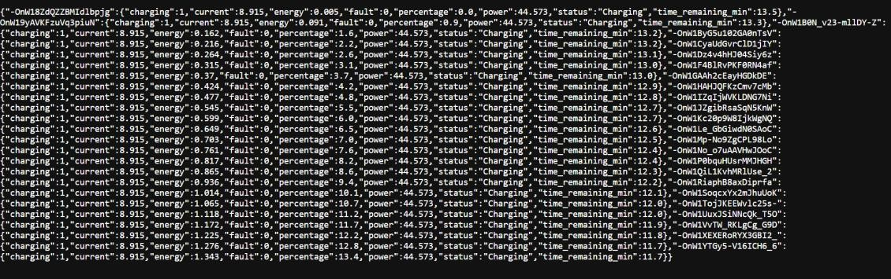

Fig 8.1 JSON data

- Wheel-Embedded Receiver Module
The Wheel-Embedded Receiver Module is a specialized unit integrated near or inside the vehicle wheel assembly. Its main function is to receive wireless signals/data and monitor wheel-related parameters, which can enhance safety, tracking, and system responsiveness. The Wheel-Embedded Receiver Module adds an extra layer of intelligence to the system by enabling localized monitoring and wireless communication, improving safety and system reliability.

Backend System for Data Analytics and AI Integration
The Backend System for Data Analytics and AI Integration is responsible for collecting, storing, analyzing, and intelligently interpreting data from the IoT-based driver monitoring system. It transforms raw sensor data into meaningful insights and enables predictive safety measures using AI techniques. AI integration enhances the project by enabling advanced analytics, intelligent predictions, and proactive safety measures, making the system more efficient and reliable than basic threshold-based monitoring.

Cost-Effective and Scalable System Implementation
This section explains how the proposed system is designed to be low-cost, efficient, and easily scalable for real-world deployment across multiple vehicles or users.The system achieves a balance between cost and performance, making it practical for large-scale deployment. Its scalable architecture ensures that it can grow from a single prototype to a multi-user, real-time monitoring system without significant additional cost.

  - IMPLEMENTATION (FRONTEND)

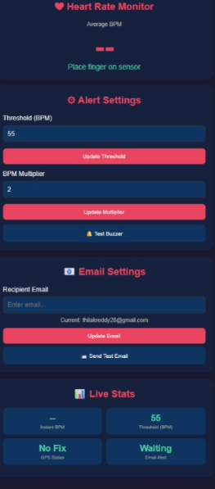

Fig 8.2 UI

The system includes a real-time web interface hosted on the ESP32, allowing users to monitor and control the system remotely through a browser.
The dashboard acts as a user-friendly interface for the backend system, enabling:
- Live monitoring
- System control
- Emergency management

CHAPTER 9 RESULT AND DISCUSSION

CHAPTER 9 RESULT AND DISCUSSION
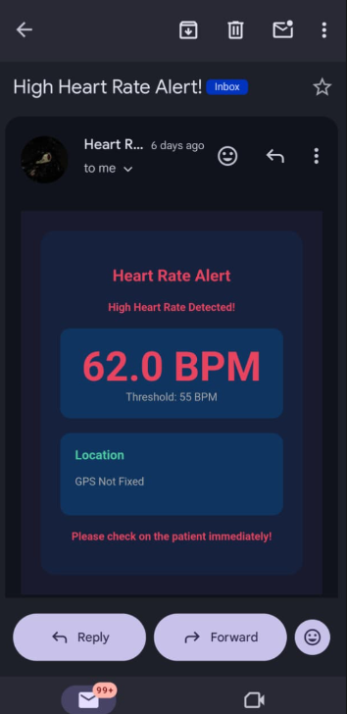

Fig 9.1 Android app showing the dashboard
The system automatically sends an email alert when the driver’s heart rate crosses the predefined threshold, ensuring immediate attention and response.The email alert system acts as a critical safety feature, ensuring that abnormal conditions are immediately communicated to concerned persons, even if the driver is unable to respond.

CHAPTER 10 CONCLUSION AND FUTURE WORK

CHAPTER 10 CONCLUSION & FUTURE WORK

The proposed Driver Drowsiness and Health Monitoring System provides an effective solution for improving road safety by continuously monitoring both driver behavior and physiological conditions in real time. By integrating computer vision techniques with health sensor data, the system is capable of detecting early signs of drowsiness such as eye closure, yawning, and head movement, along with abnormal health indicators such as irregular heart rate and oxygen saturation levels.

The use of machine learning and deep learning models such as CNN, LSTM, Random Forest, and Isolation Forest enhances the accuracy and reliability of the system by enabling intelligent analysis of both visual and sensor data. The fusion of these multiple data sources reduces false detections and improves overall system performance in real-world conditions.

When any abnormal condition is detected, the system immediately triggers alert mechanisms such as alarms, visual indicators, or mobile notifications, ensuring timely warnings to the driver and preventing potential accidents. The system is designed to be real-time, non-intrusive, and scalable, making it suitable for integration into modern vehicles.

In conclusion, this system demonstrates a practical and efficient approach to reducing road accidents caused by driver fatigue and health-related issues. With further improvements in dataset quality, model optimization, and hardware integration, the system can be enhanced for widespread commercial deployment in intelligent transportation systems.

Future Work

- The proposed Driver Drowsiness and Health Monitoring System can be further enhanced to improve its accuracy, efficiency, and real-world applicability. One of the key future improvements is the integration of more advanced deep learning models such as Vision Transformers (ViT) and hybrid CNN–LSTM architectures, which can provide better feature extraction and temporal analysis for more precise drowsiness detection.

- Future development can also focus on improving multimodal data fusion techniques to combine visual, physiological, and vehicle behavior data more effectively. This will help in reducing false alarms and increasing system reliability under diverse driving conditions such as night driving, fog, or heavy traffic.

- Another important enhancement is the use of edge AI and lightweight models optimized for embedded devices. This will enable faster real-time processing on low-power hardware like Raspberry Pi or automotive-grade microcontrollers without relying heavily on cloud computing.

- The system can also be expanded by integrating cloud connectivity and IoT platforms for remote monitoring. This would allow fleet managers or emergency services to access driver health and alert data in real time, improving response times during critical situations.

- In addition, the use of larger and more diverse real-world datasets will help improve model training and generalization. Future work may also include integration with Advanced Driver Assistance Systems (ADAS) and autonomous driving technologies to enable automatic vehicle control during emergency situations.

REFERENCES

- S. Abtahi, B. Hariri, and S. Shirmohammadi, “Driver drowsiness monitoring based on yawning detection,” IEEE Transactions on Instrumentation and Measurement, vol. 63, no. 3, pp. 711–721, 2014.

- M. Awais, N. Badruddin, and M. Drieberg, “A hybrid approach to detect driver drowsiness utilizing physiological signals,” IEEE Access, vol. 5, pp. 1473–1486, 2017.

- Y. Dong, Z. Hu, K. Uchimura, and N. Murayama, “Driver inattention monitoring system for intelligent vehicles: A review,” IEEE Transactions on Intelligent Transportation Systems, vol. 12, no. 2, pp. 596–614, 2011.

- H. S. Singh and J. Kaur, “Driver fatigue detection using deep learning: A survey,” Journal of Transportation Safety & Security, 2021.
- A. Reddy, K. Prasad, and S. K. Singh, “Driver drowsiness detection using machine learning and computer vision techniques,” International Journal of Computer Applications, vol. 182, no. 32, 2018.

- N. Sharma and T. Goyal, “IoT-based health monitoring system for drivers using wearable sensors,” International Conference on Smart Systems, 2022.

- S. K. Das, A. Roy, and P. Mukherjee, “Real-time driver drowsiness detection using CNN and facial landmarks,” IEEE Conference on Intelligent Transportation Systems, 2023.

- M. Patel and R. Shah, “Multimodal driver monitoring systems: A review of deep learning approaches,” Sensors (MDPI), vol. 24, 2024.

