**Sri Lanka Institute of Information**

**Technology**



**Data Warehousing & Business Intelligence**

**Assignment 02**

**Submitted by:**

**Britto T.A(IT20100698)**

**1. Data Source for the Assignment 02.**

Data Source – HetRecMovies_DW

**HetRecMovies_DW have following tables**

* DimDate
* DimMovieActors
* DimMovieGenres
* DimMovies
* DimRottenTomatoes
* FactUserRatedMovies

**DimDate**

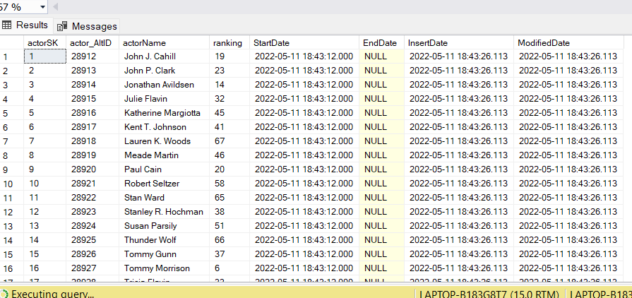 **DimMovieActors**

**DimMovies**

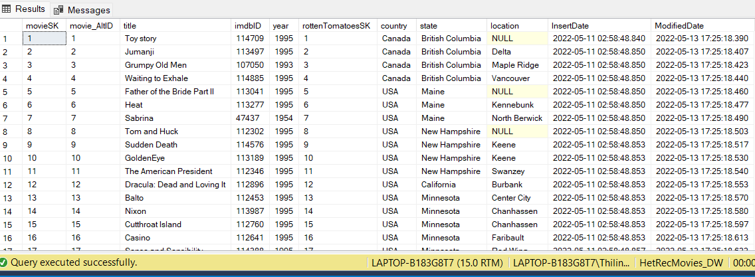

**DimMovieGenres**

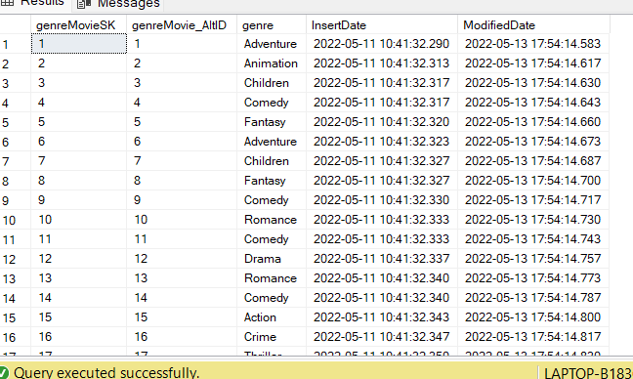

**DimRottenTomatoes**

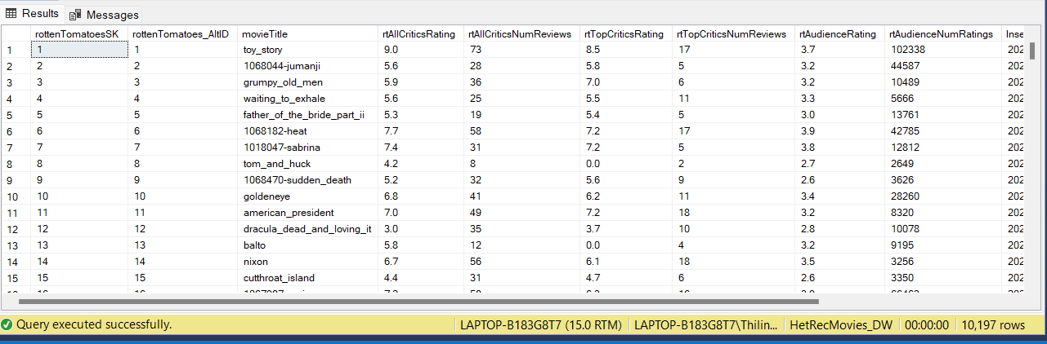

**FactUserRatedMovies**

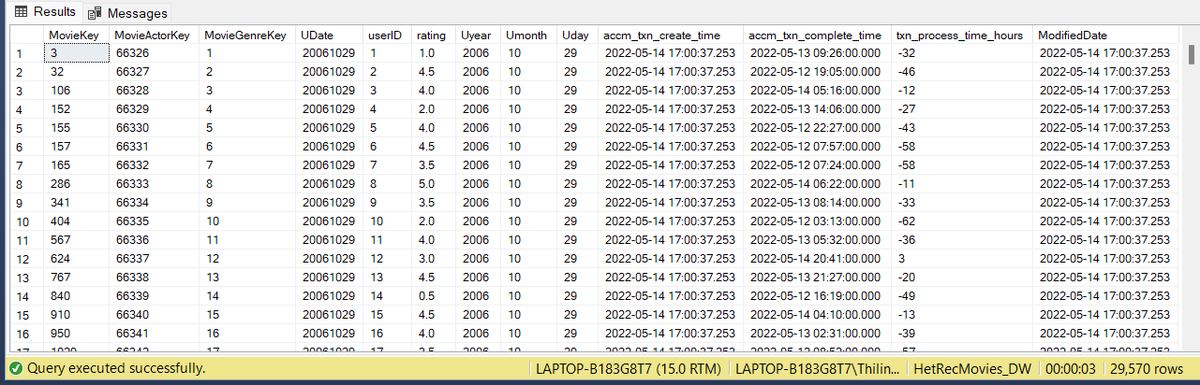

**ER Diagram.**

**2)SSAS Cube Implementation.**

* First, I create Analysis Service Project renamed as “HetRecMovies Analysis”.
* Then we should configure components starting from data sources to dimensions.
* Then I create my Data Source Which is

DS_HetRecMovies_DW.

* Created Date source View as DSV_Het RecMovies_DW.

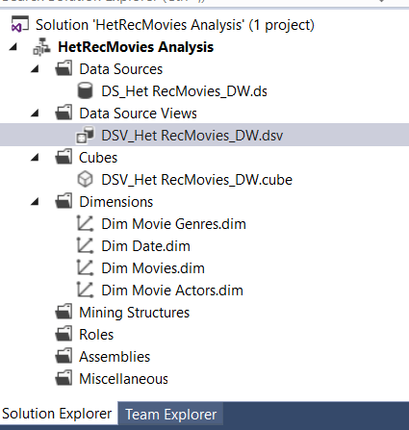

Then create the cube named DSV_Het RecMovies_DW. cube. This is the snowflake schema

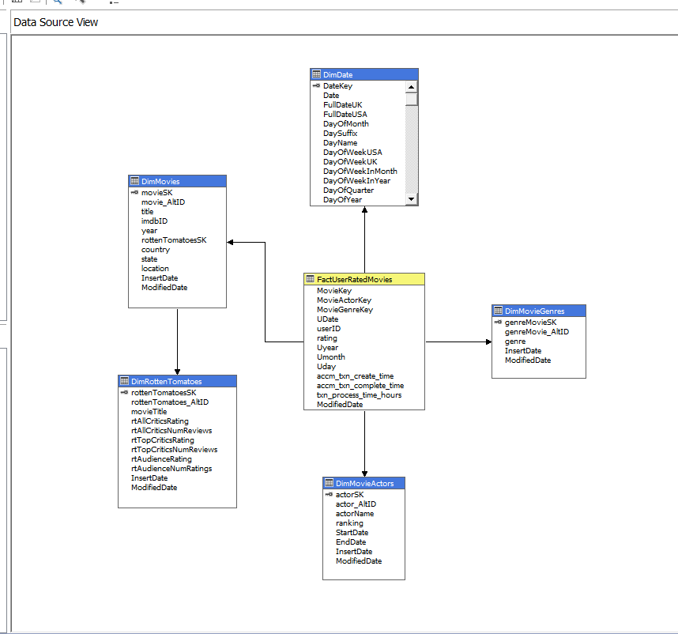

**Create Hierarchies:**

A) Right click on the Dimension and Click open.

B) Select all the attributes that needs to create reports on the dimension and drag them into the left side of attributes section.

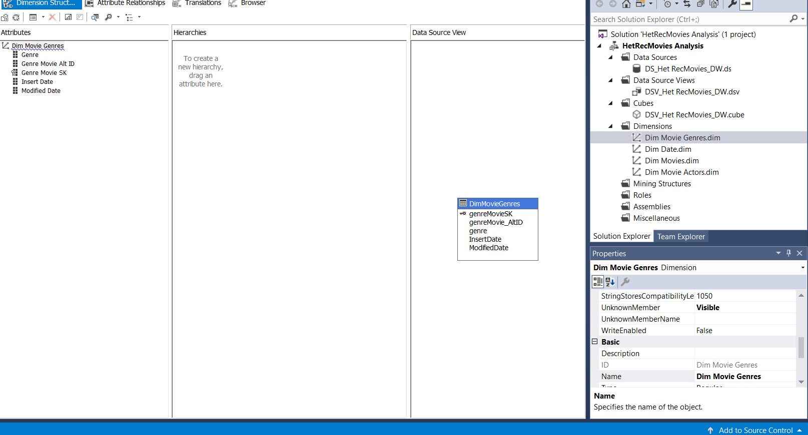 **DimMovieGenres**

**DimDate**

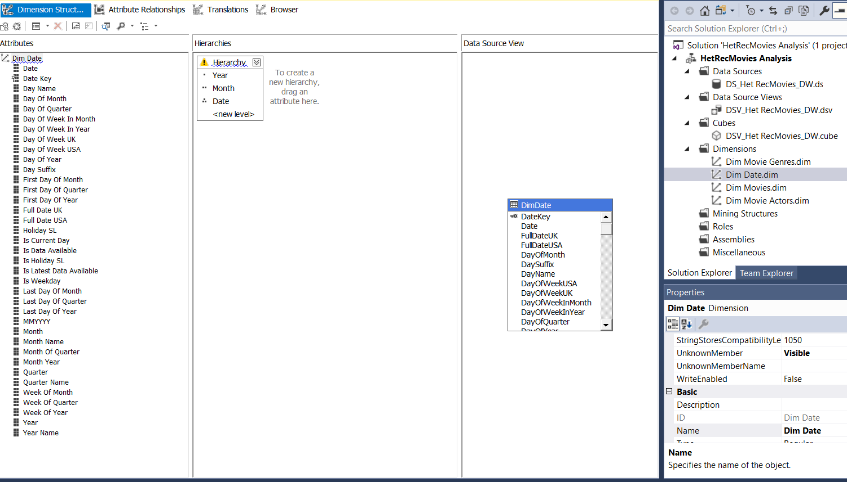Drag and drop Hierarchical attributes into the DimDate Hierarchy section and create new Hierarchy.

**DimMovie**

Drag and drop Hierarchical attributes into the DimMovies Hierarchy section and create new Hierarchy

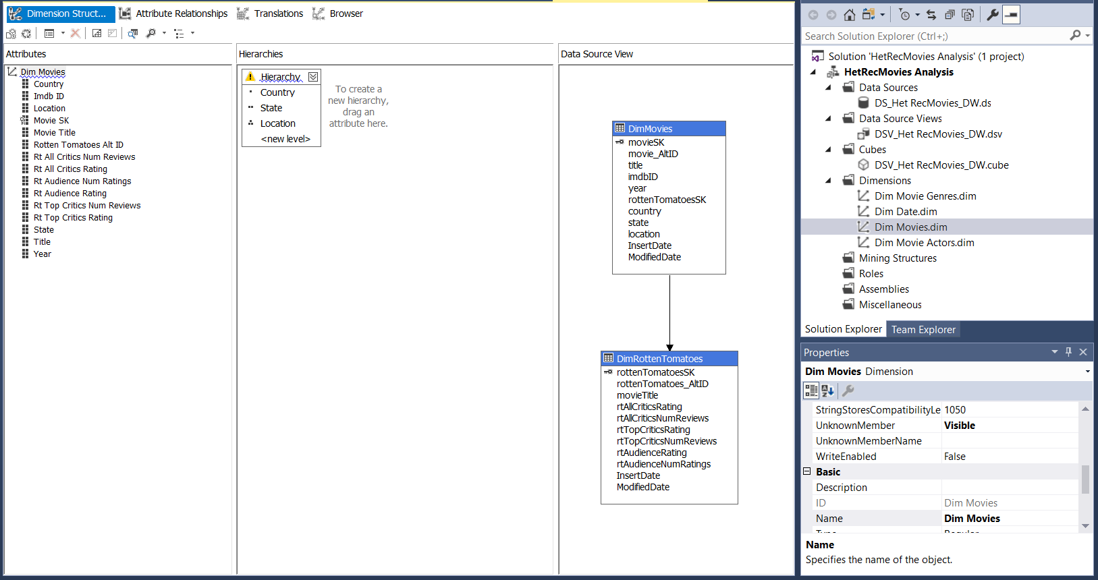

**DimMovieActors**

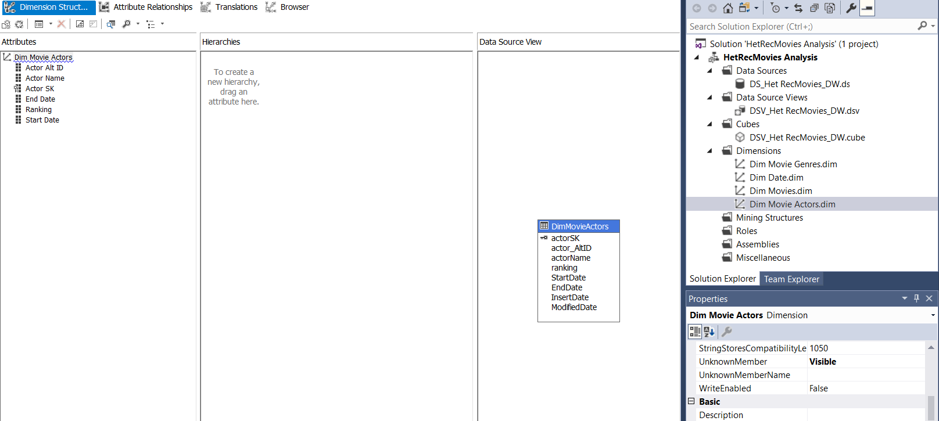

**Deploy the project:**

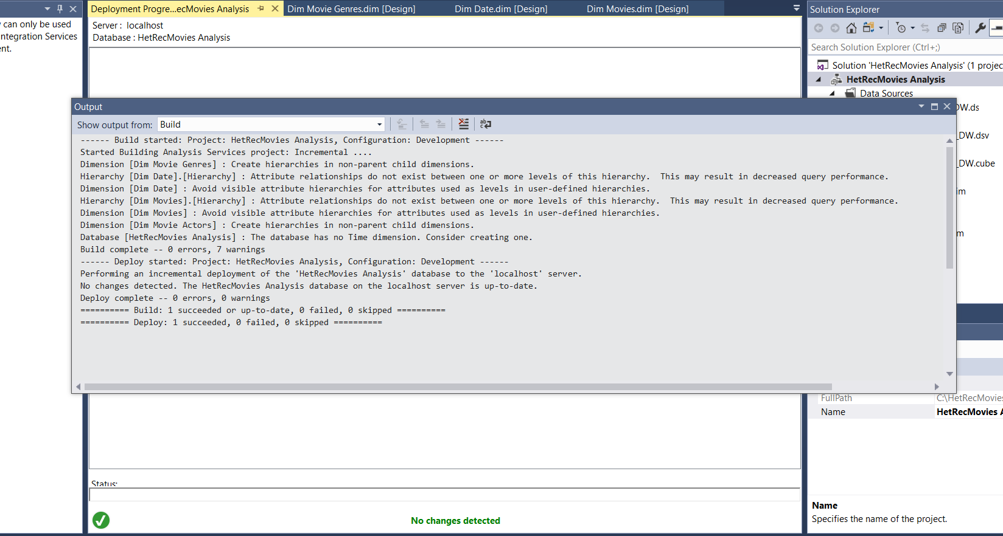 Right click on the SSAS project and click Deploy

Then I deploy the cube. -cube successfully deployed

**KPI**

* Create the KPI.Name the KPI as **“KPI User Rating”.**
* Then select “FactUserRatedMovies” as the Associated Measure Group. In the Measure Group on the lower left side panel, expand Measures and the expand “FactUserRatedMovies”. Drag and drop ‘rating’ attribute to Global Expression area and modify the expression as flows:

**[Measures]. [Rating] > 2.0**

* Then I save the all the changes. After processing the cube we can see like this.

**3. Demonstration of OLAP operations.**

* First ,I generate the MDX query using the cube’s browser.

Then I click on execute button. To get MDX query I click on Design Mode button.

* Then I connect to the Excel using HetRecMovies_SSAS using the above MDX Query.

In the next window,past the MDX query I copied,and click on validate button to ensure there are no erros, and click finish.

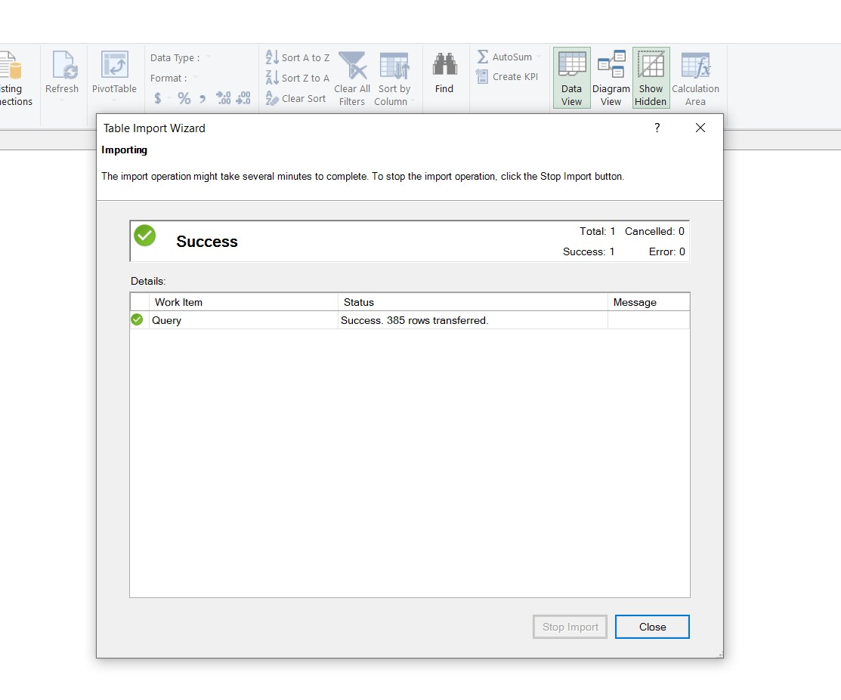

Initially I see this interface.

In the Excel,I can see all the fields I selected via the MDX Query.

**ROLL-UP OLAP OPERATION**

After OLAP Cube deployment, OLAP operations were demonstrated using Excel application

**DRILL-DOWN OLAP OPERATION**

**SLICE OLAP OPERATION**

**DICE OLAP OPERATION**

**4.SSRS Reports.**

**I use Report Builder to create my reports.**

* First step to create Data Source. In order to create the data source, I add the my data source as data “DataSource1”.
* Next I create the data set. In order to create the data set right click on DataSet and open up Dataset properties window. In the query section, provide the dataset name as “Dataset1” and select use the data set embedded in my dataset.

**select fr.rating**

**,mo.country**

**,mo.title**

**,mg.genre**

**,dd.[Year]**

**,rt.rtAudienceRating**

**,rt.rtAllCriticsRating**

**,rt.rtTopCriticsRating**

**from FactUserRatedMovies fr**

**INNER JOIN DimMovieS mo ON mo.movieSK = fr.MovieKey**

**INNER JOIN DimMovieGenres mg ON mg.genreMovieSK = fr.MovieGenreKey**

**INNER JOIN DimDate dd ON dd.DateKey = fr.UDate**

**INNER JOIN DimRottenTomatoes rt ON rt.rottenTomatoesSK = fr.MovieKeyExceute**

the above query that I have create using SQL server. Then I click ok button to create the dataset.

**1.Create the Materix report.**

Then I create matrix using matrix wizard and it display as below;

Then I run the matrix report ;

**2.Create the Parameterized Report.**

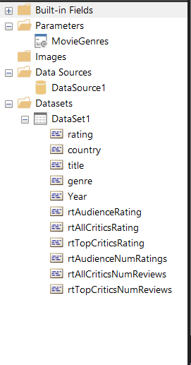

And enable users to add multiple parameters values by changing the Dataset query Like this.

**select fr.rating**

**,mo.country**

**,mo.title**

**,mg.genre**

**,dd.[Year]**

**,rt.rtAudienceRating**

**,rt.rtAllCriticsRating**

**,rt.rtTopCriticsRating**

**,rt.rtAudienceNumRatings**

**,rt.rtAllCriticsNumReviews**

**,rt.rtTopCriticsNumReviews**

**from FactUserRatedMovies fr**

**INNER JOIN DimMovieS mo ON mo.movieSK = fr.MovieKey**

**INNER JOIN DimMovieGenres mg ON mg.genreMovieSK = fr.MovieGenreKey**

**INNER JOIN DimDate dd ON dd.DateKey = fr.UDate**

**INNER JOIN DimRottenTomatoes rt ON rt.rottenTomatoesSK = fr.MovieKey**

**Where mg.genre = @MovieGeneres**

Then I save the report-to-report server. Then I can see the report can get the output like this.

**3.Create More than One Parameter Report**

. I Created 2 data sets to implement more than one parameter report

DataSet2 query:

**SELECT DISTINCT**

**DimMovies.[year]**

**,DimMovies.movieSK**

**FROM**

**DimMovies**

**ORDER BY**

**DimMovies.[year]**

DataSet3 query:

**SELECT**

**DimMovies.country**

**,DimMovies.movieSK**

**FROM**

**DimMovies**

**WHERE**

**DimMovies.movieSK = @YearParameter**

**ORDER BY**

**DimMovies.country**

**YearParameter**

**CountryParameter**

**4.REPORT WITH DRILL Through**

Query for create drill down:

**SELECT**

**FactUserRatedMovies.rating**

**,DimMovieGenres.genre**

**,DimMovies.[year]**

**FROM**

**FactUserRatedMovies**

**INNER JOIN DimMovies**

**ON FactUserRatedMovies.MovieKey= DimMovies.movieSK**

**INNER JOIN DimMovieGenres**

**ON FactUserRatedMovies.MovieGenreKey = DimMovieGenres.genreMovieSK**

5.drill down

